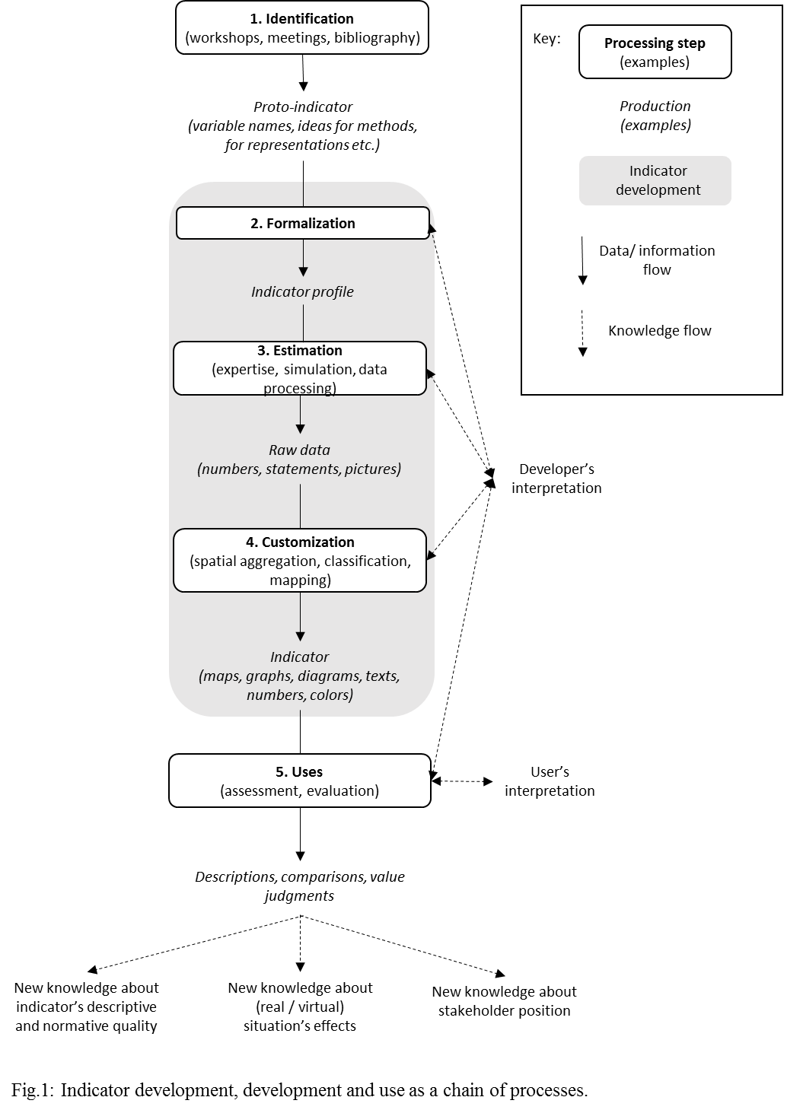
Fig. 1 Indicator identification, development and use as a chain of processes.

Table 1. Criteria and potential indicators to assess water management options. Because an indicator can inform multiple criteria, the total number of indicator profiles among criteria exceeds 146 (total number of indicator profiles). Numbers in parentheses indicate the number of proto-indicators that could not be further formalized.
 | Criteria |  | Indicator profiles
 | Name | Content | No. |  |  | Names of selected examples
 | Safety | Damage caused by water; Public health and drinking water | 9 (2) |  |  | Number of days under critical low flow; Runoff coefficient of upstream areas
 | Food security | Quantity of food products; Healthiness of food products | 4 |  |  | Nutritional content of food production; Energy content of food production
 | Local identity | Protecting agricultural identity and local expertise; Landscape diversity (non-specialization) | 20 (1) |  |  | Agricultural land cover diversity; Proportion of farms and production types with a quality label
 | Wealth and employment | Agricultural sector; Tourism; Hydropower | 14 (1) |  |  | Cumulative revenue of all farms in the area; Diversity of potential recreational water activities; Hydropower production from existing plants
 | Biodiversity | Aquatic and terrestrial biodiversity | 14 |  |  | Pollution from plant protection practices; Variation in minimum average flow for 10 consecutive days; Heterogeneity in landscape composition and configuration
 | Long-term adaptability of water-use activities | Vulnerability to socio-economic shocks; Vulnerability to changes in water availability; Development capacities | 27(3) |  |  | Crop yields under climate change; Available water stock at the end of each irrigation season; Diversity of agricultural production
 | Adjustment potential | Leeway for water managers and users to adapt water supply to demand (and vice-versa) throughout the year |  | 9 |  | Impact of water-use restrictions on agricultural production; Temporal distribution of water needs
 | Maintaining natural capital | Natural functioning of hydrological system; Natural functioning of soils | 18 (3) |  |  | Number of days with bare soil; Renewal rate of underground water stock; Volume of rainwater returned to the environment
 | Equity among water users | Equity in distribution of water use potential; Equity in distribution of costs and effort | 11 |  |  | Number of farms with increased/decreased irrigation costs; Areas with increased/decreased irrigation water
Efficiency |  | Efficiency of water management decisions;  Efficiency of the water management infrastructure;  Efficiency of agricultural water | 19 |  | Yield of agricultural production compared to potential yield; Cost of 1 cubic m of water released from reservoirs; Use rate of reservoirs
 | Political intelligibility | Conformity with political/regulatory objectives; Citizen approval | 8 |  | Number of days with decreed restrictions on water use; Average water consumption per ha

Table 2. Extract of the indicator profile database for indicators used as examples in the results (indicators are listed in the order in which they appear in the text)
No. (see Appendix) | Indicator name | Definition | Source | Criterion/a | Estimation method | Resolution of raw data | Aggregation scale(s) | Evaluation scale(s) | Representation(s)
67 | Area affected by water restrictions at key periods | Number of ha that encounter water use restrictions when crop production is highly sensitive to water stress. | experts | Adjustment potential | Model simulation | Islet/Field | Farm type; Agricultural landscape; Crop type; Restriction zone | Landscape; Sub-landscape (spatial units); Sub-landscape (classes) | single values; map
21 | Irrigation cost per ha | Average annual costs per ha related to irrigation (including amortization of equipment costs) | experts | Equity | Model simulation | Islet/Field | Crop type | Landscape | single values
44 | Variation in water stored in soils | Difference between water stored in soils at the end of the simulation period (15 years) and the beginning of simulation | authors | Reproduction of natural capital | Model simulation | Islet/Field | Elementary watershed | Landscape; Sub-landscape (spatial units) | map
94 | Pollution from plant protection practices | Qualitative estimate of pollution pressure based on:  - the quantity of chemicals applied  - the moment when chemicals are applied (occasional leaching or not) | stakeholders+authors | Preservation of biodiversity; Safety | Model simulation | Islet/Field | Elementary watershed; Entire landscape | Landscape; Infra (spatial units) | map; single value
113 | Volume of rainwater returned to the environment | Volume of rainwater returned to water bodies or soil each year (average)  (Underground infiltration + Surface flow + Sub-surface flow - Irrigation) / Rainwater | authors | Reproduction of natural capital | Model simulation | Islet/Field | Entire landscape | Landscape | single value
70 | Irrigation capacity of all farms | Cumulative value of the irrigation capacity of all irrigation equipment, expressed relative to the irrigation needs of crops. | experts; stakeholders | Long-term adaptability of water-use activities | Calculations based on scenario data | Islet/Field | Agricultural landscape | Landscape | graph
112 | Impact of water use restrictions on agricultural yields | Average yields without restrictions - Average yields with restrictions | stakeholders+authors | Adjustment potential | Model simulation | Islet/Field | Farm type; Agricultural landscape | Landscape; Infra (classes) | graph
139 | Use rate of reservoirs | Volume of water withdrawn from reservoirs for agricultural use / Volume of water stored in the reservoirs | stakeholders+authors; experts | Efficiency | Model simulation | Reservoirs | Entire water system | Landscape | graph
50 | Semi-natural elements contributing to water purification | Proportion of the landscape covered by semi-natural elements that contribute to water purification (wet grasslands, forests, etc.) | stakeholders+authors | Safety | Calculations based on scenario data | Land cover unit | Land cover unit; Entire landscape | Landscape | single value; map
69 | Match between water storage capacity and irrigation needs | Storage capacity in reservoirs for agricultural use / Volume of irrigation water necessary to meet crop needs | experts | Efficiency | Model simulation | Islet/Field; Reservoirs | Entire landscape | Landscape | single value
144 | Farms with increase/decrease in irrigation costs | Farms with an increase or decrease in irrigation costs compared to the reference scenario (with different thresholds: -30%, -20%, -10%, +10%, +20%, +30%) | experts | Equity | Calculations based on scenario data | Farm | Farm; Farm type; Agricultural landscape | Landscape | graph; map
101 | Two-year flood flow | Value of the 2-year flood flow under a scenario of change / Value of the 2-year flood flow without water withdrawals | experts; stakeholders | Reproduction of natural capital | Model simulation | River/river segment | River/river segment | Landscape; Sub-landscape (spatial units) | single values; map
2 | Impacts on the diversity of recreational water activities | Expert estimates of impacts of scenarios on swimming, canoeing-kayaking, and fishing based on scenario descriptions and simulations of the quantity of water in rivers.  Impacts must be estimated in terms of:  - number of potential sites where the activities are practiced  - maintenance / disappearance / development of currently practiced activities | experts; stakeholders+authors | Wealth and employment; Local identity | Expert estimates | Entire water system; Site of practice | Entire water system; Site of practice | Landscape | map; narratives
81 | Nitrate pressure | Quantity of nitrates that could pollute vulnerable drinking water watersheds (due to previous pollution or lack of proper equipment). | experts | Safety | Model simulation | Islet/Field | Specific zone | Landscape; Sub-landscape (spatial units) | map
76 | Changes in gross margin generated by each type of agricultural production | For each form of agricultural production: (gross margin in the scenario − reference gross margin) / reference gross margin.  The number of employees involved in the value chain of each production type should be included as additional information. | experts; stakeholders+authors | Wealth and employment | Model simulation | Islet/Field | Crop type | Landscape; Sub-landscape (classes) | graph

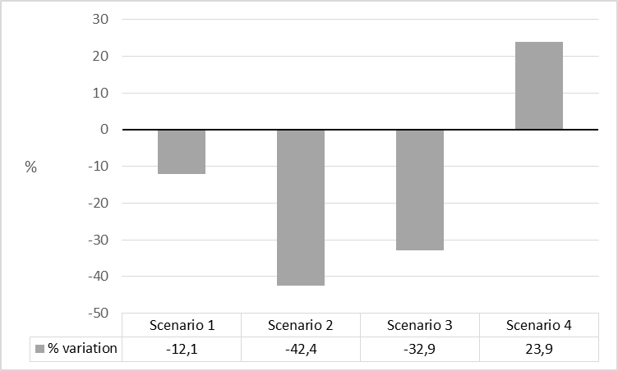
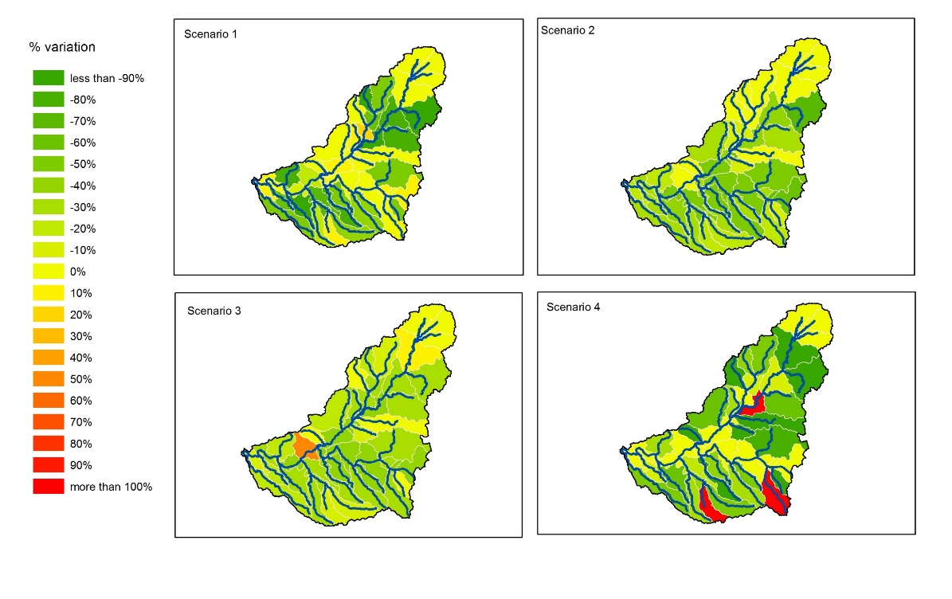

Fig. 2: Indicators resulting from two different spatial aggregation choices. Up: partial aggregation (at the scale of elementary watersheds); down: complete aggregation (at the scale of the entire landscape). The two series of indicators are made out of the same raw data of agricultural water withdrawals simulated at the field scale for 4 scenarios.

