Interpretative Summary, Billa et al., page XX. The evaluation of nutritional deficits in dairy cows may be performed by measuring the concentrations of plasma metabolites, which require invasive blood sampling. The use of milk as source of noninvasive indicators would facilitate monitoring of animals. Concentrations of minor milk constituents were modified during partial restriction, suggesting their potential use as biomarkers of nutritional status.

RUNNING HEAD: MILK METABOLITES DURING UNDERNUTRITION

Milk metabolites as noninvasive indicators of nutritional status of midlactation Holstein and Montbéliarde cows

P.A. Billa*, Y. Faulconnier*, T. Larsen†, C. Leroux*, J.A.A. Pires*

* INRA, Université Clermont Auvergne, VetAgro Sup, UMR Herbivores, F-63122 Saint-Genès-Champanelle, France
† Department of Animal Science, Aarhus University, DK-8830 Tjele, Danemark

ABSTRACT
The objective was to investigate the effects of feed restriction on concentrations of selected milk metabolites in midlactation Holstein and Montbéliarde cows, and explore their correlations with energy balance and classic plasma and milk indicators of nutritional status. Eight Holstein and 10 Montbéliarde cows (165 ± 21 DIM) underwent 6 d of feed restriction during which feed allowance was reduced to meet 50% of their net energy for lactation (NE_{L}) requirements. The experiment was divided in four periods: Control (CONT; d -3 to -1), restriction (REST; d 1 to 6), WEEK1 (d 7 to 13) and WEEK2 (d 14 to 18) after refeeding at ad libitum intake. Intake, milk production, energy balance and plasma metabolites were used to validate the feed restriction model. Concentrations of seven milk metabolites, i.e. BHB, glucose, glucose-6-phosphate, isocitrate, glutamate, uric acid and free amino groups were measured in morning milk samples, and fatty acids in pooled PM and AM samples. Feed restriction induced a negative energy balance (-42.5 ± 4.4 MJ/d), increased plasma non-esterified fatty acids and BHB, and decreased plasma glucose concentrations. Feed restriction increased milk glucose-6-phosphate and isocitrate (+38% and +39%, respectively) and decreased milk BHB, glucose, glutamate, uric acid and free amino group concentrations (-20%, -57%, -65%, -42% and -14%, respectively), compared to pre- restriction. Milk concentrations of medium chain fatty acids (e.g. sum of C10 to C15) decreased and those of long chain (e.g. 18:0, cis-9 18:1) increased during restriction. Breed differences were not detected for the majority of variables. All studied milk metabolites were significantly correlated with energy balance (r_{s} = 0.48, 0.63, -0.31, -0.45, 0.61 for BHB, glucose, glucose-6-phosphate, isocitrate and glutamate, respectively). Milk glucose and glutamate were the most correlated with plasma metabolites and milk FA associated with lipomobilization. These results suggest that milk metabolites may be used as noninvasive indicators of NEB and metabolic status of dairy cows.

INTRODUCTION
Milk composition is modulated by a diversity of factors, including genetics, lactation stage, nutrition and health status, therefore, milk is an obvious source of biomarkers for the monitoring of dairy ruminants. Early lactation is characterized by a rapid increase in milk yield, mobilization of body protein and fat reserves, negative energy balance (NEB), and modifications in milk protein, fat and fatty acid composition. Complex homeorhetic and homeostatic adaptations are required to the direct limiting nutrients towards the mammary gland and support milk synthesis during early lactation (Bell and Bauman, 1997). The occurrence of metabolic disorders related to energy metabolism is typical during this period, and plasma concentrations of non-esterified fatty acids (NEFA) and BHB are classic indicators for herd troubleshooting (Oetzel, 2004). Experimental feed restriction models are used to induce nutrient deficits and NEB at different stages of lactation, assess the production and metabolic responses (Gross et al., 2011a; Bjerre-Harpøth et al., 2012; Friggens et al., 2016), and the effects of NEB on various biological functions of the dairy cow (Moyes et al., 2009; Abdelatty et al., 2017; Pires et al., 2019). Metabolic responses to feed restriction models are of greater amplitude during early lactation compared to later stages (Bjerre-Harpøth et al., 2012), but midlactation period is more convenient to run experimental protocols and less prone to confounding due to the dynamic nature of early lactation (Contreras et al., 2016).
The reliance on body reserve mobilization for milk synthesis during early lactation is largely driven by genetics (Friggens et al., 2013). Breed differences between Holstein (HOLS) and Montbéliarde (MONT) cows have been described in various production systems (Dillon et al., 2003; Pomiès et al., 2007; Pires et al., 2015). Holstein cows prioritize milk, fat, protein and lactose secretion compared with MONT (Dillon et al., 2003; Pomiès et al., 2007; Pires et al., 2015), but experience greater BCS loss and metabolic deviations during early lactation (Dillon et al., 2003; Pires et al., 2015). Therefore, we hypothesized that breed effects might be used as a model to induce different production and metabolic responses to a nutritional challenge.
Milk is a source of novel indicators of nutritional status of dairy cows. Milk sampling is easy to perform in dairy operations, and can be automated for inline analyses. Certain molecules of intermediary metabolism are present in milk and may be indicators of physiological and nutritional state of dairy cows (Gross and Bruckmaier, 2019). For instance, milk is classically used to monitor ketosis by cow-side tests (Oetzel, 2004) and by automated inline BHB measurements. Milk glucose, glucose-6 phosphate, and acid uric acid concentrations are modulated by diet digestibility and correlated with DMI in midlactation cows (Larsen et al., 2016). Furthermore, milk glucose and glucose-6 phospate concentrations vary according to DIM (Larsen and Moyes, 2015; Zachut et al., 2016; Ferris et al., 2018).
Milk concentrations of these metabolites may reflect modifications of metabolic pathways in mammary epithelial cells, including glucose utilization for glycolysis and lactose synthesis (Chaiyabutr et al., 1981,), glucose-6-phosphate and isocitrate to produce reducing potential (i.e.; NADPH) for de novo fatty acid synthesis (Garnsworthy et al., 2006; Chaiyabutr et al., 1981), and to counterbalance oxidative stress associated with FA oxidation (Zachut et al, 2016). Milk uric acid originates in part from ruminal digestion of purine bases and has been suggested as an indicator of microbial protein synthesis (Larsen and Moyes, 2010). Milk glutamate and free amino acid content may reflect the availability and metabolism of amino acids.
The effects of NEB and breed on concentrations of minor milk metabolites are still insufficiently documented. We hypothesized that concentrations of selected metabolites in milk are modified during periods of NEB, and may constitute novel indicators of energy balance and metabolic status of dairy cows. Thus, the objective was to determine the effects of NEB induced by partial feed restriction on milk concentrations of selected metabolites, assess potential differences between midlactation HOLS and MONT cows, and evaluate their relationships with classic indicators of metabolic status and lipomobilization.

MATERIALS AND METHODS

Experimental Design, Animals, Diets and Housing
All procedures were approved by the ethic committee on animal experimentation (APAFIS # 3737-2015043014541577v2). Twenty multiparous midlactation cows (165 ± 21 DIM), 10 Holstein-Friesian and 10 Montbéliarde (1.5 ± 0.29 BCS, 0 to 5 scale) were used to study the effects of 6 d of feed-restriction to meet 50% of NE_{L} requirements on milk production, classic plasma and putative milk biomarkers of metabolic status. Two HOLS cows were excluded from the study, one due to clinical mastitis and one due to noncompliance with the restriction protocol. Phenotypic measurements were performed from d -3 to +18 relative of initiation of restriction, corresponding to the following periods: control (CONT; d -3 to -1), restriction (REST; d 1 to 6), week 1 (WEEK1; d 7 to 13), and week 2 (WEEK2; d 14 to 18; Figure 1). Five cows of each breed were randomly allocated to a group of 10 animals that initiated the experimental protocol one day apart. Mammary and liver biopsies were performed on d 0 and d 6 for complementary studies (Billa et al., 2019). The experiment was conducted at the INRA Herbipôle experimental farm of ‘Marcenat’ (45°18'21’N, 2°50'13’E; 1100 m of altitude; https://doi.org/10.15454/1.5572318050509348E12) during April and early May.
During CONT, WEEK1 and WEEK2 periods, all cows were allowed ad libitum intake of a TMR (Table 1). During REST period, feed allowance was reduced to meet 50% of individual NE_{L} requirements calculated from BW, feed intake and milk production and composition recorded before restriction (INRA, 2007). Cows had free access to water and were housed in a free stall barn equipped with automatic feed bunks that control individual access and weight feed intake (CRFI, Biocontrol, Rakkestad, Norway). Gates were programmed to divide individual daily feed allowance in 4 equal portions in 6-h periods. Cows ate 3 ± 0.9 kg of hay (58.9% NDF, 31.9% ADF, 11.5% CP and 5.4 MJ /kg of DM) during the two d after refeeding to provide extra fiber and decrease the risk of ruminal acidosis due to the transition. The ration was analyzed for DM content to calculate individual DMI. Energy balance was estimated according to the INRA system (INRA, 2007), in which NE_{L} is expressed as “unité fourragère lait” (UFL; 1 UFL = 7.12 MJ), as follows:
NE intake (UFL) = UFL/kg DM × DMI (kg) - E; with E corresponding to the “digestive interaction”, calculated as a function of the percentage concentrate in the diet (% Conc; DM-basis) and UFL intake (i.e., UFL/kg DM × DMI (kg)), using the formula E= (0.00063 × %Conc²) - (0.017 × UFLintake) + (0.002 × UFLintake² ).
NE production (UFL) = milk yield (kg) × [0.44 + (0.0055 × ( - 40 + fat content; g/kg)) + (0.0033*( - 31 + protein content; g/kg))];
NE maintenance (UFL) = 0.041 × BW^{0.75} × 1.1;
Energy balance (UFL) = NE intake - NE maintenance - NE production.

Sampling, Measurements and Chemical Analyses
Milk Sampling and Analysis. Cows were milked twice daily at approximately 6:30 and 16:00. Milk yield was recorded and milk composition was determined by mid-infrared spectroscopy (LIAL, Aurillac, France) in morning and evening milk samples. Weighted milk component means were computed according to PM/AM production and composition.
Morning milk samples were collected to determine metabolite concentrations on d -3, -2, -1, 1, 2, 3, 4, 5, 6, 7, 8, 9, 10, 11, 12, 13, and 18 relative to initiation of feed restriction (Figure 1), before distribution of fresh TMR, and conserved at -20°C until analyses. Enzymatic-fluorometric methods were used to quantify milk content of BHB (Larsen and Nielsen, 2005), uric acid (Larsen and Moyes, 2010), isocitrate (Larsen, 2014), glucose and glucose-6-phosphate (Larsen, 2015), glutamate and free amino groups (NH₂) (Larsen and Fernández, 2017). Morning and evening milk samples were collected on d -2, -1, 1, 2, 3, 4, 5, 6 and 13 to determine milk fatty acid (FA) composition by gas chromatography, as previously described (Lerch et al., 2012). Briefly, samples were lyophilized and pooled according PM and AM production, to provide daily composite samples for each cow. Samples were methylated and injected into 7890A GC system CN10271102 Series gas chromatograph equipped with a flame ionization detector (Agilent technologies, Santa Clara, California, USA). Peaks were routinely identified through comparison of retention times with FA methyl ester standards. Peak integration was conducted using Chemstation software (Agilent technologies, Santa Clara, California, USA).
Blood Sampling and Analyses. Jugular blood samples were collected on d -3, -2, 1, 2, 3, 4, 5, 6, 7, 8, 9, 11, 13 and 18 relative to initiation of feed restriction, after morning milking and before feed distribution. Blood samples were drawn into EDTA (1.95 mg/mL; Terumo Europe NV, Leuven, Belgium) and Li-heparin (135 USP U; Terumo Europe NV, Leuven, Belgium) tubes. Plasma was separated by centrifugation at 1,400×g for 15 min at 4°C and conserved at -20°C until analysis. Plasma (EDTA) glucose, BHB, urea and NEFA concentrations were quantified spectrophotometrically and insulin measured by RIA (Pires et al., 2019). Plasma (heparin) glutamine, glutamate and free amino groups (NH₂) concentrations were quantified by enzymatic-fluorometric methods (Larsen and Fernández, 2017).

Statistical Analyses
Statistical analyses were performed using SAS enterprise guide (Version 9.4; SAS Institute INC, Cary, NC). Daily data was analyzed as repeated measures by mixed models that included day, breed and their interaction as fixed effects, cow as random effect, and Kenward-Roger adjustment for calculation of degrees of freedom. The Schwarz’s Bayesian criterion was used to compare the fitting of different variance-covariance structures, including spatial power, AR (1), ARH (1) and CS. The means for each variable within animal and period were calculated in order to compare periods (CONT, REST, WEEK1 and WEEK2) and explore breed by period interactions. The models included the fixed effects of period, breed and their interaction, and the random effect of cow. Significant time effects (i.e., day or period) and breed by time interactions were explored by the Fisher’s protected least significant difference using the PDIFF and SLICE options of the LSMEANS statement. Residuals were checked for normality and homoscedasticity. Heterogeneous variance was tested whenever suggested by residual plots. Least squares means (LSM) and standard error of the mean (SEM) were estimated from untransformed values, whereas P-values may reflect statistical analysis of log-transformed data when transformation was necessary. Relationships among variables were explored by Spearman rank correlations. Linear regressions between energy balance and milk metabolite concentrations were analyzed using PROC REG procedure of SAS. The significance level was predefined as P ≤ 0.05 and trends toward significance at 0.05 < P ≤ 0.10.

RESULTS AND DISCUSSION

Production Responses
A significant period effect was observed for DMI, energy balance, milk and milk component yields (Table 2 and Supplemental Figure 1). Per design, energy balance became negative (-42.5 ± 4.4 MJ/d) and milk, fat and protein yields decreased during REST. Energy balance returned to pre-restriction values during WEEK1, and DMI, fat and protein yields during WEEK2. The effect of restriction on milk, fat and protein yields are in accordance with previous studies in midlactation Holstein cows (Gross et al., 2011a; Bjerre-Harpøth et al., 2012; Pires et al., 2016).
A significant breed effect was observed for DMI, milk, protein and lactose yields, which were greater in HOLS than in MONT cows (Table 2). Energy balance and fat yield tended to be greater in HOLS than in MONT. Nonetheless, milk yield differences between HOLS and MONT during CONT (+17% for HOLS) were less marked than reported in previous studies during mid lactation (+21%; Pomiès et al., 2007; Ferlay et al., 2010). Differences among studies could be explained by feeding systems, milking frequency, and the lactation stage.

Plasma Metabolite and Insulin Concentrations
Plasma metabolite and insulin concentrations are presented in Table 3 and Supplemental Figures 2 and 3. Significant time effects were observed for all plasma variables. Plasma NEFA, BHB and glutamate increased whereas plasma glucose, glutamine, urea, NH₂ and insulin concentrations decreased during the REST. Plasma NEFA, BHB, glucose and NH₂ returned to CONT values on WEEK1. Plasma glutamine, urea and NH₂ returned to CONT values on WEEK2. Plasma glutamate was lower at the end of WEEK2 than before the challenge. Plasma glucose concentrations returned to CONT value during WEEK1 and became greater than CONT concentrations on WEEK2. Plasma insulin was significantly greater than CONT concentrations on WEEK1, but was lower than CONT on WEEK2.
The increase in plasma NEFA concentrations during REST reflects lipomobilisation (Chilliard et al., 2000a) and is in accordance with previous feed-restriction studies involving mid- and late lactation cows (Bjerre-Harpøth et al., 2012; Gross and Bruckmaier, 2011a; Pires et al., 2016). Nonetheless, the increase in plasma NEFA observed during REST in our experiment was smaller than observed in underfed early lactation cows (Bjerre-Harpøth et al., 2012; Pires et al., 2019). Plasma BHB concentrations increased during restriction (Table 3 and Supplemental Figure 2), but remained below the 1.2 mM threshold of subclinical ketosis (LeBlanc et al., 2005), which is in agreement with previous research in underfed midlactation cows (Moyes et al., 2009; Gross et al., 2011a; Bjerre-Harpøth et al., 2012). As plasma BHB originates in part from rumen butyrate (Miettinen and Huhtanen, 1996), its concentrations observed during REST probably reflect concomitant modifications of DMI and ruminal butyrate synthesis, and incomplete beta-oxidation of mobilized NEFA. Two cows had increased concentrations of BHB the morning after refeeding the TMR at ad libitum intake (d 7; Supplemental Figure 3), which may result from increased DMI and a shift in ruminal butyrate production. Accordingly, insulin was greatest the day after refeeding at ad libitum intake (d 7, Supplemental Figure 2).
The decrease in plasma glutamine and NH₂ concentrations observed during REST may reflect reduced DMI and amino acid absorption. Glutamine and glutamate are intermediates in many anabolic and catabolic pathways, including regulation of metabolic acidosis, lymphocyte proliferation, and casein synthesis (Lobley et al., 2001). Plasma glutamine, glutamate and total amino acid concentrations decrease during periods of NEB, such as early lactation (Meijer et al., 1995) and during experimental feed restriction in midlactation cows (Girard et al., 2019). Decreased supply of amino acids for intestine absorption may have contributed more to these changes than amino acid catabolism, because plasma urea concentration also decreased during REST, as previously suggested (Girard et al., 2019). The increase in plasma glutamate concentration observed during REST (Table 3 and Supplemental Figure 3) may be due in part to spontaneous glutamine deamination.
Holstein cows had greater plasma glucose, glutamate and NH₂, concentrations than MONT (Supplemental Figures 2 and 3). The greater glucose concentrations observed in HOLS compared to MONT contrast with previous research during the first weeks of lactation in low input systems (Pires et al., 2015). These discrepancies may be explained by different lactation stage (early vs. midlactation), diet, and undernutrition model (early lactation spontaneous NEB vs. midlactation feed restriction). The greater BHB concentrations observed in HOLS during CONT (Table 3) probably reflect their greater DMI, ruminal butyrate and BHB synthesis compared with MONT, because all animals were in positive energy balance.

Milk Metabolite Concentrations
Significant time effects were observed for milk concentrations of all metabolites studied (Table 4, Figures 2 and 3). Milk BHB, glucose, glutamate, uric acid and NH₂ decreased, whereas glucose-6-phosphate and isocitrate concentrations increased during REST. Milk glutamate, isocitrate and NH₂ concentrations returned to pre-restriction values on WEEK1. Milk BHB, glucose and uric acid returned to pre-restriction concentrations on WEEK2. Milk glutamate was greater whereas glucose-6-phosphate and isocitrate concentrations were lower on WEEK2 compared to CONT.
The decrease of milk uric acid concentrations observed during REST is in agreement with results obtained when cows were offered low energy diets (Larsen et al., 2016). Milk BHB concentrations decreased during REST despite a small but significant increase in plasma BHB, which suggests that BHB was preferentially metabolized in the mammary gland. In contrast, BHB concentrations increase both in plasma and milk during early lactation, and both matrices are used to diagnose subclinical ketosis (Nielsen et al., 2003; Oetzel, 2004). Increased milk glucose-6-phosphate and isocitrate, and decreased milk glucose concentrations during REST are in agreement with previous observations in starved goats (Chaiyabutr et al., 1981) and in early lactation cows (Larsen and Moyes, 2015; Zachut et al., 2016). Glucose-6-phosphate and isocitrate are precursors for NADPH synthesis via the pentose phosphate and isocitrate dehydrogenase pathways, respectively. Increased milk glucose-6-phosphate and isocitrate content during REST may reflect a shift in these pathways in mammary epithelial cells, due to low plasma insulin, decreased de novo FA synthesis and synthesis of other milk components.
Significant breed effects were observed for milk uric acid and isocitrate concentrations when individual data were analyzed by period (Table 4). Nonetheless, only a trend was detected for milk isocitrate concentration when daily data were analyzed as repeated measures, probably because many time points measured after refeeding (WEEK1 and WEEK2) did not differ between HOLS and MONT (Figures 2 and 3). Breed by time interactions were not observed for any of the milk metabolites analyzed in this study.

Milk Fatty Acid Concentrations
Milk FA concentrations are presented in Table 5 and Supplemental Figure 4. Significant time effects were observed for all FA and FA classes, except for total odd and branched chain fatty acids (∑ OBCFA). Milk FA concentrations returned to prechalenge values on d 13, except for OBCFA.
Concentrations of FA with 10 to 15 carbons (∑ 10:0 to 15:0), 16:0 and ∑ OBCFA with carbon chain shorter than 16 (∑ OBCFA< C16) decreased during REST, whereas concentration of 18:0 and cis-9 18:1 and of FA with carbon chain greater than 16 (∑ > C16) increased. These modifications in milk FA profile are in agreement with other feed restriction studies (Chilliard et al., 2000b; Gross et al., 2011b; Abdelatty et al., 2017). The decrease of Σ 10:0 to 15:0 and 16:0 during REST reflect a diminution of de novo FA synthesis in mammary gland, due to a decreased availability of precursors (e.g., acetate and propionate) absorbed from rumen (Chilliard et al., 2000b; Gross et al., 2011b). The increase of 18:0, and cis-9 18:1 and ∑ > C16 FA reflect body fat mobilization (Chilliard et al., 2000b; Gross et al., 2011b ; Pires et al., 2013).
The Σ 10:0 to 15:0 and 16:0 decreased gradually until d 3 of restriction (Supplemental Figure 5), indicating a gradual downregulation of de novo FA synthesis. This downregulation would reduce NADPH requirements for mammary gland lipogenesis (Bell and Bauman, 1997), and may explain the gradual increase in glucose-6-phosphate and isocitrate concentrations during REST, which became significant at 48 h of REST (Figure 2). This pattern may reflect concomitant effects of limiting plasma glucose availability and reduced glucose uptake by mammary gland during REST, downregulation of lactose synthesis (Chaiyabutr et al., 1981), and decreased NADPH requirements for de novo fatty acid synthesis (Chaiyabutr et al., 1981; Garnsworthy et al., 2006). Milk glucose-6-phosphate and isocitrate concentrations decreased on d 5 and 6 of REST, before refeeding at ad libitum intake. Epithelial cell homeostatic mechanisms may have reestablished an equilibrium between cytosolic concentrations of glucose 6-phosphate and isocitrate and the activity of metabolic pathways for which they are precursors (e.g., NADPH and lactose synthesis). Zachut et al. (2016) proposed that FA oxidation in mammary cells during periods of lipomobilization would increase the oxidative stress, requiring the upregulation of the pentose phosphate pathway to generate reducing potential to neutralize reactive oxygen species. Mammary gland gene expression shows a shift towards increased reliance on β-oxidation for energy and sparing of glucose in underfed early lactation cows (Pawłowski et al., 2019). Oxidative stress may have occurred in our study, inducing a gradual depletion of glucose-6-phosphate and isocitrate on d 5 and 6 of restriction. Indicators of oxidative stress were not measured in the current study.
The decrease in ∑ OBCFA < C16 observed during restriction (Table 5 and Supplemental Figure 4) may be explained by reduced ruminal synthesis and incorporation of absorbed FA into milk fat. The increase in milk ∑ OBCFA C>16 content (data not shown) during REST suggests that these FA were mobilized from adipose tissue. The majority of milk OBCFA originates from digested rumen bacteria. Branched chain FA are synthesized by elongation of carbon chains originating from branched chain amino acids (e.g. valine, leucine and isoleucine), and part of the odd chain FA are synthesized by elongation of propionate and valerate. A smaller proportion is synthesized de novo from elongation of proponiate (Vlaeminck et al., 2005, 2015).
A breed effect was observed for milk 18:0 content, which was greater in HOLS than MONT cows. No breed by time interaction was observed for milk FA concentrations.

Correlation and regression analyses
Correlations are presented in Tables 6 and 7 and regressions between energy balance and milk metabolites are presented in Figure 4 and Supplemental Figure 5. All variables presented were significantly correlated with energy balance, except plasma urea concentration and milk total OBCFA content. Among plasma metabolites, NEFA and glucose had the greatest absolute correlation with energy balance (r_{s} = -0.72 and r_{s} = 0.64, respectively; Table 6). Among milk metabolites, milk glucose and glutamate had the greatest absolute correlations with energy balance (r_{s} > 0.60) and plasma NEFA (r_{s} = -0.67, Table 6), which is a classic indicator of lipomobilization. Moreover, milk glucose was correlated with plasma glucose (r_{s} = 0.61) which is also modulated by NEB (Meijer et al., 1995; Bjerre-Harpøth et al., 2012; Girard et al., 2019). Milk isocitrate and glucose-6-phosphate concentrations were negatively correlated with energy balance (r_{s} = -0.45 and -0.31, respectively; Table 6). Milk glucose and milk glutamate concentrations present the best regressions with energy balance (r² = 0.49 and 0.46, respectively; P < 0.001; Figure 4). Whereas milk glucose-6-phosphate and milk isocitrate present a weak regression with energy balance (r² = 0.10 and 0.26, respectively; P < 0.001). These results suggest that milk glucose and glutamate concentrations may be good indicators of NEB and metabolic status of dairy cows.
Table 7 presents the milk FA correlations with selected variables. Milk FA composition is used as a biomarker of lipomobilization in this study, and was measured in pooled samples of PM/AM milkings, therefore it integrates modifications occurring during 24 h periods, as for the calculations of energy balance. Milk ∑ > C16, 18:0 and cis-9 18:1 were negatively correlated with energy balance (r_{s} = -0.54 to -0.56), whereas milk ∑ 10:0 to 15:0, 16:0 and ∑ OBCFA < C16 were positively correlated with energy balance (r_{s} = 0.39 to 0.52). These results were expected due to the known associations among NEB, lipomobilization and milk FA composition (Gross et al., 2011b; Pires et al., 2013). Accordingly, FA potentially synthesized de novo in mammary gland, such as ∑ 10:0 to 15:0 and OBCFA < C16, were positively correlated with plasma glucose, and negatively correlated with plasma NEFA and BHB. Opposite correlations were observed among these plasma metabolites and ∑ > C16, which are FA potentially mobilized from adipose. Moreover, milk glucose, glutamate and isocitrate concentrations were significantly correlated with all reported milk FA and FA classes (r_{s} > 0.45 in absolute value), except for total OBCFA, further supporting potential of milk glucose, glutamate and isocitrate as biomarkers of NEB and metabolic status of dairy cows.

CONCLUSIONS
The feed restriction model induced NEB and modified plasma metabolites and milk FA concentrations in midlactation cows as expected. The absence of marked breed differences for most variables may be explained by the short duration of the nutritional challenge (6 d) and lactation stage, as phenotypical differences exist between HOLS and MONT during early lactation. Milk concentrations of FA and selected metabolites were modulated by feed restriction in midlactation cows. Milk glucose and glutamate concentrations presented the strongest correlations with classic indicators of metabolic status and the best regressions with energy balance under this experimental model. Milk glucose and glutamate concentrations may constitute good noninvasive indicators of energy balance, lipomobilization and metabolic status. Further research is warranted in early lactation cows, because feed restriction models during established lactation lead to relatively smaller deviations of classic indicators of NEB and metabolic status compared to early lactation.

ACKNOWLEDGEMENTS
The authors thank the staff at Herbipôle INRA (UE1414, Marcenat, France) for animal care and sampling; A. Delavaud, S. Bes, D. Chadeyron, E. Tixier and M. Tourret (INRA, UMR1213, Saint-Genès-Champanelle, France) for sample collection and laboratory analyses; J. Clausen and C. Berthelsen (Aarhus University, Tjele, Danemark) for milk metabolite analyses. This research was partially funded by FEDER and Région Auvergne S3 project nr. 23000794, and Compte d'affection Spécial au Développement Agricole et Rural (CASDAR; Paris, France) project nr. 00001908 (Biomarq’lait).

REFERENCES

Abdelatty, A.M., M.E. Iwaniuk, M. Garcia, K.M. Moyes, B.B. Teter, P. Delmonte, A.K.G. Kadegowda, M.A. Tony, F.F. Mohamad, and R.A. Erdman. 2017. Effect of short-term feed restriction on temporal changes in milk components and mammary lipogenic gene expression in mid-lactation Holstein dairy cows. J. Dairy Sci. 100:4000–4013. doi:10.3168/jds.2016-11130.
Bell, A.W., and D.E. Bauman. 1997. Adaptations of glucose metabolism during pregnancy and lactation. J. Mammary Gland Biol. Neoplasia 2:265–278. doi:10.1023/A:1026336505343.
Billa, P.A., Y. Faulconnier, T. Ye, M. Chervet, F. Le Provost, J.A.A. Pires, and C. Leroux. 2019. Deep RNA-Seq reveals miRNome differences in mammary tissue of lactating Holstein and Montbéliarde cows. BMC Genomics 20:621. doi:10.1186/s12864-019-5987-4.
Bjerre-Harpøth, V., N.C. Friggens, V.M. Thorup, T. Larsen, B.M. Damgaard, K.L. Ingvartsen, and K.M. Moyes. 2012. Metabolic and production profiles of dairy cows in response to decreased nutrient density to increase physiological imbalance at different stages of lactation. J. Dairy Sci. 95:2362–2380. doi:10.3168/jds.2011-4419.
Chaiyabutr, N., A. Faulkner, and M. Peaker. 1981. Changes in the concentrations.of the minor Constituents of goat’s milk during starvation and on refeeding of the lactating animal and their relationship to mammary gland metabolism. Br. J. Nutr. 45:149–157. doi:10.1079/BJN19810087.
Chilliard, Y., A. Ferlay, Y. Faulconnier, M. Bonnet, J. Rouel, and F. Bocquier. 2000a. Adipose tissue metabolism and its role in adaptations to undernutrition in ruminants. Proc. Nutr. Soc. 59:127–134. doi:10.1017/S002966510000015X.
Chilliard, Y., A. Ferlay, R.M. Mansbridge, and M. Doreau. 2000b. Ruminant milk fat plasticity: nutritional control of saturated, polyunsaturated, trans and conjugated fatty acids. Ann. Zootech. 49:181–205. doi:10.1051/animres:2000117.
Contreras, G.A., K. Thelen, S.E. Schmidt, C. Strieder-Barboza, C.L. Preseault, W. Raphael, M. Kiupel, J. Caron, and A.L. Lock. 2016. Adipose tissue remodeling in late-lactation dairy cows during feed-restriction-induced negative energy balance. J. Dairy Sci. 99:10009–10021. doi:10.3168/jds.2016-11552.
Dillon, P., F. Buckley, P. O’Connor, D. Hegarty, and M. Rath. 2003. A comparison of different dairy cow breeds on a seasonal grass-based system of milk production: 1. Milk production, live weight, body condition score and DM intake. Livest. Prod. Sci. 83:21–33. doi:10.1016/S0301-6226(03)00041-1.
Ferlay, A., B. Martin, S. Lerch, M. Gobert, P. Pradel, and Y. Chilliard. 2010. Effects of supplementation of maize silage diets with extruded linseed, vitamin E and plant extracts rich in polyphenols, and morning v. evening milking on milk fatty acid profiles in Holstein and Montbéliarde cows. Animal. 4:627–640. doi:10.1017/S1751731109991224.
Ferris, C.P., P.J. Purcell, A.W. Gordon, T. Larsen, and M. Vestergaard. 2018. Performance of Holstein and Swedish-Red × Jersey/Holstein crossbred dairy cows within low- and medium-concentrate grassland-based systems. J. Dairy Sci. 101:7258–7273. doi:10.3168/jds.2017-14107.
Friggens, N.C., L. Brun-Lafleur, P. Faverdin, D. Sauvant, and O. Martin. 2013. Advances in predicting nutrient partitioning in the dairy cow: recognizing the central role of genotype and its expression through time. Anim. Int. J. Anim. Biosci. 7:89–101. doi:10.1017/S1751731111001820.
Friggens, N.C., C. Duvaux-Ponter, M.P. Etienne, T. Mary-Huard, and P. Schmidely. 2016. Characterizing individual differences in animal responses to a nutritional challenge: Toward improved robustness measures. J. Dairy Sci. 99:2704–2718. doi:http://dx.doi.org/10.3168/jds.2015-10162.
Garnsworthy, P.C., L.L. Masson, A.L. Lock, and T.T. Mottram. 2006. Variation of Milk Citrate with Stage of Lactation and De Novo Fatty Acid Synthesis in Dairy Cows. J. Dairy Sci. 89:1604–1612. doi:10.3168/jds.S0022-0302(06)72227-5.
Girard, C.L., N. Vanacker, V. Beaudet, M. Duplessis, and P. Lacasse. 2019. Glucose and insulin responses to an intravenous glucose tolerance test administered to feed-restricted dairy cows receiving folic acid and vitamin B12 supplements. J. Dairy Sci. 102:6226–6234. doi:10.3168/jds.2019-16298.
Gross, J., H.A. van Dorland, R.M. Bruckmaier, and F.J. Schwarz. 2011a. Performance and metabolic profile of dairy cows during a lactational and deliberately induced negative energy balance with subsequent realimentation. J. Dairy Sci. 94:1820–1830. doi:10.3168/jds.2010-3707.
Gross, J., H.A. van Dorland, R.M. Bruckmaier, and F.J. Schwarz. 2011b. Milk fatty acid profile related to energy balance in dairy cows. J. Dairy Res. 78:479–488. doi:10.1017/S0022029911000550.
Gross, J.J., and R.M. Bruckmaier. 2019. Review: Metabolic challenges in lactating dairy cows and their assessment via established and novel indicators in milk. animal 13:s75–s81. doi:10.1017/S175173111800349X.
INRA. 2007. Alimentation des bovins, ovins et caprins: besoins des animaux, valeurs des aliments. Editions Quae Versailles, France.
Larsen, T. 2014. Fluorometric determination of free and total isocitrate in bovine milk. J. Dairy Sci. 97:7498–7504. doi:10.3168/jds.2014-8018.
Larsen, T. 2015. Fluorometric determination of free glucose and glucose 6-phosphate in cows’ milk and other opaque matrices. Food Chem. 166:283–286. doi:10.1016/j.foodchem.2014.06.017.
Larsen, T., L. Alstrup, and M.R. Weisbjerg. 2016. Minor milk constituents are affected by protein concentration and forage digestibility in the feed ration. J. Dairy Res. 83:12–19. doi:10.1017/S0022029915000692.
Larsen, T., and C. Fernández. 2017. Enzymatic-fluorometric analyses for glutamine, glutamate and free amino groups in protein-free plasma and milk. J. Dairy Res. 84:32–35. doi:10.1017/S0022029916000789.
Larsen, T., and K.M. Moyes. 2010. Fluorometric determination of uric acid in bovine milk. J. Dairy Res. 77:438–444. doi:10.1017/S0022029910000580.
Larsen, T., and K.M. Moyes. 2015. Are free glucose and glucose-6-phosphate in milk indicators of specific physiological states in the cow?. Anim. Int. J. Anim. Biosci. 9:86–93. doi:10.1017/S1751731114002043.
Larsen, T., and N.I. Nielsen. 2005. Fluorometric Determination of β-Hydroxybutyrate in Milk and Blood Plasma. J. Dairy Sci. 88:2004–2009. doi:10.3168/jds.S0022-0302(05)72876-9.
LeBlanc, S.J., K.E. Leslie, and T.F. Duffield. 2005. Metabolic Predictors of Displaced Abomasum in Dairy Cattle. J. Dairy Sci. 88:159–170. doi:10.3168/jds.S0022-0302(05)72674-6.
Lerch, S., A. Ferlay, K.J. Shingfield, B. Martin, D. Pomiès, and Y. Chilliard. 2012. Rapeseed or linseed supplements in grass-based diets: Effects on milk fatty acid composition of Holstein cows over two consecutive lactations. J. Dairy Sci. 95:5221–5241. doi:10.3168/jds.2012-5337.
Lobley, G.E., S.O. Hoskin, and C.J. McNeil. 2001. Glutamine in Animal Science and Production. J. Nutr. 131:2525S-2531S. doi:10.1093/jn/131.9.2525S.
Meijer, G. a. L., J.V.D. Meulen, J.G.M. Bakker, C.J.V.D. Koelen, and A.M.V. Vuuren. 1995. Free Amino Acids in Plasma and Muscle of High Yielding Dairy Cows in Early Lactation. J. Dairy Sci. 78:1131–1141. doi:10.3168/jds.S0022-0302(95)76730-3.
Miettinen, H., and P. Huhtanen. 1996. Effects of the Ratio of Ruminal Propionate to Butyrate on Milk Yield and Blood Metabolites in Dairy Cows. J. Dairy Sci. 79:851–861. doi:10.3168/jds.S0022-0302(96)76434-2.
Moyes, K.M., J.K. Drackley, J.L. Salak-Johnson, D.E. Morin, J.C. Hope, and J.J. Loor. 2009. Dietary-induced negative energy balance has minimal effects on innate immunity during a Streptococcus uberis mastitis challenge in dairy cows during midlactation. J. Dairy Sci. 92:4301–4316. doi:10.3168/jds.2009-2170.
Nielsen, N.I., K.L. Ingvartsen, and T. Larsen. 2003. Diurnal Variation and the Effect of Feed Restriction on Plasma and Milk Metabolites in TMR-fed Dairy Cows. J. Vet. Med. A Physiol. Pathol. Clin. Med. 50:88–97. doi:10.1046/j.1439-0442.2003.00496.x.
Oetzel, G.R. 2004. Monitoring and testing dairy herds for metabolic disease. Vet. Clin. North Am. Food Anim. Pract. 20:651–674. doi:10.1016/j.cvfa.2004.06.006.
Pawłowski, K., J.A.A. Pires, Y. Faulconnier, C. Chambon, P. Germon, C. Boby, and C. Leroux. 2019. Mammary Gland Transcriptome and Proteome Modifications by Nutrient Restriction in Early Lactation Holstein Cows Challenged with Intra-Mammary Lipopolysaccharide. Int. J. Mol. Sci. 20:1156. doi:10.3390/ijms20051156.
Pires, J.A.A., Y. Chilliard, C. Delavaud, J. Rouel, D. Pomiès, and F. Blanc. 2015. Physiological adaptations and ovarian cyclicity of Holstein and Montbéliarde cows under two low-input production systems. Anim. Int. J. Anim. Biosci. 9:1986–1995. doi:10.1017/S1751731115001317.
Pires, J.A.A., C. Delavaud, Y. Faulconnier, D. Pomiès, and Y. Chilliard. 2013. Effects of body condition score at calving on indicators of fat and protein mobilization of periparturient Holstein-Friesian cows. J. Dairy Sci. 96:6423–6439. doi:10.3168/jds.2013-6801.
Pires, J.A.A., K. Pawlowski, J. Rouel, C. Delavaud, G. Foucras, P. Germon, and C. Leroux. 2019. Undernutrition modified metabolic responses to intramammary lipopolysaccharide but had limited effects on selected inflammation indicators in early-lactation cows. J. Dairy Sci.. doi:10.3168/jds.2018-15446.
Pires, J.A.A., L.F. Stumpf, I.D. Soutullo, J.B. Pescara, S.E. Stocks, and R.R. Grummer. 2016. Effects of abomasal infusion of nicotinic acid on responses to glucose and β-agonist challenges in underfed lactating cows. J. Dairy Sci. 99:2297–2307. doi:10.3168/jds.2015-10308.
Pomiès, D., B. Martin, Y. Chilliard, P. Pradel, and B. Rémond. 2007. Once-a-day milking of Holstein and Montbéliarde cows for 7 weeks in mid-lactation. Anim. Int. J. Anim. Biosci. 1. doi:10.1017/S1751731107000778.
Vlaeminck, B., C. Dufour, A.M. van Vuuren, A.R.J. Cabrita, R.J. Dewhurst, D. Demeyer, and V. Fievez. 2005. Use of Odd and Branched-Chain Fatty Acids in Rumen Contents and Milk as a Potential Microbial Marker. J. Dairy Sci. 88:1031–1042. doi:10.3168/jds.S0022-0302(05)72771-5.
Vlaeminck, B., R. Gervais, M.M. Rahman, F. Gadeyne, M. Gorniak, M. Doreau, and V. Fievez. 2015. Postruminal synthesis modifies the odd- and branched-chain fatty acid profile from the duodenum to milk. J. Dairy Sci. 98:4829–4840. doi:10.3168/jds.2014-9207.
Zachut, M., G. Kra, Y. Portnik, F. Shapiro, and N. Silanikove. 2016. Milk glucose-6-phosphate dehydrogenase activity and glucose-6-phosphate are associated with oxidative stress and serve as indicators of energy balance in dairy cows. RSC Adv. 6:65412–65417. doi:10.1039/C6RA11924G.

Table 1: Diet ingredient and nutrient composition

Ingredient (% DM) | Corn silage | 66.3
 | Barley straw | 8.0
 | Corn grain | 7.6
 | Soybean meal | 17.4
 | Mineral and vitamin mix¹ | 0.7
Nutrient  composition  (DM basis) | Net Energy (MJ/kg DM) | 6.9
 | PDI (g/kg DM) | 106
 | CP (% DM) | 13.8
 | Fat (% DM) | 2.4
 | Starch (% DM) | 23.3
 | NDF (% DM) | 34.6
 | ADF (% DM) | 18.7
¹Mineral and vitamin contained 4.5% P, 23% Ca, 4.5% Mg, 1% S, 400,000 IU/kg of vitamin A, 100,000 IU/kg of vitamin D3, 1,600 IU/kg of vitamin E, 400 IU/kg of vitamin B1, 1 g/kg of Cu, 5 g/kg of Zn, 4 g/kg of Mn, 0.1 g/kg of I, 40 mg/kg of Co and 24 mg/kg of Se; Galaphos Midi Repro granule, CCPA, Aurillac, France.

Table 2. Effects of feed restriction on energy balance, DMI, milk yield, and milk component yield in midlactation Holstein (HOLS) and Montbéliarde (MONT) cows¹.

 |  | Period |  |  |  | SEM | P-value
 |  | CONT | REST | WEEK1 | WEEK2 |  | Breed | Period | Breed × Period
Energy balance (MJ/d) | HOLS | 37ª | -42^{b} | 34ª | 34ª | 5 | 0.09 | 0.001 | 0.09
 | MONT | 23 | -43 | 23 | 32 | 4
DMI (kg/d) | HOLS | 25ª | 9^{c} | 22^{b} | 24ª | 0.8 | 0.01 | 0.001 | 0.08
 | MONT | 21 | 8 | 19 | 23 | 0.8
Milk yield (kg/d) | HOLS | 29ª | 19^{d} | 24^{c} | 27^{b} | 1.2 | 0.01 | 0.001 | 0.25
 | MONT | 24 | 16 | 21 | 24 | 1.1
Fat yield (g/d) | HOLS | 1030ª | 770^{b} | 836^{b} | 964ª | 43 | 0.07 | 0.001 | 0.48
 | MONT | 896 | 695 | 739 | 919 | 38
Protein yield (g/d) | HOLS | 883ª | 565^{c} | 722^{b} | 844ª | 38 | 0.03 | 0.001 | 0.75
 | MONT | 785 | 494 | 628 | 782 | 36
Lactose yield (g/d) | HOLS | 1466ª | 966^{d} | 1197^{c} | 1316^{b} | 68 | 0.01 | 0.001 | 0.28
 | MONT | 1217 | 797 | 1007 | 1180 | 63
Body weight (kg) | HOLS | 680ª | 628^{c} | - | 661^{b} | 21 | 0.35 | 0.001 | 0.64
 | MONT | 661 | 605 | - | 626 | 19

¹ Intake was limited to meet 50% of NE_{L} requirements during restriction period (REST, d 1 to 6). Cows were allowed ad libitum intake during control period (CONT, d -3 to -1) and after restriction (WEEK1, d 7 to 13; WEEK2, d 14 to 18).
^{a, b, c, d} Concern main period effects pooled across both breeds. Period LSMEANS not sharing a common superscript differ (P ≤ 0.05).
^{y, z} Breed LSMEANS not sharing a common superscript differ within the period (P ≤ 0.05), presented when Breed × Period effect was significant.

Table 3. Effects of feed restriction on plasma metabolite and insulin concentrations in midlactation Holstein (HOLS) and Montbéliarde (MONT) cows¹.

 |  | Period |  |  |  | SEM | P -value
 |  | CONT | REST | WEEK1 | WEEK2 |  | Breed | Period | Breed × Period
NEFA (mM) | HOLS | 0.11^{b} | 0.69ª | 0.09^{b} | 0.08^{b} | 0.03 | 0.93 | 0.001 | 0.98
 | MONT | 0.11 | 0.68 | 0.09 | 0.10 | 0.03
BHB (mM) | HOLS | 0.61^{y,bc} | 0.64ª | 0.56^{ab} | 0.51^{c} | 0.04 | 0.53 | 0.003 | 0.05
 | MONT | 0.48^{z} | 0.62 | 0.59 | 0.52 | 0.03
Glucose (mM) | HOLS | 3.84^{b} | 3.50^{c} | 4.04^{ab} | 3.95ª | 0.07 | 0.08 | 0.001 | 0.77
 | MONT | 3.77 | 3.32 | 3.93 | 3.87 | 0.06
Glutamate (mM) | HOLS | 0.10^{b} | 0.11ª | 0.09^{c} | 0.09^{c} | 0.003 | 0.07 | 0.001 | 0.17
 | MONT | 0.09 | 0.10 | 0.09 | 0.09 | 0.003
Glutamine (mM) | HOLS | 0.16ª | 0.11^{c} | 0.16^{b} | 0.15^{ab} | 0.01 | 0.61 | 0.001 | 0.13
 | MONT | 0.16 | 0.10 | 0.13 | 0.15 | 0.01
Urea (mM) | HOLS | 4.61ª | 3.50^{b} | 3.71^{b} | 4.63ª | 0.41 | 0.07 | 0.001 | 0.3
 | MONT | 5.36 | 4.61 | 4.10 | 4.99 | 0.38
NH₂ (mM)² | HOLS | 1.43ª | 1.21^{b} | 1.47ª | 1.48ª | 0.04 | 0.01 | 0.001 | 0.19
 | MONT | 1.4 | 1.09 | 1.28 | 1.38 | 0.04
Insulin (µU/ml) | HOLS | 20.3^{b} | 8.5^{d} | 25.2ª | 16.1^{c} | 1.8 | 0.13 | 0.001 | 0.6
 | MONT | 15.7 | 7.2 | 24.5 | 13.7 | 1.6

¹ Intake was limited to meet 50% of NE_{L} requirements during restriction period (REST, d 1 to 6). Cows were allowed ad libitum intake during control period (CONT, d -3 to -1) and after restriction (WEEK1, d 7 to 13; WEEK2, d 14 to 18).
^{a, b, c, d} Concern main period effects pooled across both breeds. Period LSMEANS not sharing a common superscript differ (P ≤ 0.05).
^{y, z} Breed LSMEANS not sharing a common superscript differ within the period (P ≤ 0.05) , presented when Breed × Period effect was significant.
² Free amino groups (NH₂): Estimation of free amino acid concentration

Table 4. Effects of feed restriction on milk metabolite concentrations in midlactation Holstein (HOLS) and Montbéliarde (MONT) cows¹.
 |  | Period |  |  |  | SEM | P-value
 |  | CONT | REST | WEEK1 | WEEK2 |  | Breed | Period | Breed × Period
BHB (µM) | HOLS | 54.7^{b} | 40.3^{c} | 64.5ª | 46.7^{b} | 5.2 | 0.93 | 0.001 | 0.55
 | MONT | 49.1 | 41.6 | 62.0 | 51.8 | 4.6
Glucose (mM) | HOLS | 0.54ª | 0.22^{c} | 0.47^{b} | 0.51^{ab} | 0.03 | 0.15 | 0.001 | 0.17
 | MONT | 0.47 | 0.21 | 0.45 | 0.45 | 0.02
Glucose-6-phosphate (µM) | HOLS | 20.5^{b} | 32.2ª | 14.0^{c} | 27.2ª | 8.9 | 0.24 | 0.001 | 0.12
 | MONT | 35.5 | 45.9 | 18.8 | 48.7 | 7.9
Glutamate (mM) | HOLS | 0.39ª | 0.14^{c} | 0.39ª | 0.33^{b} | 0.06 | 0.77 | 0.001 | 0.99
 | MONT | 0.38 | 0.13 | 0.38 | 0.31 | 0.06
Isocitrate (mM) | HOLS | 0.12^{c} | 0.17ª | 0.13^{c} | 0.13^{b} | 0.01 | 0.05 | 0.001 | 0.29
 | MONT | 0.14 | 0.19 | 0.13 | 0.16 | 0.01
Uric acid (mM) | HOLS | 0.15ª | 0.09^{c} | 0.13^{b} | 0.16ª | 0.01 | 0.003 | 0.001 | 0.54
 | MONT | 0.12 | 0.07 | 0.09 | 0.12 | 0.01
NH₂ (mM)¹ | HOLS | 0.81ª | 0.71^{b} | 0.84ª | 0.83ª | 0.04 | 0.31 | 0.001 | 0.72
 | MONT | 0.79 | 0.66 | 0.79 | 0.79 | 0.03

¹ Intake was limited to meet 50% of NE_{L} requirements during restriction period (REST, d 1 to 6). Cows were allowed ad libitum intake during control period (CONT, d -3 to -1) and after restriction (WEEK1, d 7 to 13; WEEK2, d 14 to 18).
^{a, b, c, d} Concern main period effects pooled across both breeds. Period LSMEANS not sharing a common superscript differ (P ≤ 0.05).
² Free amino groups (NH₂): Estimation of free amino acid concentration (Larsen and Fernández, 2017).

Table 5. Effects of feed restriction on milk fatty acid concentrations (g/100g of fatty acids) in midlactation Holstein (HOLS) and Montbéliarde (MONT) cows¹. Milk fatty acid composition was analyzed in pooled PM/AM samples.
 |  | Period |  |  | SEM | P-value
 |  | CONT | REST | WEEK1 |  | Breed | Period | Breed × Period
Σ 10:0 to 15:0² | HOLS | 23.3ª | 14.9^{b} | 22.8ª | 1.3 | 0.38 | 0.001 | 0.49
 | MONT | 23.9 | 14.5 | 25.3 | 1.1
16:0 | HOLS | 35.0^{b} | 26.6^{c} | 35.2ª | 1.1 | 0.89 | 0.001 | 0.18
 | MONT | 33.6 | 25.8 | 37.8 | 0.9
18:0 | HOLS | 7.2^{b} | 11.1ª | 8.1^{b} | 0.6 | 0.02 | 0.001 | 0.25
 | MONT | 6.9 | 10.4 | 5.7 | 0.5
cis-9 18:1 | HOLS | 18.0^{b} | 29.6ª | 17.5^{b} | 1.6 | 0.97 | 0.001 | 0.4
 | MONT | 18.7 | 31.2 | 15.1 | 1.4
Σ >C16³ | HOLS | 33.0^{b} | 52.2ª | 33.8^{b} | 2.2 | 0.43 | 0.001 | 0.3
 | MONT | 33.2 | 53.2 | 28.3 | 1.9
Σ OBCFA | HOLS | 3.9 | 3.7 | 4.0 | 0.2 | 0.37 | 0.68 | 0.11
 | MONT | 3.7 | 3.8 | 3.6 | 0.2
Σ OBCFA <C16⁴ | HOLS | 2.2^{b} | 1.8^{c} | 2.5ª | 0.2 | 0.64 | 0.001 | 0.81
 | MONT | 2.1 | 1.8 | 2.4 | 0.1

¹ Intake was limited to meet 50% of NE_{L} requirements during restriction period (REST, d 1 to 6). Cows were allowed ad libitum intake during control period (CONT, d -3 to -1) and after restriction (WEEK1, d 7 to 13; WEEK2, d 14 to 18).
^{a, b, c, d} Concern main period effects pooled across both breeds. Period LSMEANS not sharing a common superscript differ (P ≤ 0.05).
²Sum of FA with between 10 and 15 carbons.
³Sum of FA with more than 16 carbons.
⁴Sum of OBCFA with less than 16 carbons.

Table 6. Spearman rank correlations among milk metabolites and classic indicators of metabolic status in midlactation Holstein and Montbéliarde cows¹. Metabolite concentrations were measured in morning milk and plasma samples. Number in brackets correspond to the number of observations (*** P < 0.001; ** P < 0.01; * P < 0.05; † P < 0.1).

 | Energy balance |  | Plasma  NEFA |  | Plasma  BHB |  | Plasma  Glucose |  | Plasma  Glutamate |  | Plasma  NH₂¹ |  | Milk  BHB |  | Milk  Glucose |  | Milk  Glucose-6-phosphate |  | Milk  Glutamate |  | Milk  Isocitrate |  | Milk  Uric acid |  | Milk  NH₂¹
Energy balance | 1.00 |  | -0.72 | *** | -0.17 | ** | 0.64 | *** | -0.34 | *** | 0.51 | *** | 0.48 | *** | 0.63 | *** | -0.31 | *** | 0.61 | *** | -0.45 | *** | 0.30 | *** | 0.41 | ***
 | (306) |  | (231) |  | (231) |  | (231) |  | (230) |  | (231) |  | (286) |  | (285) |  | (286) |  | (285) |  | (286) |  | (286) |  | (284)
Plasma NEFA |  |  | 1.00 |  | 0.17 | ** | -0.53 | *** | 0.45 | *** | -0.56 | *** | -0.44 | *** | -0.67 | *** | 0.36 | *** | -0.67 | *** | 0.48 | *** | -0.44 | *** | -0.46 | ***
 |  |  | (249) |  | (249) |  | (249) |  | (248) |  | (248) |  | (248) |  | (247) |  | (248) |  | (247) |  | (248) |  | (248) |  | (246)
Plasma BHB |  |  |  |  | 1.00 |  | -0.33 | *** | 0.28 | *** | -0.21 | *** | 0.17 | ** | -0.27 | *** | -0.09 | ns | -0.11 | † | 0.31 | *** | -0.31 | *** | -0.06 | ns
 |  |  |  |  | (249) |  | (249) |  | (248) |  | (248) |  | (248) |  | (247) |  | (248) |  | (247) |  | (248) |  | (248) |  | (246)
Plasma glucose |  |  |  |  |  |  | 1.00 |  | -0.31 | *** | 0.46 | *** | 0.35 | *** | 0.61 | *** | -0.25 | *** | 0.56 | *** | -0.30 | *** | 0.31 | *** | 0.46 | ***
 |  |  |  |  |  |  | (249) |  | (248) |  | (248) |  | (248) |  | (247) |  | (248) |  | (247) |  | (248) |  | (248) |  | (246)
Plasma glutamate |  |  |  |  |  |  |  |  | 1.00 |  | -0.17 | ** | -0.14 | * | -0.36 | *** | 0.19 | ** | -0.39 | *** | 0.33 | *** | -0.22 | *** | -0.25 | ***
 |  |  |  |  |  |  |  |  | (248) |  | (248) |  | (247) |  | (246) |  | (247) |  | (246) |  | (247) |  | (247) |  | (245)
Plasma NH₂¹ |  |  |  |  |  |  |  |  |  |  | 1.00 |  | 0.26 | *** | 0.50 | *** | -0.20 | ** | 0.59 | *** | -0.34 | *** | 0.50 | *** | 0.44 | ***
 |  |  |  |  |  |  |  |  |  |  | (248) |  | (247) |  | (246) |  | (247) |  | (246) |  | (247) |  | (247) |  | (245)
Milk BHB |  |  |  |  |  |  |  |  |  |  |  |  | 1.00 |  | 0.30 | *** | -0.18 | ** | 0.45 | *** | -0.08 | ns | -0.03 | ns | 0.42 | ***
 |  |  |  |  |  |  |  |  |  |  |  |  | (304) |  | (303) |  | (304) |  | (303) |  | (304) |  | (304) |  | (302)
Milk glucose |  |  |  |  |  |  |  |  |  |  |  |  |  |  | 1.00 |  | -0.18 | ** | 0.70 | *** | -0.50 | *** | 0.51 | *** | 0.51 | ***
 |  |  |  |  |  |  |  |  |  |  |  |  |  |  | (303) |  | (303) |  | (303) |  | (303) |  | (303) |  | (302)
Milk glucose-6-phosphate |  |  |  |  |  |  |  |  |  |  |  |  |  |  |  |  | 1.00 |  | -0.28 | *** | 0.34 | *** | 0.05 | ns | -0.29 | ***
 |  |  |  |  |  |  |  |  |  |  |  |  |  |  |  |  | (304) |  | (303) |  | (304) |  | (304) |  | (302)
Milk glutamate |  |  |  |  |  |  |  |  |  |  |  |  |  |  |  |  |  |  | 1.00 |  | -0.36 | *** | 0.38 | *** | 0.72 | ***
 |  |  |  |  |  |  |  |  |  |  |  |  |  |  |  |  |  |  | (303) |  | (303) |  | (303) |  | (302)
Milk isocitrate |  |  |  |  |  |  |  |  |  |  |  |  |  |  |  |  |  |  |  |  | 1.00 |  | -0.17 | ** | -0.26 | ***
 |  |  |  |  |  |  |  |  |  |  |  |  |  |  |  |  |  |  |  |  | (304) |  | (304) |  | (302)
Milk uric acid |  |  |  |  |  |  |  |  |  |  |  |  |  |  |  |  |  |  |  |  |  |  | 1.00 |  | 0.28 | ***
 |  |  |  |  |  |  |  |  |  |  |  |  |  |  |  |  |  |  |  |  |  |  | (304) |  | (302)
Milk NH₂² |  |  |  |  |  |  |  |  |  |  |  |  |  |  |  |  |  |  |  |  |  |  |  |  | 1.00
 |  |  |  |  |  |  |  |  |  |  |  |  |  |  |  |  |  |  |  |  |  |  |  |  | (302)

¹ Intake was limited to meet 50% of NE_{L} requirements during restriction period (REST, d 1 to 6). Cows were allowed ad libitum intake during control period (CONT, d -3 to -1) and after restriction (WEEK1, d 7 to 13; WEEK2, d 14 to 18).
² Free amino groups (NH₂): Estimation of free amino acid concentrations (Larsen and Fernández, 2017).

Table 7. Spearman rank correlations among milk fatty acids and milk metabolites and classic indicators of metabolic status in midlactation Holstein and Montbéliarde cows¹. Milk fatty acid composition was analyzed in pooled PM/AM milk samples, and metabolite concentrations were measured in morning milk and plasma samples. Number in brackets corresponds to the number of observations. (*** P < 0.001; ** P < 0.01; * P < 0.05; † P < 0.1).

 | Σ 10:0 to 15:0² |  | 16:0 |  | 18:0 |  | Cis-9 18:1 |  | Σ >C16³ |  | Σ OBCFA<C16⁴ |  | Σ OBCFA
Energy balance | 0.52 | *** | 0.50 | *** | -0.56 | *** | -0.54 | *** | -0.55 | *** | 0.39 | *** | -0.09 | ns
 | (162) |  | (162) |  | (162) |  | (162) |  | (162) |  | (162) |  | (162)
Plasma NEFA | -0.70 | *** | -0.59 | *** | 0.61 | *** | 0.68 | *** | 0.69 | *** | -0.58 | *** | -0.09 | ns
 | (143) |  | (143) |  | (143) |  | (143) |  | (143) |  | (143) |  | (143)
Plasma BHB | -0.45 | *** | -0.37 | *** | 0.37 | *** | 0.43 | *** | 0.44 | *** | -0.48 | *** | -0.27 | **
 | (143) |  | (143) |  | (143) |  | (143) |  | (143) |  | (143) |  | (143)
Plasma glucose | 0.40 | *** | 0.49 | *** | -0.36 | *** | -0.45 | *** | -0.44 | *** | 0.28 | *** | -0.07 | ns
 | (143) |  | (143) |  | (143) |  | (143) |  | (143) |  | (143) |  | (143)
Plasma glutamate | -0.57 | *** | -0.47 | *** | 0.52 | *** | 0.52 | *** | 0.55 | *** | -0.55 | *** | -0.13 | ns
 | (143) |  | (143) |  | (143) |  | (143) |  | (143) |  | (143) |  | (143)
Plasma NH₂⁵ | 0.51 | *** | 0.52 | *** | -0.41 | *** | -0.55 | *** | -0.52 | *** | 0.51 | *** | 0.18 | *
 | (143) |  | (143) |  | (143) |  | (143) |  | (143) |  | (143) |  | (143)
Milk BHB | 0.33 | *** | 0.35 | *** | -0.23 | ** | -0.38 | *** | -0.35 | *** | 0.15 | ns | -0.23 | **
 | (161) |  | (161) |  | (161) |  | (161) |  | (161) |  | (161) |  | (161)
Milk glucose | 0.62 | *** | 0.69 | *** | -0.57 | *** | -0.66 | *** | -0.66 | *** | 0.45 | *** | -0.06 | ns
 | (160) |  | (160) |  | (160) |  | (160) |  | (160) |  | (160) |  | (160)
Milk glucose-6-phosphate | -0.12 | ns | -0.10 | ns | 0.25 | ** | 0.09 | ns | 0.15 | † | -0.05 | ns | 0.13 | ns
 | (161) |  | (161) |  | (161) |  | (161) |  | (161) |  | (161) |  | (161)
Milk glutamate | 0.68 | *** | 0.75 | *** | -0.68 | *** | -0.70 | *** | -0.71 | *** | 0.57 | *** | 0.03 | ns
 | (160) |  | (160) |  | (160) |  | (160) |  | (160) |  | (160) |  | (160)
Milk isocitrate | -0.60 | *** | -0.54 | *** | 0.61 | *** | 0.56 | *** | 0.61 | *** | -0.47 | *** | 0.04 | ns
 | (161) |  | (161) |  | (161) |  | (161) |  | (161) |  | (161) |  | (161)
Milk uric acid | 0.45 | *** | 0.46 | *** | -0.28 | *** | -0.48 | *** | -0.43 | *** | 0.53 | *** | 0.40 | ***
 | (161) |  | (161) |  | (161) |  | (161) |  | (161) |  | (161) |  | (161)
Milk NH₂⁵ | 0.48 | *** | 0.57 | *** | -0.43 | *** | -0.53 | *** | -0.52 | *** | 0.31 | *** | -0.16 | *
 | (160) |  | (160) |  | (160) |  | (160) |  | (160) |  | (160) |  | (160)
Σ 10:0 to 15:0² | 1.00 |  | 0.83 | *** | -0.85 | *** | -0.95 | *** | -0.96 | *** | 0.89 | *** | 0.28 | ***
 | (162) |  | (162) |  | (162) |  | (162) |  | (162) |  | (162) |  | (162)
16:0 |  |  | 1.00 |  | -0.78 | *** | -0.91 | *** | -0.92 | *** | 0.70 | *** | 0.04 | ns
 |  |  | (162) |  | (162) |  | (162) |  | (162) |  | (162) |  | (162)
18:0 |  |  |  |  | 1.00 |  | 0.78 | *** | 0.86 | *** | -0.74 | *** | -0.10 | ns
 |  |  |  |  | (162) |  | (162) |  | (162) |  | (162) |  | (162)
Cis-9 18:1 |  |  |  |  |  |  | 1.00 |  | 0.97 | *** | -0.85 | *** | -0.23 | **
 |  |  |  |  |  |  | (162) |  | (162) |  | (162) |  | (162)
Σ >C16³ |  |  |  |  |  |  |  |  | 1.00 |  | -0.83 | *** | -0.16 | *
 |  |  |  |  |  |  |  |  | (162) |  | (162) |  | (162)
Σ OBCFA <C16⁴ |  |  |  |  |  |  |  |  |  |  | 1.00 |  | 0.61 | ***
 |  |  |  |  |  |  |  |  |  |  | (162) |  | (162)
Σ OBCFA |  |  |  |  |  |  |  |  |  |  |  |  | 1.00
 |  |  |  |  |  |  |  |  |  |  |  |  | (162)

¹ Intake was limited to meet 50% of NE_{L} requirements during restriction period (REST, d 1 to 6). Cows were allowed ad libitum intake during control period (CONT, d -3 to -1) and after restriction (WEEK1, d 7 to 13; WEEK2, d 14 to 18).
²Sum of FA with between 10 and 15 carbons.
³Sum of FA with more than 16 carbons.
⁴Sum of OBCFA with less than 16 carbons.
⁵ Free amino groups (NH₂): Estimation of amino acid concentration (Larsen and Fernández, 2017).

Figure 1: Sampling timeline. Control period (CONT; d -3 to -1); restriction period (REST; d 1 to 6, thick line), when feed intake was restricted to meet 50% of NE_{L} requirements calculated during the CONT period; week 1 after refeeding (WEEK1; d 7 to 13); week 2 after refeeding (WEEK2: d 14 to 18). ◊ Milk yield and composition each milking. ∞ Milk sampling for milk metabolite analyses (d 1 corresponds to samples collected at 24 h of feed restriction). ○ Blood sampling for plasma metabolite and insulin analyses (d 1 corresponds to samples collected at 24 h of feed restriction). ∆ Milk sampling for milk fatty acid composition analyses (pooled PM and AM samples).
Figure 2. Effects of feed restriction on milk concentrations of (A) glucose, (B) glucose-6-phosphate, (C) isocitrate and (D) β‐hydroxybutyrate (BHB) in midlactation Holstein (HOLS; ●, solid lines) and Montbéliarde (MONT; ▲, dashed lines) cows. Intake was limited to meet 50% of NE_{L} requirements during restriction period (d 1 to 6). Cows were allowed ad libitum intake during control period (d -3 to -1) and after restriction (d 7 to 18). Values are LSM ± SEM.

Figure 3. Effects of feed restriction on milk concentrations of (A) free amino group (NH₂), (B) glutamate and (C) uric acid in midlactation Holstein (HOLS; ●, solid lines) and Montbéliarde (MONT; ▲, dashed lines) cows. Intake was limited to meet 50% of NE_{L} requirements during restriction period (d 1 to 6). Cows were allowed ad libitum intake during control period (d -3 to -1) and after restriction (d 7 to 18).Values are LSM ± SEM.

Figure 4. Relationship between energy balance and (A) milk glucose (y = 171.0x – 62.1, r² = 0.49), (B) natural log of milk glutamate (y = 42.7x + 62.7, r² = 0.46), (C) natural log of milk glucose-6-phosphate (y = -9.5x – 37.8, r² = 0.10) and (D) milk isocitrate (y = -458.4 + 70.7, r² = 0.26) in midlactation Holstein (HOLS; ●) and Montbéliarde (MONT; ▲) cows ( P < 0.001). Intake was limited to meet 50% of NE_{L} requirements during restriction period (d 1 to 6). Cows were allowed ad libitum intake during control period (d -3 to -1) and after restriction (d 7 to 18).

Billa et al. Figure 1

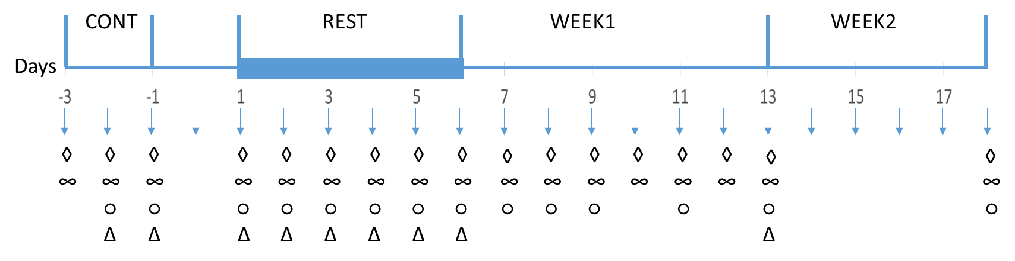
Billa et al. Figure 2

A B
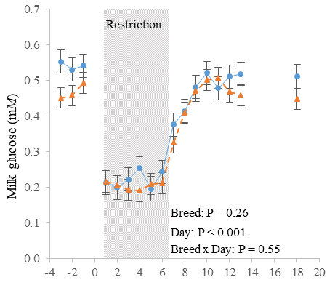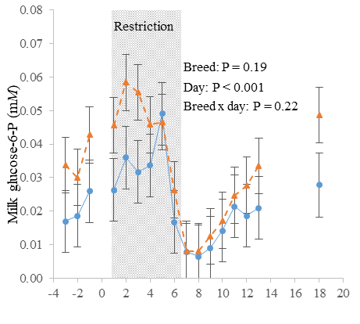
C D
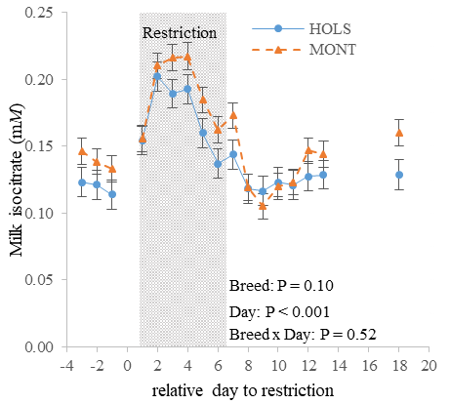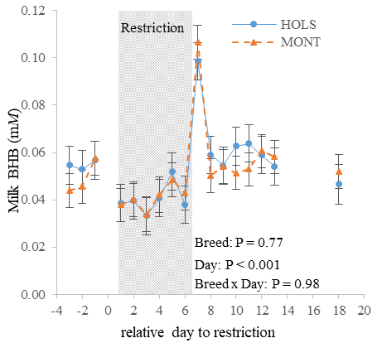

Billa et al. Figure 3
A
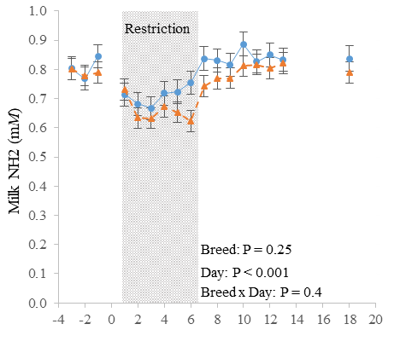
B
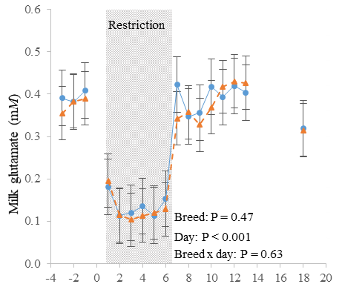
C
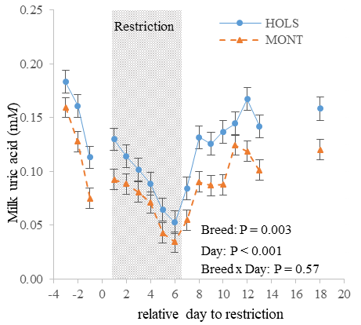
Billa et al. Figure 4

A B
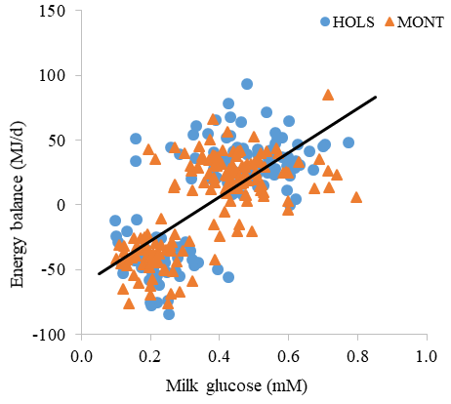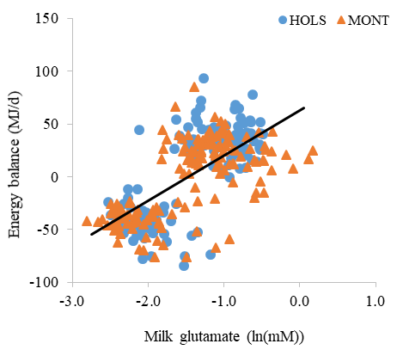
C D
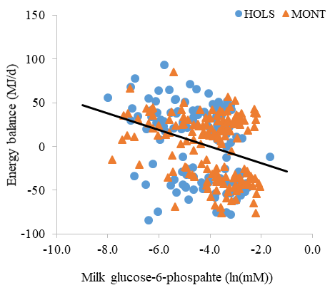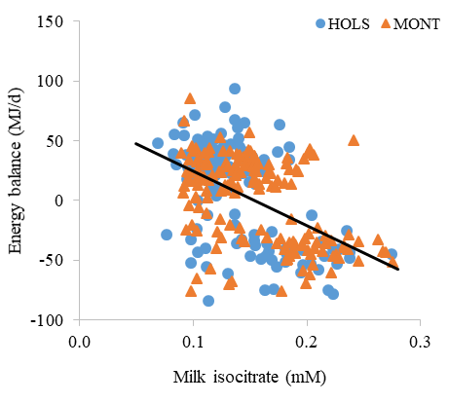

Supplemental Figure 1. Effects of feed restriction on milk yield (A), DMI (B), energy balance (C), fat (D), protein (E) and lactose (F) yield in midlactation Holstein (HOLS; ●, solid lines) and Montbéliarde (MONT; ▲, dashed lines) cows. Intake was limited to meet 50% of NE_{L} requirements during restriction period (d 1 to 6). Cows were allowed ad libitum intake during control period (d -3 to -1) and after restriction (d 7 to 18).Values are LSM ± SEM.

A B
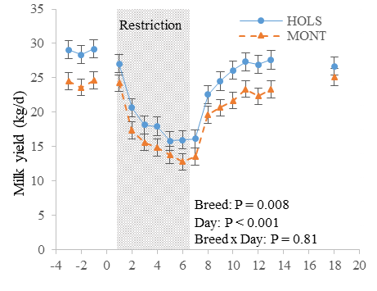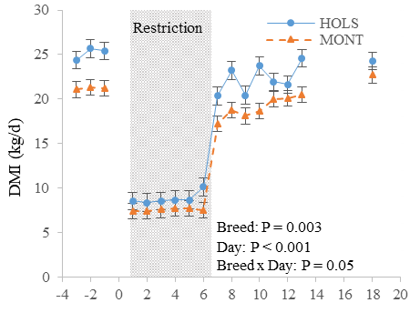
C D
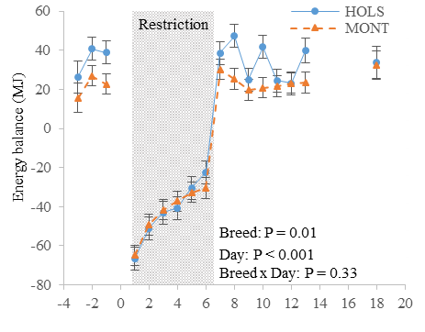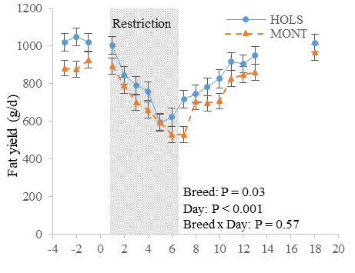
E F
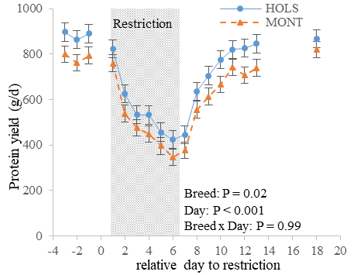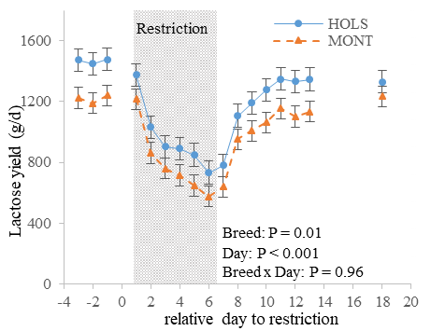
Supplemental Figure 2. Effects of feed restriction on plasma concentrations of non-esterified fatty acid (NEFA) (A), BHB (B), glucose (C) and insulin (D) in midlactation Holstein (HOLS; ●, solid lines) and Montbéliarde (MONT; ▲, dashed lines) cows. Intake was limited to meet 50% of NE_{L} requirements during restriction period (d 1 to 6). Cows were allowed ad libitum intake during control period (d -3 to -1) and after restriction (d 7 to 18).Values are LSM ± SEM.

A B
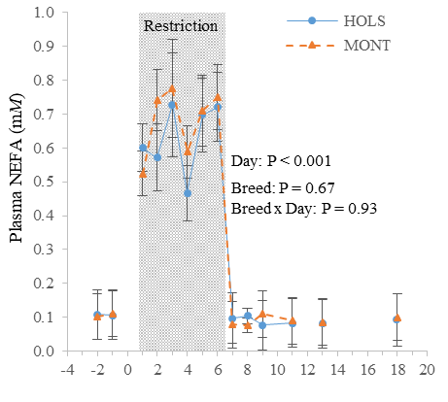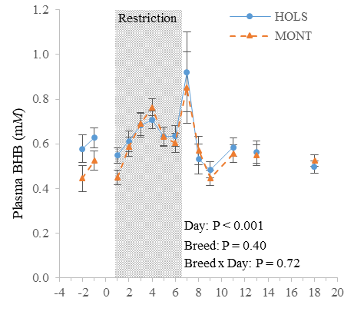
C D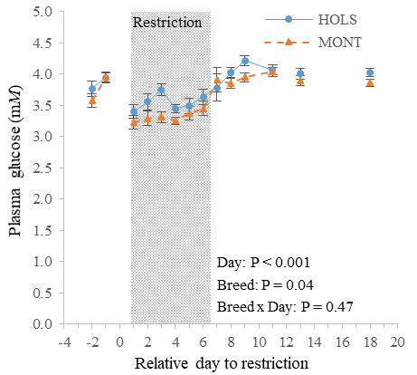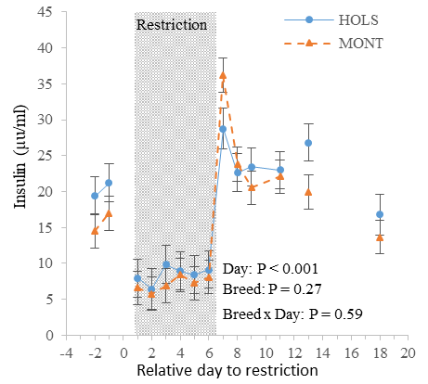

Supplemental Figure 3. Effects of feed restriction on plasma concentrations of urea (A), free amino groups (NH₂) (B), glutamate (C) and glutamine (D) in midlactation Holstein (HOLS; ●, solid lines) and Montbéliarde (MONT; ▲, dashed lines) cows. Intake was limited to meet 50% of NE_{L} requirements during restriction period (d 1 to 6). Cows were allowed ad libitum intake during control period (d -3 to -1) and after restriction (d 7 to 18).Values are LSM ± SEM.

A B
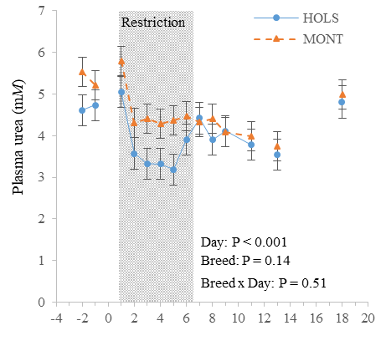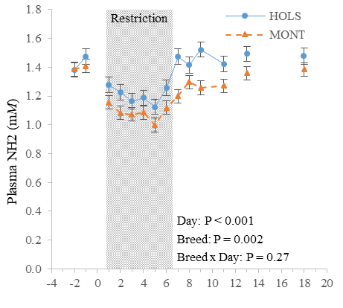
C D
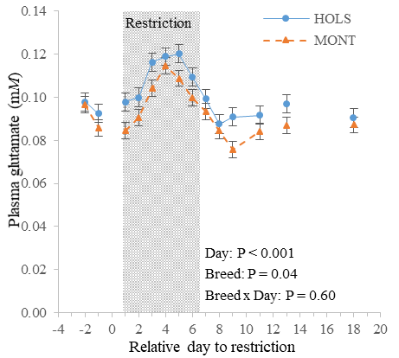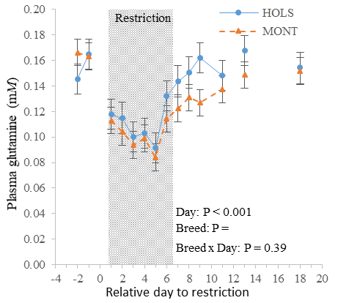

Supplemental Figure 4. Effects of feed restriction on fatty acid concentrations of sum of FA with 10 to 15 carbons (∑ 10:0 to 15:0) (A), 16:0 (B), 18:0 (C), cis-9 18:1 (D), sum greater than C16 carbon (Σ>C16) (E), sum odd and brain chain fatty acid (∑ OBCFA) (D), sum OBCFA with less than 16 carbon (∑ OBCFA<C16) (G) in midlactation Holstein (HOLS; ●, solid lines) and Montbéliarde (MONT; ▲, dashed lines) cows. Fatty acid composition was analyzed in pooled PM/AM milk samples. Intake was limited to meet 50% of NE_{L} requirements during restriction period (d 1 to 6). Cows were allowed ad libitum intake during control period (d -3 to -1) and after restriction (d 7 to 18). Values are LSM ± SEM.

A B
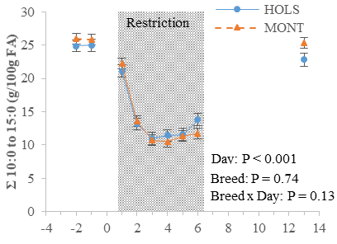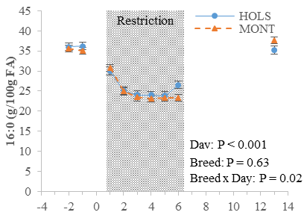
C D
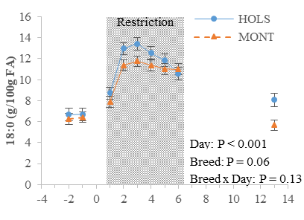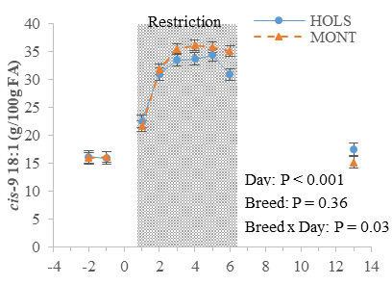
E F
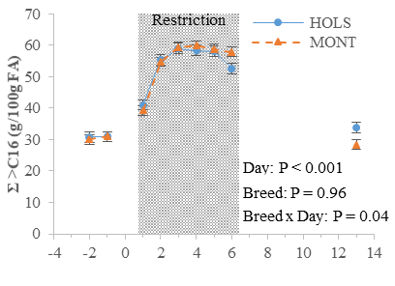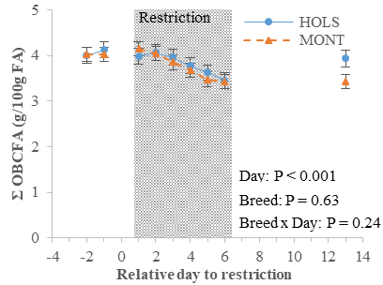
G
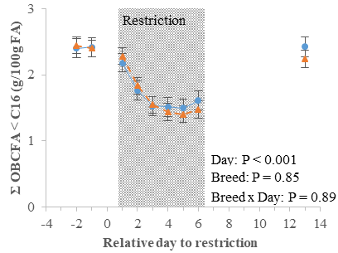

Supplemental Figure 5. Relationship between energy balance and (A) milk BHB (y = 549.5x – 26.8, r² = 0.14), (B) milk uric acid (y = 288.4x – 27.5, r² = 0.11) and (C) milk total free amino groups (NH₂; y = 129.3x – 96.5, r² = 0.17) in midlactation Holstein (HOLS; ●) and Montbéliarde (MONT; ▲) cows (P < 0.001). Intake was limited to meet 50% of NE_{L} requirements during restriction period (d 1 to 6). Cows were allowed ad libitum intake during control period (d -3 to -1) and after restriction (d 7 to 18).

A
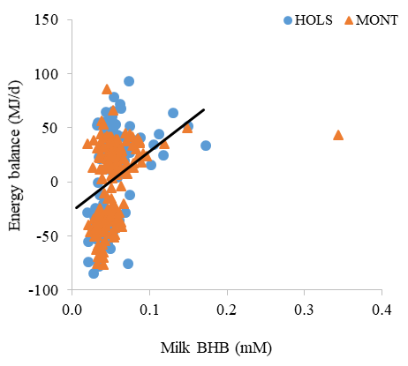
B
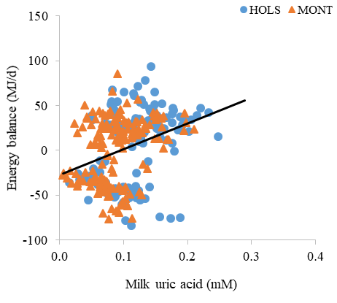
C
