World Biomedical frontiers:
Supplement :
Neonates, whatever the species considered are more susceptible to mucosal infections. Two thirds of the children that die before their fifth birthday die from infectious diseases. The mechanisms underlying their vulnerability to infections are linked to several factors, among which the peculiarities of the immune system of the young mammals play undoubtedly a major role.
The tolerogenic state of the fetus impairs immune responses in young animals and explains their reduced ability to respond to vaccines due to altered specific cell responses. Several groups identified immune cell populations with suppressive or tolerogenic functions present with higher frequency in neonates. For example, neonatal mouse CD4+ T cells have a higher potency to become Treg cells in response to TCR stimulations, a property that gradually diminishes within 2 weeks of birth. CD5⁺ B1a cells have a different tissue distribution in neonates and adults, indeed they account for more than 30% of splenic B cells in 7-day-old neonatal mice compared to approximately 2% in adults. These Breg cells can produce high amounts of IL-10, which inhibit IL-12 production by conventional dendritic cells and consequently suppress Th1 priming in vivo. The third population of regulatory cells is the erythroid suppressor cells (CD71+) that is enriched in human cord blood but also in the spleen of neonatal mice before to gradually decrease after weaning. These nucleated erythroid cells inhibit T cell, B cell, macrophage and dendritic cell responses by secreting soluble immunosuppressive factors, depletion of arginine, and direct cell-cell contact (Figure1).
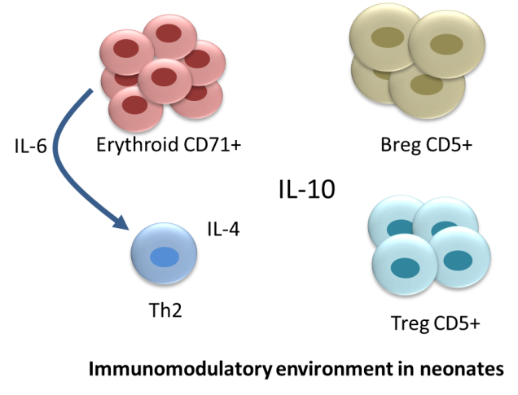
Figure 1: Immunomodulatory cells enriched in neonates contribute to their higher susceptibility to infection and impaired immune response to vaccination. IL-10 produced directly by these immunomodulatory cells or indirectly by other immune cell populations plays undoubtedly a major role in the tolerogenic state of the neonates.
In addition to the presence of suppressive cells in higher proportion, the reduced number of effector cells in peripheral organs such as the intestine contributes to the higher susceptibility of neonates to enteric infections. The neonatal intestine presents several peculiarities, a thin mucus layer, a reduce number of Paneth cells and lymphocytes in the lamina propria and in intraepithelial position.
We hypothesized that an intrinsic defect regarding the presence of dendritic cells in the neonatal intestine may also contribute to their susceptibility to an infection by the zoonotic protozoan parasite Cryptosporidium parvum. This parasite develops in the apical side of intestinal epithelial cells and leads to profuse diarrhea. Parasite development is closely linked to the immune status of its host and, logically the disease affects primarily immunocompromised adults and young infants. Using a neonatal mouse C. parvum infection model, we discovered that the small intestine of neonatal mice is almost devoid of CD103+ DC. The amplification of their number with repeated administration of FLT-3L increased the resistance of neonates to subsequent infection (Figure 2). As expected, when CD11c+ cells were depleted, neonates cannot control the infection. Infected epithelial cells produce a broad array of chemokines and we discovered that among these chemokines CXCL10 induced by IFNγ was crucial for the rapid dendritic cell recruitment during the infection (Figure 2). Interestingly, CXCL10 is also upregulated in patients suffering from cryptosporidiosis. Once recruited, we determined that neonatal CD11c+ ClassII+ CD103+DC were not only producing large amount of IL-12 but more surprisingly IFNγ in particular by the CD8α+ CD103+ DC subset. IFNγ is a known key cytokine for the control of the infection. The cytokine binds its receptor expressed at the basolateral side of intestinal epithelial cells and induces Stat-1 dependent mechanisms that block parasite development.
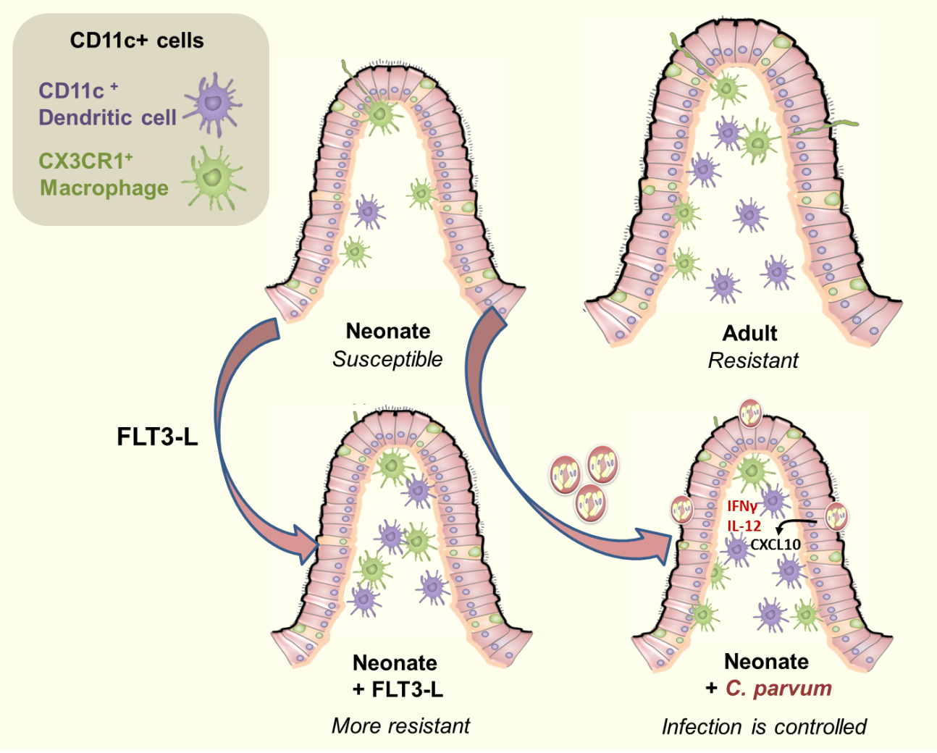
Figure 2: Neonatal intestine is almost devoid of dendritic cells but when their number is artificially increased by FLT3-L administrations, neonates become more resistant to the infection. Few days after infection, numerous CD103+ DC are recruited by a CXCL10/CXCR3 dependent mechanism and the parasite development is controlled. The protection is dependent on the presence of CD11c+ cells and their capacity to produce IL-12 and IFNγ. The presence of conventional T cells is not necessary to control the acute phase of the infection as demonstrated with CD3ε deficient neonatal mice.
Therefore, our findings highlight the importance of innate immunity and in particular dendritic cells after their rapid recruitment in the ileum where they protect intestinal cells against C. parvum infection. We developed an immunostimulation strategy to strengthen neonatal innate immunity with TLR agonists that induce a potent activation of dendritic cells. By this mean, we obtained a rapid control of the infection both by administering the agonist previous to the challenge by C. parvum (2) but also as a curative treatment when the agonist is administered during the course of the infection (3). With agonists using different signaling pathways, MyD88 versus TRIF, we determined that the MyD88 pathway was necessary for the CD11c dependent mechanism of protection. When the TRIF agonist Poly:IC administration decreased parasite load, a synergy induced by the commensal flora through TLR5/MyD88 signaling was necessary for the protection. The synergy between the two pathways leads to a stronger cytokine production of IL-12 and of type I and II interferons that facilitates the elimination of the parasite by acting on infected intestinal epithelial cells (Figure 3). The cellular sources of IFNs still need to be determined (dendritic, others) in these experimental conditions.
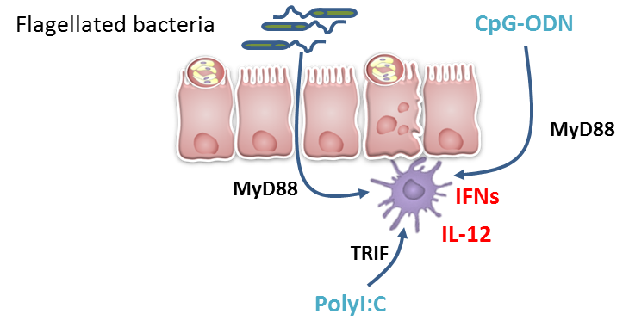
Figure 3: Immunostimulation by TLR-agonists leads to strong neonatal CD103+DC activation, IL-12 and IFNs production in the infected mucosa. CpG-ODN administration leads to strong MyD88 activation required to control the infection. Poly:IC injection leads to strong TRIF activation through TLR3 expressed by CD103+DC but also to a necessary MyD88 activation via TLR5 activation coming from flagellated commensal bacteria.
In conclusion, although neonates possess more regulatory cells and less effector cells in their intestine it is feasible to strengthen their ability to fight infections by favoring both the recruitment of dendritic cells and their activation by acting on their pattern recognition receptors.

References
- Lantier L, Lacroix-Lamandé S, Potiron L, Metton C, Drouet F, Guesdon W, Gnahoui-David A, Le Vern Y, Deriaud E, Fenis A, Rabot S, Descamps A, Werts C and Laurent F. Intestinal CD103+ dendritic cells are key players in the innate immune control of Cryptosporidium parvum infection in neonatal mice. PLoS Pathog. 2013;9(12):e1003801.

- Barrier M, Lacroix-Lamandé S, Mancassola R, Auray G, Bernardet N, Chaussé AM, Uematsu S, Akira S, Laurent F. Oral and intraperitoneal administration of phosphorothioate oligodeoxynucleotides leads to control of Cryptosporidium parvum infection in neonatal mice. J Infect Dis. 2006 May 15;193(10):1400-7.

- Lantier L, Drouet F, Guesdon W, Mancassola R, Metton C, Lo-Man R, Werts C, Laurent F*, Lacroix-Lamandé S*. Poly(I:C)-induced protection of neonatal mice against intestinal Cryptosporidium parvum infection requires an additional TLR5 signal provided by the gut flora. J Infect Dis. 2014 Feb 1;209(3):457-67.

Acknowledgements: This work was supported by INRA and by a grant from ICSA, the French Carnot Institute for Animal Health.

Contact:
Fabrice Laurent, Ph.D. Head of the laboratory Apicomplexa and Mucosaal Immunology
UMR 1282 Infectiology and Public Health
Centre INRA Val de Loire
37380 Nouzilly, France

Fabrice.Laurent@tours.inra.fr

