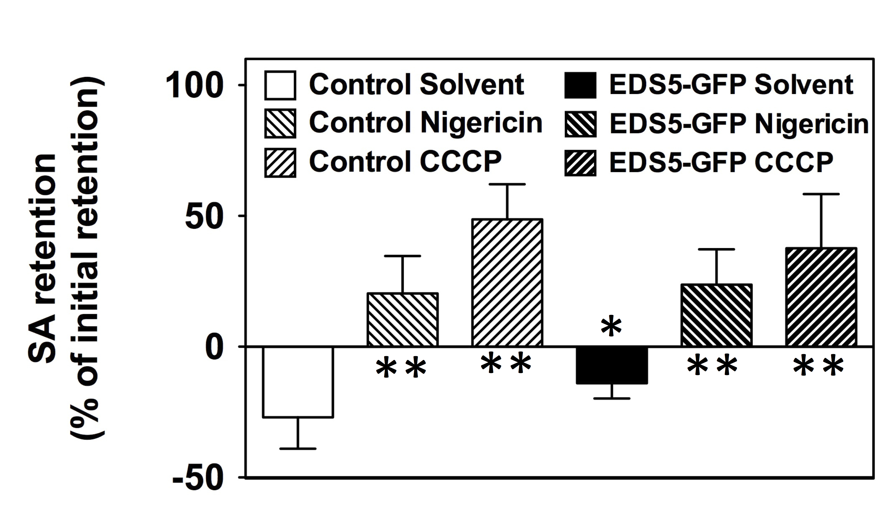Supplementary Fig. 1. Yeast background and EDS5 SA transport is disrupted by ionophores. Whole yeasts were loaded with labeled SA (¹⁴C-SA) in the presence and absence of the ionophores, nigericin and CCCP, and net SA retention was quantified as described in Kamimoto et al. (2012). Both ionophores abolish EDS5-GFP and VC-mediated SA export (negative retention) demonstrating that both EDS5 and vector control (background) SA transport is dependent on a electrochemical proton gradient. Significant differences (student’s t-test; p<0.05) of means ± SE (n = 4) to vector (Control) or solvent controls (Solvent) are indicated by one or two asterisks, respectively.

