DO agricultural Practices impact Carbon, nitrogen and Phosphorus STOICHIOMETRY IN plants and soils ON The long-term?
Ferchaud, F.¹, mary, B.¹, KEUPER, F.¹, mollier, a.², DENOROY, p.², MOREL, C.², GallET-BUDYNEK, A. ², Houot, S.³, Jouany, C.⁴, HEDDE, M.⁵, Hinsinger, P.⁵, Jourdan, C.⁵, Bertrand, I.⁵
1UR AgroImpact, Laon, 2UMR ISPA, Bordeaux, 3UMR ECOSYS, Grignon, 4UMR AGIR, Toulouse, 5UMR Eco&Sols, Montpellier
Introduction
Carbon (C), nitrogen (N) and phosphorus (P) cycles are intimately linked in ecosystems through key processes such as primary production and litter decomposition. Ecological stoichiometry has become a common approach for exploring relationships between biogeochemical cycles and ecosystems functions in ecological science (Sterner and Elser, 2002). In agronomy, the concept of stoichiometry is far less utilized, probably because the addition of fertilizer reduced biotic interactions between the C, N and P cycles. Surprisingly, little is known about the long-term impact of agricultural practices on soil stoichiometry. Within the context of agro-ecology, however, alternative agricultural practices aim to increase nutrient recycling from organic matter and soil reserves (legacy P) by reducing tillage or mineral fertilizer input. The success of such practices relies on the increase of soil biotic interactions and may impact C storage in soils on the long term, if soil organic matter stoichiometry is constrained (Bertrand et al., submitted).
We aimed at determining the long-term impacts of alternative agricultural practices on plant and soil stoichiometry. To do so, we compiled and completed a dataset of long-term (8-49 yr) field experiments in France in which P or N fertilization rates or tillage intensity was strongly reduced.
MATERIAL AND METHODS
Data were collected from a set of 7 long-term experiments (Table 1). The dataset was completed when needed by re-analysing stored soil and/or plant samples (shoot) for their C, N or P content. Different forms of soil P were investigated: total, organic and Olsen-extractable P. A database was built and statistical analyses of C:N:P ratios were performed intra and inter-sites (analyses of variance).
Table 1: Inventory of the main experimental sites, their duration and the type of treatments
Sites and Location | Duration | Agricultural practices tested
Auzeville (near Toulouse) | 1969-2018 | 0, 11, 22 and 33 kg P ha⁻¹ yr⁻¹ applied as superphosphate
Mant (south of Bordeaux) | 1975-1991 | 0, 27, 79 kg P ha⁻¹ yr⁻¹ applied as superphosphate on continuous irrigated maize
Carcares Sainte-Croix (south of Bordeaux) | 1972-2004 | 0, 44, 96 kg P ha⁻¹ yr⁻¹ applied as superphosphate on continuous irrigated maize
La Cage (Versailles) | 1998-2018 | 4 cropping systems: conventional, low input, conservation agriculture, organic farming
SOERE QualiAgro (Grignon) | 1998-2018 | Organic fertilizers (4 types) x N fertilization (2 rates)
SOERE ACBB (Estrées-Mons) | 2010-2018 | Reduced tillage, crop residue removal and reduced N fertilization
Biomass & Environment (Estrées-Mons) | 2006-2018 | Crop type (perennials vs. annuals) x N fertilization (2 rates)

RESULTS AND DISCUSSION
The main factor explaining the change in plant stoichiometric ratios (C:N, C:P, N:P) was the type of plant species. Indeed, due to their storage capacity and allocation strategy, autotrophs like plants had higher stoichiometry flexibility than heterotrophs like soil microorganims. However, agricultural practices were impacting the C, N and P contents of the plants and their ratios within plant species. For instance, organic farming in La Cage produced wheat with higher C:N and lower N:P ratios than the conventional system (30.7 vs. 24.4 and 2.5 vs. 3.4 respectively).
The agricultural soils studied presented C:N and C:P ratios ranging from 8 to 14.5 and from 15 to 28 respectively, and N:P ratios ranging from 1.5 to 2.8 (total P). The site effect was significant on the soil CNP contents and ratios (one-way ANOVA, P < 0.05). Interestingly, whereas the soil C:N ratios were constrained and not influenced by the different agricultural practices, in agreement with Zinn et al. (2018), the C:P and N:P were more flexible. E.g., at the Mant and Carcares Sainte-Croix sites we observed stable C:N ratios, whatever the treatment and duration of the experiments, while flexible C:P and N:P ratios were observed as a response to both treatment and time (Figure 1).
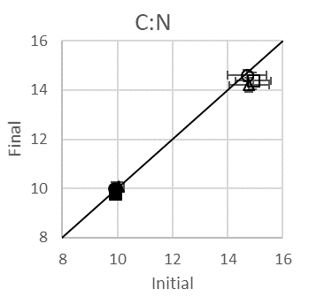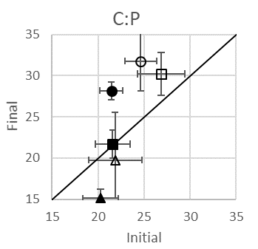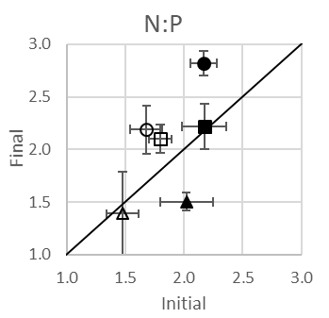
Figure 1: Initial and final C:N, C:P and N:P ratios at Mant (dark symbols, 17 years) and Carcares Sainte-Croix (light symbols, 22 years) in the 0-25 cm soil layer for three levels of P fertilization (P0: circles; P1: squares; P3: triangles)
CONCLUSION
Overall, plant stoichiometry was less constrained than soil stoichiometry in all studied agricultural systems. Specifically, soil C:N ratios were highly constrained and not influenced by long-term agricultural practices. This stability confirms the strong association between C and N in SOM and the statement by Van Groenigen et al. (2017) that storing C in soils will increase N-requirements. Interestingly, however, this was not the case for P, and we show here, for the first time, that agricultural practices influenced C:P and N:P ratios.
Acknowledgements: The authors would like to thank the department Environment and Agronomy of INRA for its financial support.
References
Bertrand, I., Viaud, V., Daufresne, T., Pellerin, S., Recous, S. Storing C while reducing nutrient inputs: Could stoichiometry limit the efficiency of agroecological practices? Submitted.
Li, X., Wang, H., Gan, S.H., Jiang, D.Q., Tian, G.M., & Zhang, Z.J. (2013). Eco-Stoichiometric Alterations in Paddy Soil Ecosystem Driven by Phosphorus Application. Plos One, 8.
Sterner, R.W. & Elser J.J. (2002) Ecological Stoichiometry: Biology of Elements from Molecules to the Biosphere. Princeton, NJ, USA: Princeton University Press, https://doi.org/10.1093/plankt/25.9.1183
Van Groenigen, J.W., Van Kessel, C., Hungate, B.A., Oenema, O., Powlson, D.S., & Van Groenigen, K.J. (2017). Sequestering Soil Organic Carbon: A Nitrogen Dilemma. Environmental Science and Technology, 51, 4738–4739.
Zinn, Y.L., Marrenjo, G.J., & Silva, C.A. (2018). Soil C:N ratios are unresponsive to land use change in Brazil: A comparative analysis. Agriculture, Ecosystems and Environment, 255, 62–72.

