Joint estimation of genetic parameters for daily recorded milk yield and body weight in first lactation Holstein cows.

T. Tribout¹, S. Minery^{1,2}, B. Dassé³, D. Saunier⁴, V. Ducrocq¹, D. Boichard¹

¹ GABI, INRA, AgroParisTech, Université Paris Saclay, 78350 Jouy-en-Josas, France
² Idele, Institut de l’Elevage, 149 rue de Bercy, 75595 Paris, France
³ BCEL-Ouest, 1 rue Pierre et Marie Curie, CS 80520, 22195 Plérin Cedex, France
⁴ FCEL, France Conseil Elevage, 42 rue de Châteaudun, 75009 Paris, France
thierry.tribout@inra.fr (Corresponding Author)

Summary

The objective of the study was to jointly estimate the genetic parameters for daily recorded milk production (MY24) and body weight (BW) in first lactation Holstein cows. A total of 329,334 MY24 and BW phenotypes recorded from day in milk (DIM) 1 to 335 on 2,207 primiparous Holstein cows, calving from October 2013 to April 2017, were analyzed. The data came from 36 commercial dairy farms equipped with milking robots with automatic weighing platform, members of the Bretagne Conseil Elevage Ouest network. The variance components, heritability and genetic correlations for MY24 and BW were estimated using a bi-variate random regression test day model, where additive genetic and permanent environmental effects for the lactation and body weight curves were modeled using orthogonal Legendre polynomials of the second and fifth orders, respectively. The heritability for MY24 increased from 0.02 to 0.26 from DIM 1 to DIM 300, and then decreased. The heritability for BW increased from 0.26 (DIM 1) to 0.42 (DIM 100), remained quite stable until DIM 322, and then declined. The genetic correlations between BW and MY24 were positive. They were very low (<0.20) in early lactation, but larger after DIM15. This preliminary study will be repeated on a larger dataset and extended to multiparous cows, to evaluate the possibility of uncoupling body mobilization in early lactation from milk production.

Keywords: random regression, genetic parameters, milk yield, body weight, dairy cow, milking robots

Introduction

Over the last years, a growing proportion of French dairy farms were equipped with milking robots that record daily the milk production and the body weight of milking cows. The objective of the present study was to exploit the high-throughput provided by commercial herds equipped with robots, to estimate genetic parameters for daily milk yield and body weight in the first lactation.

Material and Methods

Data

The data used for this study came from 36 commercial dairy farms located in the western part of France. The size of the herds varied from 46 to 189 cows, with a mean of 92. These herds are members of the Bretagne Conseil Elevage Ouest network (BCEL-Ouest, http://www.bcel-ouest.fr), one of the French milk recording agencies federated by France Conseil Elevage (FCEL, http://www.france-conseil-elevage.fr).
Data were recorded on a total of 3,226 primiparous Holstein cows, calved from February 2013 to May 2017. The cows were loose-housed in barns equipped with milking robots with automatic weighing platform (https://www.lely.com/). At each visit of a cow in the milking unit, the robot recorded the date and time of the visit, the weight of collected milk (MILK_{elem}) and the body weight of the cow.
For each cow and each test day: the sum of the MILK_{elem} was calculated and standardized into a 24 hours milk yield (MY24) as $MY24=\sum_{day}{{MILK}_{elem}}*1440/∆_{time}$, where Δ_{time} is the time interval (in minutes) between the last milking of the current test day and the last milking of the previous test day; the mean of the recorded body weights was calculated (BW). For each cow, a 3rd order polynomial was fitted to its lactation data, and the records deviating from more than 3 standard deviations from the polynomial were discarded (outliers).
Pedigree and dates of reproduction events of the animals were extracted from the French national database (SIG, INRA CTIG). For each test date of a cow, the corresponding numbers of days in milk (DIM= test date – calving date) and of days carried calf (DCC = test date – date of conception (when defined)) were calculated. The test dates between calving date and successful insemination date were grouped into a DCC=0 specific level.
In the present study, only data of cows with DIM under 335 days and DCC under 250 days were considered. Records from animals with unknown parents, older than 3.5 years at first calving, or with less than 40 daily records available were discarded. The data of a cow for a given test date were only considered if phenotypes for both MY24 and BW were available. Besides, at least five cows were required to define a herd-test date (HTD) effect level, the phenotypes of smaller contemporary groups being discarded.
At the end, 329,334 daily recorded phenotypes for MY24 and BW measured on 2,207 primiparous Holstein cows were considered in the analyses.

Model

Genetic parameters of MY24 and BW were estimated using the WOMBAT program (Meyer, 2007), considering 3 generations of ancestors for the cows, and using the following random regression bivariate animal model:
$y_{ijkltt'zpn}={HTD}_{ip}+{MN}_{jp}+\sum_{d=1}^{6}{x_{dkp}θ_{dt}} +\sum_{d=1}^{6}{u_{dlp}θ_{dt}}+\sum_{f=1}^{4}{v_{fp}δ_{ft'}}+\sum_{r=1}^{5}{p_{zrp}φ_{rt}}+\sum_{r=1}^{3}{a_{zrp}}φ_{rt}+e_{ijkltt'zpn}$ ,
where $y_{ijkltt'zp}$ is the n^{th} observation for the p^{th} trait of the animal z recorded on DIM t and DCC t’, in the i^{th} contemporary group, the k^{th} calving month, the l^{th} level of calving age and the j^{th} level of milking times per day; ${HTD}_{ip}$ is the fixed effect of the i^{th} level of Herd x Test Day effect on the p^{th} trait (21,982 levels);${MN}_{jp}$ is the fixed effect if the jth level of milking times per day (1, 2, 3, 4 to 10 times – this effect was only considered in the model for MY24); $θ_{dpt}$ is the d^{th} covariate at DIM t of cubic splines with 6 knots located at DIM 1,15, 40, 90, 200, 335 (d = 1 to 6); $x_{dkp}$ and $u_{dlp}$ are the d^{th} regression coefficient that describes the average lactation (p=1) or body weight (p=2) curve for trait p of the cows in the k^{th} calving month or in the l^{th} level of calving age (< 25, 25-27, 28-30, 31-33, >33 months of age), respectively; $δ_{ft'}$ is the f^{th} covariate at DCC t’ of cubic splines with 4 knots located at DCC 0 (before successful insemination), 99, 174, 250 (f = 1 to 4); $v_{fp}$ is the f^{th} regression coefficient that describes the average effect of DCC on lactation or body weight curve for trait p; $a_{zrp}$ and $p_{zrp}$ are the r^{th} random regression coefficients that describe the trajectory of the additive genetic effect and permanent environment effects of the z^{th} cow for the p^{th} trait, respectively; $φ_{rt}$ is the r^{th} covariate at DIM t of Legendre orthogonal polynomials for additive genetic and permanent environment effects, respectively; $e_{ijkltt'zpn}$ is the residual random effect associated with $y_{ijkltt'zpn}$.
The residual variance was considered heterogeneous throughout the lactation period. Seven periods were defined, during which the residual variance was supposed to be constant: DIM 1 to 7, 8 to 20, 21 to 50, 51 to 100, 101 to 180, 181 to 260 and 261 to 335.
Second and fifth order Legendre orthogonal polynomials were used to model the additive genetic and permanent environmental effects, respectively. These orders were determined by testing different orders of polynomials in univariate random regression analyses and selecting the models presenting the best fit according to their respective Bayesian Information Criterion (BIC).

Results and Discussion

Variance components

The values of estimated additive genetic, permanent environmental and residual variances across lactation are presented in Figure 1. The resulting values of heritabilities (h²) and proportion of variance of permanent environment origin (p²) are presented in Figure 2.
The additive genetic, permanent environmental and residual variances showed similar evolutions across lactation for both traits. The genetic variances increased continuously throughout the complete milking period. The relative increase was larger for MY24 than for BW. The permanent environmental variances showed a large initial decrease, followed by a slow regular decline (MY24) or increase (BW) up to DIM 315, and then increased sharply. The latter trend is probably an artifact caused by the lower number or records available in the last days of lactation, and h² and p² estimates after DIM315 are therefore questionable. Residual variances dropped sharply during the first days of lactation, and then remained stable (BW) or declined regularly (MY24) up to the end of the milking period. Similar initial decreases for environmental variances were reported by Druet et al. (2005) and Bignardi et al. (2011) for test day milk yields recorded on Holstein cows. Our estimates of residual variances were low, resulting in values of p² varying from 0.49 to 0.67 for BW, and from 0.63 to 0.84 for MY24 (Figure 2). These results for MY24 are markedly higher than those reported by other studies (e.g. Druet et al., 2003) estimated p² values ranging from 0.43 to 0.50 for milk yield of primiparous Holstein cows). This is probably the consequence of use of milking robots, providing a large number of records for a cow with a daily time step (whereas other studies usually used monthly data), each record being strongly correlated with the previous and following ones, reducing the residual variance to the benefit of permanent environmental variance. One can also assume that milking robots, allowing a cow to decide her milking times and intervals according to her needs, contribute to increase the repeatability of her milk production.
The heritability for MY24 was very low until DIM 40 (about 0.02) and then increased regularly up to 0.26 at DIM 300. These values are in the low range of the literature for test day milk yields of primiparous Holstein cows: Druet et al. (2005), Muir et al. (2007) and Bignardi et al. (2011) reported heritabilities comprised between 0.15 and 0.41 (with a maximum at DIM 170), about 0.30, and varying from 0.15 to 0.30, respectively. Perhaps the number of cows in our dataset or their pedigree structure were insufficient to disentangle the genetic and the permanent environmental parts of the phenotypes, resulting in inflated p² and shrinked h².
Genetic parameters for test-day body weight recorded on lactating cows are scarce in the literature, probably because of the difficulty, until recently, of carrying out repeated weighing on a large number of heavy animals over a long period of time. Our estimates of heritability for BW varied from 0.36 to 0.45 across the lactation, ignoring the first and last days in milk. These values are lower than the heritabilities estimated by Berry et al. (2003) on multiparous Holstein-Friesian cows (0.48 to 0.61).

Genetic correlations

The genetic correlations (r_{g}) between MY24 at adjacent DIM were globally very high, and decreased as the distance between records increased (Figure 3). MY24 were less correlated in early lactation than after, approximately, DIM 60. To illustrate, r_{g} was larger than 0.90 between MY24 at DIM 150 and MY24 from DIM 58 to 284, whereas only MY24 from DIM 5 to 33 had similar r_{g} with MY24 at DIM 20. Besides, daily milk production before DIM 10 had negative r_{g} (up to -0.36) with MY24 after DIM 60. This suggests that a high milk production in early lactation, which requires substantial body mobilization, is detrimental to the global production of the cow.
As for MY24, r_{g} between BW at adjacent DIM was very high, and decreased as the distance between records increased. However, the rate of r_{g} decline with time distance was much slower than for milk production, the minimum r_{g} value estimated (0.72) being observed between BW at DIM1 and DIM295. For example, BW at DIM 15 had r_{g} values higher than 0.90 up to DIM 117, and BW at DIM 150 had rg values higher than 0.98 with BW from DIM 86 to DIM335.
The estimates of genetic correlations between MY24 and BW are shown in Figure 4. Overall, r_{g} varied from -0.07 (MY24 at DIM 1 vs BW at DIM 221) to 0.48 (MY24 at DIM 76 vs BW at DIM 231). Until DIM21, MY24 seemed uncorrelated with BW at any DIM (rg < 0.20), but the genetic correlation was larger for the rest of the lactation, the strongest relation being observed for MY24 from DIM 50 to 250 and BW after DIM 50. The genetic correlation between the two traits at a same DIM increased from 0.08 to 0.40 from DIM 1 to DIM 45, remained almost stable up to DIM 250, and then decreased to 0.33.

Conclusion

Milking robots provide valuable data on a large number of animals that allow studying the joint evolution of milk production and body weight of cows throughout lactation. This preliminary study will be repeated on a larger set of data to refine the results presented here, and to estimate genetic parameters for milk production and body weight in later parities. These data will be useful to evaluate the possibility of uncoupling production and body mobilization in early lactation that has unfavorable impacts on cow fertility, longevity and economic profitability.

Acknowledgements

This work was performed in the framework of the DEFFILAIT project (ANR-15-CE20-0014), funded by the French Agence Nationale de la Recherche (ANR) and ApisGene. BCEL-Ouest and FCEL are gratefully acknowledged for managing the data from milking robots.

List of References

Berry, D.P., F. Buckley, P. Dillon, R.D. Evans, M. Rath & R.F. Veerkamp, 2003. Genetic parameters for body condition score, body weight, milk yield, and fertility estimated using random regression models. J. Dairy Sci. 86:3704-3717.
Bignardi, A.B., L. El Faro, R.A.A. Torres Junior, V.L. Cardoso, P.F. Machado & L.G. Albuquerque, 2011. Random regression models using different functions to model test-day milk yield of Brazilian Holstein cows. Genetics and Molecular Research 10(4): 3565-3575.
Druet, T., F. Jaffrézic, D. Boichard & V. Ducrocq, 2003. Modeling Lactation Curves and Estimation of genetic parameters for first lactation test-day records of French Holstein cows. J. Dairy Sci. 86: 2480-2490.
Druet, T., F. Jaffrézic & V. Ducrocq, 2005. Estimation of genetic parameters for test day records of dairy traits in the first three lactations. Genet. Sel. Evol. 37 (2005) 257-271.
Meyer, K., 2007. WOMBAT -A tool for mixed model analyses in quantitative genetics by REML, J. Zhekiang Uni. SCIENCE B 8: 815-821. [doi:10.1631/jzus.2007.B0815]
Muir, B.L., Kistemaker, G., Jamrozik, J., Canavesi, F., 2007. Genetic parameters for a multiple-trait multiple-lactation random regression test-day model in Italian Holsteins. J. Dairy Sci. 90: 1564-1574.

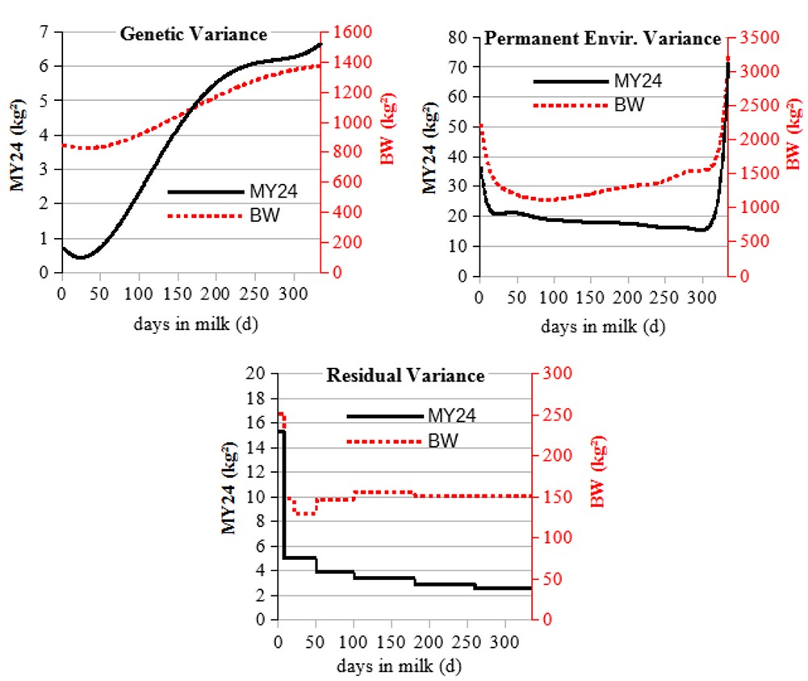
Figure 1. Estimates of variances for the genetic, permanent environment and residual effects across lactation for daily recorded milk yield (MY24) and body weight (BW).

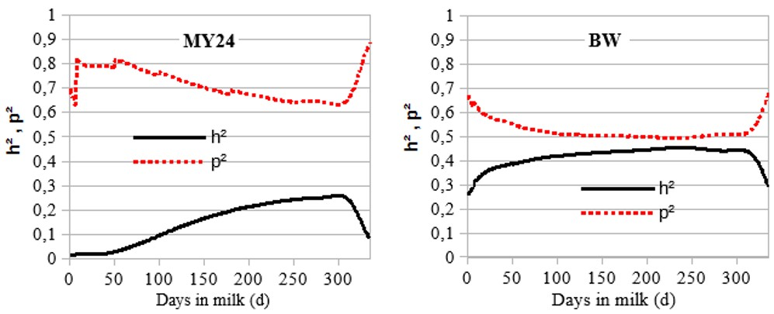
Figure 2. Estimates of heritability across lactation for daily recorded milk yield (MY24) and body weight (BW).

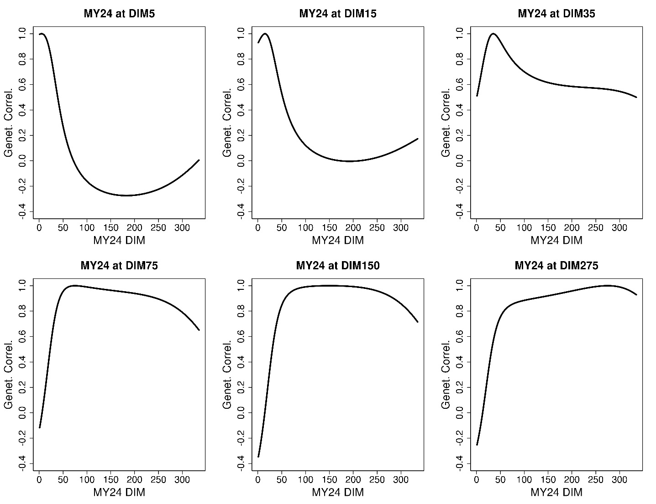
Figure 3. Evolution of genetic correlation between daily recorded milk yield (MY24) at DIM 5, 15, 35, 75, 150, 275 and MY24 across lactation.
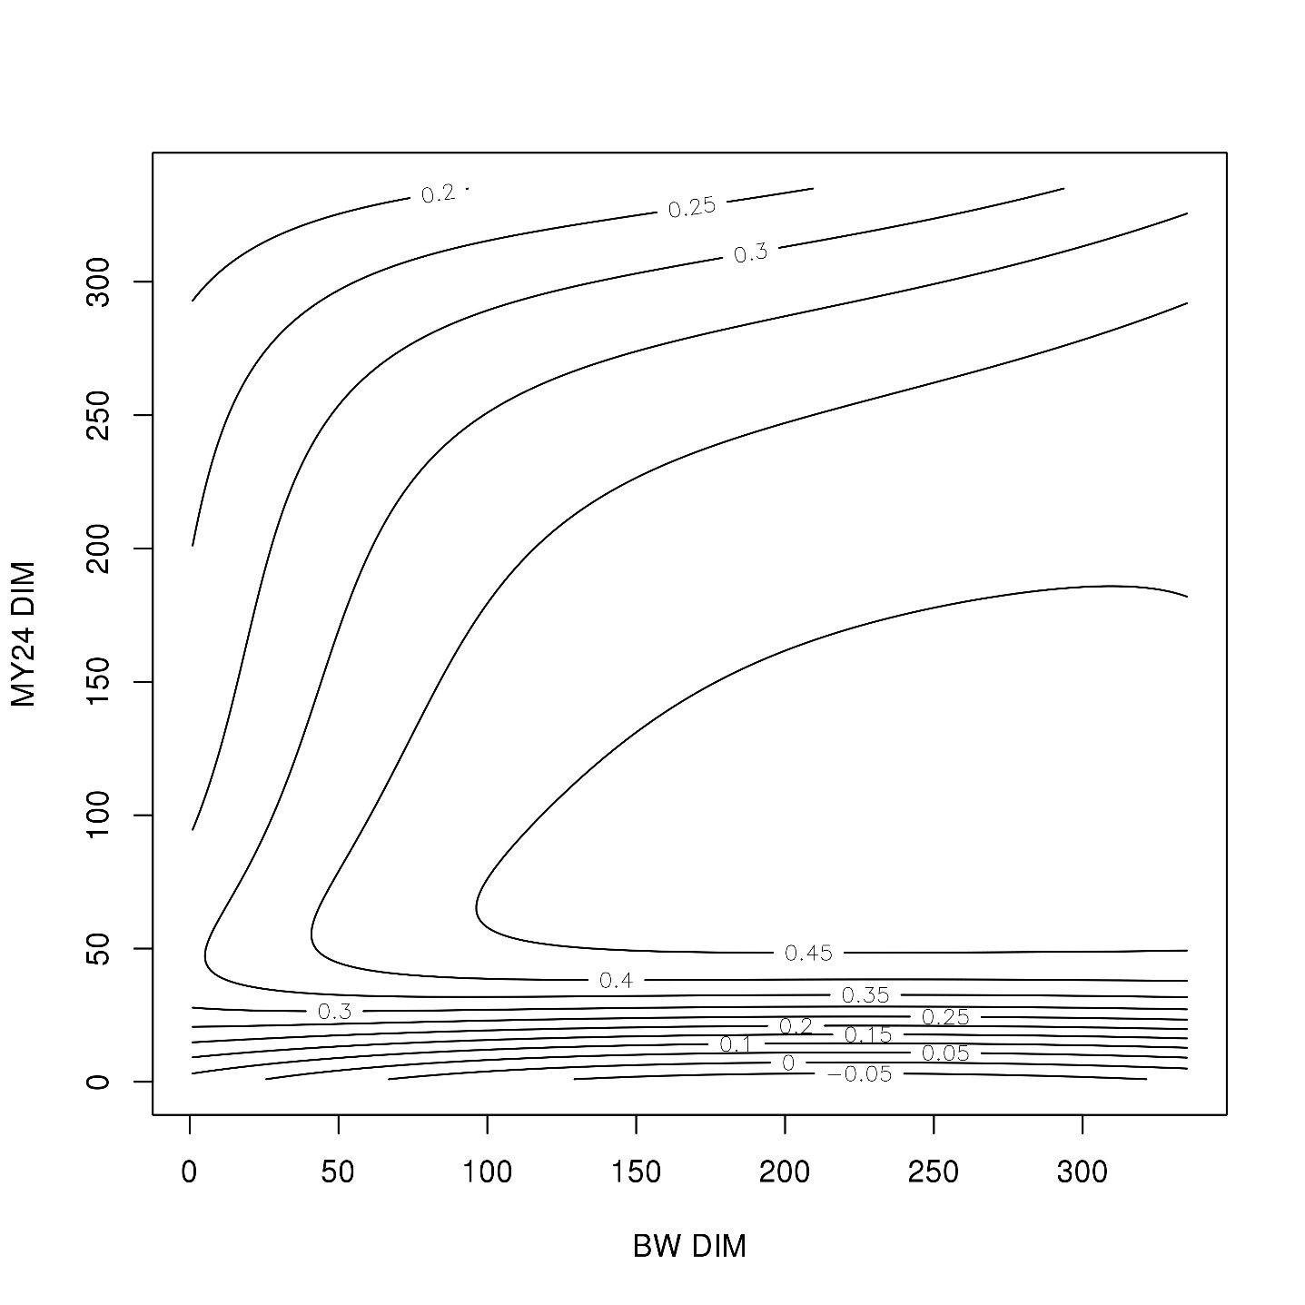
Figure 4. Genetic correlation estimates between daily recorded milk yield (MY24) and body weight (BW) across lactation.

