Automated measurement of dairy cow grooming behaviour from real time location system

B. Meunier^{1*}, E. Delval¹, C. Cirié², M.M. Richard¹, P. Pradel², Y. Gaudron¹, D. Ledoux¹, I. Veissier¹
¹ INRA, VetAgro Sup, UMR1213 Herbivores, Site de Theix, 63122 Saint-Genès-Champanelle, France
² INRA, UE1414 HERBIPOLE, Site de Marcenat, 63122 Saint-Genès-Champanelle, France
*bruno.meunier@inra.fr

Abstract

It has been reported that grooming behaviour may be related to status (calving, stress), health (mastitis) and production (milk yield). Consequently, accurate long-term monitoring of grooming behaviour could advantageously serve as a PLF solution to give alarms or well-being indicators. The main activities of dairy cows (resting, moving, eating, and so on) can be monitored indoors 24/7 using a real-time location system (RTLS). During the EU-PLF project (2012-16), the CowView RTLS (GEA) was assessed on 160 cows, equipped with tags, in our freestall barn enhanced with mechanical swinging brushes (Delaval). From the large positioning dataset collected (1 location/animal/s), we extracted grooming behaviour (scratching using the brush) with good sensitivity (80%) and a suitable positive predictive value (60%). The accuracy of our grooming detection algorithm was evaluated by comparing the results output against video analyses. Then, 23 dairy cows were monitored for 32 days, and patterns of grooming activity were analysed to study variations between cows and between days. 24-h video recording was re-visualized to explain the false detections observed, i.e. a cow detected in the brush area without grooming or a cow classified as grooming but not localized in the area. The kinetics of daily time spent grooming showed high day-to-day and inter-individual variations. Noisy tags appeared to be responsible for most of the false detections. Once smoothed, the kinetics modelled offer promising applications for detecting alterations in cow grooming behaviour patterns.

Keywords: monitoring, behaviour, RTLS, grooming, cow

Introduction

Grooming is a natural and essential (Bolinger et al, 1997) behaviour for dairy cows. Grooming behaviour is reported to be potentially related to physiological status (calving (Newby et al, 2013), stress (Mandel et al, 2013) and health (mastitis, Fogsgaard et al, 2012). Equipping freestall barns with mechanical brushes may help cows to self-groom more body regions, thus reducing boredom, stress and dirt. Cows may only use brushes for a few minutes a day, e.g. 6 min/d spread over 7 daily visits (DeVries et al, 2007), but with large variations, e.g. 31 min/d (±18) in precalving cows (Newby et al, 2013). A monitoring device able to automatically measure grooming behaviour could therefore help detect such states and better serve precision livestock farming (PLF) approaches.
In a previous study (research paper submitted in March 2017) performed during the EU-PLF project (2012-16), we demonstrated, using a real time location system (RTLS) versus video and a dedicated algorithm, that we could monitor grooming behaviour—specifically, scratching using a mechanical brush—with good sensitivity (nearly 80%) and a suitable positive predictive value (PPV) of 60%. Since the cows were localized (x, y) at the 1 Hz datarate, we were able to continuously detect even short visits to the area of the brush. Nevertheless, this validation work was only realized at herd level and for a short period of time; i.e. 24h.
Here we focussed on how this grooming monitoring approach—already applied and validated for more basic and major behaviours such as resting in the cubicle (Tullo et al, 2016)—can serve to acquire more precise behavioural patterns, at individual level and over the long term. To this end, we first reanalyzed the video used as the “gold standard” for our first study in order to understand the technical reasons why we had so many false detections (PPV=60%), and to investigate a filtering strategy. Then, from our big RTLS dataset, we extracted the individual kinetics of grooming patterns over a longer period, and proposed a dedicated data mining approach in order to assess the relevance of the measurement tools from a biological point of view.

Materials and Methods

The study was conducted at the INRA Herbipole experimental unit, in a freestall barn equipped with the CowView RTLS (GEA Farm Technologies, Germany). In one of the rearing pens equipped with a mechanical swinging brush (Delaval, Sweden), the (x, y) positions of 23 cows (8 lactating cows, 10 dry cows, 5 heifers), each equipped with an active ultra-wideband tag, were collected continuously (1 location/animal/s) from 5 January 2016 to February 6 2016. We also recorded 24 h of video film of the brush area between 22 and 23 January 2016 to determine whether or not cows used the brush.
A 3.6 m² area around the brush was empirically defined, and cows localized by the RTLS in this area were considered as “using the brush” (Figure 1). An algorithm developed under ImageJ v1.50c image processing software (Schneider et al, 2012) allowed automatic extraction of a continuous profile of individual grooming behaviour. These profiles were first compared against the 24-h video to explain the false detection qualitatively using The Observer V11.5 software (Noldus, The Netherlands). Then, these profiles were summarized on a daily basis, visualized, and smoothed with a moving average filter to remove the false detections. Finally, the smoothed profiles were submitted to a hierarchical clustering analysis, using Euclidean distance and the Ward’s aggregation method bundled with XLStat software (Addinsoft, France), to blindly sort the cows and evaluate the relevance of the biological information contained in such data.

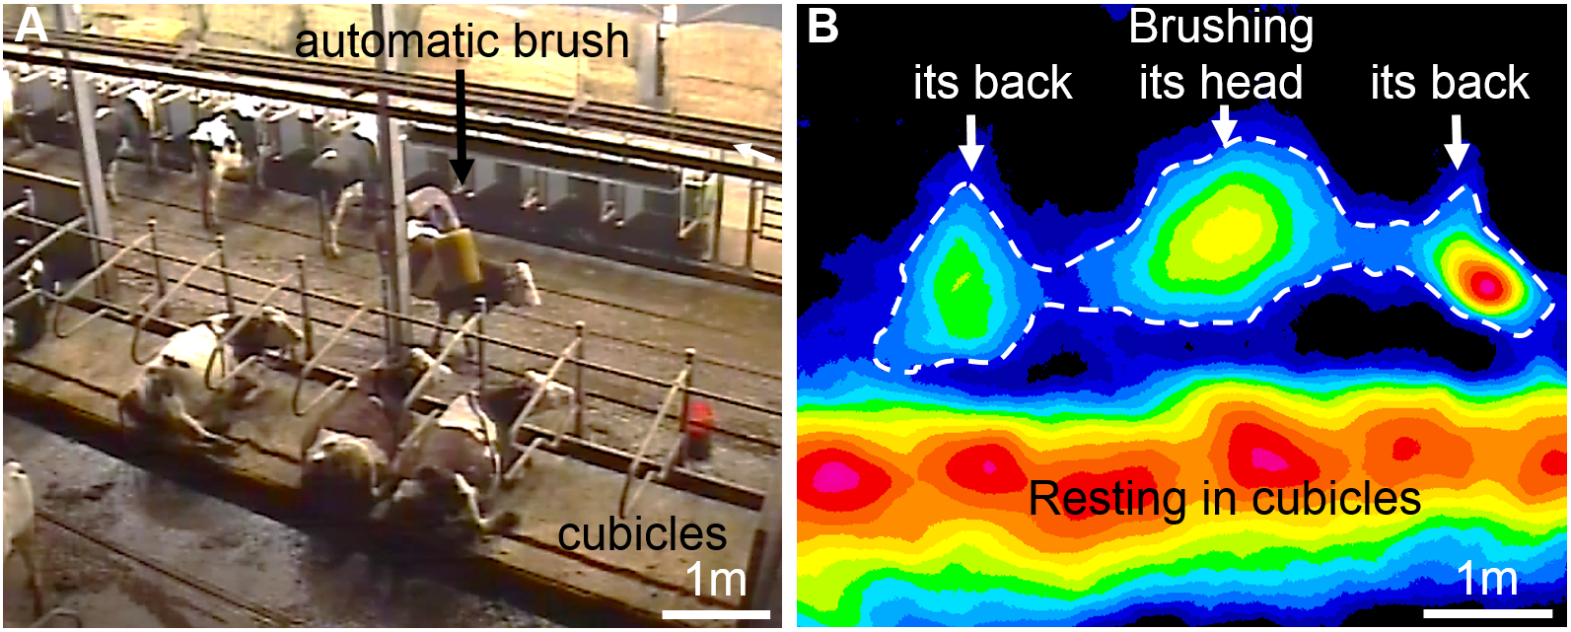
Figure 1. Snapshot of the video (A) and the corresponding heat map representation of density of occupancy processed from the RTLS data (B). Hot colours are associated with high levels of occupancy by the cows. The 3.6 m² area with the dashed outline has been empirically drawn to be more probably associated with the use of the brush.

Results and Discussion

The RTLS data were collected for the 23 cows and the 32 consecutive days with less than 5% missing values.
According to the video analysis, the 23 cows used the brush for 8.3 h/d, i.e. 21.6 min/cow/d spread over 6.6 daily visits. These values are mid-range between those obtained in the studies by DeVries et al, 2007 and Newby et al, 2013. For the same 24-h period, the cows were detected in the brushing area for 10.0 h (+21% compared to video evidence), and for an average 10.3 h/d (±1.4 h) over the full 32-d period. This leads to conclude that our measure is quite stable and that the pressure on the brush is potentially high (10h/24h).
Comparison of RTLS profile against video profile found that most false-positive detections were due to cows standing in the area without using the brush and, to a lesser extent, cows standing in a very near area (e.g. the neighbouring cubicles) that was badly located due to the positioning noise. Concerning false-negatives, we observed very few individuals using the brush differently from the majority, i.e. body parallel to the cubicles when brushing its back (Figure 1-B). False-negatives were due first to the limited area of interaction, which could be enlarged, and second to the positioning noise due to tags badly positioned on the neck or tags masked by their environment. It is reasonable to assume that detection performance would have been better if we had restricted the area to a circle around the axis of the brush, although in that case we would only have detected cows brushing their head and neck, which accounts for only 29% of total brush-use time (De Oliveira et al, 2015).
Figure 2 shows the raw and smoothed daily duration of brush use (or, more precisely, presence in the brush area) for the two major and the two minor users. The plot reveals high day-to-day variation (potentially as much as 400 percent) as a consequence of both inter-individual biological variability (unknown) and technical variability (to recap, sensitivity was nearly 80% and PPV was 60%). This justified smoothing the data with the smallest window, that we considered as 5 consecutive days, that does not induce a substantial phase-shift in the time-series. The dashed curves in Figure 2 reveal cyclics variation in the behavioural pattern between cows that may be potentially biologically relevant (e.g: oestrus cycle, calving, day in milk…) for long-term analysis and between periods potentially explained by extern events (e.g: temperature and humidity levels (Mandel et al, 2013).

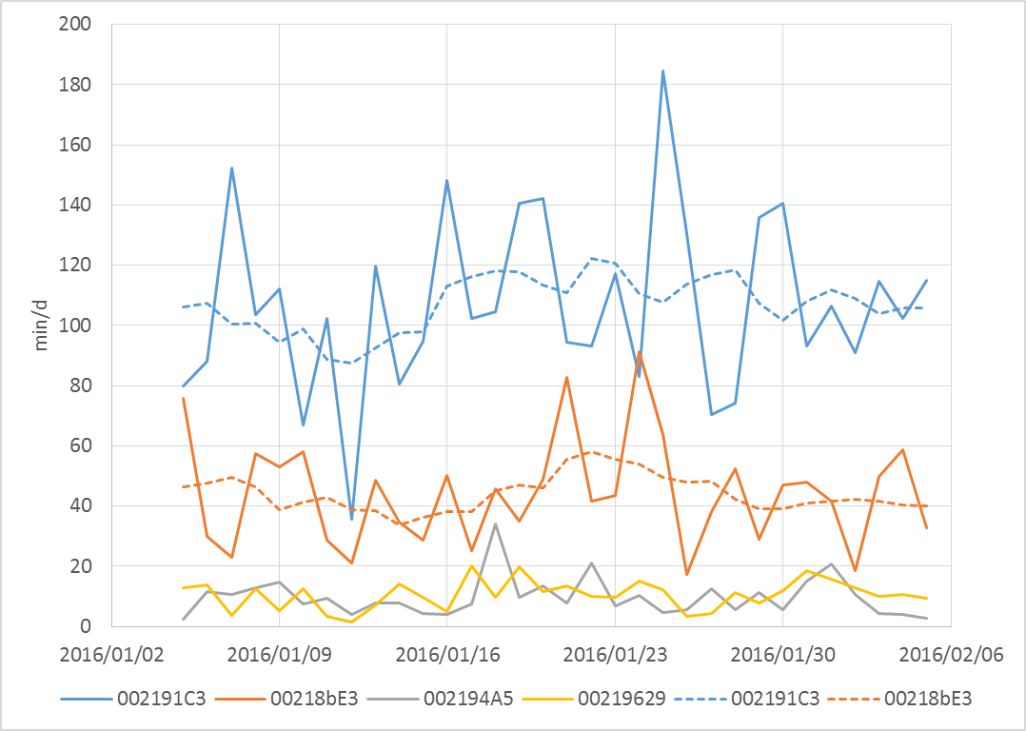
Figure 2. Daily duration (min/d) of being in the brush area for the two major and two minor brush-user cows (distinguished by their tag numbers). The smoothed profiles (dashed line) are more informative as they potentially filter out the false (positive and negative) detections.

Figure 3-A depicts the dendrogram resulting from the clustering analysis. The automatic classification, without a priori information, revealed 4 groups of cows whose daily time spent in the brush area were homogenous, relatively stable during this long time-period (32 d) and spread over a large range of brush use, from 10 to 110 min/d as depicted in Figure 3-B. This means that our automatic measurements are not only noise (found by chance), and also acts, to a certain extent, as a validation process. The real hierarchy in this group was not evaluated but is not known to be expressed with this type of resource (Val-Laillet et al, 2008) if there is little pressure on it. In fact, we found no correlation of brush use with cow’s weight for instance, even if the major user (C1) was declared by the farmer as the “big mamma” in the herd. Furthermore, the five heifers were mainly found (4/5) in the C2 cluster (one in C3), with all showing a relatively high level of brush use. Health may explain a part of clustering, for instance, if cows would suffer of different levels of extern parasites infestations.
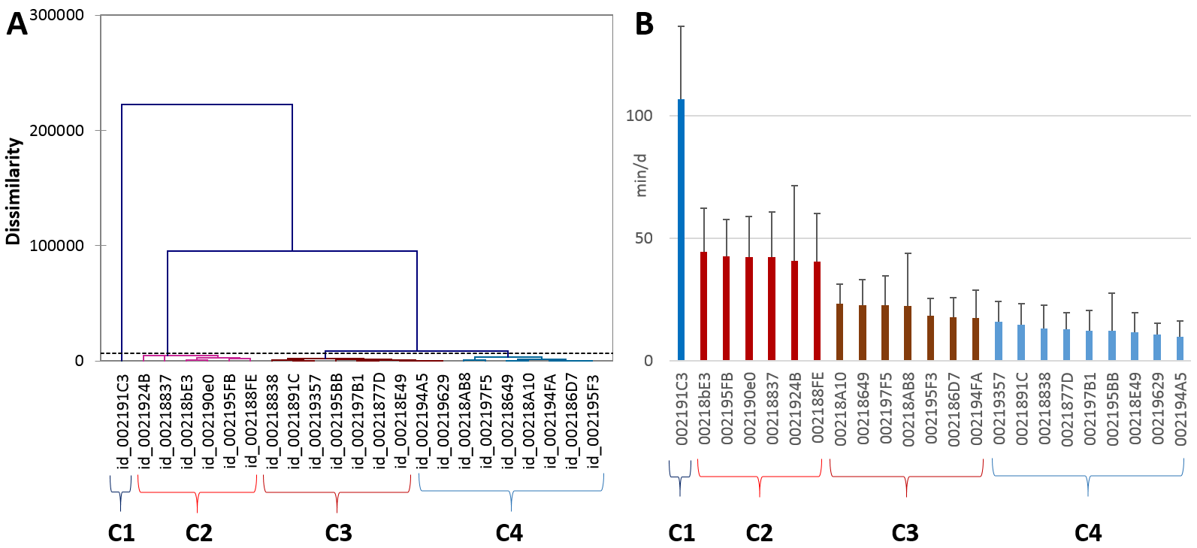
Figure 3. Dendrogram (A) resulting from the hierarchical clustering of the 23 cows, and histogram (B) of their mean (+ standard deviation) daily duration (min/d) of being in the brush area, ranged in descending order. The automatic classification (dashed horizontal line on the tree - A) revealed four significantly different groups of cows (C1 to C4) presenting different levels of brush use (B).

Conclusions

To our knowledge, this is the first study describing brush use at individual level and over the long term. The kinetics of daily time spent grooming showed high day-to-day and inter-individual variations. The approach employed here revealed interesting cows behaviour profiles, which may be potentially associated to phenotype or physiologic state as this grooming behaviour can be considered as more or less freely expressed (i.e. without farming constraint) by each individual. The high range of “brush use” observed here could be compared to other factors such as dominance, health status or well-being indicators.
Noisy tags appeared to be responsible for most of the false detections. Once smoothed, the kinetics modelled offer promising applications for detecting alterations in cow grooming behaviour patterns. Nevertheless, forgetting to consider sensor performance in interaction with the individual could lead to misinterpretations, which further underlines how that these new PLF equipment devices must always be assessed at individual level, in each set of conditions, using robust approaches.
This monitoring approach could be easily implemented in real time to develop a PLF strategy or added to other time-budget information approaches to enrich the study of animal behaviour.

Acknowledgements

The European Community provided valuable financial participation in Collaborative Project EU-PLF KBBE.2012.1.1-02-311825 under the 7th Framework Programme. The authors thank Dominique Pomiès and the staff of the INRA experimental unit Herbipole (UE1414), especially Olivier Troquier, Florence Fournier and Christiane Espinasse. We also thank Karen Helle Sloth and Karsten Kristensen from GEA.

References
Bolinger, D. J., Albright, J. L., Morrow-Tesch, J., Kenyon, S. J., Cunningham, M. D. (1997). The effects of restraint using Self-locking stnachions on dairy cows in relation to behavior, feed intake, physiological parameters, health, and milk yield. J. Dairy Sci. 80, 2411-2417
De Oliveira, D., Franko, M. A., Keeling, L. J. (2015). A sequential analysis of body regions and body positions during mechanical brush use by dairy cattle, Third DairyCare Conference, Zadar, p. 28
DeVries, T. J., Vankova, M., Veira, D. M., von Keyserlingk, M. A. (2007). Usage of Mechanical Brushes by Lactating Dairy Cows. J. Dairy Sci. 90, 241‑2245. doi:10.3168/jds.2006-648
Fogsgaard, K. K., Røntved, C. M., Sørensen, P., Herskin, M. S. (2012). Sickness behavior in dairy cows during Escherichia coli mastitis. J. Dairy Sci. 95, 630–638
Mandel, R., Whay, H. R., Nicol, C. J., Klement E. (2013). The effect of food location, heat load, and intrusive medical procedures on brushing activity in dairy cows. J. Dairy Sci. 96, 6506-6513
Newby, N. C., Duffield, T. F., Pearl, D. L., Leslie, K. E., Leblanc, S. J., von Keyserlingk, M. A. (2013). Use of a mechanical brush by Holstein dairy cattle around parturition. J. Dairy Sci. 96(4), 2339-2344. doi: 10.3168/jds.2012-6016
Schneider, C. A., Rasband, W. S., Eliceiri, K. W. (2012). NIH Image to ImageJ: 25 years of image analysis. Nat. Methods, 9(7), 671-675
Tullo, E., Fontana, I., Gottardo, D., Sloth, K. H., Guarino, M. (2016). Validation of a commercial system for the continuous and automated monitoring of dairy cow activity. J. Dairy Sci. 99(9), 7489-7494. doi: 10.3168/jds.2016-11014
Val-Laillet, D., Veira, D. M., von Keyserlingk, M. A. (2008). Short communication: dominance in free-stall-housed dairy cattle is dependent upon resource. J. Dairy Sci. 91(10), 3922-3926. doi: 10.3168/jds.2008-1332

