Animal age is a better predictor of beef eating quality than ossification score

S.P.F. Bonny^{AE}, D.W. Pethick^{A} I. Legrand^{B}, R.J. Polkinghorne^{C}, J.F. Hocquette^{D} and G.E. Gardner^{A}

Meat and Livestock Australia;
^{A}School of Veterinary and Life Sciences, Murdoch University, Murdoch, WA 6150
^{B}Institut de l’Elevage, Service Qualite´ des Viandes, MRAL, 87060 Limoges Cedex 2, France;
^{C}431 Timor Road, Murrurundi, NSW 2338, Australia;
^{D}INRA-VetAgro Sup, UMRH 1213 Theix, 63122 Saint Genes Champanelle, France;
^{E}Corresponding author. Email: S.Bonny@murdoch.edu.au

A major factor impacting on beef tenderness, an important determinant of consumer satisfaction, is the increase of collagen crosslinking with animal maturity which results in tougher meat (Bailey 1985). Ossification score, a visual assessment of calcification of the cartilage in the sacral and dorsal vertebrae, is used as a proxy for animal age in the prediction of beef eating quality in the Australian MSA system. This measurement is strongly influenced by the hormonal status of the animal and consequently considered to better reflect the physiological maturity of an animal than chronological age (Field et al. 2007). Therefore we hypothesise that ossification score will be a better predictor of eating quality than chronological age in the European production environment.
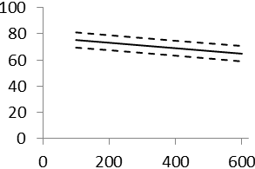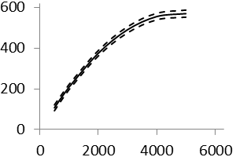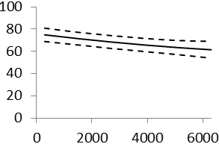 Local consumers tested the grilled striploin from 57 French cattle with ages ranging from 590 to 6135 days and ossification scores ranging from 140 to 590. The untrained consumer scores for tenderness, flavour, juiciness and overall liking were weighted (0.3, 0.3, 0.1, 0.3) and combined into a score termed MQ4. This score was analysed using a linear mixed effects model with fixed effects for muscle type, carcass hang method, cook method, gender, source country and post-mortem ageing period. Animal ID, consumer country and kill group were included as random terms. Age and ossification score were included separately as covariates.
MQ4
Ossification
Ossification
Age (days)
MQ4
Age (days)
c)
b)
a)

Figure 1. Relationship for the grilled striploin between a) Ossification and age b) MQ4 and ossification and c)MQ4 and age. Lines represent predicted mean ± SE. Points represents residuals from the predicted mean.

There was a curve-linear relationship (P<0.05) between ossification and age (Fig 1a) which plateaued at 4000 days and had a correlation of 0.77. Both measurements showed a negative relationship with MQ4 (P<0.05). With every 100 point increase in ossification score or 1000 days increase in age MQ4 decreased by 1.8 and 2.1 points. Across the full range of age or ossification, MQ4 decreased by 8.14 and 11.63 points (Figure 1b and 1c). Across these ranges there was also no evidence of heteroskedasticity, kurtosis or skewness of residuals.
Contrary to our hypothesis increasing animal age had the greater magnitude of effect on MQ4. This can be explained by the plateau in the relationship between ossification and age indicating that ossification loses sensitivity in animals with advanced maturity. The relationship between ossification and age requires more data for cattle of advanced maturity, given that these animals are common in the French production system. Furthermore, we need to evaluate the relative effectiveness of ossification and age at both younger and older extremes.

Bailey A.J., (1985). Journal of Animal Science 60(6):1580-1587.
Field R., et al. (2007). Journal of Animal Science 75(3):693-699.

