MEANS: A software and database platform for multi-criteria assessment of agri-food systems
Julie Auberger^{1,2*}, Joël Aubin^{1,2}, Geneviève Gésan-Guiziou^{2,3}, Caroline Malnoë^{1,2}, Véronique Raimbert^{1,2}, Hayo van der Werf^{1,2}

¹ INRA, UMR1069 Sol, Agro-hydro systèmes, Spatialisation, 35000 Rennes, France
2 Agrocampus Ouest, 35000 Rennes, France
3 INRA, UMR1253 Science et Technologie du Lait et de l’Œuf, 35000 Rennes, France.

∗ Corresponding author. E-mail: Julie.Auberger@rennes.inra.fr

ABSTRACT
INRA, the French National Institute for Agricultural Research, has launched in 2012 the development of the MEANS platform, dedicated to the multi-criteria sustainability assessment of agri-food systems. The main objectives of the platform are to facilitate multi-criteria assessments of farming and agri-food systems by INRA scientists and to assemble and share INRA research results: data describing agri-food systems and models to support multi-criteria sustainability assessment. At first, the MEANS platform is designed for environmental assessment within the methodological framework of Life Cycle Assessment (LCA).
MEANS provides two complementary software programs, available on line (http://www.inra.fr/means): MEANS-InOut, an in-house developed tool, and a commercial LCA software program (Figure 1). The LCA software allows calculating impact indicators for production systems which have been described in the MEANS-InOut software (description of production practices, technical design, system performances). MEANS-InOut and LCA software contain databases that are incremented by and shared among users. In future versions, MEANS-InOut will propose several models to calculate a given substance flow (agricultural pollutant emissions, inputs use). Thus MEANS-InOut will be a way to promote models developed by scientists.
A first version of MEANS-InOut, operational for crop production has been released in November 2014. In the full paper a case study of wheat production will be presented to illustrate the functionalities of the platform.
Since 2014 INRA builds partnerships with ADEME and CIRAD in order to:
- Speed up the development of MEANS-InOut software, for animal productions and process engineering of agricultural products.
- Extend the functionalities of MEANS, integrating new agri-food systems (ex: tropical productions), models and multi-criteria assessment methods developed by the partners (ex: the ADEME AGRIBALYSE National project).
- Expand the audience of the platform to animal production and food processing.

Keywords: multi-criteria assessment, agri-food systems, software platform.

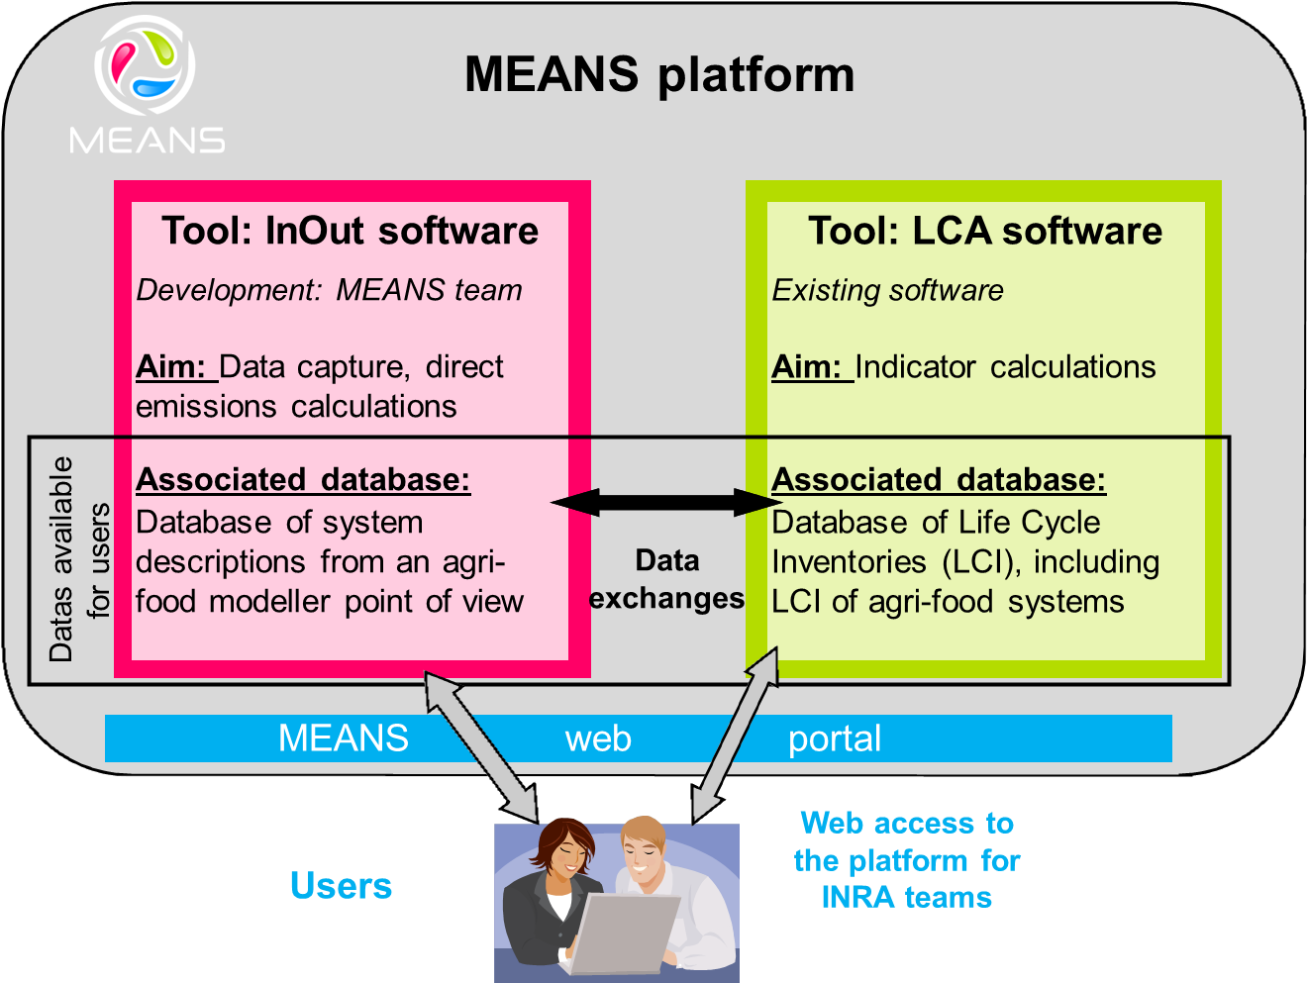

Figure 1: MEANS software and databases

