spectroscopic methods to measure heartwood stilbenes of Scots pine

Pulkka, S.*, Segura, V., Charpentier, J.-P.2, Tapanila, T., Harju, A.M.1, Tanner, J., Venäläinen, M.1 Jääskeläinen, A.-S. & Pâques, L.E.2

ABSTRACT

Fast and accurate methods are needed to measure durability related chemical characteristics from solid wood. In the field of forest tree breeding the measurements would be performed from increment core samples collected from standing trees. In this study we have assessed the potential of Near Infrared Spectroscopy (NIRS) for evaluating the content of stilbenes (STB) pinosylvin (PS) and its monomethyl ether (PSM) from heartwood samples of Scots pine, Pinus sylvestris L. Gas chromatography mass spectrometry (GC-MS) was used as a reference method. Increment core samples originating from a Scots pine progeny trial were divided into calibration and validation sets. Predictive models were developed for the calibration set using partial least-square regression. Prediction accuracy of the models was evaluated using the validation set. The best model was characterized by a R² of 0.87 for the validation set, demonstrating the usefulness of NIRS for evaluating the content of stilbenes. Also a technology based on UV-fluorescence of stilbenes will be briefly discussed.

Key words: Spectroscopy, Monte Carlo Cross Validation (MCCV), Competitive Adaptive Reweighted Sampling (CARS), stilbenes, heartwood

INTRODUCTION

Stilbenes are naturally occurring extractives in Scots pine heartwood (Erdtman, 1939). They protect heartwood against fungal decay and deterioration (Hart and Shrimpton, 1979). There is wide, genetically determined variation in stilbene content among the individual trees (Fries et al., 2000). Stilbene content is laborious to measure by using chemical analyses (GC-MS). Thus, high-throughput methods are of great interest in the field of forest tree breeding and in saw industry. Spectroscopic methods will allow measuring the individual differences fast and reliably (Tsuchikawa et al., 1996). Moreover, by introducing the method into forest tree breeding the selective seed harvest in seed orchards would be possible (Partanen et al., 2011).

The present study aims at assessing the accuracy of three high-throughput phenotyping methods to predict the content of stilbenes in Scots pine heartwood: Near Infrared Spectroscopy (NIRS) (see e.g. Gierlinger et al., 2002), UV resonance Raman spectroscopy (UVRRS) (see e.g. Nuopponen et al., 2004), and fiber-optic spectrometry based on UV excited fluorescence of stilbenes (see e.g. Antikainen et al., 2012). Stilbenes were measured on the surface of solid samples. In the case of NIRS measurements several spectra pretreatment methods and the number of measurements from a single wood sample were optimized.

MATERIAL AND METHODS

  - Material and sample preparation

Scots pine wood samples used in NIRS and UVRRS measurements were collected from a 43-year-old half-sib progeny trial at Leppävirta in eastern Finland in 2009. Mainly ten trees from each of the 53 half-sib families originating from open-pollination have been sampled. Heartwood samples with the length of 20-30 mm including the annual rings from 5 to 8 (counted from the pith) were taken from a random side of the increment cores. Each heartwood sample was halved longitudinally. The other half was milled for chemical analysis, and the other half was subjected to optical measurements.

Pilot measurements of UV-fluorescence were performed for samples that were collected from a 44-year-old half-sib progeny trial at Savonranta in eastern Finland in 2010. One increment core per tree was collected. Heartwood samples including the annual rings from 5 to 8 were used for chemical analyses and the rest of the core was stored in darkness at -20 °C for future measurements. UV-fluorescence was measured from some of the leftover heartwood samples near the pith.

  - Chemical analyses

The concentrations of PS and PSM in milled heartwood samples were analysed by using gas chromatography – mass spectrometry (GC-MS). Details of the method except some improvements are described in Partanen et al. (2011). The sum of their content, total stilbenes (STB), in wood was used as reference in NIRS measurements. It was done for all 474 samples of Leppävirta and for four samples of Savonranta that were used in pilot UV-fluorescence measurements.

  - NIRS measurements

The heartwood samples were stabilised at 22 RH% at room temperature. The NIRS device used was PerkinElmer Spectrum 400 equipped with NIRA module and INGAAS detector. The resolution of device was 8 cm⁻¹. Two to five measurements per sample were taken depending on the length of the individual sample. Each measurement consisted of 64 averaged scans within a circle having radius of about 4 mm. Measurements per sample were taken in every 5 millimeters. Resulted spectra ranged between 4000 and 10000 cm⁻¹ with a step size of 2 cm⁻¹. Total number of sample measured by NIRS was 474.

  - UVRRS measurements

Solid increment core heartwood samples were analysed by UVRRS. Measurement and calibration details are described in Jääskeläinen et al. (2010). Number of samples measured by UVRRS was 262.

  - UV-fluorescence measurements by fiber-optic spectrometry

UV-fluorescence measurements were based on the fluorescence of stilbenes under UV excitation. The measurements were performed on the halved increment core samples of Scots pine heartwood. The set-up consisted of Avantes Starline AvaSpec-2048 spectrometer, UV-LED-light, fiber-optic cables, collimating lenses and reference tile. Light beam formed a spot on the sample and detector lens was pinpointed to this spot. The maximum peak along the increment core was detected. In this pilot test the four samples contained about 10, 15, 20, and 25 mg/g of STB.

RESULTS AND DISCUSSION

  - NIRS measurements

Chemical analyses resulted in heartwood (Leppävirta) STB concentrations from 1.81 to 23.02 mg/g (average=10.83 mg/g and standard deviation 4.08 mg/g). Calibration was done by using 212 samples, and the remaining 262 samples constituted the validation set. Data were processed by RSoftware. First, statistical pretreatments were applied to the spectra to improve the signal quality resulting in 7 spectra modalities: raw (no statistical pre-treatment), norm (normalization), der1 (first derivative on raw spectra), der2 (second derivative on raw spectra), norm_der1 (first derivative on normalized spectra), norm_der2 (second derivative on normalized spectra). Spectra of raw and 2nd derivative on normalized data are shown in Fig. 1.
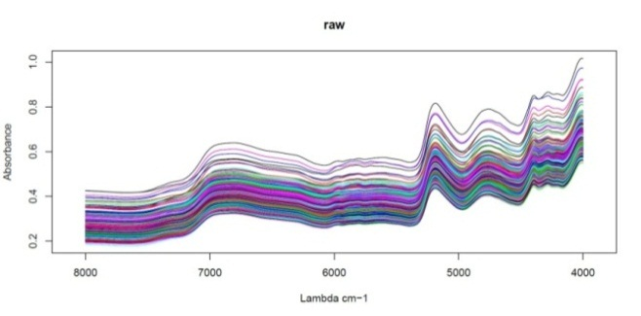
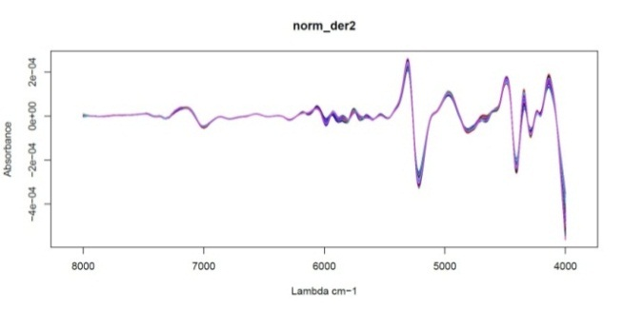

Fig. 1. Raw and 2nd derivative on normalized spectra from Scots pine heartwood surface measurements by NIRS.

Second, partial-least square (PLS) regressions were carried out for each spectra modality to build the calibration models. The number of components of each PLS regression was optimized within a 4-fold cross-validation sampling scheme repeated 100 times (Monte Carlo Cross Validation, MCCV). Additionally, an automatic selection of wavenumbers was carried out using the competitive adaptive reweighted sampling (CARS) approach (Li et al., 2009). Model accuracy was evaluated both within the calibration set through the cross-validation procedure and the validation set using the coefficient of determination (R²) and the root mean square error (RMSE) of prediction. The best PLS regression model corresponded to the second derivative on normalized spectra pretreatment. It was characterized by R² and RMSE of 0.90 and 1.29 mg/g in the calibration set and R² and RMSE of 0.87 and 1.54 mg/g in the validation set (Fig. 2).
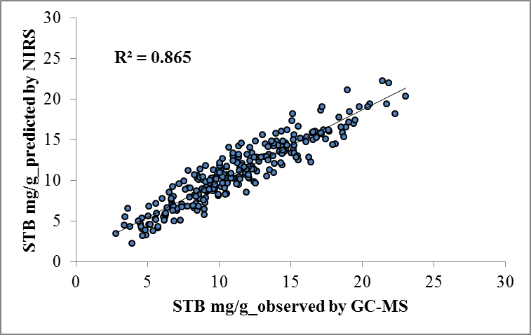
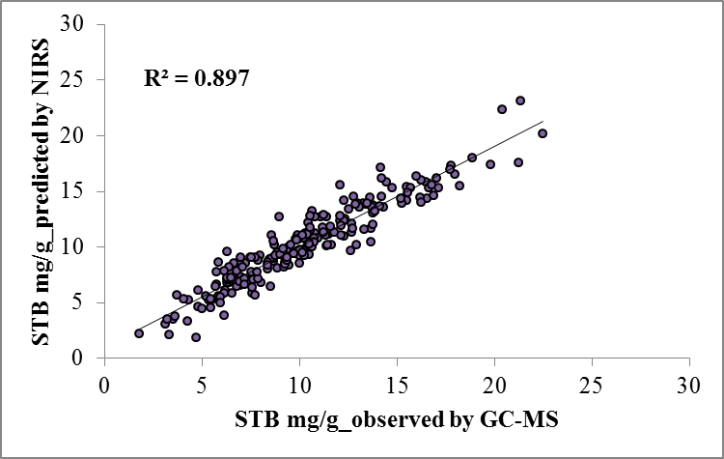
Validation

RMSE=1.54
nobs =262

Calibration

RMSE=1.29
nobs =212

Fig. 2. Prediction of STB concentration measured by NIRS.

  - UVRRS measurements

Heartwood samples included in the validation set had earlier been measured by UVRRS (Jääskeläinen et al., 2010). The R² value between reference method GC-MS and UVRRS prediction was 0.42 (Fig. 3a). There is relatively weak correspondence between the predictions originating from UVRRS measurements and NIRS measurements (Fig. 3b).
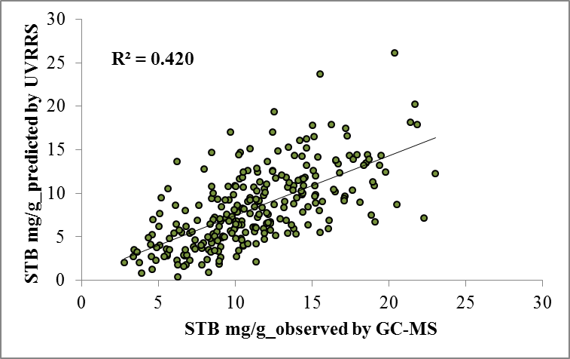
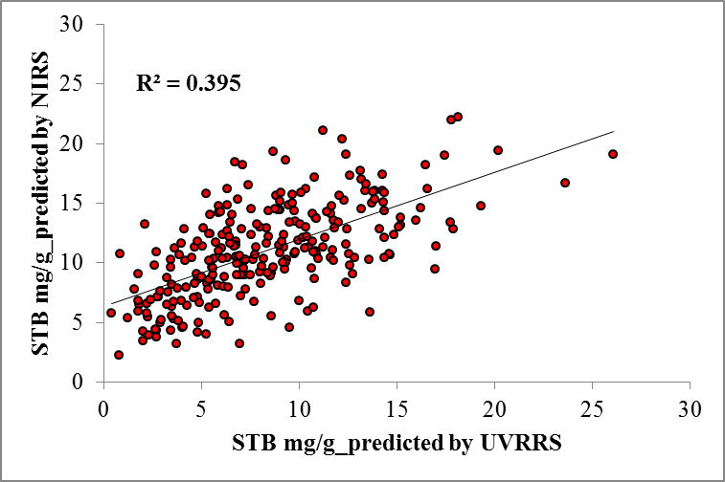
a.

b.

Fig. 3. a. Prediction of STB concentration measured by UVRRS. b. Comparison between NIRS and UVRRS predictions of STB concentration.

  - UV-fluorescence measurements by fiber-optic spectrometry

Four heartwood samples near the pith of Scots pine increment cores sampled from Savonranta were measured by fiber-optic spectrometer. The order of the magnitude of the peaks corresponded well with the wet-chemistry (GC-MS) results of about 10, 15, 20, and 25 mg/g content of STB. The comparison is presented in Fig. 4. Advantages of UV-fluorescence method compared to NIRS are the cost effectiveness of stilbene concentration measurements and higher flexibility in the sample sequence automation set-ups. Jones et al. (2008) have discussed other NIRS related issues including continuous calibration requirements, difficulties in applying NIRS to fiber-optic probe, and high moisture affection to accuracy. These are not as decisive obstacles for UV-fluorescence system than for NIRS. Thus, the UV-fluorescence measurement and calibration methods will be developed further.
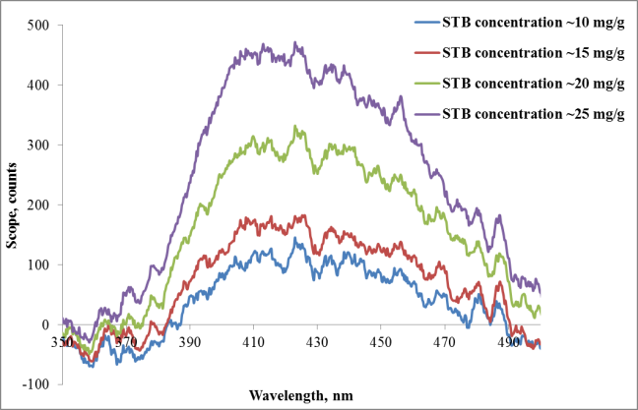

Fig. 4. Stilbene concentration of Scots pine heartwood samples near the pith measured by fiber-optic spectrometer. The measurement is based on UV- induced stilbene fluorescence.

CONCLUSIONS

Spectroscopic methods that were studied, namely NIRS, UVRRS, and UV-fluorescence fiber-optic spectroscopy are fast and non-destructive ways to measure stilbene concentrations from Scots pine heartwood. To replace chemical analysis of STB with optical technology, development of calibration methods is required. Calibration method of UVRRS is quite challenging because stilbene peak is related to lignin peak and the concentration of lignin is not equal among the samples. NIRS method predicts well the stilbene concentrations on the solid heartwood sample. The development of UV-fluorescence method aims to obtain calibration method which will not require any GC-MS analyses later on. Also flexibility in sampling automation and cost effectiveness of UV-fluorescence measurement set-up will be better compared to the NIRS device. These features are appreciated in breeding the chemical quality of Scots pine heartwood and in controlling of timber quality.

ACKNOWLEDGEMENTS

The main author thanks laboratories of the Research Unit "Breeding, Genetics and Physiology of Forest" of INRA Orleans, France for the opportunity to carry out NIRS measurements there in autumn 2014. We thank all the staff that participated in sampling, preparation, and analyses of the increment cores. Rita Hatakka and Antti Kivioja from Aalto University worked with the UVRRS measurements and are acknowledged for their contributions. Financial support from the European Community's Seventh Framework Programme (FP7/ 2007-2013) under the Grant Agreement n° 284181-TREES4FUTURE WP11 project, the Forestcluster and TEKES via the Fubio, EffTech, and Effibre projects, as well as the Regional Council of South Savo and the City of Savonlinna for UV-fluorescence measurements are greatly acknowledged.
REFERENCES

Antikainen, J., Hirvonen, T., Kinnunen, J. & Hauta-Kasari, M. 2012. Heartwood detection for Scotch pine by fluorescence image analysis. Holzforschung 66(7): 877–881.
Erdtman, V.H. 1939. Die phenolischen Inhaltsstoffe des Kiefernkernholzes, ihre physiologishe Bedeutung und hemmende Einwirkung auf die normale Aufschlieβbarkeit des Kiefernkernholzes nach dem Sulfitverfahren. Justus Liebigs Annalen der Chemie 539(1): 116–127.
Fries, A., Ericsson, T. & Gref, R. 2000. High heritability of wood extractives in Pinus sylvestris progeny tests. Canadian Journal of Forest Research 30(11): 1707–1713.
Gierlinger, N., Schwanninger, M., Hinterstoisser, B. & Wimmer, R. 2002. Rapid determination of heartwood extractives in Larix sp. by means of Fourier transform near infrared spectroscopy. Journal of Near Infrared Spectroscopy 10: 203–214.
Hart, J.H. & Shrimpton, D.M. 1979. Role of stilbenes in resistance of wood to decay. Phytopathology 69(10): 1138–1143.
Jones, P.D., Schimleck L.R., Daniels, R.F., Clark, A. & Purnell, R.C. 2008. Comparison of Pinus taeda L. whole-tree wood property calibrations using diffuse reflectance near infrared spectra obtained using a variety of sampling options. Wood Science and Technology 42(5): 385–400.
Jääskeläinen, A.-S., Hatakka, R., Kivioja, A., Harju, A., Partanen, J. & Venäläinen, M. 2010. Pinosylvin distribution in wood as studied by UV resonance Raman spectroscopy. European Workshop on Lignocellulosics and Pulp, August 16-19, 2010, Hamburg, Germany. Proceedings: 465–468.
Li, H., Liang, Y., Xu, Q. & Cao, D. 2009. Key wavelengths screening using competitive adaptive reweighted sampling method for multivariate calibration. Analytica Chimica Acta 648(1): 77–84.
Nuopponen, M., Willför, S., Jääskeläinen, A.-S. & Vuorinen, T. 2004. A UV resonance Raman (UVRR) spectroscopic study on the extractable compounds in Scots pine (Pinus sylvestris) wood: Part II. Hydrophilic compounds. Spectrochimica Acta Part A: Molecular and Biomolecular Spectroscopy 60(13): 2963–2968.
Partanen, J., Harju, A. M., Venäläinen, M. & Kärkkäinen, K. 2011. Highly heritable heartwood properties of Scots pine: possibilities for selective seed harvest in seed orchards. Canadian Journal of Forest Research 41(10): 1993–2000.
Tsuchikawa, S, Hayashi, K. & Tsutsumi, S. 1996. Nondestructive measurement of the subsurface structure of biological material having cellular structure by using near-infrared spectroscopy. Applied Spectroscopy 50(9): 1117–1124.

Natural Resources Institute Finland (Luke), Bio-based Business and Industry, Finlandiantie 18, FI-58450 Punkaharju, Finland. *Tel: +358 29 532 2422, E-mail: susanna.pulkka@luke.fi
Unit A.G.P.F., Platform GénoBois, 2163, avenue de la pomme de pin, CS40001 ARDON, 45075 ORLEANS CEDEX 2, France
Natural Resources Institute Finland (Luke), Green technology, Jokiniemenkuja 1, 01300 Vantaa, Finland
Natural Resources Institute Finland (Luke), Bio-based Business and Industry, Jokiniemenkuja 1, 01300 Vantaa, Finland
VTT, Espoo, Otaniemi, P.O. Box 1000, 02044 VTT, Finland

