Enhanced Quality of Myelin Water Fraction Mapping from GRASE Imaging Data of Human Brain using a New Nonlocal Estimation of multi-Spectral Magnitudes (NESMA) Filter
Mustapha Bouhrara¹, Michael C. Maring¹, David A. Reiter¹, Jean-Marie Bonny², Richard G. Spencer¹
¹Laboratory of Clinical Investigation, National Institute on Aging, NIH, Baltimore, Maryland, USA.
²UR370 QuaPA - INRA, F-63122 Saint-Genès-Champanelle, France.
PURPOSE: Myelin water fraction (MWF) mapping permits direct visualization of myelination patterns in both the developing brain and in disease.¹⁻⁴ MWF is conventionally measured through multicomponent T₂ analysis of CPMG or GRASE data.^{1-2,5} Use of the non-negative least-squares algorithm (NNLS) permits analysis without a prior assumption about the number of underlying distinct relaxation components. A well-known drawback of this method is the instability of NNLS with respect to noise, leading to significant inaccuracies in derived MWF estimates (Fig.1).⁶ To overcome this limitation, noise reduction filters may be applied during post-processing.⁷ However, conventional filtering can introduce bias and obscure small-scale structures. We have recently developed a new nonlocal multispectral filter that significantly outperforms current filters, including available nonlocal filters, in term of noise reduction and detail preservation in T₁ and T₂ weighed image sets.⁸ Here, we evaluated the performance of this filter for MWF determination from multiple echo imaging data, and compared the results to those calculated from unfiltered images and from images filtered using conventional Gaussian averaging (GA) or boxcar averaging (BA) filters.
MATERIALS & METHODS: Image acquisition: 3D GRASE images were acquired from the brains of two healthy subjects (male, 24-years-old; female, 43-years-old) using a 3T Philips Achieva MRI system (Philips, Best, The Netherlands). 32 echoes were acquired with TE_{n}=n*ΔTE, where ΔTE=11ms, TR=1000ms, EPI factor=3, acquisition voxel size=1.5mmx1.5mmx3mm and reconstructed voxel size=1mmx1mmx3mm. Image filtering: The filter we have recently introduced restores the amplitude of an index voxel using a maximum likelihood estimate (MLE) based on M pre-selected voxels with similar signal decays.⁸ In the present implementation, to decrease processing time, the MLE is replaced here by the simple average of the amplitudes of those similar voxels. This markedly decreases the computational time while maintaining nearly equivalent filtering performance (data not shown). The number M of similar pixels is conventionally held constant in the construction of nonlocal filters. However, the optimal value may in fact vary among different image regions. We therefore implemented a spatially adaptive selection of M using relative Euclidian distance (RED), defined as the sum over all TEs of the absolute signal differences between the index voxel and a given voxel, divided by the averaged signal value over all TEs of the index voxel. Voxels with RED≤5% were considered similar to the index voxel. We denote this new filter by Nonlocal Estimation of multi-Spectral Magnitudes (NESMA). For comparison, we also implemented 5x5x3 GA and BA filters. MWF mapping: In each voxel, MWF was calculated using a regularized NNLS algorithm. The regularization factor was defined based on the discrepancy principle such that 1.02χ²_{min}≤ χ² ≤1.025χ²_{min}, where χ²_{min} is the calculated misfit between the data and the model obtained from the nonregularized solution.^{1,6} Finally, the MWF is calculated as the integral of the T₂ distribution between 8 and 40ms, normalized by the total area under the distribution.^{1-2,5-7}
RESULTS & DISCUSSION: Fig.2 shows examples of MWF maps calculated from unfiltered and filtered images using the NESMA, GA and BA filters. As is readily seen, there is substantial random variation in derived MWF maps from unfiltered images. While the random variation was reduced using the GA or BA filters, this comes at the expense of blurring and loss of image detail. However, MWF maps calculated from images filtered with NESMA exhibited preservation of edges and small structures, as well as greatly reduced random variation compared with unfiltered images. Fig.3 shows a comparison of derived MWF values from the brains of the two subjects. MWF maps calculated from images filtered with NESMA are displayed for three different slices. The results indicate higher MWF values in a middle-aged subject in several image regions as compared to the younger subject, in good agreement with recent literature⁹. These preliminary analyses, although only on two subjects, serve to indicate the consistency of our method with previous literature and to demonstrate the sensitivity of the measurement to MWF changes with age.
CONCLUSION: Estimation of MWF in the human brain from GRASE imaging data was markedly improved through use of the NESMA filter. NESMA allows preservation of edges and small structures in derived MWF maps. The use of NESMA may contribute significantly to the goal of high quality MWF mapping in clinically feasible imaging times.
REFERENCES: [1] Whittall KP et al. Magn Reson Med 1997;37:34-43. [2] Laule C et al. J Neurol 2004;251:284-293. [3] Deoni SCL et al. Brain Struct Funct 2016;221:1189-1203. [4] Bouhrara M and Spencer RG NeuroImage 2016;127:456-471. [5] Prasloski T et al. NeuroImage 2012;63:533-539. [6] Zhang J et al. Magn Reson Med 2015;73:223-232. [7] Jones CK et al. Magn Reson Med 2003;50:206-209. [8] Bouhrara M et al. IEEE TMI 2016;DOI:10.1109/TMI.2016.2601243. [9] Arshad M et al. NeuroImage 2016;143:26-39.

SYNOPSIS: Changes in myelin water fraction (MWF) represent a biomarker for central nervous system disease. However, high quality mapping of MWF is challenging, requiring very high signal-to-noise ratio for accurate and stable results. In this work, we demonstrate the potential of a new multispectral filter to permit high quality MWF mapping using in-vivo GRASE brain imaging datasets. Indeed, unlike conventional averaging filters, our filter permits substantial reduction of the random variation in derived MWF estimates while preserving edges and small structures. Finally, our results regarding patterns of MWF as a function of age are consistent with recent literature.
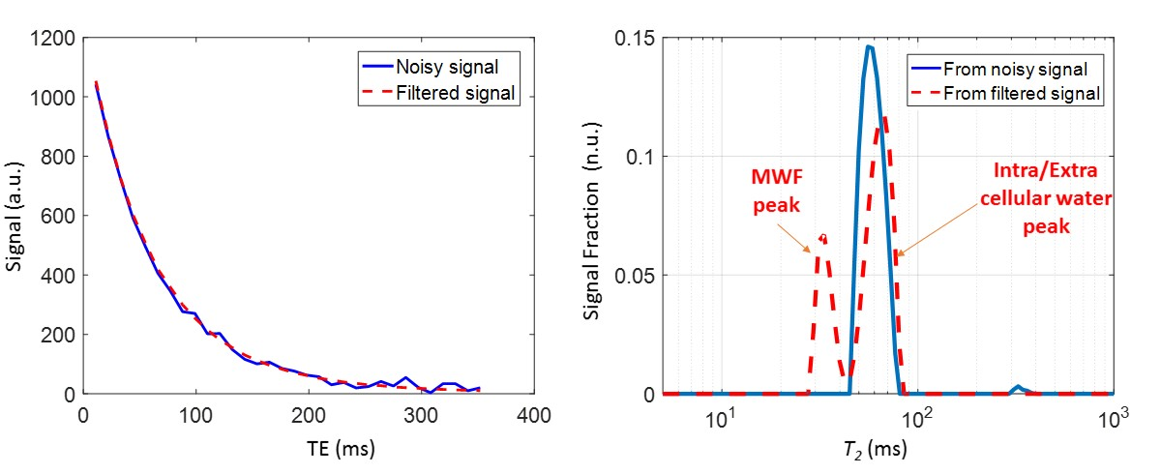
Figure.1. Illustration of the instability of NNLS to noise. Left panel: signal decays as a function of TE. Right panel: T₂ distribution obtained using NNLS from a given voxel of the in-vivo data before and after image filtering using our new multispectral filter, NESMA. Two distinct peaks, corresponding to MWF and intra/extra cellular water,^{1-2,5-7,9} are visible in the T₂-distribution obtained from the filtered signal. In contrast, only one peak was visible in the T₂-distribution obtained from the noisy signal. This illustrates the high degree of sensitivity of the NNLS analysis to noise, and the significant improvement obtained through NESMA filtering.
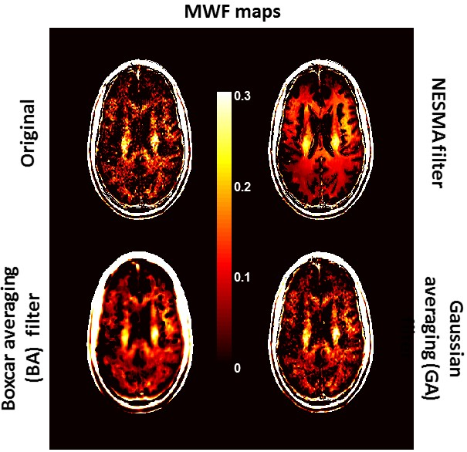

Figure 2. Example of MWF maps derived using GRASE acquisition with NNLS from the original (unfiltered) images and from corresponding images obtained using the NESMA, boxcar averaging (BA), and Gaussian averaging (GA) filters. The kernel size of both the BA and GA filters was fixed to 5 x 5 x 3 voxels. The blurring effect of the BA and GA filters is evident; this blurring is absent in the NESMA-filtered image.
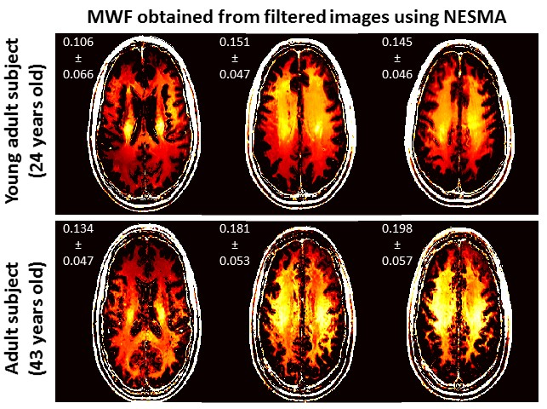
Figure 3. MWF maps derived using GRASE acquisition with NNLS analysis and NESMA filtering. Results are shown for three corresponding slices for both subjects. For each slice, the mean and standard deviation of derived MWF values are displayed. Visual inspection of MWF maps and comparison of mean values show that the brain of the older subject exhibits greater MWF values as compared to the brain of the younger subject in several brain regions, as is consistent with recent literature.⁹

