SMOS and AMSR-E brightness temperature cross-validation over the Salar de Uyuni
Escorihuela A.(1), M.J. Escorihuela(1), Y.H. Kerr (2), P. Richaume (2) and J.P. Wigneron (3)
isardSAT, Barcelona (1), CESBIO, Toulouse(2), INRA, Bordeaux (3)
1. CONTEXT and OBJECTIVE
The Salar de Uyuni is the largest salt flat in the world. It is located in the Bolivian altiplane at a height of about 3700 m between latitudes 19º45 S and20º 40 S and between longitudes 68º17W and 66º45W. The Salar is covered with a solid salt crust with a thickness varying between tens of centimeters to a few meters. Underneath its surface isa lake of brine 2 to 20 meters deep. The Salar's surface is about 9600 km2 (several tenths the SMOS footprint). It is located in a rather uninhabited area with no RFI (Radio Frequency Interferences). Salar's climate is cold and dry, being characterized by low temperatures, low relative humidity levels and low precipitation. The rainfall is very low and concentrated from December to March. During the austral summer (from December to March), the surface can be covered by a thin water layer. This water layer disappears in the dry season, from April to November, leaving the Salar surface extremely flat and smooth. The large area, clear skies and exceptional surface flatness make the Salar an ideal object for calibrating Earth observation satellites. Consequently, the Salar has been used to calibrate radar and laser altimeters as well as spectral reflectances. The aim of this study is to use the Salar for SMOS brightness temperature vicarious calibration.
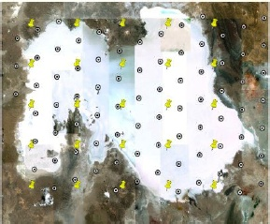
Fig1: The study area with centers of SMOS DGG(dots) and AMSR-E pixels (pins).
2. SMOS AND AMSR-E DATA
The radiometric temporal and spatial signature of the Salar was characterized using data from the AMSR-E on-board Aqua previously to SMOS launch. AMSR-E is a multi-channel passive microwave instrument launched in 2002, which measures brightness temperatures at five frequencies in the range of 6.9 to 89GHz (incidence angle 55). AMSR-E brightness temperature is resampled at 25x25km providing 30 pixels over the Salar. Concerning SMOS data, there are56 DGG over the Salar.
3. SPATIAL AND TEMPORAL SIGNATURE
The brightness temperature (TB) was shown to be uniform spatially over the Salar both at V-pol and H-pol at AMSR-E lower frequencies (6.9 and 10.7 GHz) and SMOS frequency (1.4 GHz) in [1, 2]. This study will be therefore dedicated to the temporal signature. SMOS data at 42.5º incidence angle from 9th June2010 (version 340 and later is used).
SMOS L1c is provided at the antenna level, this data was interpolated and rotated in order to obtain BT at V and H polarization at 42.5º incidence angle. The temporal evolution of SMOS and AMSR-E BT is plotted in Fig-2 up for V-pol and Fig-2 down for H-pol. We observe that both follow the same tendency, although SMOS TB is always lower than AMSR-E TB (at 6.9GHz). That difference it's probably due to AMSR-E lower spatial resolution (the IFOV is74x43 km at 6.9 GHz ) which makes that AMSR-E TB is an average between interior and exterior Salar brightness temperature. Since the brightness temperature outside the Salar is higher than the Salar BT, this increases AMSR-E BT temperature. Also, the different observing frequencies (1.4 GHz for SMOS and 6.9 GHz for AMSR-E) make that actually the sensors have different penetration on the soil. The emission observed by SMOS would come from a deeper layer which is wetter and thus the BT is lower. Here is a bigger discrepancy between AMSR-E and SMOS BT temperatures on humid season at V-pol than at H-pol. Which is due to the fact that at V-pol we have higher differences between interior and exterior TB than at H-pol.

Fig 2: SMOS and AMSR-E brightness temperature at V-pol (up)
and H-pol (down) over one center pixel (DGGid=1234071)
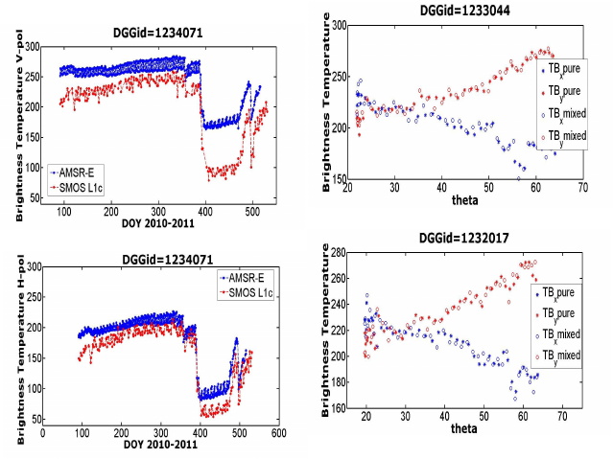 Fig 3: SMOS brightness temperature at the antenna level over two center pixel measurements done in X-pol pure and mixed and Y-pol pure and mixed.
Note: Although most graphs are shown over DGG 1234071, similar results have been obtained over other Salar center pixels.

4. PURE and MIXED MEASUREMENTS
In Full Polarization, some X and Y polarization measurements are acquired at the same time that cross-polarization measurements, we call that' mixed' measurements to distinguish them from 'pure' measurements acquired independently. In this study, we assessed the influence of 'mixed' measurements over the angular signature. This is shown in Fig.3 for two inner DGG of the Salar. It is shown that 'mixed' measurements are more noisy than 'pure' measurements. This is expected because of the lower integration time which is 0.4s for 'mixed' measurements and 0.8s for 'pure' measurements. However, 'mixed' measurements do not seem to induce any bias in the angular signature.
4. Brightness Temperature L2vs L1
The Salar is a non-nominal surface, thus only the dielectric constant is estimated in the L2 algorithm. Using this estimated value of dielectric constant, TOA (top of atmosphere) brightness temperature, ASL (above surface level) brightness temperature and other parameters are also calculated. The comparison between TB_TOA estimated from dielectric constant (L2) and TB browse which is measured (L1)is shown in Fig 4.
We can appreciate that both are very similar on dry season. This result shows that we have good estimations of dielectric constant on the dry season. However, between DOY 390 and 480andthat there is no TB_TOA, the algorithm is not able to estimate the dielectric constant on humid season. Further investigation is currently on going to understand the unability of the algorithm to estimate the dielectric constant when the Salar is inundated.

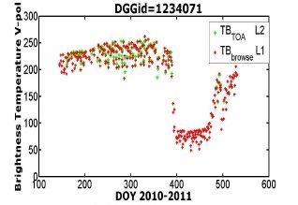
Fig 4: TB TOA and TB browse at V-pol over one center pixel (DGGid=1234071)

5.DIELECTRIC CONSTANT
On fig.5 we see that SMOS retrieved values of the dielectric constant (MD model), on dry season are almost constant and around Є=11 -1j. During the wet season we only have few values (again the algorithm isn't working properly), which can reachЄ=170 -17j.
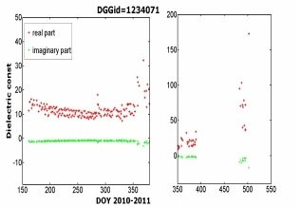
Fig. 5: Complex dielectric constant temporal signature over same pixel
6.DIELECTRIC CONSTANT vs EMISSIVITY
In Fig 6, the SMOS L2 dielectric constant product is plot against emissivity. The theoretical relationship for a Fresnel surface is also plotted. There is more agreement for higher emissivity values (dry) than for lower (humid). Besides at V-pol there is more agreement between theoretical values and measurements than at H-pol, this can be due to a better agreement on models at vertical polarization.
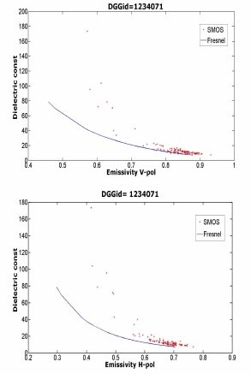
Fig 6: SMOS Dielectric constant vs Emissivity over pixel 1234071, for both vertical (up) and horizontal (down) polarization.

7. CONCLUSIONS AND PERSPECTIVES
The aim of this study was to use the Salar for SMOS brightness temperature vicarious calibration. SMOS brightness temperature over the Salar the Uyuni, follows the same temporal evolution as the AMSR-E brightness temperature, although SMOS TB are lower. That's because AMSR-E lower spatial resolution (IFOV is 74x43 km) which makes that AMSR-E TB is an average between interior and exterior Salar brightness temperature. Concerning spatial homogeneity, it was shown that brightness temperature was almost homogeneous all over the Salar. In the full polarization, pure and mixed measurements seem to have no impact on the signal. Both SMOS TB browse and TB TOA are very similar, which shows good estimations of dielectric constant. The algorithm which retrieves dielectric constant is not working at humid season but seems to be right on dry season. The relation between emissivity and dielectric constant is very similar to the theoretical relation calculated from Fresnel reflections coefficients on dry season.
References
[1] M.J. Escorihuela, Y. Kerr, P. Richaume, J.-P. Wigneron and M. Roca “Smos brightness temperature validation over the Salar de Uyuni” SMOS Validation and Retrieval Team (SVRT). Workshop, 11-13 March 2009, Lisbon, Portugal.
[2] M.J. Escorihuela, Y. Kerr, P. Richaume, J.-P. Wigneron and M. Roca “Calibration and Validation of SMOS Brightness Temperature over the Salar de Uyuni” ESA Living Planet Symposium 28 June-2 July 2010, Bergen, Norway.

