

**The REVALTER Project**

**“Multi-scale assessment of livestock development pathways in Vietnam”**

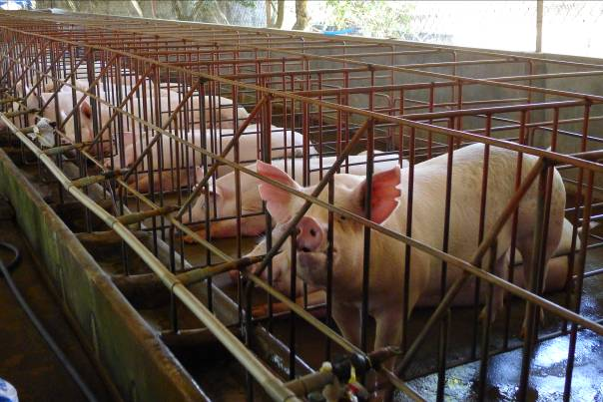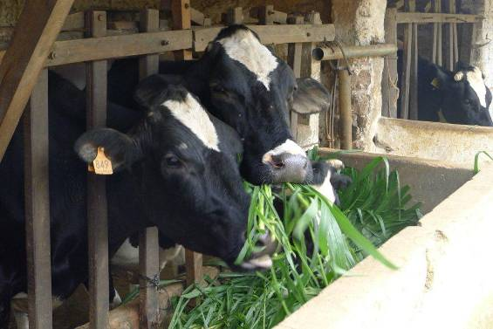

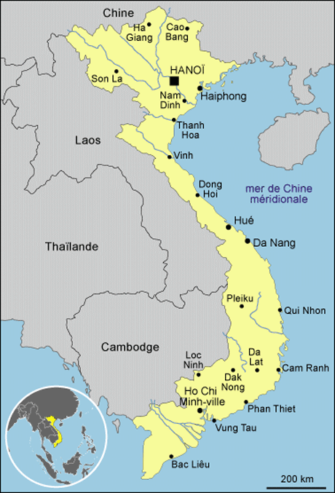

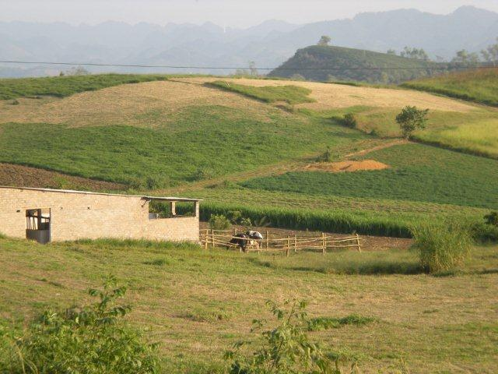

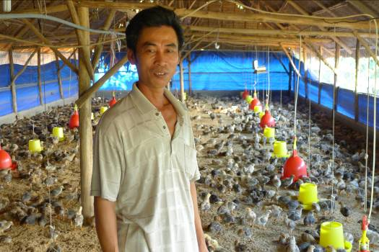

**Task 1.1**

**Typology of farms in Thong Nhat**

***By: Nguyen Tien Dinh (RUDEC/IPSARD)***

*Nathalie Hostiou (INRA)*

*Samir Messad (CIRAD)*

*Sylvie Cournut (VetAgroSup)*

*Tran Doc Lap (Nong Lam’s University)*

**



***Hanoi, 2015***

# TABLE OF CONTENTS

1. Context 3

2. Question and objectives 5

3. Presentation of the study area 6

3.1. Presentation of the district «Thong Nhat» 6

3.2. Characteristic of agricultural production 7

4. Presentation of the method to collect data 9

4.1. Description of the questionnaire (Appendix 1) 9

4.2. Organization of surveys 10

4.3. Farm sample 10

4.4. Variables selected to create the typology of farms and to identify farm sustainability 11

5. Presentation of the method to analyze data 14

6. Results 14

6.1. A short description of the sample 14

6.2. The farm typology according to the capitals (description of the groups of farms) 22

6.3. Description of the groups according to sustainable indicators 28

7. CONCLUSION 29

ANNEX 30

# LIST OF TABLES

Table 1: Production value of agriculture - forestry - fishery of Thong Nhat district in 2005-2010 (Unit: Millions VND) 8

Table 2: Results of the livestock industry development of Thong Nhat district 8

Table 3: Criteria to define a farm 10

Table 4: Variables used to construct farms’ typology 11

Table 5: Characteristic of the entire sample 14

Table 6 : History of pig livestock in household (start pig farming) 15

Table 7 : Labor working on farm livestock 15

Table 8 : Revenue from activities of HHs 16

Table 9 : Turn over of pig livestock in the last 12 months of HHs 16

Table 10 : Land of household 17

Table 11 : Equipment for pig 17

Table 12 : Use credit for pig production in the last 3 years 18

Table 13 : Number of pigs in the last 12 months 18

Table 14 : Using time labor for pig (cleanning, feeding, animal care… ) 18

Table 15 : Feed purchase for pig 19

Table 16 : Health care for pigs 20

Table 17 : Weight sold pig (kg/head) 20

Table 18 : Type of selling (% idea Yes) 21

Table 19 : Distance to the nearest dwelling place 21

Table 20 : Treat the waste from pig production 22

Table 21 : Description of the groups 25

Table 22 : Description of the typology according to the localization (%) 25

# LIST OF MAPS

Map 1: Administrative map of district’s Thong Nhat and 2 communes for survey 6

Map 2: The number of pig and the number of households in Thong Nhat 9

# LIST OF FIGURES

Figure 1 : Descriptors’ groups MFA inter-structure (links between Capital groups; links between ‘capital’ groups and ‘sustainability’ groups (factor 1 & 2). 23

Figure 2 : MFA factorial map of farmers (Factor 1 & 2). Links between localization and ‘Capital’ typology 23

Figure 3 : Graphical representation of Dong Nai farmers based on MFA coordinates 24

# 1. Context

The REVALTER project aims at promoting a new vision of livestock development in Vietnam, a country faced with extremely rapid intensification and industrialization of the sector. In order to build some sustainable scenarios for the future, the project will review the past and current changes that affect environmental, economic and social relationships between livestock breeding, agriculture and rural territories.

Livestock farming systems are changed rapidly in Vietnam due to some transformations at national and local levels:

- Increase of livestock production : over the last 2 decades, agricultural production has been increasing by 5.8% per annum. Livestock has been growing even faster in the recent years, at an average growth rate of 10 %. Between 2000 and 2010, poultry meat and pig meat production are more than doubled, and milk production was multiplied by 6.

- Increase of GDP and livestock products consumption : the Vietnamese economy has been growing rapidly over the last decade, leading to the increase of the people’s living standards and higher consumer demand for animal products such as meat, eggs and milk (Huong et al, 2009; Tisdell, 2010).

- Setting up national and local policies by the government to increase production, and to intensify livestock production : the official “livestock development strategy to 2020” defined in May 2008 aims to encourage the rapid increase of animal production to respond to the growing demand (MARD, 2009). This strategy is to promote intensification and industrialization of the livestock sub-sector through the development of large farms. The negative impacts of this “livestock revolution” are not clearly identified. For example for pig production, the policy mainly focuses on intensification of pig farms in the Red River Delta and areas surrounding large cities (Decision 166/2001/QD-TTg) (Herold et al, 2010). 15 different subsidies to the pig sector with local application were identified in Mai Son district, such as direct subsidies for the rearing of breeding stock, direct subsidies for the purchase of breeding stock, artificial insemination (Drucker et al, 2006).

- At farm level changes on farm structure are observed with the development of more market oriented farms and large-scale farms. But smallholder farms are very important for livestock production in Vietnam. 71% of farm households own pigs. Pork accounts for 70% of all livestock production. 80% of pig production are estimated to be small-scale (Lemke et al, 2006). The traditional livestock pig production is characterized by household resource-driven production. Smallholder pig herds include 1-2 sows and 10 fatteners, relying mainly on local available feeds. In Vietnam, the development of intensive large-scale farms is occurring (Hoàng Vũ Quang, 2012). These farms are characterized by market-oriented production, commercial high-protein-energy concentrate feed.

- Better access to market has consequences on livestock practices (more commercial feed, less local breed, …). For example in pig production in Dong Nai, it was observed an increase of commercial feed in industrial and semi-industrial pig farms. In industrial farms, farmers tend to feed using rations consisting only of commercial feeds. In semi-industrial farms, it is composed by maize, roughage, rice barn, broken rice, cassava + commercial feeds. In subsistence farm, feed is based exclusively on local available feeds (maize, roughage, rice barn, broken rice, cassava). With the intensification of pig production farmers purchase more commercial feed.

- In Vietnam farms are become more specialized and large scale farms are also developed in different regions of the country. Livestock farming systems are more and more diversified but with there is little knowledge about farms’ types (Pham Duy Khanh, 2010; Lairez, 2012).

- The different types of livestock farming systems have not the same consequences on farms’ sustainability (economical, social and environmental). For example for milk production : large scale and specialized farms have to deal with some environmental problems (pollution) and economics problems (production cost is higher than in small farms), (Lairez, 2012). However small farms also deals with some problems: workload, pollution, feed self-sufficiency for animals…) (Pham Duy Khanh, 2010).

# 2. Question and objectives

***Two main questions were identified for task 1.1:***

- Which is the diversity of livestock farming system due to a better access/integration to the market?

- Are some types of livestock farming systems more sustainable than another?

This action 1.1 aims at categorizing livestock farming systems, and investigating sustainability of livestock farming systems. This task allows identifying farming system critical sustainability issues for change.

# 3. Presentation of the study area

## 3.1. Presentation of the district «Thong Nhat»

Thong Nhat district, is located in the center of Dong Nai province: the East is border with Long Khanh province; the West is border with Trang Bom province; the South is border with Long Thanh province and Cam My province; the North is border with Dinh Quan province

The Thong Nhat district has 10 administrative units. The commune are: Gia Tan 1; Gia Tan 2; Gia Tan 3; Gia Kiem, Quang Trung; Bau Ham 2; Lo 25; Hung Loc, Thanh Xuan, Xuan Thien. The communes are located along the National Highway 1A and Highway 20, both are very convenient to travel between regions.

Population: about 151.277 people, the average population density is 612 people/km2 (2010).

The total natural land of the district is 24,717 ha, of which 21,608 ha of agricultural land (accounting for 87%), composed of annual crops (4,796 ha), perennial land (16 363 ha), 316 ha of forest land, 85 hectares of aquaculture land; 2,916 hectares of non-agricultural land (11.8%); 193 hectares of unused land. 2,351 ha of land are used for crops (of which 1,879 ha of rice : 79%). .

***Map 1: Administrative map of district’s Thong Nhat and 2 communes for survey***

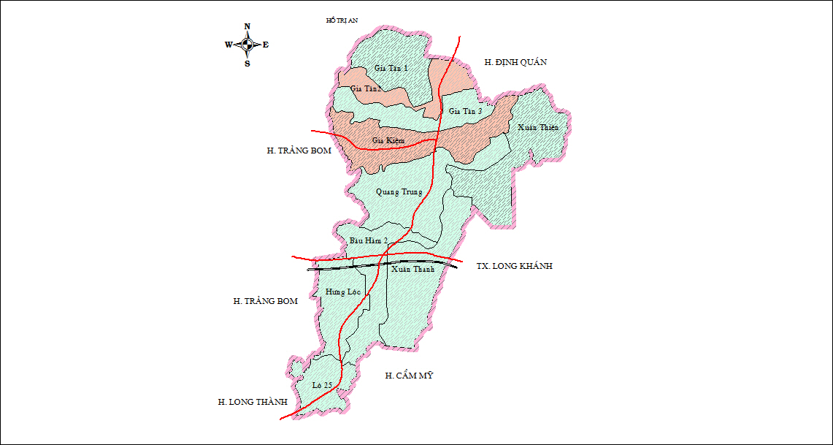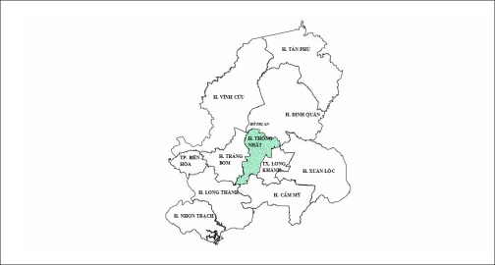

**Gia Tan 2 Commune**

**Gia Kiem Commune**

***Economic:***

18 ethnic groups live and work in the district, in which the Kinh people account for about 93%, the rest are ethnic Hoa (Chinese), Chơ ro, Tày and some other minorities.

Religion in the district is very diverse, mostly Christian, accounting for 76%, followed by Buddhist and other religions such as Protestant, Cao Dai.

Economic growth is 10% on annual average, and 13% for the period 2010 - 2013. The economic structure is based on the 3 sectors services - industry – agriculture, which positive increases:

* proportion of service sector rose from 38.8% in 2004 to nearly 47% in 2013;
* proportion of industry-handicraft increased from 10.8% to over 19%;
* Proportion of agriculture - forestry - fishery decreased from 50.4% to over 34%. However, the growth of the agricultural sector in Thong Nhat district is about 4.8% higher than the provincial average (2011-2012).

Industrial and handicraft production have increased slowly but still account for a small proportion, mainly handicraft production in the household. Commercial and services have been developed rapidly and a high proportion with the market system, business center, shops, dealers supply agricultural materials, construction materials, food, consumer goods, agricultural trade,.....

Because economic development, people's contribution to the state budget has increased each year. From just over 90 billion VND in 2004 to end of 2013 amounted to nearly 120 billion VND. Rural areas were innovated, and now, over 70% of system roads managed by the district has been concreted, nearly 60% of system roads managed by the commune roads are asphalted; the proportion of households using electricity from the national grid reach 99%; 98% of households using clean water.

## 3.2. Characteristic of agricultural production

Agricultural production plays a key role in the economy of the district but there is a growing trend in percentage in the economic structure of the district. Some of the main crops in the district are: 5,700 ha of rubber ; 5,000 ha of fruit trees ; 4,300 ha of maize; 4,081 ha of rice; 1,600 ha of beans and vegetables;; ; 1,500 ha of coffee; 350 ha of soybean 370 ha of pepper (table 1).

***Table 1: Production value of agriculture - forestry - fishery of Thong Nhat district in 2005-2010 (Unit: Millions VND)***

|  |  |  |  |  |
| --- | --- | --- | --- | --- |
| **N0** | **Sector** | **Year** | | Average growth*(****%****/year****)*** |
| **2005** | **2010** |
|  | ***The total value of production at constant prices (94)*** | ***472.9*** | ***617.9*** | ***5.49*** |
| 1.1 | Agriculture | 461.1 | 606.2 | 5.62 |
| 1.2 | Crop | 327.3 | 356.0 | 1.69 |
| 1.3 | Livestock | 123.2 | 237.6 | 14.04 |
| 1.4 | Service | 10.6 | 12.6 | 3.52 |
| 1.5 | Forestry | 9.7 | 9.8 | 0.21 |
| 1.6 | Fisheries | 2.1 | 1.9 | -1.98 |

Currently, in Thong Nhat district, the livestock sector is concentrated with many large farms with a total of 659 farms, of which 436 pig farms, 125 chicken farms and 98 quail farms (Table 2).

* The cattle increased from 514 heads of cows in 1995 to nearly 2,500 heads of cows in 2013. The beef cattle production is concentrated in the communes of Hung Loc, Bau Ham 2, Xuan Thien, Thanh Xuan (about 91% total).
* Pigs in the district has increased rapidly, from about 57 thousand in 2003 to 263thousandin 2013. Pig raising is mainly concentrated in 4 communes of Gia Tan 1, Gia Tan 2, Gia Tan 2, and Gia Kiem (about 70% of total).
* Also fast-growing for poultry, mainly chickens with over 1.2 million and 1.4 million quail, concentrated mainly in Xuan Thien commune and Quang Trung commune.

***Table 2: Results of the livestock industry development of Thong Nhat district***

|  |  |  |  |  |
| --- | --- | --- | --- | --- |
| **N0** | **Livestock** | **Unit** | **2010** | **2011** |
| 1 | Cattle | Head | 2.900 | 2.540 |
| 2 | Goat | Head | - | 2.030 |
| 3 | Pig | Head | 200.49008 | 235.841 |
| *Which: sow* | *Head* | *23.200* |  |
| 4 | Poultry | 1.000 heads | 1.100 | 2.512 |
| *Which: chicken* | *1.000 heads* | *804* | *-* |
| 5 | Production of pork | Ton | - | 1.523 |
| Production of poultry meat | Ton | - | 1.256 |
| Production of eggs | 1.000 eggs | - | 21.435 |

Thong Nhat district is characterized by :

* The presence of feed industries (Bocquillet, 2013) with 12 of 95 identified ;
* An increase of pigs number ;
* An increase of farms size : the proportion of farms with more than 50 pigs is higher than in Vietnam (20% against 0,78%).

Thong Nhat district is characterized by a stong level of industrialization of the pig sector (see map below).

***Map 2: The number of pig and the number of households in Thong Nhat***

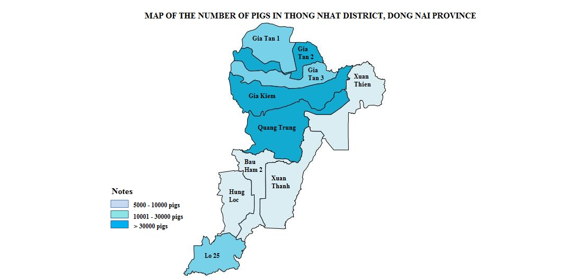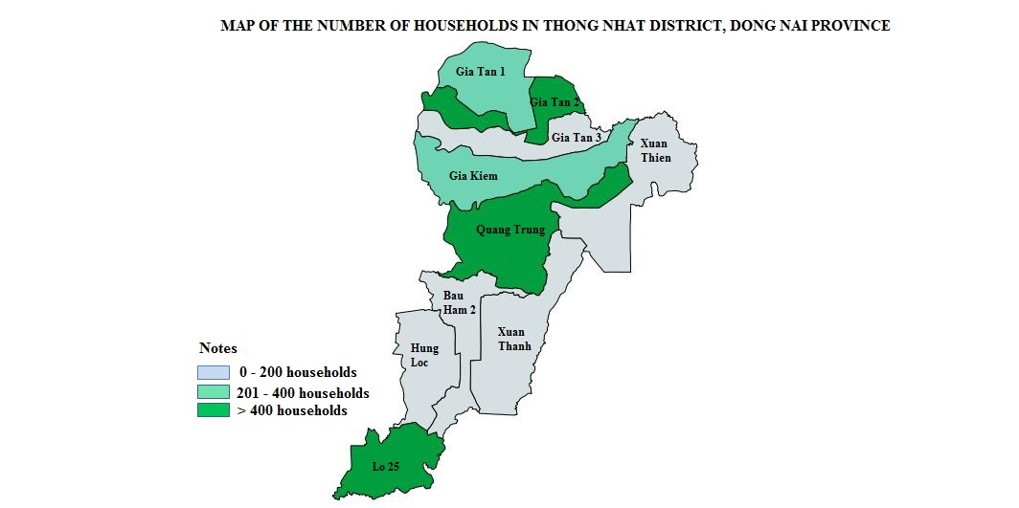

# 4. Presentation of the method to collect data

## 4.1. Description of the questionnaire (Appendix 1)

The questionnaire was composed of 14 pages, 74 questions were translated in vietnamese to conduct the survey. The questionnaire was composed of 4 main part:

1. ***Part I: Survey’s information***: 12 questions.
2. ***Part II: Farm resource endowment*** (with 60 questions): Farm settlement; Short history of the farm; Labour (family labour and hired worker); Building and equipment; Land of household; Turn-over and activities of household (crop, fishery, livestock, off-farm activities).
3. ***Part III: Pig production and management***: Contract with industries; Kind of pigs and breed; Pig reproduction; Number of hours per day for pig production; Technical growth and reproduction performances; Pig feeding; Pig health; Revenues/markets; Credit; Environment; Training, agricultural extension.
4. ***Part IV: Main difficultie and plan of change for the future***.

## 4.2. Organization of surveys

- Surveys were carried out by 2 institutes: Rudec and Nong Lam’s University

- Time of survey: 1/2014

- Direct interview in the farm with the farmer.

- Time for an interview: 45-60 mm.

## 4.3. Farm sample

- Two communes (Gia Tan 2 commune and Gia Kiem commune) were selected according to the followed criteria:

* Diversity of production systems: (i) household and farm; (ii) location: residential; zone planning/ or livestock concentrated zones (in both communes);
* Pig density : higher in Giam Kiem :;
* Herd size (number of heads/farm): Small-scale in Gia Tan 2 commune (a lot of households); Large-scale in Gia Kiem commune (a lot of farms);

- Criteria to select farms:

* **Farm type**: family farm or large farm (Table 3).
* **Localisation**: (i) Residential areas; (ii) Ancien breeding zone (outside planning areas); (iii) Concentrated areas (Inside planning areas).
* **Number of pig/farm**: small-scale livestock (family farm) with less than 100 heads of pigs, livestock commercial farms with more than 100 heads of pigs.

Farms were selected for interviews following:

* Family farms: 135
* Commercial farms: 9
* In addition, 02 farms "CONTRACT" for companies (contractual farm) were selected for survey.

***Table 3: Criteria to define a farm***

|  |  |  |
| --- | --- | --- |
| **Criteria to define a farm** | **Pig farm** | **Poultry farm** |
| 1. Output value | > 1,000 million / year | > 1,000 million / year |
| 1. Herd size (number of head) | - Sow: > 30 heads | - Poultry for egg: > 2,000 heads |
| - Pig for meat: > 100 heads | - Poultry for meat: > 5,000 heads |
| - Sow and pig for meat: convert 3 pig for meat = 1 sow | - Poultry for egg and for meat: convert 2.5 poultry for egg = 01 poultry for meat |

*Source: Decision No3396/QD-UBND of Provincial People's Committees Dong Nai*

## 4.4. Variables selected to create the typology of farms and to identify farm sustainability

Variables to build the typology are presented in Table 4.

***Table 4: Variables used to construct farms’ typology***

| **#** | **Variable** | **Definition of the variable** | **Classes** |
| --- | --- | --- | --- |
| **I** | **Natural capital** |  |  |
| 1 | Distance to nearest dwelling place | Distance to the nearest dwelling place | 1: < 500m 2: >=500 m |
| 2 | Beginning of pig production | When did you start your farm (agriculture or livestock activities)? | 1: < 10 years 2: 10-20 years 3: > 20 years |
| 3 | Type of land | Type of land of household | 1. For 50 years 2. For 20 years  3. Hiring land |
| 4 | Total land | Surface of land of household | 1: <=5000 m2 2: > 5000 m2 |
| **II** | **Physical capital** |  |  |
| 1 | Number of Sow |  | 1: <10 heads 2: 10-30 heads 3: > 30 heads |
| 2 | Number of Fatternner pig |  | 1: <100heads 2: 100-200 heads 3: > 200 heads |
| **III** | **Human capital** |  |  |
| 1 | Labor of household  in age working | Number of labor of household in age of working (15< age<60) | 1: <=2 labor 2: >2-<=5 labor 3: > 5 labor |
| 2 | Hiring regular labor | Hiring regular labor | 1 : Yes 2: No |
| 3 | Hiring Occasional labor | Hiring occasional labor | 1: Yes  2: No |
| 4 | Family labor working regularly | Number of family labor working regularly on farm | 1: <=1 labor 2: >1-<=2 labor 3: > 2 labor |
| 5 | Family labor working occasionally | Number of family labor working occasionally on farm | 1: <1 labor 2: >=1 labor |
| **IV** | **Financial capital** |  |  |
| 1 | Type of building | Building for livestock rearing | 1 :Traditional (wooden made) 2:Improved livestock building  3: Modern livestock buildings  4: Temperature controlled livestock building |
| 2 | Value of machine | Main machineries and equipement for livestock, if any (more than 2 millions VND) | 1: <50 million 2: >=50 million |
| 3 | Credit | Did you take bank loan ? | 1: Yes  2 : No |
| 4 | Total income of HH/year | Total Turn-over of household (including production activities, social support, deposits and forex) | 1: <100 million 2: 100-<200 million 3:>200 million |
| **V** | **Livestock farming** |  |  |
| 1 | Farrowing interval of a sow |  | 1: 4-4.5 month 2:5-5.5 month 3: 6 month |
| 2 | Age at weaning |  | 1: <=25 days 2: >25-<=30 days 3: > 30 days |
| 3 | Weight at weaning |  | 1: <= 8 kg 2: 8-<=10 kg 3: > 10 kg |
| 4 | Age at sale for piglets |  | 1: <=40 days 2: >40-<=50 days 3: > 50 days |
| 5 | Age at sale for fatteners |  | 1: <=5 months 2: >5-<=6 months 3: > 6 months |
| 6 | Weight sale for fatteners |  | 1: <=110 kg 2: > 110 kg |
| 7 | Weight of piglets bought for fattening |  | 1: <=15kg 2: > 15 kg |
| 8 | Time of fatterning |  | 1: <=4 kg 2: >4-<=5 kg 3: >5 kg |
| 9 | Weight of fatteners |  | 1: <=110 kg 2: > 110 kg |
| 10 | Feed purchased |  | 1: <500 2: 500-<1000 3: > 1000 |
| 11 | Animal health care | Who does animal health care for your herd ? | 1 : veterinary  2: family member 3: other |
| **VI** | **Economical sustainability** |  |  |
| 1 | Selling pig last 12 months |  | 1: <100 heads 2: 100-<200 heads 3: 200-<500 heads 4: >500 heads |
| 2 | Cash benefit from selling pig |  | 1: <500 million 2: 500-<1000 million 3: 1000-<2000 million 4: >2000 million |
| 3 | Ratio of profit of livestock | Ratio of profit of livestock/Total income of HH/year | 1: 0-<20% 2: 20-<40% 3: 40-<60% 4: 60-<80% 5: 80-100% |
| **VII** | **Environmental sustainability** |  |  |
| 1 | Treatment of the waste from pig production |  | 1 : Biogaz  2 : Compost 3: dry manure 4: Selling 5: Free irigate 6: Other |
| **VIII** | **Social sustainability** |  |  |
| 1 | Training in last 2 years |  | 1 : Yes  2 : No |
| 2 | Number of HH’s members participating in pig farming | Number of HH’s member participating in pig farming | 1 = 1 2 = 2 3 = 3 4 = >3 |
| 3 | Total hours per day for pig farming |  | 1: <5 hour 2: 5-10 hour 3: > 10 hour |
| **IX** | **Localisation *(illustrative)*** |  |  |
| 1 | Location of farm | Farm location | 1: residential area 2: ancien breeding zone 3: Concentrated areas |
| 2 | Type of Farm |  | 1: Farm holder 2: Certified farm |

# 5. Presentation of the approach to analyze data

To analyse the data using statistical analysis, several steps were followed :

1. Enter data: Excel files for Nong Lam’s University; and CSPro Software for Rudec 🡺 Exporter in Excel files and joint with data of Nong Lam’s University to finalize of database.
2. Clean the data base using the questionnaire .
3. Analyze data: Stata, SPSS to describe the sample of farms and to select relevant variables for the typology.
4. Statistical analysis: MFA analysis[1] with R software[2], and support of Samir Messad (Cirad).

160 farms were surveyed. However, 16 farms surveyed were not used in the analysis, because too much information missing. So, 144 farms surveyed were used in the analysis (135 households farms/ family farms and 9 larges farms/ commercial farms). In addition, 02 farms "CONTRACT" for companies (contractual farms) were also used in the analyze.

# 6. results

## 6.1. A short description of the sample

***Table 5: Characteristic of the entire sample***

|  |  |  |
| --- | --- | --- |
|  | **Mean** | **Standard deviation** |
| Year of beginning of livestock activity | 1995 | 9,46 |
| Year of beginning of pig activity | 1997 | 8,62 |
| Number of persons in the household | 4,9 | 1,5 |
| Number of persons in the household in age of working | 3,7 | 1,6 |
| Land area (m²) | 3692 | 5977 |
| Reproductive herd | 91 | 108 |
| Total herd | 177 | 188 |
| Total income of HH/year (*million VND)* | 204 | 221 |

*\* Note: Calculate for 144 farms surveyed were used*

Livestock activity and pig activity were developed in these farms in the 90s, but with a large variability in the sample (respectively 9,46 and 8,62). Pig activity was not the first livestock activity developed in the farms (Table 5).

The family in the household was composed of 4,9 persons, of which 3,7 in age of working.

The land area is very variable in the sample with 3692 m² on average (sd = 5977).

Farms (family farms and commercial farms) has on average 177 pigs (sows + boars + fatteners), which family farms has on average 50 pigs and commercial farms has on average 200 pigs. A contractual farms has over 300 pigs (sows + boars + fatteners).

***Table 6 : History of pig livestock in household (start pig farming)***

|  |  |  |  |
| --- | --- | --- | --- |
|  |  | **% HHs > 10 years** | **% HHs < 10 years** |
| Family farms | < 50 heads | 17.8 | 82.2 |
| >= 50 heads | 21.1 | 79.0 |
| ***Average*** | ***19.5*** | ***80.5*** |
| Commercial farms | Inside residential | 50.0 | 50.0 |
| Outside residential | 0.0 | 100.0 |
| Planning areas | 25.0 | 75.0 |
| ***Average*** | ***23.1*** | ***76.9*** |

In most of the sample (family farms and commercial farms) pig activity had less than 10 years, it can be considered as a recent activity.

***Table 7 : Labor working on farm livestock***

|  |  |  |  |  |
| --- | --- | --- | --- | --- |
|  |  | Total number of member in farm (person) | Number of labor in age of working (person) | Total labor working on farm (person) |
| Family farms | < 50 heads | 4.9 | 3.7 | 1.9 |
| >= 50 heads | 4.8 | 3.6 | 2.4 |
| ***Average*** | ***4.8*** | ***3.6*** | ***2.2*** |
| Commercial farms | Inside residential | 5.5 | 5.0 | 2.5 |
| Outside residential | 5.3 | 4.0 | 4.0 |
| Planning areas | 5.9 | 4.3 | 4.4 |
| ***Average*** | ***5.7*** | ***4.3*** | ***4.0*** |

Workforce of commercial farms is more important than in family farms (4 persons in commercial farms and 2.2 in family farms).

***Table 8 : Revenue from activities of farms***

|  |  |  |  |  |  |
| --- | --- | --- | --- | --- | --- |
|  | | ***Revenue total*** *(Million VND/year)* | ***Which:*** | | |
| *Crop*  *(%)* | *Livestock*  *(%)* | *Off-farm*  *(%)* |
| Family farms | < 50 heads | 105 | 17.3 | 44. 5 | 38.3 |
| >= 50 heads | 192 | 11.7 | 73.9 | 14.4 |
| ***Average*** | ***148*** | ***13.7*** | ***63.4*** | ***22.9*** |
| Commercial farms | Inside residential | 250 | 0.0 | 50.0 | 50.0 |
| Outside residential | 925 | 1.4 | 97.3 | 1.3 |
| Planning areas | 428 | 12.7 | 81.0 | 6.4 |
| ***Average*** | ***515*** | ***7.1*** | ***85.4*** | ***7.5*** |

The revenue of commercial farms is higher than in family farms (515 millionVND/y and 148 millionVND/y respectively).

The commercial farms seem more specialized in livestock activity (85,41 % of the revenue come from livestock activity) than family farms.

Family farms combined on farm activities (livestock and crops) and off farm activities.

The importance of off farm activities is higher in family farms with less than 50 pigs.

***Table 9 : Turn over of pig livestock in the last 12 months of farms***

|  |  |  |  |
| --- | --- | --- | --- |
|  | | Number of pigs sell in the last 12 months *(Heads)* | Total money from selling pigs in the last 12 months (Turn-over) *(million VND)* |
| Family farms | < 50 heads | 65 | 210 |
| >= 50 heads | 218 | 842 |
| ***Average*** | ***143*** | ***535*** |
| Commercial farms | Inside residential | 225 | 560 |
| Outside residential | 403 | 1,533 |
| Planning areas | 610 | 1,767 |
| ***Average*** | ***503*** | ***1,527*** |

The revenus provided by the selling of pigs is higher in commercial farms than in family farms.

In family farms the revenue is better in larger herds (more than 50 heads) due to a high number of pigs sold per year.

In the case of farms, farms located in planning areas sold more pigs than in the 2 other locations, and by consequence had a higher revenue.

**Assets and resources**

***Table 10 : Land of farms***

|  |  |  |  |  |  |
| --- | --- | --- | --- | --- | --- |
|  | | **Land of household (m2)** | ***Which:*** | | |
| Land for 50 years (%) | Land for 20 years (%) | Land for >50 years (%) |
| Family farms | < 50 heads | 1625 | 68.5 | 6.4 | 25.1 |
| >= 50 heads | 4106 | 40.1 | 10.3 | 49.6 |
| ***Average*** | ***2890*** | ***47.9*** | ***9.2*** | ***42.9*** |
| Commercial farms | Inside residential | 2250 | 100.0 | - | - |
| Outside residential | 3533 | 34.0 | - | 66.0 |
| Planning areas | 5275 | 62.2 | 1.5 | 36.3 |
| ***Average*** | ***4407*** | ***59.9*** | ***1.1*** | ***38.9*** |

Commercial farms had larger areas than family farms (4,407 m² / 2,890 m²).

***Table 11 : Equipment for pig***

|  |  |  |  |  |
| --- | --- | --- | --- | --- |
|  |  | Main machineries and equipment for livestock *(Millions VND)* | Type of machineries and equipment | |
| *Traditional and temperature* | *Modern and Automatic system* |
| Family farms | < 50 heads | 6.1 | x |  |
| >= 50 heads | 23.0 | x |  |
| ***Average*** | ***14.7*** | ***x*** |  |
| Commercial farms | Inside residential | 75.8 | x |  |
| Outside residential | 105.7 |  | x |
| Planning areas | 294.4 |  | x |
| ***Average*** | ***217.2*** |  | ***x*** |

Family farm had less machineries and equipment for livestock in value than farms. Commercial farms located outside residencial zones and in planning areas are equiped with modern and automatic system.

**Credit/ loans**

***Table 12 : Use credit for pig production in the last 3 years***

|  |  |  |  |  |
| --- | --- | --- | --- | --- |
|  | | Use credit  *(% HHs YES)* | Not use credit  *(% HHs YES)* | Amount  *(Million VND)* |
| Family farms | < 50 heads | 25.4 | 74.6 | 26 |
| >= 50 heads | 34.8 | 65.2 | 170 |
| ***Average*** | ***30.2*** | ***69.9*** | ***107*** |
| Commercial farms | Inside residential | 50.0 | 50.0 | 50 |
| Outside residential | 33.3 | 66.7 | 250 |
| Planning areas | 62.5 | 37.5 | 860 |
| ***Average*** | ***53.9*** | ***46.2*** | ***657*** |

The use of loans since last 3 years is more common in farms than in HH. The value of credit is higher in farms located in planning areas.

***Table 13 : Number of pigs in the last 12 months***

|  |  |  |  |  |  |  |
| --- | --- | --- | --- | --- | --- | --- |
|  | | Sow | Young sow *(gilt)* | Sucking pig | Pig for pork butcher | Breeding pig *(studsow + studboar)* |
| Family farms | < 50 heads | 43 | 49 | 79 | 52 | 92 |
| >= 50 heads | 77 | 135 | 199 | 181 |  |
| ***Average*** | ***61*** | ***103*** | ***139*** | ***129*** | ***92*** |
| Commercial farms | Inside residential | 10 | 370 |  |  |  |
| Outside residential | 15 | 2 | 150 | 580 |  |
| Planning areas | 174 | 813 | 425 | 353 |  |
| ***Average*** | ***128*** | ***500*** | ***333*** | ***444*** |  |

Farms located in planning areas hired wage earners. The number of family farm’s member participating in pig activity is higher in commercial farms than in family farm.

***Table 14 : Using time labor for pig (cleanning, feeding, animal care… )***

|  |  |  |  |  |  |
| --- | --- | --- | --- | --- | --- |
|  | | Number of HH’s member participate for pig farming *(Person)* | Total hours (all labor) per day for pig farming *(hours/day)* | Total hours done by all women  *(hours /day)* | Number of hours per day done by all hired labor  *(hours /day)* |
| Family farms | < 50 heads | 1.5 | 4.0 | 2.5 | 0 |
| >= 50 heads | 1.9 | 5.9 | 3.7 | 1 |
| ***Average*** | ***1.7*** | ***5.0*** | ***3.1*** | ***0.6*** |
| Commercial farms | Inside residential | 2.5 | 5.0 | 5.0 |  |
| Outside residential | 2.7 | 11.3 | 3.7 |  |
| Planning areas | 2.8 | 9.3 | 3.5 | 6.5 |
| ***Average*** | ***2.7*** | ***9.1*** | ***3.8*** | ***6.5*** |

**Use feed**

***Table 15 : Feed purchase for pig***

|  |  |  |  |  |  |  |  |
| --- | --- | --- | --- | --- | --- | --- | --- |
|  | | ***Feed industrial*** | | ***Corn*** | | ***Other product*** | |
| *(Kg/year)* | *(Million VND/year)* | *(Kg/year)* | *(Million VND/year)* | *(Kg/year)* | *(Million VND/year)* |
| Family farms | < 50 heads | 10,133 | 132 | 440 | 3.7 | 180 | 3.2 |
| >= 50 heads | 44,793 | 544 | 874 | 17.5 | 1,515 | 24.4 |
| ***Average*** | ***27,089*** | ***333*** | ***661*** | ***10.7*** | ***861*** | ***14.0*** |
| Commercial farms | Inside residential | 56,250 | 675 | - | - | - | - |
| Outside residential | 121,542 | 1,227 | - | - | - | - |
| Planning areas | 184,063 | 1,324 | 1,000 | 6.0 | 875 | 4.4 |
| ***Average*** | ***149,971*** | ***1,202*** | ***615*** | ***3.7*** | ***538*** | ***2.7*** |

Commercial farms, particularly those located in planning areas and outside residencial zones, used more feed from industry (in value and quantity).

***Table 16 : Health care for pigs***

|  |  |  |  |  |  |
| --- | --- | --- | --- | --- | --- |
|  | | **Health care for pigs** | | Using vaccination  *(% farm)* | Pigs get FMD or/and PRRS during last 3 years  *(% farm)* |
| *Veterinarian*  *(% farm)* | *Family member*  *(% farm)* |
| Family farms | < 50 heads | 2.7 | 97.3 | 100.0 | 17.8 |
| >= 50 heads | 10.5 | 89.5 | 100.0 | 32.9 |
| ***Average*** | ***6.7*** | ***93.3*** | ***100.0*** | ***25.5*** |
| Commercial farms | Inside residential | 0.0 | 100.0 | 100.0 | 0.0 |
| Outside residential | 0.0 | 100.0 | 100.0 | 0.0 |
| Planning areas | 12.5 | 87.5 | 100.0 | 25.0 |
| ***Average*** | ***7.7*** | ***92.3*** | ***100.0*** | ***15.4*** |

In family farms and commercial farms farms, health care for pigs is carried out by family member.

**Commerce**

***Table 17 : Weight sold pig (kg/head)***

|  |  |  |  |  |  |  |  |
| --- | --- | --- | --- | --- | --- | --- | --- |
|  | | Boar | Sow | Young sow *(gilt)* | Sucking pig | Pig for pork butcher | Breeding pig *(studsow + studboar)* |
| Family farms | < 50 heads | 107 | 85 | 107 | 13 | 107 | 13 |
| >= 50 heads | 113 | 103 | 111 | 12 | 107 |  |
| ***Average*** | ***111*** | ***95*** | ***109*** | ***13*** | ***107*** | ***13*** |
| Commercial farms | Inside residential |  |  | 100 |  |  |  |
| Outside residential |  |  |  |  | 110 |  |
| Planning areas | 100 | 100 | 110 | 20 | 102 |  |
| ***Average*** | ***100*** | ***100*** | ***107*** | ***20*** | ***105*** |  |

There are no difference between family farms and commercial farms in weight sold pig.

***Table 18 : Type of selling (% idea Yes)***

|  |  |  |  |
| --- | --- | --- | --- |
|  | | Selling with contract  *(% numbre YES)* | Selling without contract  *(% numbre YES)* |
| Family farms | < 50 heads |  | 100.0 |
| >= 50 heads | 4.3 | 95.7 |
| ***Average*** | ***2.3*** | ***97.7*** |
| Commercial farms | Inside residential |  | 100.0 |
| Outside residential |  | 100.0 |
| Planning areas | 14.3 | 85.7 |
| ***Average*** | ***8.3*** | ***91.7*** |

There are no difference between family farms and commercial farms in type of selling (selling without contract).

**Environment**

***Table 19 : Distance to the nearest dwelling place***

|  |  |  |
| --- | --- | --- |
|  | | Distance to the nearest dwelling place (m) |
| Family farms | < 50 heads | 142 |
| >= 50 heads | 512 |
| ***Average*** | ***330*** |
| Commercial farms | Inside residential | 55 |
| Outside residential | 500 |
| Planning areas | 2,250 |
| ***Average*** | ***1,509*** |

***Table 20 : Treat the waste from pig production***

|  |  |  |  |  |  |  |  |  |  |
| --- | --- | --- | --- | --- | --- | --- | --- | --- | --- |
|  | | **Treat the waste from pig production** | | | | | | **Use any chemical for treating waste** | |
| *Biogas (% Yes)* | *Compost (% Yes)* | *Dry manure (% Yes)* | *Selling manure (% Yes)* | *Free irrigate (% Yes)* | *Other (% Yes)* | *% Yes* | *% NO* |
| Family farms | < 50 heads | 19.8 | 1.2 | 8.1 | 38.4 | 15.1 | 17.4 | 26.4 | 73.6 |
| >= 50 heads | 25.0 | 2.2 | 10.9 | 47.8 | 7.6 | 6.5 | 17.1 | 82.9 |
| ***Average*** | ***22.5*** | ***1.7*** | ***9.6*** | ***43.3*** | ***11.2*** | ***11.8*** | ***21.6*** | ***78.4*** |
| Commercial farms | Inside residential | 66.7 | 0.0 | 0.0 | 33.3 | 0.0 | 0.0 | 50.0 | 50.0 |
| Outside residential | 25.0 | 0.0 | 25.0 | 50.0 | 0.0 | 0.0 | 100.0 | 0.0 |
| Planning areas | 18.2 | 0.0 | 18.2 | 45.5 | 9.1 | 9.1 | 37.5 | 62.5 |
| ***Average*** | ***27.8*** | ***0.0*** | ***16.7*** | ***44.4*** | ***5.6*** | ***5.6*** | ***53.9*** | ***46.2*** |

There are no difference between Commercial farms and Family farms to treat the waste form pig production (combinaison of biogas, dry manure, selling compost, free irrigate). Commercial farms used more chemical to treate waste than Family farms.

## 6.2. The farm typology according to the capitals (description of the groups of farms)

**Typology of farmers (n=144) Dong Nai area**

160 farms were surveyed. However, 16 farms surveyed were not used in the analysis, because too much information missing. So, 144 farms surveyed were used in the analysis (135 Family farms and 9 Commercial farms).

The typology is based on capital criteria (used as active variables in the analysis): natural (4 variables), physical (2 variables), human (5 variables), financial (4 variables), pigs (11 variables).

Then the relationship with the 3 dimensions of the sustainability were described (economical = "ecosus", social = "socsus", environmental = "envsus").

***Figure 1 : Descriptors’ groups MFA inter-structure (links between Capital groups; links between ‘capital’ groups and ‘sustainability’ groups (factor 1 & 2).***

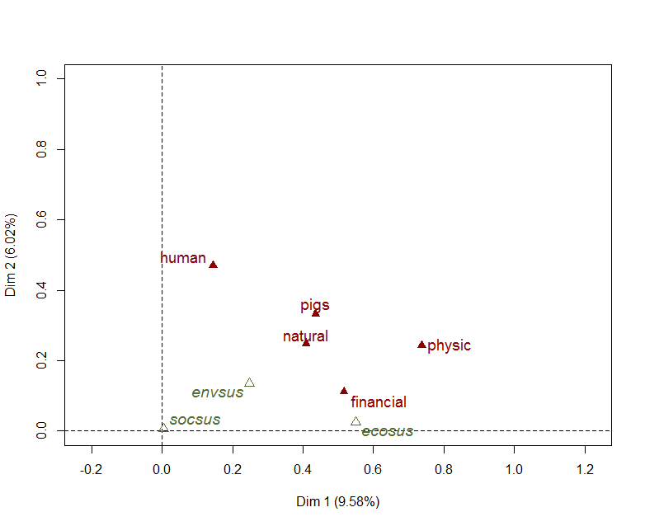

Figure 1 shows that, there were strong linkage between physical capital and financial capital and those were significant association with the structure of the farms. The group of variables for economical sustainability had a closed relation with the groups of physical capital and financial capital. Natural capital have a relatively medium weight in the analysis. The position is around the center of the graph (projection quality near 0.4-0.5 for factor 1).

***Figure 2 : MFA factorial map of farmers (Factor 1 & 2). Links between localization and ‘Capital’ typology***

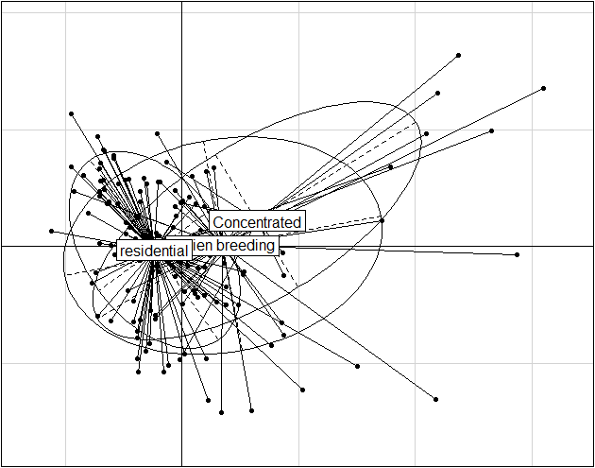

The capital variable groups were not strongly affected by the localization of the farms (see figure 2). There were not significant differences on capital variables between farms located in **residencial area**, **concentrated zones**, and **ancien breeding zone**.

***Figure 3 : Graphical representation of Dong Nai farmers based on MFA coordinates***

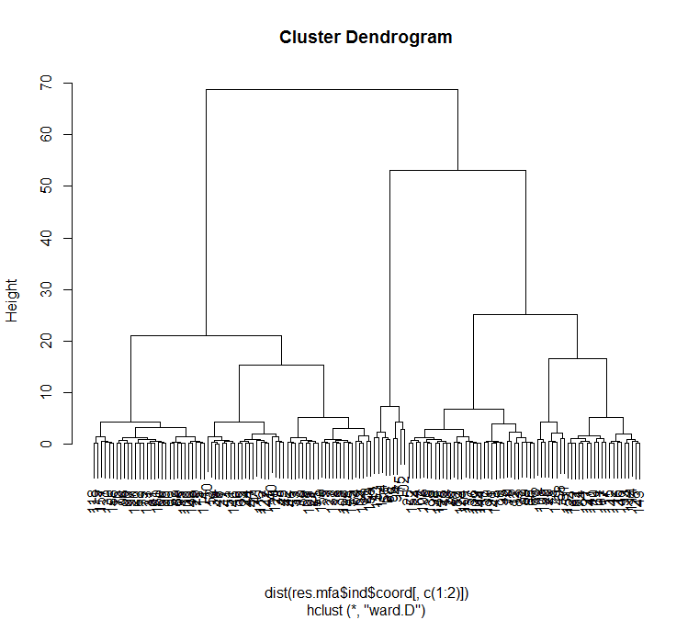

The hierarchical clustering help to identify 3 types of farms (Figure 3)

Description of the typology with ‘capital’ (active variables) criteria

***Table 21 : Description of the groups***

|  |  |  |  |  |  |
| --- | --- | --- | --- | --- | --- |
| **Variable** | | **Type 1** | **Type 2** | **Type 3** | **Type 4** |
| ***Natural capital*** | Distance to nearest dwelling place (m) | 156 | 413 | 1249 | 2750 |
| Beginning of pig production (years) | 16 | 20 | 13 | 2 |
| Total land (ha) | 2135 | 4544 | 8390 | 25150 |
| ***Physical capital*** | N° of sows | 5 | 10 | 36 | 0 |
| N° of fatteners | 41 | 71 | 298 | 1350 |
| ***Human capital*** | Labor of HH in age of working (pers) | 3 | 4 | 4 | 5 |
| Hiring regular labor (%) | 0 | 2 | 11 | 100 |
| Hiring Occasional labor (%) | 0 | 3 | 0 | 0 |
| Family labor working regularly (pers) | 2 | 2 | 2 | 3.5 |
| Family labor working occasionaly (pers) | 0 | 1 | 0 | 2 |
| ***Financial capital*** | Value of machines | 6 | 18 | 50 | 207 |
| Total income of HH per year | 139 | 227 | 275 | 315 |
| % Profit of livestock/Total income of HH/year | 52 | 33 | 83 | 96 |
| ***Livestock farming*** | Farrowing interval of a sow (month) | 5 | 5 | 5 |  |
| Age at weaning (days) | 29 | 29 | 28 |  |
| Weight at weaning (kg) | 9 | 8 | 10 |  |
| Age at sale for piglets (days) | 46 | 48 | 41 |  |
| Age at sale for fatteners (days) | 6 | 6 | 6 |  |
| Weight sale for fatteners (kg) | 107 | 106 | 109 |  |
| Weight of piglets bought for fattening (kg) | 14.1 | 17 | 15 | 5.6 |
| Time of fatterning (month) | 4.9 | 4.4 | 5 | 5.3 |
| Weight of fatteners (kg) | 107.6 | 105 | 105 | 96.3 |
| Feed purchased (million VND) | 238 | 382 | 2120 |  |

***Table 22 : Description of the typology according to the localization (%)***

|  |  |  |  |  |
| --- | --- | --- | --- | --- |
| **Criteria** | **Type 1** | **Type 2** | **Type 3** | **Type 4** |
| Residencial area | 71 | 63 | 11 | 0 |
| Concentrated zones | 12 | 10 | 22 | 100 |
| Ancien breeding zone | 17 | 27 | 67 | 0 |

1. ***Type 1 (Family farms /Hộ gia đình): Small land area and pig herd, low technical performances, low income, few loans, use of crops form the farm to feed the herd, low workforce***

This group is composed of 72 farms.

Farms are located inside residential areas (71%).

They are characterized by a small area of land (2135 m²); and the agricultural activities was located near the dwelling-place (156 m). Pig activity started more than 16 years ago.

Herd size is small (5 sows), with a low number of fatteners (41 heads).

They have few labor (3 workers in the household in age working (15< age<60). There are 2 family labor working on the farm. They don’t hire labor for livestock.

The mode of building for livestock rearing is traditional (wooden made) or improved livestock building (Concrete soil with roof-open, no drainage for manure). The main machineries and equipement for livestock is the lower value of the sample (6 millions). Most of the farms do not take bank loan (credit) for livestock. Low income of household (including production activities, social support, deposits and forex) is 139 millions VND/year.

Tecnical performances are low. For the piglet production, the age at weaning is 29 days and weight at weaning is 9 kg. All of farm feed purchased 238 millions VND during last 12 months for pigs because feed for pigs came from the farm: rice, maize,…

1. ***Type 2 : Medium farm with large family workforce (Gia trại):***

This group is composed of 63 farms.

The land area is large (4544 m2) with land for 50 years.

The farms have an intermediate number of sows (10 heads of sows) and 71 heads of fatteners.

The workforce is composed of a large number of persons in the HH in age of working (4). There are a lot of family labor working regularly and working occasionally on farm (2 labors family).

Financial capital: It isn’t clear to explain this type with the type of building, the main machineries and equipement for livestock, and his credit. But this type of farm is characterized by income of household from 227 millions VND/year.

The pig livestock farming with technical growth: For the piglet production: Farrowing interval of a sow is 5 months; Age at weaning in 29 days and weight at weaning in 8 kg; Age at sale for piglets in 48 days. The most of farm feed purchased total of 382 millions VND during last 12 months for pigs.

Particular location for these farms: 63% HHs inside residential areas; 27% HHs in ancien breeding zone; and 10% Hhs in concentrated zones. Most of the farms have lot of experience with the pig livestock, because this activity started more than 20 years ago.

1. ***Type 3 (Commercial farm): Large farm industrialisation with hired labor (Trang trại):***

This group is composed of 9 farms.

Farms are mainly located in Farm location inside zone ancient breeding (67%), far dwelling-place (1249 m).

These farms have the bigger number of sows (36 heads of sows) and of fatteners (298 heads) and the larger agricultural area (8930 m²).

They hire labor workforce. 2 family workers work regularly on the farm.

Buidling for pig are modern with the use of controled temperature. The main machineries and equipement for livestock have a value more than 50 millions. Most of the farms take bank loan (credit) for livestock. The income of household (including production activities, social support, deposits) is 275 millions VND/year.

They purchase feed for pig raising (2120 millions VND) during last 12 months.

1. ***Type 4: Contractual farm for companie (Trang trại gia công):***

2 farms are selected.

With the contractual farm, farms provide labor, tools and equipment to raise pigs (fatteners). The company provides piglets, feed, veterinary and vaccines. The company is also responsible for guiding and monitoring farming techniques, product purchase and payment of remuneration to farmers based on production results.

Farms are located in concentrated zones, far from dwelling-place (2750 m).

Natural capital: They started their farm10 - 20 years ago, but they have contract with a company for 2-5 years. They have large surface of land (25150 m2), mainly composed of land for 50 years. They also hire land for livestock activity.

Physical capital: Largeholders with 1350 heads of fattener pigs;

Human capital: A lot of labor of household in age working (more 5 labor). Hiring labor for livestock, there are 1-2 family labor working regularly and about 01 family labor working occasionally on farm.

Financial capital: The mode of temperature controlled livestock building. The main machineries and equipement for livestock have an importantvalue (more 207 millions VND). Most of the farms have bank loan (credit) for livestock. They have hight income (including production activities, social support, deposits and forex) with 315 millions VND/year, and mainly form pig livestock (share of 96% total income of farm).

The pig livestock farming with technical growth: Weight sale for fatteners is less 110 kg, and weight of piglets bought for fattening less 15 kg. Animal health care by family member and company staff.

## 6.3. Description of the groups according to sustainable indicators

1. ***Type 1 (Family farms)***

Economical sustainability: Selling pig last 12 months is less 100 heads of pigs. Cash benefit from selling pig is less 500 millions VND.

Environmental sustainability: Treat the waste from pig production follow free irrigate.

Social sustainability: Total hours per day for pig farming is less 5 hour.

1. ***Type 2 (Medium farm)***

Economical sustainability: Selling pig last 12 months is around 100-200 heads of pigs. Cash benefit from selling pig is around 500-1000 millions VND.

1. ***Type 3 (Commercial farm)***

Economical sustainability: Selling pig last 12 months is more 200 heads of pigs. Cash benefit from selling pig is more 1000 millions VND. Total income of farm/year is more 200 millions, and mainly form pig livestock (share of 80-100% total income of farm).

Social sustainability: Total hours per day for pig farming is more 10 hour.

1. ***Type 4: Contractual farm***

Economical sustainability: Selling pig last 12 months is more 500 heads of pigs. Cash benefit from selling pig is less 500 millions VND. Total income of farm/year is mainly form pig livestock (share of 80-100% total income of farm).

Environmental sustainability: Treat the waste from pig production by Biogaz, or Compost, or selling manure.

Social sustainability: about 2-3 of farm’s member participate in pig farming. Total hours per day for pig farming is 5-10 hour.

# 7. CONCLUSION

- Pig production in the study site can be sorted into 4 major types following: Type 1: Family farm (Hộ gia đình); Type 2: Medium farm (Gia trại); Type 3: Commercial farm (Trang trại); Type 4: Contractual farm (Trang trại gia công).

- Physical capital, Financial capital and Human capital had strong effects to the typologies of farms. For the physical capital are: number of sow and number of fatteners. For the financial capital: type of building, value of machine, bank loan and total income of farm/year. For the human capital are: number household labor; use hiring labor or number of family labor working regularly on farm.

- Commercial farm (type 3) and Contractual farm (type 4) seem more sustainable economically than small household farm and farm specialization follow : number selling pig last 12 months, cash benefit from selling pig and ration of profit of livestock/total household incom/year. However, the most of these farm taked bank loan (credit), and thay must to paid a high interest rates for the banks, and hiring land, labor. So that, their net income from pig livestock of farm maybe lower than Family farm and Medium farm.

- For the environmental sustainability: The family farm and medium farm located inside residential areas, near dwelling-place, and treat the waste from pig production follow free irrigate is being a challenge for environmental sustainability.

# ANNEX

**Description of the typology 3 classes with ‘capital’ (active variables) criteria**

> summary(clusters)

1 2 3

74 62 9

# natural capital

1 2 3

Distance.1 2.2739 0.0511 -4.8159

Distance.2 -2.2739 -0.0511 4.8159

beginpig.1 2.5571 -2.5325 -0.1052

beginpig.2 -1.8542 1.2199 1.3402

beginpig.3 -1.2090 1.9088 -1.4090

landtype.1 -2.5978 2.5814 0.0893

landtype.2 0.4409 -0.4492 0.0075

landtype.3 -1.7807 0.8429 1.9610

landtype.NSP 3.9927 -3.5230 -1.0486

lantotal.1 4.5843 -4.0631 -1.1667

lantotal.2 -4.5843 4.0631 1.1667

> # Physic Capital

1 2 3

sow.1 6.8589 -4.7903 -4.3883

sow.2 -5.8540 6.1175 -0.4150

sow.3 -2.7592 -2.3359 10.5060

Fatternnerpig.1 5.1245 -2.5583 -5.3715

Fatternnerpig.2 -3.7337 3.6334 0.2856

Fatternnerpig.3 -3.1515 -1.2814 9.1569

> # human capital

1 2 3

Larborhold.1 3.2330 -3.3415 0.1534

Larborhold.2 -1.4352 1.4178 0.0665

Larborhold.3 -2.2191 2.3865 -0.2957

Hireregulabor.1 -1.4488 0.2077 2.5758

Hireregulabor.2 1.4488 -0.2077 -2.5758

Hireoccalabor.1 -1.4488 1.6420 -0.3651

Hireoccalabor.2 1.4488 -1.6420 0.3651

Familylaborregular.1 -0.7041 1.8542 -2.3430

Familylaborregular.2 1.8893 -2.4947 1.2007

Familylaborregular.3 -2.7592 1.5662 2.5051

Familylaborocca.1 3.5618 -4.3841 1.6098

Familylaborocca.2 -3.5618 4.3841 -1.6098

> # Financial Capi

1 2 3

Building.1 -0.0294 0.2077 -0.3651

Building.2 2.6593 -1.5567 -2.3177

Building.3 -2.5173 1.6898 1.7505

Building.4 -1.0209 -0.8643 3.8873

Valueequipement.1 2.4654 -0.1052 -4.8922

Valueequipement.2 -2.4654 0.1052 4.8922

Credit.1 -2.5774 1.6313 1.9952

Credit.2 2.5774 -1.6313 -1.9952

Incometotal.1 3.9566 -3.5697 -0.8779

Incometotal.2 -1.2185 2.1943 -1.9747

Incometotal.3 -3.1580 1.5280 3.4099

>

> # pig production

1 2 3

Farrowing.1 -0.0935 0.1539 -0.1220

Farrowing.2 0.8110 -1.6390 1.6803

Farrowing.3 -3.6927 4.0794 -0.7138

Farrowing.NSP 3.8964 -3.3175 -1.2704

Ageweaning.1 0.6814 -0.6598 -0.0588

Ageweaning.2 -5.3927 4.5798 1.7822

Ageweaning.3 2.1610 -1.6914 -1.0092

Ageweaning.NSP 4.6311 -3.9757 -1.4429

Weightweaning.1 -2.9126 3.5182 -1.1794

Weightweaning.2 1.4197 -1.8215 0.7935

Weightweaning.3 2.2023 -2.5211 0.6066

Agesalefatteners.1 -1.2090 1.4660 -0.5010

Agesalefatteners.2 -2.5571 1.8562 1.4918

Agesalefatteners.3 1.6102 -1.7954 0.3453

Agesalefatteners.NSP 2.6622 -1.8889 -1.6427

Weightsalefatteners.1 -0.5191 0.2341 0.5955

Weightsalefatteners.2 0.5263 -0.6867 0.3177

Weightsalefatteners.NSP 0.1875 0.3220 -1.0486

Feedpurchased.1 4.0560 -1.0873 -6.1739

Feedpurchased.2 -2.1018 2.6905 -1.1622

Feedpurchased.3 -3.5100 -1.7080 10.7743

Healthcare.1 0.6651 -1.7736 2.2586

Healthcare.2 -0.6651 1.7736 -2.2586

Healthcare.3 NaN NaN NaN

**# zone**

1 2 3

zone.ancien breeding -1.2535 0.0153 2.5657

zone.Concentrated -1.6343 0.8191 1.7064

zone.residential 2.0792 -0.4647 -3.3549

|  |  |  |  |  |  |
| --- | --- | --- | --- | --- | --- |
| **#** | **Variable** | **Classes** | **Small farm** | **Medium farm** | **Large farm** |
| **I** | **Natural capital** |  |  |  |  |
| 1 | Distance to nearest dwelling place | 1: < 500m 2: >=500 m | Distance.1 |  | Distance.2 |
| 2 | Beginning of pig production | 1: < 10 years 2: 10-20 years 3: > 20 years | beginpig.1 | beginpig.3 |  |
| 3 | Type of land | 1. For 50 years 2. For 20 years  3. Hiring land |  | landtype.1 | landtype.3 |
| 4 | Total land | 1: <=5000 m2 2: > 5000 m2 | lantotal.1 | lantotal.2 |  |
| **II** | **Physical capital** |  |  |  |  |
| 1 | Number of Sow | 1: <10 heads 2: 10-30 heads 3: > 30 heads | sow.1 | sow.2 | sow.3 |
| 2 | Number of Fatternner pig | 1: <100heads 2: 100-200 heads 3: > 200 heads | Fatternnerpig.1 | Fatternnerpig.2 | Fatternnerpig.3 |
| **III** | **Human capital** |  |  |  |  |
| 1 | Labor of household  in age working | 1: <=2 labor 2: >2-<=5 labor 3: > 5 labor | Larborhold.1 | Larborhold.3 |  |
| 2 | Hiring regular labor | 1 : Yes 2: No |  |  | Hireregulabor.1 |
| 3 | Hiring Occasional labor | 1: Yes  2: No |  |  |  |
| 4 | Family labor working regularly | 1: <=1 labor 2: >1-<=2 labor 3: > 2 labor | Familylaborregular.2 | Familylaborregular.1 | Familylaborregular.3 |
| 5 | Family labor working occasionally | 1: <1 labor 2: >=1 labor | Familylaborocca.1 | Familylaborocca.2 |  |
| **IV** | **Financial capital** |  |  |  |  |
| 1 | Type of building | 1 :Traditional (wooden made) 2:Improved livestock building  3: Modern livestock buildings  4: Temperature controlled livestock building | Building.2 |  | Building.3 Building.4 |
| 2 | Value of machine | 1: <50 million 2: >=50 million | Valueequipement.1 |  | Valueequipement.2 |
| 3 | Credit | 1: Yes  2 : No | Credit.2 |  | Credit.1 |
| 4 | Total income of HH/year | 1: <100 million 2: 100-<200 million 3:>200 million | Incometotal.1 | Incometotal.2 | Incometotal.3 |
| **V** | **Livestock farming** |  |  |  |  |
| 1 | Farrowing interval of a sow | 1: 4-4.5 month 2:5-5.5 month 3: 6 month |  | Farrowing.3 | Farrowing.2 |
| 2 | Age at weaning | 1: <=25 days 2: >25-<=30 days 3: > 30 days | Ageweaning.3 | Ageweaning.2 | Ageweaning.2 |
| 3 | Weight at weaning | 1: <= 8 kg 2: 8-<=10 kg 3: > 10 kg | Weightweaning.3 | Weightweaning.1 |  |
| 4 | Age at sale for piglets | 1: <=40 days 2: >40-<=50 days 3: > 50 days |  | Agesalefatteners.2 |  |
| 5 | Feed purchased | 1: <500 2: 500-<1000 3: > 1000 | Feedpurchased.1 | Feedpurchased.2 | Feedpurchased.3 |
| 6 | Animal health care | 1 : veterinary  2: family member 3: other |  | Healthcare.2 | Healthcare.1 |
|  | **Localisation (illustrative)** |  |  |  |  |
|  | Location of farm | 1: residential area 2: ancien breeding zone 3: Concentrated areas | zone.residential |  | zone.ancien breeding zone.Concentrated |

**Description of the typology with the sustainability criteria**

# economical sustainability

1 2 3

Pigsale.1 4.5784 -2.8343 -3.6742

Pigsale.2 -1.6756 2.5583 -1.7741

Pigsale.3 -3.7968 1.2091 5.3870

Pigsale.4 -1.4488 -1.2265 5.5167

Pigbenefit.1 3.7265 -1.5567 -4.5287

Pigbenefit.2 -1.3797 2.1306 -1.5101

Pigbenefit.3 -3.2578 0.0847 6.5759

Pigbenefit.4 -1.4488 -1.2265 5.5167

Profitlivestockrate.1 0.1188 0.0758 -0.4015

Profitlivestockrate.2 0.7173 0.0117 -1.5101

Profitlivestockrate.3 0.7471 -0.4872 -0.5488

Profitlivestockrate.4 0.3808 -0.2676 -0.2401

Profitlivestockrate.5 -1.5819 0.5246 2.2017

> # social sustainability

1 2 3

Training.1 -0.7173 0.8359 -0.2277

Training.2 0.7173 -0.8359 0.2277

Familylaborforpig.1 0.4731 0.0683 -1.1202

Familylaborforpig.2 0.5594 -0.5977 0.0665

Familylaborforpig.3 -1.9868 1.5662 0.9049

Familylaborforpig.4 -1.0209 -0.8643 3.8873

Hourforpig.1 2.5884 -1.0070 -3.2979

Hourforpig.2 -1.7524 1.0780 1.4203

Hourforpig.3 -2.3152 -0.1265 5.0560

> # enviromental sustainability

1 2 3

Treatwaste.1 -2.2339 1.6036 1.3402

Treatwaste.2 -0.0294 0.2077 -0.3651

Treatwaste.3 -1.7628 1.1406 1.3135

Treatwaste.4 1.1129 -0.7969 -0.6717

Treatwaste.5 2.7425 -2.3398 -0.8845

Treatwaste.6 0.6814 -0.1399 -1.1250

|  |  |  |  |  |  |
| --- | --- | --- | --- | --- | --- |
| **#** | **Variable** | **Classes** | **Small farm** | **Medium farm** | **Large farm** |
| **VI** | **Economical sustainability** |  |  |  |  |
| 1 | Selling pig last 12 months | 1: <100 heads 2: 100-<200 heads 3: 200-<500 heads 4: >500 heads | Pigsale.1 | Pigsale.2 | Pigsale.3 Pigsale.4 |
| 2 | Cash benefit from selling pig | 1: <500 million 2: 500-<1000 million 3: 1000-<2000 million 4: >2000 million | Pigbenefit.1 | Pigbenefit.2 | Pigbenefit.3 Pigbenefit.4 |
| 3 | Ration of profit of livestock | 1: 0-<20% 2: 20-<40% 3: 40-<60% 4: 60-<80% 5: 80-100% |  |  | Profitlivestockrate.5 |
| **VII** | **Environmental sustainability** |  |  |  |  |
| 1 | Treat the waste from pig production | 1 : Biogaz  2 : Compost 3: dry manure 4: Selling 5: Free irigate 6: Other | Treatwaste.5 | Treatwaste.1 |  |
| **VIII** | **Social sustainability** |  |  |  |  |
| 1 | Training in last 2 years | 1 : Yes  2 : No |  |  |  |
| 2 | Number of HH’s member participate in pig farming | 1 = 1 2 = 2 3 = 3 4 = >3 |  | Familylaborforpig.3 |  |
| 3 | Total hours per day for pig farming | 1: <5 hour 2: 5-10 hour 3: > 10 hour | Hourforpig.1 |  | Hourforpig.3 |
|  | **Localisation (illustrative)** |  |  |  |  |
|  | Location of farm | 1: residential area 2: ancien breeding zone 3: Concentrated areas | zone.residential |  | zone.ancien breeding zone.Concentrated |

**References**

Drucker, A.G., Bergeron, E., Lemke, U., Thuy, L.T., Valle Zárate, A., 2006. *Identification and qualification of subsidies relevant to the production of local and imported pig breeds in Vietnam*. Tropical Animal Health and Production 38, 305-322.

Herold, P., Roessler, R., Willam, A., Momm, H., Valle Zárate, A., 2010. *Breeding and supply chain systems incorporating local pig breeds for small-scale pig producers in Northwest Vietnam*. Livestock Science 129, 63-72.

Hoàng Vũ Quang, 2012. *Mode of livestock production and of commerce of livestock products. Case of pig production*. Outlook conference, Hà Nội, 37p.

Huong, P.T.M., Hau, N.V., Kaufman, B., Valle Zárate, A., Mergenthaler, M., 2009. *Emerging supply chains of indigenous pork and their impacts on smallscale farmers in upland areas of Vietnam*. International Association of Agricultural Economists Conference, Beijing, China, p. 19 p.

Lairez, J. (2012). *Durabilité de l’élevage laitier dans un territoire en mutation à Ba Vì, Vietnam. Mémoire de fin d’étude en vue de l’obtention du diplôme d’ingénieur agronome : Ressources Systèmes agraires et Développement*. Montpellier : SupAgro Montpellier, 114p.

Lemke, U., Kaufman, B., Thuy, L.T., Emrich, K., Valle Zárate, A., 2006. *Evaluation of smallholder pig production systems in North Vietnam: pig production management and pig performances*. Livestock Science 105, 229-243.

MARD, 2009. *Livestock development strategy to 2020*.

Pham Duy khanh, 2010. *Réflexion méthodologique pour caractériser la diversité des exploitations laitières en vue de mettre en place un réseau d’observation des élevages : une étude dans le delta du fleuve Rouge au Vietnam*. Mémoire de master : EDTS. Paris : AgroParisTech, 74p.

Tisdell, C., 2010. *An Economic Study of Small Pigholders in Vietnam: Some Insights Gained and the Scope for Further Research*. University of Queensland, p. 36.

Escofier, B., Pagès, J., 1994. *Multiple factor analysis (AFMULT package)*. Comput.Statistics Data Anal. 18, 121–140.

Lê, S., Josse, J., Husson, F., 2008. *FactoMineR: an R package for multivariate analysis*. J. Stat. Software 25 (1), 1–18.

R Core Team (2014). *R: A language and environment for statistical computing*. R Foundation for Statistical Computing, Vienna, Austria. URL <http://www.R-project.org/>

1. Multiple Factor Analysis (MFA) studies several groups of variables (numerical and/or categorical) defined on the same set of individuals. MFA approaches this kind of data according to many points of view already used in others methods as: factor analysis in which groups of variables are weighted, canonical analysis, Procrustes analysis, STATIS, INDSCAL. In MFA, these points of view are considered in a unique framework.
2. R is a free software environment for statistical computing and graphics.