Cellulose nanocrystals as amphiphilic particles for the interface.

F. Cherhal, H. Bizot, B. Cathala and I. Capron
INRA, UR1268 Biopolymères, Interactions et Assemblages, 44300 Nantes, France.
Isabelle.capron@nantes.inra.fr

Increasing environmental awareness is prompting scientists and industrialists to develop strategies for environmental sustainability by using processes and materials with low cost, energy consumption and toxicity, together with high biodegradability. There is strong motivation within this context to replace petroleum-based polymers with polymers from renewable resources. Emulsions are used in large application domains such as food, cosmetics, pharmaceutical or coatings. These emulsions usually use surfactants issued from the petro-chemical industry. For example, in 2001, surfactants represented 11 million tons among which only 20% was of vegetal origin. In a same time, it is referred that a lot of vegetal wastes, notably in the wood industry, will have to find new developments in the coming period.
In a recent study, we showed that it was possible to obtain highly stable oil-in-water Pickering emulsions stabilized only by unmodified Cellulose NanoCrystals (CNC)¹. The amazing properties of these systems in terms of stability and mechanical behaviour for encapsulation of any oil, including vegetable oils, are due both to their anisotropic shape and to the irreversible nature of such particles adsorption². Furthermore, the CNC preparation by enzymatic or acid hydrolysis, or oxidation process, may introduce charged groups at the surface. This provides good colloidal stability thanks to charge repulsions but can prevent stabilizing ability. We used this original ability of the nanocrystals to stabilise oil/water interface to study the influences of surface charge on their amphiphilic properties³. Furthermore, according to the process and the botanic origin, the CNCs may provide naturally a large range of particles from 200 nm to several microns in length leading to variable aspect ratios. This was used to develop various formulations leading to stable fluid or interconnected emulsions⁴.
As a result, CNC appears as a stiff anisotropic versatile plateform with amphiphilic contrasted surfaces that develop hydrogen bonds, van der Waals, electrostatic, and hydrophobic interactions. These properties make it a good renewable and biocompatible candidate for petroleum derivatives alternative in numerous interfacial applications.

²⁻⁴

1. Kalashnikova, I.; Bizot, H.; Cathala, B.; Capron, I., Langmuir 2011, 27, (12), 7471-7479.
2. Binks, B. P., Curr. Opin. Colloid Interface Sci. 2002, 7, (1-2), 21-41.
3. Kalashnikova, I.; Bizot, H.; Cathala, B.; Capron, I., Biomacromolecules 2012, 13, (1), 267-275.
4. Kalashnikova, I.; Bizot, H.; Cathala, B.; Capron, I., Soft Matter 2012, DOI: 10.1039/c2sm26472b.

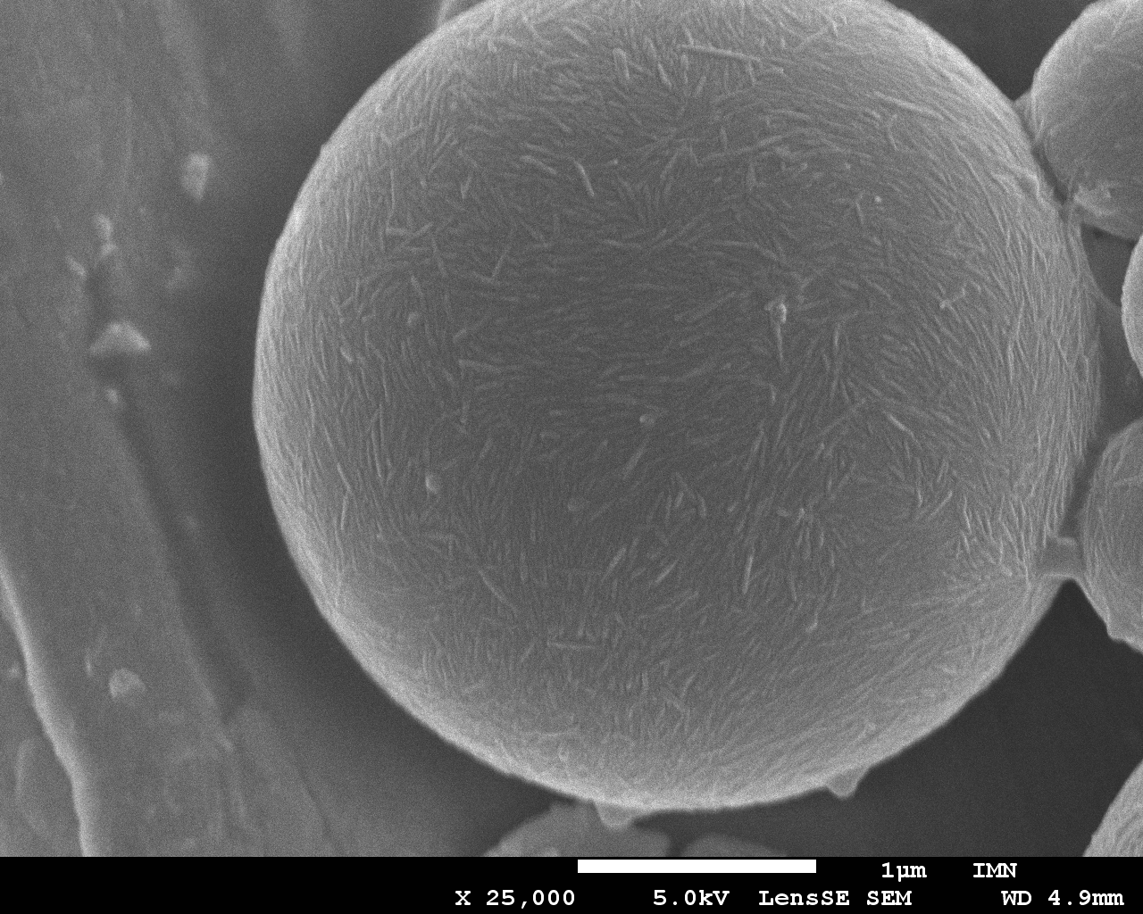

On the programme, plenary lectures, presentations, round table discussions, stands on 6 topics

Conversion of lignocellulosic biomass
Pre-treatment, deconstruction and conversion of lignocellulosic biomass to chemical platforms or transportation (renewables : wood, corns, beets…)
Conversion of carbohydrates to higher value added chemicals

Conversion of vegetable oils, derivatives and by-products
Conversion of vegetable oils
Reactions involving (unsaturated) fatty acids/esters, glycerol or minor compounds (esterification, transesterification, oxidation, metathesis, hydroformylation, hydrogenation, ...)

Valorisation of by-products (including CO2), waste and recycling
Chemical valorization of waste
All processes involving biogas and more generally agricultural waste
Chemical valorization of CO2

Eco-efficient processes
Design of energy (and atoms)-saving processes for the rational conversion of renewable carbon
Chemical and physical pre-treatments of biomass, green solvents, alternative media, catalysis,
process design, process intensification...

Catalytic materials specifically dedicated to innovative processes incorporating bio-based materials
Preparation and characterization of materials for the selective conversion of biomass :
eco-design, green synthesis, bio-sourced precursors, ...

Environmental impact of all actions implemented
All works evaluating the ecological impact of chemicals and processes on the environment.

