Supporting Information SI-1
Normalization of TOC distributions to 100%:

Table 1 (Section 3.2.1) showed that the TOC recovery was 75.4% for the control soil and 70.9% for the amended soil. Organo-mineral particles (and OM particles for the lightest fraction) smaller than 0.2 μm (centrifugation threshold) likely remained in suspension in the fractionation solution after each centrifugation step of the fractionation procedure (described in Section 2.2). We assumed that these suspended organo-mineral particles should have been collected in each fractionation step proportionally to the TOC distribution actually detected in each density fraction. In other words, the TOC loss in each fraction was proportional to the TOC recovery in the same fraction and the normalization to 100% represented the TOC distribution without losses.
Supporting Information SI-2
Normalization Zn distributions to 100%

The Zn recovery in the control soil (88.3%) was higher than the TOC recovery in this soil (75.4%). Conversely, Zn recovery in the amended soil (57.5%) was lower than the TOC recovery in this soil (70.9%). We hypothesized that:
(i) Organo-mineral particles that did not settle during centrifugation were potential Zn-bearing phases and partially accounted for the Zn losses in each step of the fractionation procedure.
(ii) Zn contents subject to aqueous extraction (i.e. by the fractionation solution) were negligible in the control soil, but high in the amended soil. Indeed, via sequential extraction, we reported that only 1.5% of the Zn was present in readily available fractions (assessed as “exchangeable” and “adsorbed”) in the control soil, whereas 23.1% of the Zn was found in the same fractions in the amended soil (Formentini et al., 2015).
Therefore, in the control soil (virtually absent of aqueous extractable Zn), Zn losses were ascribed to losses of Zn-containing organo-mineral particles that did not settle during centrifugation. Equation 1 was applied to estimate the Zn concentrations in each fraction using the TOC distribution as a proxy:

${Zn}_{corrected}^{f_{i}}={Zn}_{detected}^{f_{i}}+ \left({Zn}_{bulk loss} x \frac{{TOC}_{distribution}^{f_{i}}}{100}\right)$ (1)

where ${Zn}_{corrected}^{f_{i}}$ is the estimated Zn concentration in each fraction (mg·kg⁻¹ of bulk soil); ${Zn}_{detected}^{f_{i}}$ is the Zn concentration detected in each fraction (quantified as mg·kg⁻¹ of bulk soil, as opposed to mg·kg⁻¹ of fraction in Table 1); ${Zn}_{bulk loss}$ is the difference between the Zn present in the bulk soils and the sum of the Zn detected within density fractions (mg·kg⁻¹ of bulk soil); and ${TOC}_{distribution}^{f_{i}}$ is the normalized TOC distribution in each fraction (%).
In the amended soil, Equation 1 was used to account for the lost Zn in each density fraction until the proportion of lost TOC was reached. The amount of lost Zn that exceeded the proportion of lost TOC may have consisted of Zn extracted by the fractionation solution. This amount of Zn was quantified separately from the soil density fractions, and referred to as the Zn fraction extracted by the fractionation solution (DF₆).

Supporting Information SI-3
X-ray diffractograms of the five density fractions for the control soil (black lines) and the amended soil (red lines).
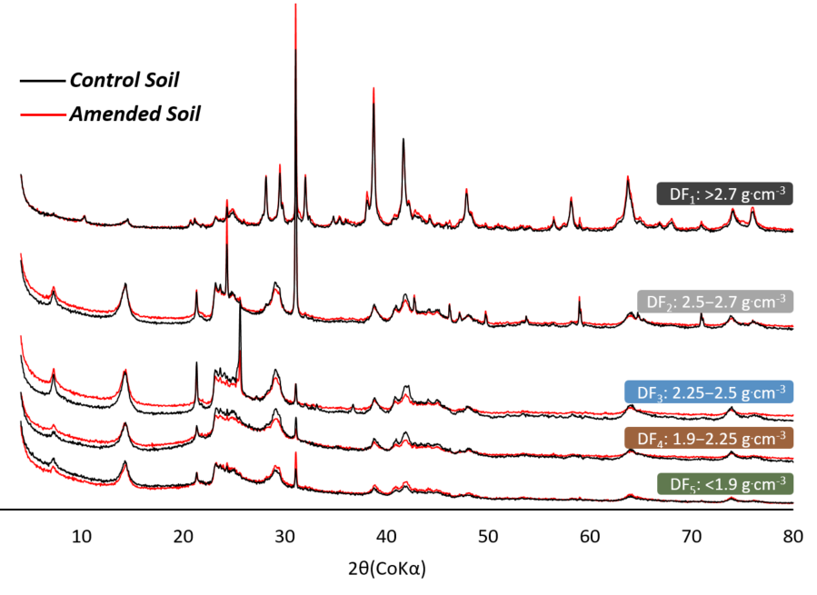

Supporting Information SI-4
k³-weighted Zn K-edge EXAFS and Fourier transform (FT) spectra of DF₅ (<1.9 g.cm⁻³) and DF₂ (2.5−2.7 g.cm⁻³) for the control and amended soils (black lines) superimposed by the best LCF for each sample (red lines)

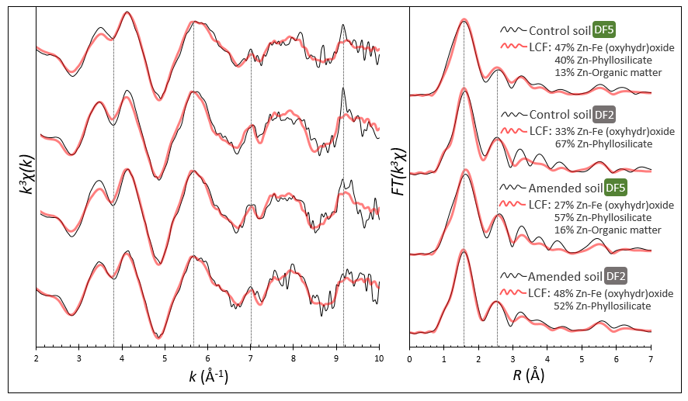

Supporting Information SI-5
Library of XAS spectra from Zn reference compounds used for the LCF procedure
