Supplementary Informations

Location | Position (latitude, longitude) | Altitude (m) | Climate (Joly et al., 2010)
Carquefou | 47.319461 -1.491685 | 7.4 | Oceanic
Etiolles | 48.667431 2.479903 | 84.2 | Degraded oceanic
Gardouch | 43.370952 1.673424 | 238.3 | Southwestern basin
La Tour-de-Salvagny | 45.797595 4.712050 | 286.2 | Degraded oceanic
Saint-Genès-Champanelle | 45.705787 2.971739 | 966.8 | Mountainous
Velaine-en-Haye | 48.704871 6.082540 | 334.1 | Semi-continental
Table S1: Position, altitude and corresponding climate of the different sampling locations
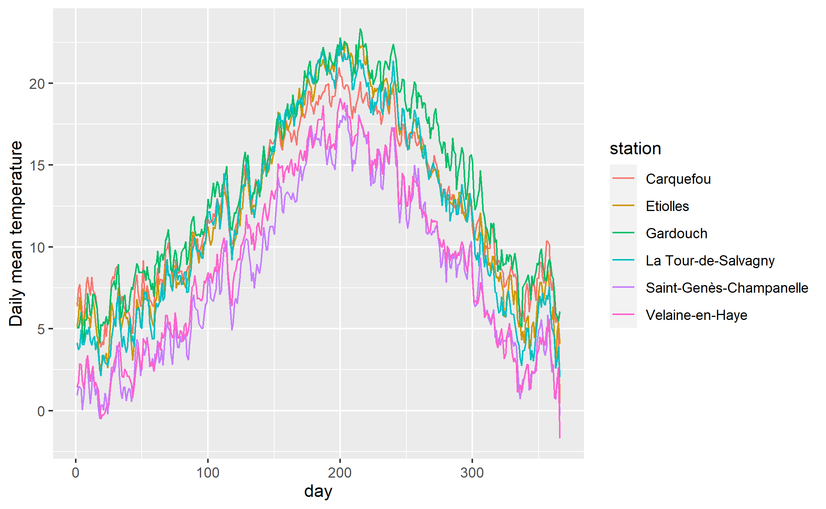
Figure S1: Daily average observed temperature data for the different locations.
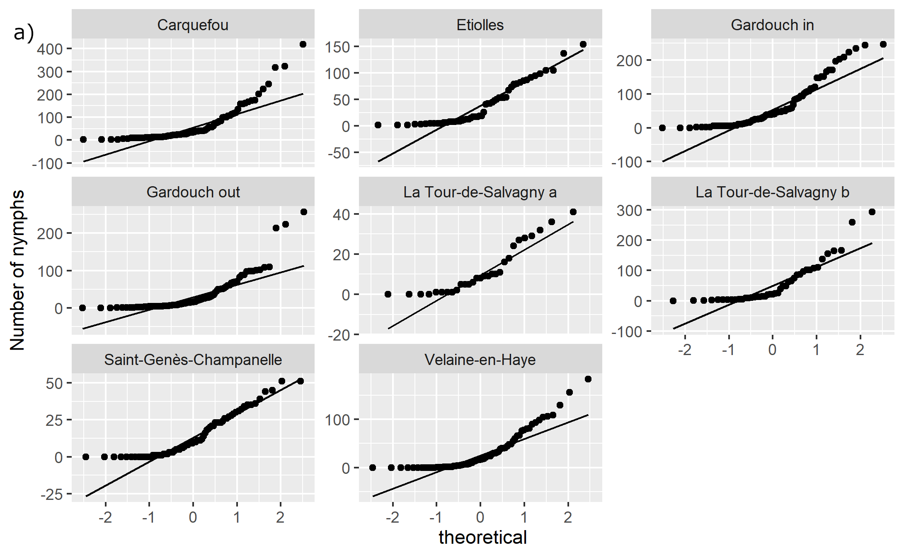

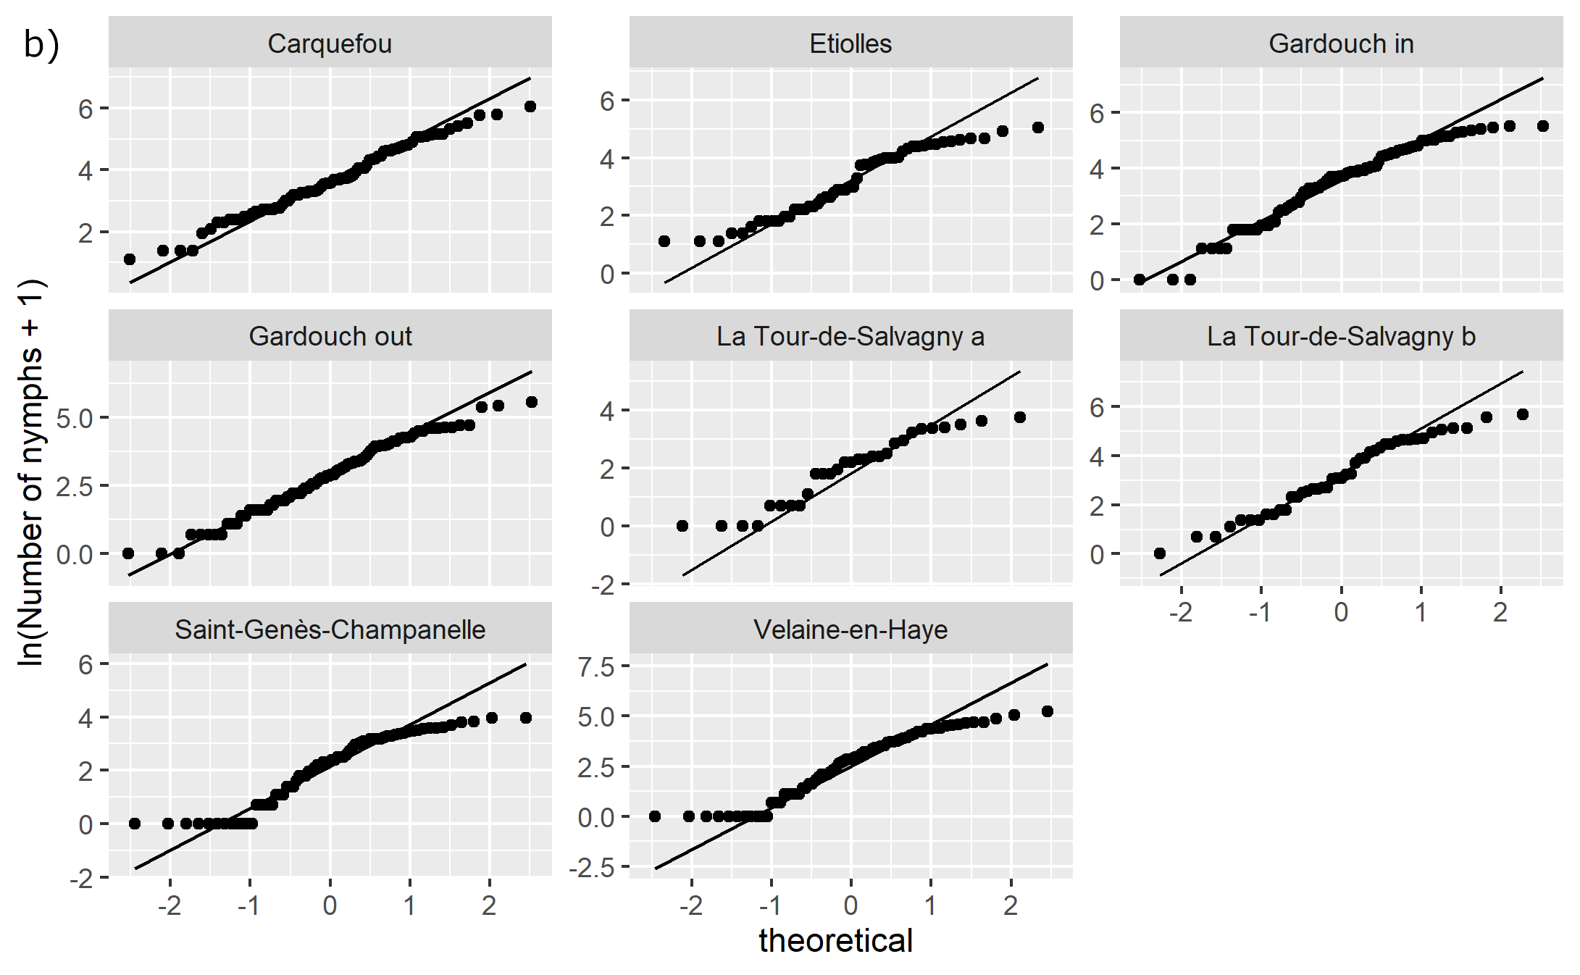

Figure S2: QQ plots of the data for the different sites without (a) or with (b) logarithmic transform.

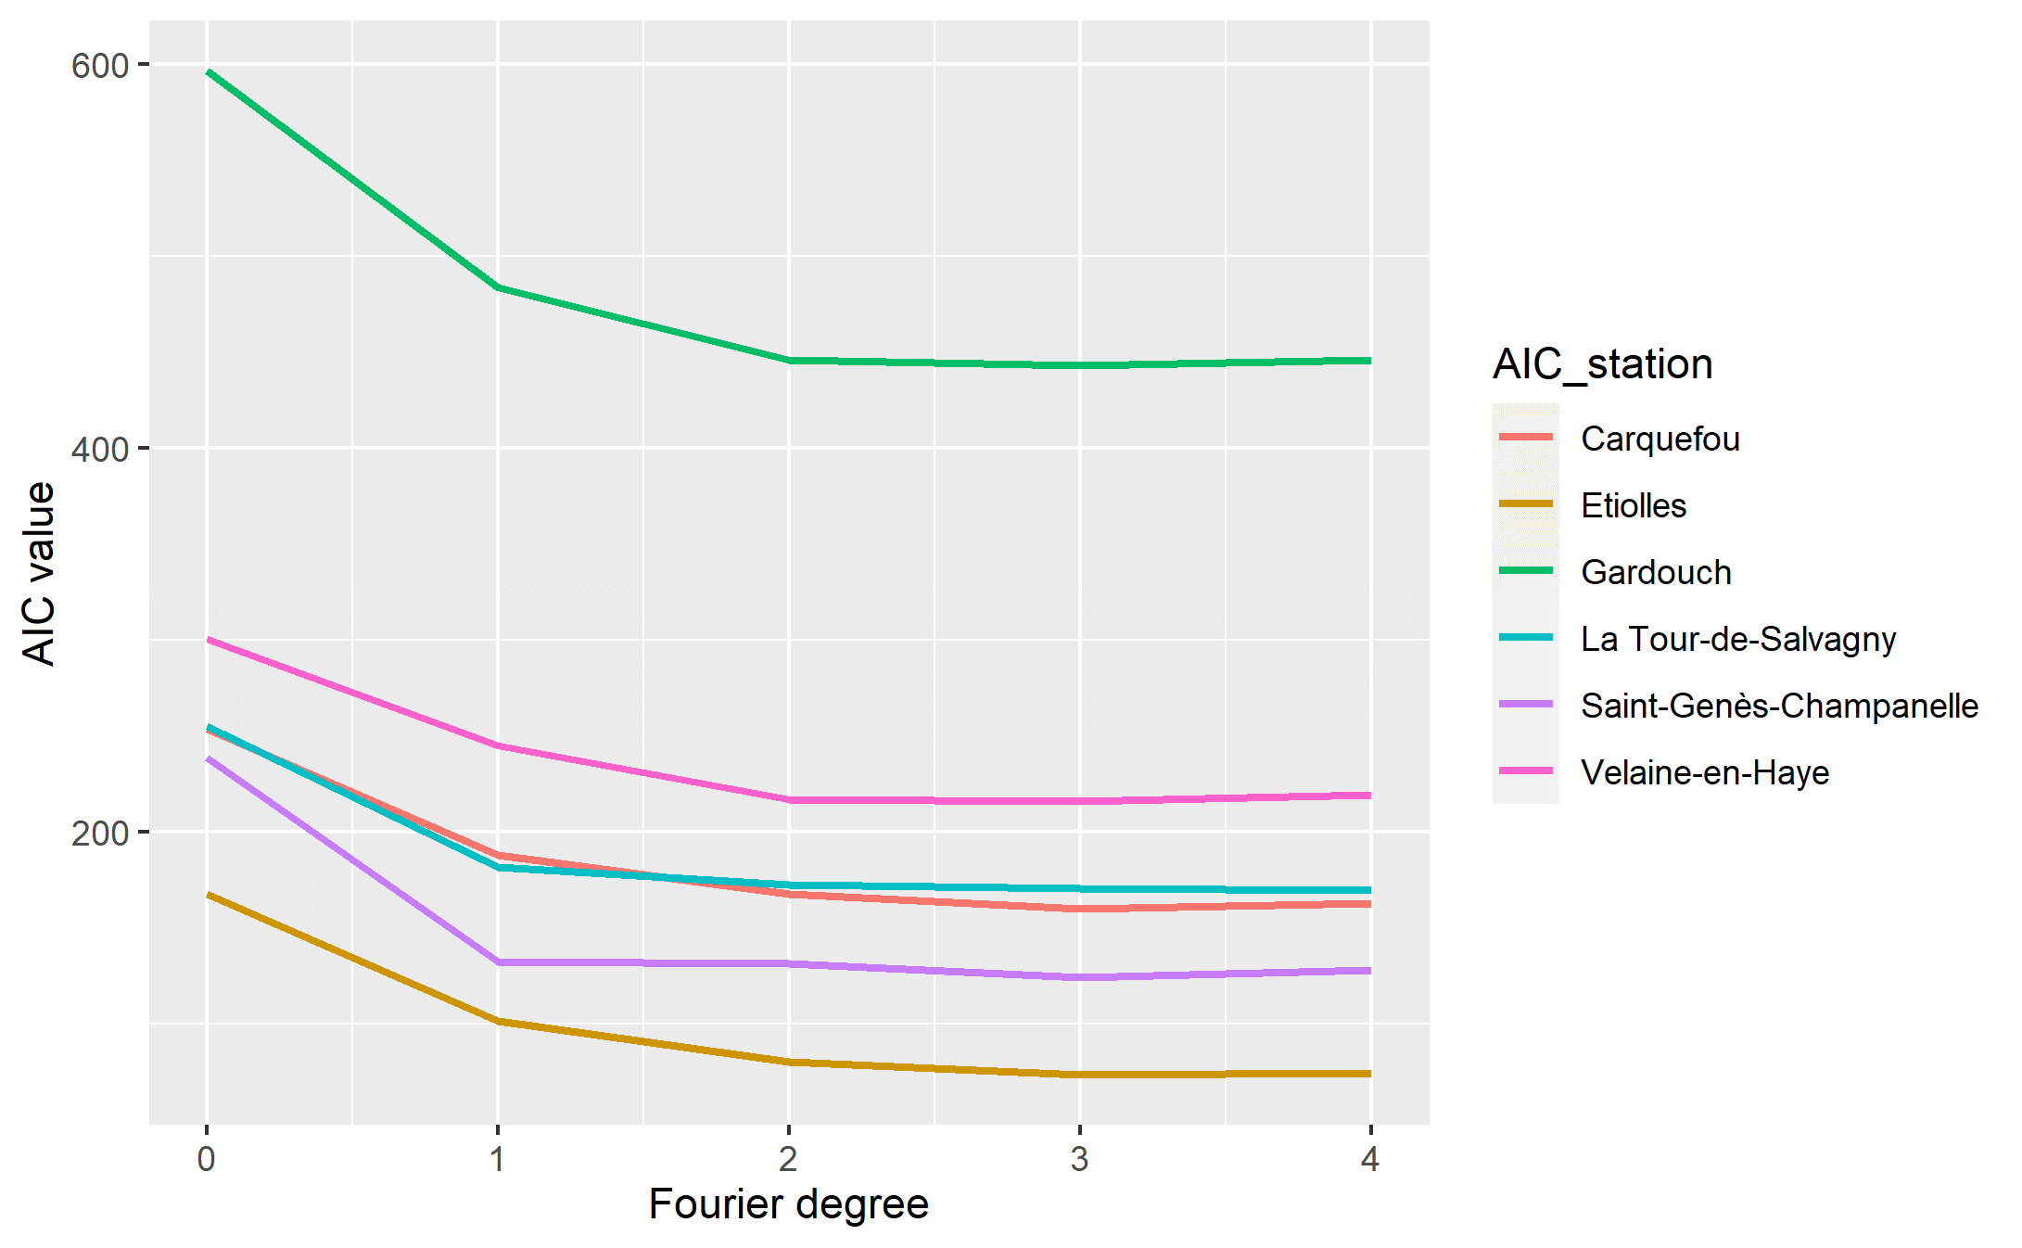
Figure S3: AIC values of harmonic regressions as a function of Fourier degree (parameter K) for the different sites. A unique AIC value was computed for La Tour-de-Salvagny and Gardouch sites.

R script

## ---- message = 'FALSE'------------------------------------------------------------------------------------------------
library(tidyverse)
library(ggplot2)
library(ggrepel)

## ----------------------------------------------------------------------------------------------------------------------
ticks <- as_tibble(
read.csv("data/data_for_regression.csv",
stringsAsFactors = FALSE))
ticks <- ticks[-which(ticks$IDsite %in% c("9","10","11")),]

## ----------------------------------------------------------------------------------------------------------------------
ticks <- ticks %>%
mutate(date = as.Date(date, "%Y-%m-%d"),
day_year = as.integer(format(date, "%j")),
day_radian = day_year / 365 * 2 * pi,
year = (as.integer(format(date, "%Y"))),
log_nymph = log(NbNymphe + 1))

## ---- message = FALSE--------------------------------------------------------------------------------------------------
ls_site_station <- ticks %>%
group_by(IDsite) %>%
summarise(
IDsite = unique(IDsite)) %>%
mutate(id = row_number(),
IDstation = c(1,1,2,4,5,7,7,6),
IDstation_1 = c("S1", "S1", "S2", "S4", "S5", "S6S7", "S6S7", "S8"),
site = c("La Tour-de-Salvagny a", "La Tour-de-Salvagny b", "Saint-Genès-Champanelle", "Etiolles", "Carquefou", "Gardouch in", "Gardouch out", "Velaine-en-Haye"),
station = c("La Tour-de-Salvagny", "La Tour-de-Salvagny", "Saint-Genès-Champanelle", "Etiolles", "Carquefou", "Gardouch", "Gardouch", "Velaine-en-Haye")) %>%
select(id, IDsite, IDstation, IDstation_1, site, station)

ticks <- left_join(ticks, ls_site_station)

## ----------------------------------------------------------------------------------------------------------------------
ticks %>%
group_by(site, station) %>%
summarise(
n_collectes = length(unique(date)),
min_date = min(date),
max_date = max(date)
)

## ----densities abundances----------------------------------------------------------------------------------------------
ggplot(ticks, aes(x = NbNymphe)) +
geom_density() +
facet_wrap(~site, scale = "free_x")
ggsave("figures/abundance_densities.png")

## ----densities log abundances------------------------------------------------------------------------------------------
ggplot(ticks, aes(x = log(NbNymphe+1))) +
geom_density() +
facet_wrap(~site)
ggsave("figures/abundance_log_densities.png")

## ----qqplot abundance untransformed------------------------------------------------------------------------------------
ggplot(ticks, aes(sample = NbNymphe)) +
stat_qq() +
stat_qq_line() +
facet_wrap(~site, scales="free_y") +
ylab("Number of nymphs")
ggsave("figures/abundance_qqplots.png")

## ----qqplot ln abundance-----------------------------------------------------------------------------------------------
ggplot(ticks, aes(sample = log(NbNymphe + 1))) +
stat_qq() +
stat_qq_line() +
facet_wrap(~site, scales="free_y") +
ylab("ln(Number of nymphs + 1)")
ggsave("figures/abundance_log_qqplots.png")

## ----------------------------------------------------------------------------------------------------------------------
## Months in English
Sys.setlocale("LC_ALL","English")
ticks %>%
mutate(day_of_year = paste0("2020-", format(date, "%m-%d"))) %>%
ggplot(., aes(x = as.Date(day_of_year), y = log_nymph, col = factor(year))) +
geom_point() +
facet_wrap(~ site) +
scale_x_date(breaks = function(x) seq.Date(from = as.Date("2020-01-01"),
to = as.Date("2020-12-31"),
by = "1 month"),
date_labels = "%b") +
theme(axis.text.x = element_text(angle = 90, hjust = 1)) +
xlab("") +
ylab("ln(Number of nymphs + 1)") +
scale_color_discrete(name = "Year")
ggsave("figures/log_nymph_year_site.png")

## ----------------------------------------------------------------------------------------------------------------------
ticks <- ticks %>% select(IDsite,date,NbNymphe,day_year,day_radian,year,log_nymph,id,IDstation,IDstation_1,station)

## ----------------------------------------------------------------------------------------------------------------------
## Without sites 1a et 1b (Salvagny a et Salvagny b)
ls_stations <- unique(as.character(ticks$IDstation))

# Same colour for all sites throughout
colrs <- c(1,2,3,4,6,7)

# Test of the models and AIC computation
AIC_table <- data.frame(
degre_Fourier=rep(c(0:4),6),
AIC_station = rep(unique(ticks$station),each=5),
mdL = NA)

## For Salvagny a et Salvagny b one model with distinct intercepts

mdL0_1 <- lm(log_nymph ~ 1 + factor(IDsite),
data = ticks, subset = IDsite %in% c("1a", "1b"))

mdL1_1 <- lm(log_nymph ~ factor(IDsite) +
cos(day_radian) + sin(day_radian),
data = ticks, subset = IDsite %in% c("1a", "1b"))

mdL2_1 <- lm(log_nymph ~ factor(IDsite) +
cos(day_radian) + sin(day_radian) +
cos(2 * day_radian) + sin(2 * day_radian),
data = ticks, subset = IDsite %in% c("1a", "1b"))

mdL3_1 <- lm(log_nymph ~ factor(IDsite) +
cos(day_radian) + sin(day_radian) +
cos(2 * day_radian) + sin(2 * day_radian) +
cos(3 * day_radian) + sin(3 * day_radian),
data = ticks, subset = IDsite %in% c("1a", "1b"))

mdL4_1 <- lm(log_nymph ~ factor(IDsite) +
cos(day_radian) + sin(day_radian) +
cos(2 * day_radian) + sin(2 * day_radian) +
cos(3 * day_radian) + sin(3 * day_radian) +
cos(4 * day_radian) + sin(4 * day_radian),
data = ticks, subset = IDsite %in% c("1a", "1b"))

AIC_table$mdL[1] <- AIC(mdL0_1)
AIC_table$mdL[2] <- AIC(mdL1_1)
AIC_table$mdL[3] <- AIC(mdL2_1)
AIC_table$mdL[4] <- AIC(mdL3_1)
AIC_table$mdL[5] <- AIC(mdL4_1)

## Same for Gardouch
mdL0_5 <- lm(log_nymph ~ 1 + factor(IDsite),
data = ticks, subset = IDsite %in% c("6", "7"))

mdL1_5 <- lm(log_nymph ~ factor(IDsite) +
cos(day_radian) + sin(day_radian),
data = ticks, subset = IDsite %in% c("6", "7"))

mdL2_5 <- lm(log_nymph ~ factor(IDsite) +
cos(day_radian) + sin(day_radian) +
cos(2 * day_radian) + sin(2 * day_radian),
data = ticks, subset = IDsite %in% c("6", "7"))

mdL3_5 <- lm(log_nymph ~ factor(IDsite) +
cos(day_radian) + sin(day_radian) +
cos(2 * day_radian) + sin(2 * day_radian) +
cos(3 * day_radian) + sin(3 * day_radian),
data = ticks, subset = IDsite %in% c("6", "7"))

mdL4_5 <- lm(log_nymph ~ factor(IDsite) +
cos(day_radian) + sin(day_radian) +
cos(2 * day_radian) + sin(2 * day_radian) +
cos(3 * day_radian) + sin(3 * day_radian) +
cos(4 * day_radian) + sin(4 * day_radian),
data = ticks, subset = IDsite %in% c("6", "7"))

AIC_table$mdL[21] <- AIC(mdL0_5)
AIC_table$mdL[22] <- AIC(mdL1_5)
AIC_table$mdL[23] <- AIC(mdL2_5)
AIC_table$mdL[24] <- AIC(mdL3_5)
AIC_table$mdL[25] <- AIC(mdL4_5)

pred <- expand.grid(
date = seq(as.Date("2014-01-01"), as.Date("2019-12-31"), by = "1 day"),
id = 1:8
)

pred <- full_join(pred, ls_site_station)

pred <- pred %>%
mutate(day = as.numeric(format(date, "%j")),
day_radian = day / 365 * 2 * pi)

pred$ln_nNymph <- rep(NA)

pred$ln_nNymph <- rep(NA)

## Models for all sites except Salvagny and Gardouch
for(i in c(2:4,6)){

i_station <- ls_stations[i]

mdL0 <- lm(log_nymph ~ 1,
data = ticks, subset = IDsite == i_station)

mdL1 <- lm(log_nymph ~ cos(day_radian) + sin(day_radian),
data = ticks, subset = IDsite == i_station)

mdL2 <- lm(log_nymph ~ cos(day_radian) + sin(day_radian) +
cos(2 * day_radian) + sin(2 * day_radian),
data = ticks, subset = IDsite == i_station)

mdL3 <- lm(log_nymph ~ cos(day_radian) + sin(day_radian) +
cos(2 * day_radian) + sin(2 * day_radian) +
cos(3 * day_radian) + sin(3 * day_radian),
data = ticks, subset = IDsite == i_station)

mdL4 <- lm(log_nymph ~ cos(day_radian) + sin(day_radian) +
cos(2 * day_radian) + sin(2 * day_radian) +
cos(3 * day_radian) + sin(3 * day_radian) +
cos(4 * day_radian) + sin(4 * day_radian),
data = ticks, subset = IDsite == i_station)

AIC_table$mdL[(i - 1)*5+1] <- AIC(mdL0)
AIC_table$mdL[(i - 1)*5+2] <- AIC(mdL1)
AIC_table$mdL[(i - 1)*5+3] <- AIC(mdL2)
AIC_table$mdL[(i - 1)*5+4] <- AIC(mdL3)
AIC_table$mdL[(i - 1)*5+5] <- AIC(mdL4)

}

## ----------------------------------------------------------------------------------------------------------------------
AIC_table %>%
ggplot(., aes(x = degre_Fourier, y = mdL, colour=AIC_station)) +
geom_line(size = 1) +
ylab("AIC value") +
xlab("Fourier degree") +
scale_color_manual(values=c("#F8766D", "#CD9600", "#00BE67", "#00BFC4", "#C77CFF", "#FF61CC"))
ggsave("figures/AIC_degree.png")

## ----------------------------------------------------------------------------------------------------------------------
mdL2_1 <- lm(log_nymph ~
cos(day_radian) + sin(day_radian) +
cos(2 * day_radian) + sin(2 * day_radian),
data = ticks, subset = IDsite %in% c("1a", "1b"))

mdL2_2 <- lm(log_nymph ~ factor(IDsite) +
cos(day_radian) + sin(day_radian) +
cos(2 * day_radian) + sin(2 * day_radian),
data = ticks, subset = IDsite %in% c("1a", "1b"))

mdL2_3a <- lm(log_nymph ~
cos(day_radian) + sin(day_radian) +
cos(2 * day_radian) + sin(2 * day_radian),
data = ticks, subset = IDsite == "1a")

mdL2_3b <- lm(log_nymph ~
cos(day_radian) + sin(day_radian) +
cos(2 * day_radian) + sin(2 * day_radian),
data = ticks, subset = IDsite == "1b")

pred_1ab <- pred[pred$IDsite %in% c("1a", "1b"),]

pred_1ab$mdL2_1 <- predict(mdL2_1, pred_1ab)
pred_1ab$mdL2_2 <- predict(mdL2_2, pred_1ab)
pred_1ab$mdL2_3 <- rep(NA)
pred_1ab$mdL2_3[pred_1ab$IDsite == "1a"] <- predict(mdL2_3a, pred_1ab[pred_1ab$IDsite == "1a",])
pred_1ab$mdL2_3[pred_1ab$IDsite == "1b"] <- predict(mdL2_3b, pred_1ab[pred_1ab$IDsite == "1b",])

## ----------------------------------------------------------------------------------------------------------------------
mdL3_1 <- lm(log_nymph ~
cos(day_radian) + sin(day_radian) +
cos(2 * day_radian) + sin(2 * day_radian),
data = ticks, subset = IDsite %in% c("6", "7"))

mdL3_2 <- lm(log_nymph ~ factor(IDsite) +
cos(day_radian) + sin(day_radian) +
cos(2 * day_radian) + sin(2 * day_radian),
data = ticks, subset = IDsite %in% c("6", "7"))

AIC(mdL3_1)
AIC(mdL3_2)

## ----------------------------------------------------------------------------------------------------------------------
rm(list = ls()[grep("mdL", ls())])
rm(list = ls()[grep("pred", ls())])

## ---- message = FALSE--------------------------------------------------------------------------------------------------
pred <- expand.grid(
date = seq(as.Date("2014-01-01"), as.Date("2021-12-31"), by = "1 day"),
id = 1:8
)

pred <- full_join(pred, ls_site_station)

pred <- pred %>%
mutate(day = as.numeric(format(date, "%j")),
day_radian = day / 365 * 2 * pi)

pred$ln_nNymph <- rep(NA)

## ----------------------------------------------------------------------------------------------------------------------
ls_sites <- unique(ticks$IDsite)

## Models for La Tour de Salvagny
mdL_S1 <- lm(log_nymph ~ factor(IDsite) +
cos(day_radian) + sin(day_radian) +
cos(2 * day_radian) + sin(2 * day_radian),
data = ticks, subset = IDsite %in% c("1a", "1b"))

qqnorm(resid(mdL_S1), main = paste("1a", "1b"))
abline(a = 0, b = 1)

pred$ln_nNymph[pred$IDsite %in% c("1a", "1b")] <- predict(mdL_S1, pred[pred$IDsite %in% c("1a", "1b"),])

## Models for Gardouch
mdL_S67 <- lm(log_nymph ~ factor(IDsite) +
cos(day_radian) + sin(day_radian) +
cos(2 * day_radian) + sin(2 * day_radian),
data = ticks, subset = IDsite %in% c("6", "7"))

qqnorm(resid(mdL_S67), main = paste0("6 - 7"))
abline(a = 0, b = 1)

pred$ln_nNymph[pred$IDsite %in% c("6", "7")] <- predict(mdL_S67, pred[pred$IDsite %in% c("6", "7"),])

## Models for sites except Gardouch and La Tour de Salvagny
for(i in c(3:5, 8)){

i_site <- ls_sites[i]

nm <- paste0("mdL_S", i_site)

mdL <- lm(log_nymph ~ cos(day_radian) + sin(day_radian) +
cos(2 * day_radian) + sin(2 * day_radian),
data = ticks, subset = IDsite == i_site)

assign(nm, mdL)

pred$ln_nNymph[pred$IDsite == i_site] <- predict(mdL, pred[pred$IDsite == i_site,])

qqnorm(resid(mdL), main = ls_sites[i])
abline(a = 0, b = 1)

}

pred$ln_nNymph[pred$ln_nNymph < 0] <- 0

## ----------------------------------------------------------------------------------------------------------------------
curvs <- pred %>%
filter(date > "2018-12-31" & date < "2020-01-01") %>%
group_by(IDsite) %>%
mutate(dif_1 = ln_nNymph - lag(ln_nNymph, default = NA),
dif_2 = dif_1 - lag(dif_1, default = NA ),
dif_1_sign = sign(dif_1) - lag(sign(dif_1), default = NA ),
dif_2_sign = sign(dif_2) - lag(sign(dif_2), default = NA )
)

dat_pic <- curvs %>%
filter(dif_1_sign == -2) %>%
select( date, id, IDsite, IDstation, site, station,day, ln_nNymph) %>%
mutate(type_event = "max")

dat_min <- curvs %>%
filter(dif_1_sign == 2) %>%
select( date, id, IDsite, IDstation, site, station,day, ln_nNymph) %>%
mutate(type_event = "min")

dat_inflx <- curvs %>%
filter(dif_2_sign == -2) %>%
select( date, id, IDsite, IDstation, site, station,day, ln_nNymph) %>%
mutate(type_event = "inflx")

curvs_events <- bind_rows(dat_pic, dat_min, dat_inflx) %>%
arrange(IDsite)

rm(list = c("dat_pic", "dat_min", "dat_inflx"))

## ----------------------------------------------------------------------------------------------------------------------
events <- curvs_events %>%
filter(type_event == "max" & date < "2019-10-01")

events <- bind_rows(
events,
curvs_events %>%
filter(site %in% c("Lyon a", "Lyon b", "Sénart", "Nancy") &
type_event == "inflx" & date > "2019-09-01" & date < "2019-11-01"),
curvs_events %>%
filter(site %in% c("Carquefou", "Toulouse int", "Toulouse ext") &
type_event == "min" & date > "2019-08-01" & date < "2019-11-01")
) %>%
arrange(IDsite)

## ----------------------------------------------------------------------------------------------------------------------
Sys.setlocale("LC_ALL","English")
plot_labs <- curvs %>%
group_by(site) %>%
summarise(date = max(date),
day = max(day),
ln_nNymph = last(ln_nNymph))

ggplot(curvs, aes(x = date, y = ln_nNymph, colour = site)) +
geom_line(size = 1) +
geom_text_repel(data = plot_labs,
aes(x = date, y = ln_nNymph, label = site),
nudge_x = 30,
segment.linetype = 5) +
geom_point(data = events[events$type_event == "max",],
aes(x = date, y = ln_nNymph, colour=site),
size = 3) +
scale_x_date(breaks = function(x) seq.Date(from = as.Date("2019-01-01"),
to = as.Date("2019-12-31"),
by = "1 month"),
date_labels = "%b") +
ylab("ln(Number of nymphs + 1)") +
xlab("") +
theme(axis.text.x = element_text(angle = 90, hjust = 1)) +
theme(legend.position = "none")
# scale_color_manual(values=c("#F8766D", "#CD9600", "#7CAE00","#00BE67", "#00BFC4", "#00A9FF", "#C77CFF", "#FF61CC"))

ggsave("figures/superimposed_abundances.png")

## ----------------------------------------------------------------------------------------------------------------------
Sys.setlocale("LC_ALL","English")
plot_labs <- curvs %>%
group_by(site) %>%
summarise(date = max(date),
day = max(day),
ln_nNymph = last(ln_nNymph))

ggplot(subset(curvs, IDsite %in% c("5", "6", "7")),aes(x = date, y = ln_nNymph, colour = site)) +
geom_line(size = 1) +
geom_text_repel(subset(plot_labs,site %in% c("Carquefou","Gardouch in","Gardouch out")),mapping=aes(x = date, y = ln_nNymph, label = site),
nudge_x = 30, segment.linetype = 5) +
geom_point(subset(events,events$type_event == "max" & events$IDsite %in% c("5", "6", "7")), mapping=aes(x = date, y = ln_nNymph,colour = site),size = 3) +
scale_x_date(breaks = function(x) seq.Date(from = as.Date("2019-01-01"),
to = as.Date("2019-12-31"),
by = "1 month"),
date_labels = "%b") +
ylab("ln(Number of nymphs + 1)") +
xlab("") +
theme(axis.text.x = element_text(angle = 90, hjust = 1)) +
theme(legend.position = "none")+
scale_color_manual(values=c("#F8766D", "#7CAE00", "#00BE67" ))

## ----------------------------------------------------------------------------------------------------------------------
Sys.setlocale("LC_ALL","English")
plot_labs <- curvs %>%
group_by(site) %>%
summarise(date = max(date),
day = max(day),
ln_nNymph = last(ln_nNymph))

ggplot(subset(curvs, IDsite %in% c("1a", "1b", "4", "8")),aes(x = date, y = ln_nNymph, colour = site)) +
geom_line(size = 1) +
geom_text_repel(subset(plot_labs,site %in% c("La Tour-de-Salvagny a","La Tour-de-Salvagny b","Etiolles","Velaine-en-Haye")),mapping=aes(x = date, y = ln_nNymph, label = site),
nudge_x = 30, segment.linetype = 5) +
geom_point(subset(events,events$type_event == "max" & events$IDsite %in% c("1a", "1b", "4", "8")), mapping=aes(x = date, y = ln_nNymph,colour = site),size = 3) +
scale_x_date(breaks = function(x) seq.Date(from = as.Date("2019-01-01"),
to = as.Date("2019-12-31"),
by = "1 month"),
date_labels = "%b") +
ylab("ln(Number of nymphs + 1)") +
xlab("") +
theme(axis.text.x = element_text(angle = 90, hjust = 1)) +
theme(legend.position = "none")+
scale_color_manual(values=c("#CD9600", "#00BFC4","#00A9FF", "#FF61CC"))

## ----------------------------------------------------------------------------------------------------------------------
Sys.setlocale("LC_ALL","English")
plot_labs <- curvs %>%
group_by(site) %>%
summarise(date = max(date),
day = max(day),
ln_nNymph = last(ln_nNymph))

ggplot(subset(curvs, IDsite=="2"),aes(x = date, y = ln_nNymph, colour = site)) +
geom_line(size = 1) +
geom_text_repel(subset(plot_labs,site == "Saint-Genès-Champanelle"),mapping=aes(x = date, y = ln_nNymph, label = site),
nudge_x = 30, segment.linetype = 5) +
geom_point(subset(events,events$type_event == "max" & events$IDsite == "2"), mapping=aes(x = date, y = ln_nNymph,colour = site),size = 3) +
scale_x_date(breaks = function(x) seq.Date(from = as.Date("2019-01-01"),
to = as.Date("2019-12-31"),
by = "1 month"),
date_labels = "%b") +
ylab("ln(Number of nymphs + 1)") +
xlab("") +
theme(axis.text.x = element_text(angle = 90, hjust = 1)) +
theme(legend.position = "none")+
scale_color_manual(values="#C77CFF")

## ----------------------------------------------------------------------------------------------------------------------
pred_tick <- pred %>%
select(date, id, IDsite, IDstation, site, station, day, day_radian, ln_nNymph)

pred_tick <- left_join(pred_tick,
ticks %>%
select(IDsite, date, log_nymph))

## ----------------------------------------------------------------------------------------------------------------------
ggplot(pred_tick, aes(x = date, y = ln_nNymph)) +
geom_line() +
geom_point(aes(y = log_nymph, col = "red")) +
facet_wrap(~ site) +
theme(legend.position = "none") +
xlab("Time") +
ylab("ln(number of nymphs + 1)")
ggsave("figures/ln_nymphs_observed_predicted.png")

## ----------------------------------------------------------------------------------------------------------------------
meteo <- as_tibble(
read.csv("data/imputedMeteo_New.csv"))

## ----------------------------------------------------------------------------------------------------------------------
meteo <- meteo %>%
mutate(date = as.Date(Date))

## ----------------------------------------------------------------------------------------------------------------------
meteo <- meteo %>%
mutate(year = format(date, "%Y"),
day = as.numeric(format(date, "%j")),
day_radian = day / 365 * 2 * pi)
meteo <- meteo[-which(meteo$Site %in% c("S9")),]

## ---- message = FALSE--------------------------------------------------------------------------------------------------
ls_site_station_meteo <- meteo%>%
group_by(Site) %>%
summarise(
Site = unique(Site)) %>%
mutate(station = c("La Tour-de-Salvagny", "Saint-Genès-Champanelle", "Etiolles", "Carquefou", "Gardouch", "Velaine-en-Haye")) %>%
select(Site, station)

meteo <- left_join(meteo, ls_site_station_meteo)

## ----------------------------------------------------------------------------------------------------------------------
ggplot(meteo, aes(x = date, y = TM_m1)) +
geom_point() +
facet_wrap(~ station)

## ----------------------------------------------------------------------------------------------------------------------
meteo_day <- meteo %>%
group_by(Site, day) %>%
summarise(station = unique(station),
date = max(date),
temp_mean = mean(TM_m1),
U_min = mean(UN_m1),
U_mean = mean(UM_m1))

meteo_day <- meteo_day %>%
filter(!is.na(temp_mean)) %>%
mutate(
temp_tmp = ifelse(temp_mean >= 5,temp_mean, 0),
temp_cumsum = cumsum(temp_mean),
temp_cumsum1 = cumsum(temp_tmp),
U_cumsum = cumsum(U_mean))

## ----------------------------------------------------------------------------------------------------------------------
ggplot(data = meteo_day, aes(x = day, y = temp_mean, col = station)) +
geom_line()+
scale_color_manual(values=c("#F8766D", "#CD9600", "#00BE67", "#00BFC4", "#C77CFF", "#FF61CC"))+
ylab("Daily mean temperature")
ggsave("figures/temperature_data.png")

## ----------------------------------------------------------------------------------------------------------------------
tick_peak <- events %>%
filter(type_event == "max") %>%
ungroup() %>%
select(day, station) %>%
group_by(station) %>%
summarise(day = unique(day), station = unique(station))

meteo_day$New_Date=as.Date(meteo_day$day, origin = "2021-01-01")

tick_peak <- left_join(
tick_peak,
meteo_day %>%
select(day, New_Date, station, Site, temp_cumsum)
)

## ----------------------------------------------------------------------------------------------------------------------

meteo_day %>%
filter(day < 220 & temp_cumsum < 2000) %>%
ggplot(., aes(x = New_Date, y = temp_cumsum, col=station)) +
geom_line(size = 1) +
scale_color_manual(values=c("#F8766D", "#CD9600", "#00BE67", "#00BFC4", "#C77CFF", "#FF61CC")) +
geom_point(tick_peak,
mapping = aes(x = New_Date, y = temp_cumsum), size=3) +
geom_text_repel(data = tick_peak,
aes(x = New_Date, y = temp_cumsum, label = station),
force = 50,
segment.linetype = 5) +
ylim(0, 2000) +
xlab("") +
ylab("Cumulative temperature (°C.d)") +
theme(legend.position = "none")
ggsave("figures/cumulative_temp_peak.png")

## ----------------------------------------------------------------------------------------------------------------------

date_peak <- events %>%
filter(type_event == "max") %>%
ungroup() %>%
select(day, station) %>%
group_by(station)
# %>%
# summarise(day, station)

date_peak <- left_join(
date_peak,
meteo_day %>%
select(day, New_Date, station, Site, temp_mean, temp_cumsum)
)

## ----------------------------------------------------------------------------------------------------------------------
hiv <- tibble(
site = unique(ls_site_station$site),
ln_nNymph_MoyHiv = rep(NA),
ln_nNymph_Max = rep(NA),
ln_nNymph_Mean = rep(NA),
ln_nNymph_MoyHiv_sur_Max = rep(NA),
ln_nNymph_MoyHiv_sur_Mean = rep(NA),
teta_MoyHiv = rep(NA))

for(i in 1:nrow(ls_site_station)){

## Moyenne du ln(nombre de nymphes) pour janvier 2019 pour IDsite i
hiv$ln_nNymph_MoyHiv[i] <- mean(pred$ln_nNymph[pred$id == i & pred$date > "2020-12-31" & pred$date < "2021-02-01"])
## Max du ln(nombre de nymphes) pour toute l'année pour IDsite i
hiv$ln_nNymph_Max[i] <- max(pred$ln_nNymph[pred$id == i])
## Moyenne du ln(nombre de nymphes) pour toute l'année pour IDsite i
hiv$ln_nNymph_Mean[i] <- mean(pred$ln_nNymph[pred$id == i])
## Moyenne du ln(nombre de nymphes) pour janvier divisé par le max pour toute l'année pour IDsite i
hiv$ln_nNymph_MoyHiv_sur_Max[i] <- hiv$ln_nNymph_MoyHiv[i]/hiv$ln_nNymph_Max[i]
## Moy / max / Moy ?
hiv$ln_nNymph_MoyHiv_sur_Mean[i] <- hiv$ln_nNymph_MoyHiv[i]/hiv$ln_nNymph_Mean[i]
hiv$teta_MoyHiv[i] <- mean(meteo_day$temp_mean[meteo_day$station == ls_site_station$station[i] & meteo_day$date > "2020-12-31" & meteo_day$date < "2021-02-01"])

}

## ----------------------------------------------------------------------------------------------------------------------
ggplot(hiv, aes(x = teta_MoyHiv, y = ln_nNymph_MoyHiv_sur_Max, col = site)) +
xlab("Average temperature (°C)") +
ylab("Relative nymph density") +
geom_point(size=3)
ggsave("figures/winter_density_temperature.png")

