Aquatic organic matter decomposition in the terrestrial environments of an intermittent headwater stream
Nans Barthélémy^{1,2} ; Romain Sarremejane¹ ; Thibault Datry¹
¹ INRAE, UR RiverLy, centre de Lyon-Villeurbanne, 5 rue de la Doua CS70077, 69626, Villeurbanne, Cedex, France
² Univ Lyon, Université Claude Bernard Lyon 1, CNRS, ENTPE, UMR5023, Ecologie des Hydrosystèmes Naturels et Anthropisés (LEHNA), 69622, Villeurbanne, France
Corresponding author mail: nans.barthelemy@univ-lyon1.fr
Nans Barthélémy: 0000-0001-8720-7589
Romain Sarremejane: 0000-0002-4943-1173
Thibault Datry: 0000-0003-1390-6736
Abstract
Rivers and their riparian zones are linked by reciprocal subsidies such as leaf fall or the emergence of biphasic aquatic organisms. Transfers of subsidies from freshwater to terrestrial ecosystems have been broadly studied, yet few studies have explored the transfer of aquatic organic matter (AOM) to surrounding terrestrial ecosystems as a response of hydrological variability. When rivers dry or flood, AOM can be transferred to terrestrial ecosystems and decomposed by terrestrial organisms, however, this process remains poorly investigated. In this study, we monitored the decomposition rate of several types of AOM (algae, macroinvertebrate and fish) exposed to different drying intensity, on the gravel bars and in the riparian zone of an intermittent headwater stream. The contribution of different terrestrial organisms to this decomposition rate was also explored. We showed that decomposition rates did not differ between the gravel bars and riparian zone although the invertebrate assemblages, which colonized the AOM, did. The decomposition rates depended mainly on the type of organic matter, with AOM of animal origin being decomposed more rapidly than that of vegetal origin. Microorganisms and vertebrates contributed most to the decomposition. Our results suggest that stranded AOM is consumed by terrestrial organisms; however, environmental conditions such as temperature and humidity can affect its decomposition. As extreme hydrological events are becoming more frequent, we need further research to explore how stranded AOM decomposition changes across seasons, river types and climates to improve our understanding of this process and its importance for terrestrial food webs.
Key words: intermittent-river, subsidies, drying-event, aquatic-organic-matter, decomposition
Statements and Declarations
This research was funded by the European Union’s Horizon 2020 research and innovation programme under the Marie Skłodowska-Curie grant agreement No 891090 (MetaDryNet) and by the DRYvER project (http://www.dryver.eu/) under grant agreement No. 869226.
Conflict of interest: The authors declare no conflicts of interest with this work.
1. Introduction
Rivers are dynamic ecosystems that drain water and materials from their surrounding terrestrial environments and that sustain a unique and disproportionate amount of biodiversity in relation to their proportion on earth (Dudgeon et al. 2006). They are characterized by spatial fluxes of organisms (e.g. macroinvertebrate, fishes), materials (e.g. water, carbon) and energy (nutrients), linking different ecosystems, which together form a meta-ecosystem (Loreau et al. 2003). Rivers interact with the riparian zone in a horizontal dimension linking the aquatic and terrestrial habitats through subsidies, i.e. resources such as preys, detritus and nutrients that are transferred between a donor and a recipient ecosystem (Richardson et al. 2010). For example, post-flood water draw-down (Bunn et al. 2006; Sousa et al. 2012) and the emergence of biphasic life cycle aquatic organisms (e.g., insects and amphibians; Regester et al. 2006; Schriever et al. 2014) enable the transfer of nutrients and carbon from the river to the riparian zone and floodplain. These exchanges can be defined as aquatic-terrestrial subsidies (Baxter et al. 2005), whereas organic matter that enters rivers through runoff, and leaf and terrestrial organism falls (Vannote et al. 1980; Courtwright and May 2013; Milardi et al. 2015), can be defined as terrestrial-aquatic subsidies (Nakano and Murakami 2001). Although less studied than terrestrial-aquatic subsidies, aquatic-terrestrial subsidies are of significant importance for terrestrial ecosystems because they can represent a major part of their annual energy budget (Baxter at al. 2005; Nakano and Murakami 2001).
Variations in the hydrological regime can result in the transfer of aquatic organic matter (AOM) towards adjacent terrestrial habitats. For example, during floods the riparian zone and exposed riverine sediments (ERS; i.e. relatively non-vegetated, within-channel deposited bars of silts, sands and gravels non-submerged when the river is at base flow; Bates et al. 2007) can be submerged by water that transports dead organic matter, organisms and sediments (Polis et al. 1997). When the water recedes, AOM may be stranded in terrestrial habitats and becomes available for terrestrial consumers. Drying events may also promote transfers of AOM towards the terrestrial environment. As in-channel water recedes during drying events, aquatic organisms which could not seek refuge in perennial sections or the hyporheic zone can be stranded and die (Stanley et al. 1997; Boulton 2003). Drying events can occur cyclically and predictably in intermittent rivers and streams; those rivers that cease to flow and dry at some point in time and which represent more than half of the world's rivers by length (Datry et al. 2014; Messager et al. 2021). These watercourses are highly dynamic, with the alternation of wet and dry phases leading to the expansion and contraction of terrestrial and aquatic habitats through time (Stanley et al. 1997). This high hydrological variability often results in multiple phases of flooding and drying of the riverbed and riparian habitats, which can promote transfers of aquatic subsidies into the terrestrial environment (Corti and Datry 2012; Steward et al. 2012).
Studies dealing with the decomposition of AOM in terrestrial environments are scarce; focusing mainly on the decomposition of anadromous species (e.g. salmons and lampreys) carcasses transported to the riparian zone by large vertebrate predators and scavengers (e.g. bears, mink and river otters) and due to changes in hydrology (Ben-David et al. 1998; Hilderbrand et al. 1999; Dunkle et al. 2020). Facultative vertebrate scavengers (i.e. non-obligate scavengers that will occasionally feed on carcasses, such as rodents, corvids, foxes and martens) have also been observed feeding on carcasses of aquatic organisms at the aquatic-terrestrial interface (Ben-David et al. 1997; Schlichting et al. 2019). Invertebrates and microorganisms (bacteria and fungi) also play a key role in the decomposition of terrestrial and aquatic organic matter (Chapin et al. 2002; Bruder et al. 2011; Hocking et al. 2009). Dry riverbeds are colonized by a specific set of organisms, mainly invertebrates attracted by newly freed microhabitats and the high availability of stranded AOM at the water edge (Henshall et al. 2011). For example, Bastow et al (2002), observed grasshoppers consuming stranded algae on drying riverbeds. Carabid Coleoptera, especially from the Bembidion genus, have also been shown to feed on washed ashore aquatic insects (Hering and Plachter 1997; Paetzold et al. 2005). Invertebrate communities differ between the riparian zone and dry riverbeds, especially in intermittent rivers (Steward et al. 2011), suggesting that species decomposing the AOM and their activity may differ among these habitats. However, little is known about the contribution of these different assemblages to the decomposition of AOM across terrestrial habitats.
Another factor affecting the decomposition of AOM in terrestrial environment is the season at which the transfer occurs, as the assemblage of scavenger organisms that will consume this matter might change throughout the year (Power and Dietrich 2002). For example, organisms specialized in the consumption of stranded AOM on dry riverbeds should be more abundant during seasons when drying typically occurs. This might especially be true for the “clean-up crew” a community of organisms, mainly composed of invertebrates, that colonizes dry riverbeds at the initiation of drying events and consume stranded and dying aquatic organisms (Steward et al. 2022). Besides, several abiotic factors can influence decomposition; humidity and temperature being the most important. For example, low humidity levels have been linked with a sharp decrease in the abundance of grasshoppers feeding on algae (Bastow et al. 2002). Such preference for humid AOM could be due to its higher palatability, but also attractiveness for organisms seeking water, particularly in very arid environment (McCluney & Sabo 2009). As the intensity and duration of flooding and drying events will increase in the future (Trenberth 2011), so might the exchanges between aquatic-terrestrial habitats. Therefore, it is crucial to understand how stranded AOM is processed and transferred to terrestrial environments, especially considering that more than 50% of riparian predator diets rely on aquatic subsidies across broad geographic regions (Lafage et al. 2019), even more so as resources of aquatic origin are of higher nutritive quality than terrestrial ones (Twining et al. 2019).
In this study, we aimed 1) to measure the decomposition rates of aquatic organic matter (AOM) in the ERS of an intermittent headwater stream and its adjacent riparian zone, and 2) to identify the relative contribution of major groups of terrestrial decomposers involved in this process. First, we hypothesized (H1) that the decomposition rate of the AOM would vary depending on the zone of deposition of the matter (i.e. riparian vs. ERS), due to local differences in biotic and abiotic characteristics. We predicted a higher decomposition rate on the riparian zone mainly due to a lesser exposure to flooding events allowing vegetation development and greater habitat stability, which may sustain a higher diversity and abundance of decomposers (Steward et al. 2011, Corti and Datry 2016). Second, we hypothesized that AOM of animal origin would be (H2) consumed faster than algae which are of lower nutritive value and (H3) mainly decomposed by vertebrates and invertebrates. We then hypothesized (H4) that the AOM decomposition rate lowers as drying duration increases because of its influence on organic matter moisture content. Last, we hypothesized (H5) that the relative contribution of different major groups of terrestrial organisms to the rate of AOM decomposition would differ depending on its desiccation level; due to a decrease in the interest of vertebrates and invertebrates towards the dry AOM which, due to the drying process, will become less palatable for these organisms.

2. Methods
2.1. Study site
The study was conducted in the upstream section of a small headwater stream: The Buizin, located in the east of France, south of the Jura mountains. The Buizin is a 12km long stream and is one of the main tributaries of the Albarine river (length: 59.4 km long), which flows into the Ain river (Corti and Datry 2012). The study site is an intermittent section with a substrate dominated by bedrock (40%), cobbles (35%), gravels (15%) and boulders (10%). Streambed drying at the site result from infiltrations caused by a porous karstic bedrock, and typically occur in summer when precipitations are low and evapotranspiration is high. The study site was dry for 17 weeks in 2020 based on a yearlong daily photo observation taken with camera traps permanently installed at the site. These drying events occurred from late June to late November in 2020, interspersed with small rewetting events linked to precipitation, lasting from a few days to a couple of weeks. Over-bank flooding events in the Buizin, are scarce (1-2 per year) and usually occur in spring and early summer due to heavy precipitations coupled with snow melt (Personal observation). The water level and the flow velocity were relatively low in early March (mean depth 21.5cm and mean flow velocity 0.394m/s, taken with a current meter at 11 points across a longitudinal transect) exposing several non-vegetated gravel bars. In spring, a diverse community of aquatic invertebrates (Table S1) and an abundant population of Salamander larvae (Salamandra salamandra; personal observation) inhabit the stream. The mean minimal and maximal air temperature during the experiment were 1.3°C and 12.2°C, respectively (data obtained from the nearest meteorological station). The Buizin is a shaded stream due to the important tree canopy present in the riparian zone. This canopy was composed of Acer pseudoplatanus (approximately 30% of the total tree species), Corylus avellana (25%), Carpinus betulus (25%), Fraxinus excelsior (10%), and the remaining 10% was composed of others tree species (i.e. Acer campestre and Fagus sylvatica). The riparian zone was also colonized by non-woody vegetation, mainly mosses, Hedera.sp, Rubus.sp and Allium ursinum.
2.2. Organic matter decomposition experiment
A full factorial field experiment was performed in early March 2021 on a 40-meter-long section of the Buizin (Fig. 1) in two habitats (riparian vs. ERS) to assess the decomposition rate of the AOM from different origins (algae, macroinvertebrate and fish), desiccation levels (dry vs. fresh) and exposed to different consumers (three different mesh sizes preventing access to resources) at three sampling dates. Filamentous algae (Division: Chlorophyta), chironomid larvae (Family: Chironomidae) and rainbow trout (Oncorhynchus mykiss) were used as AOM types. The AOM was selected based on its environmental relevance and ease of acquisition in large quantity. Chironomid larvae and trouts are naturally present in the Buizin stream (Table S1), although trouts are only present 500 meters downstream of the study site (Unpublished data). The algae naturally present in the Buizin stream in March are not filamentous, however filamentous algae were chosen because they were more convenient to harvest in sufficient quantity. Algae were harvested in experimental ponds at the Lyon 1 University campus (4.8679°; 45.7798°), then rinsed to remove sediments, organisms and debris; smaller debris were picked with pliers. Frozen larvae of red Chironomids and fresh rainbow trout were bought from local suppliers. Our desiccation level treatment consisted in comparing decomposition among dry vs fresh organic matter. For half of the samples (n=162) 5g (± 0.1g) of algae (n=54), 10g (± 0.1g) of Chironomidae (n=54) and 15g (± 0.1g) of trout (boneless muscle tissue; n=54), were dried at 90°C for 96 hours (dry treatment), to simulate a severe drying event (i.e. that has lasted for several days or weeks) and then weighed to obtain their initial dry mass. For the other half, the same mass was used but not dried (fresh treatment) to simulate a recent drying event (i.e. that occurred a few hours or days ago). The mean ratio between humid and dry masses from the “dry treatment” was used to estimate the initial dry mass of the “fresh treatment” for each AOM types. The organic matter was then placed in cylindrical aluminum cups (7cm diameter for 1.7cm height) that were either unsealed, sealed with a 1cm coarse mesh, limiting the access to vertebrates, or a 0.25mm fine mesh to prevent access to vertebrates and invertebrates. All cups were pierced at the bottom (circle of 2cm diameter) to drain water in case of precipitation, the hole was covered with 0.25mm mesh to prevent the loss of matter. As estimating the mass of AOM transferred from the aquatic environment to the terrestrial environment during changes in hydrological regime is challenging, the initial masses were selected to be sufficiently high, in order to allow the quantification of mass loss.
On March 4th, 27 cups were randomly placed on six different gravel bars and their adjacent riparian zones. Cups were inserted into the sediments until they were flush to ground level. Two photo-traps with movement detection were placed facing a gravel bar and its adjacent riparian zone in order to allow the identification of potential vertebrates attracted by the AOM. Three coarse mesh, three fine mesh and three unsealed cups of each types of dry and fresh organic matter (total=108) were randomly retrieved from the ERS and the riparian zone on day 4, 8 and 21 after the start of the experiment, in order to assess the decomposition rate of the organic matter. In the lab, the organic matter was carefully rinsed above a 0.25 mm sieve with tap water and sorted to remove sediments, invertebrates found during this process were preserved in 96% alcohol and later identified, mainly at the family level. The organic matter was then dried at 90°C for 96 hours and weighed, then burned at 500°C for 1 hour to quantify the ash free dry mass.
2.3. Statistical analyses
We used a Generalized Linear Mixed-Effect Model (GLMM) to compare the percent mass loss between the removal dates (4 days, 8 days, 21 days), the desiccation levels (dry and fresh), the types of AOM (algae [A], Chironomidae [C], fish [F]); the habitats (exposed riverine sediment [ERS] vs. riparian zone [RP]); and the mesh sizes (0.25mm, 1cm and unsealed). We first used a global model in which we used site of deposition, corresponding to the identity of the gravel bar and adjacent riparian patches, as the random intercept; all other variables (and specific interactions) were fixed (see Table 1 for model specifications). For each model, we used a binomial distribution, and in case of overdispersion (i.e. when the observed response variance was greater than the theoretical variance), a quasibinomial distribution (both with a logit link function) which are both fitted to the analysis of proportional data. Similar results were obtained when using a beta distribution (Table S2). We used a model averaging approach, comparing the Akaike Information Criterion (AIC) of every model with each possible variable combination, and averaging all models with a Δ AIC value threshold of 2 (i.e. selecting all models with an AIC <2 from the model with the lowest AIC: “top model”). The model averaging approach was only performed if more than one model was within the selected delta threshold; if no model was within a Δ AIC <2, we solely selected the top model. The same approach was applied on subsets of data (e.g. a dataset containing only the algae as AOM) to test specific hypotheses (H2, H3 and H4) that the global model, which was kept parsimonious (i.e. avoiding to include overly complex interaction terms with more than two variables) could not test. Models obtained from these subsets of data are hereafter referred as secondary models. Details on the models and variables used are available in supplementary material (Table S3). Additional contrasts were used to compare differences in response variables among each factor containing more than two levels, (e.g. for the removals dates, the second removal date was used as intercept to specifically assess how much it differed from the third removal date). Differences in invertebrate assemblages found in the cups were also assessed. Because the abundances were relatively low, no transformation was applied to the data prior to the analyses. We used a Permutational Multivariate Analysis of Variance using distance matrices (PERMANOVA) with the Bray Curtis dissimilarity index to compare assemblages between the habitats (Anderson 2017). Assemblages were compared by separating the cups by type of AOM resulting in a total of three groups (e.g. all invertebrates found in different cups containing algae were considered to belong to the same group), that were subdivided by the desiccation level of the AOM and the habitats (i.e., dry vs fresh; ERS vs RP). The different removal dates were combined to account for the low abundance of invertebrates in the first and second removal dates. To take into account the loss of several cups due to environmental conditions, each invertebrate abundance was divided by the number of cups retrieved in each group. No invertebrates were found in cups containing dry algae in the ERS, thus, this group was removed from the analyses.
A non-negligible number of cups were removed from analyses due to small rodent damages on cups sealed with the 0.25mm and the 1cm mesh (n=28), and a small flood which occurred 3 days before the last removal date, which submerged 2 gravel bars where cups were placed. Thus, 21 cups were submerged or lost during this flooding event and were removed from the analyses. 8 samples were compromised during the laboratory processing, making a total loss of 57 cups out of the 324 initials. All analyses were conducted on R studio (R version 4.0.3 (2020-10-10)); glmer function in lme4 package (Bates et al. 2007) and glmmPQL function in the MASS package (Ripley et al. 2013) were used for the GLMM with binomial distribution and with quasibinomial distribution, respectively. dredge and model.avg functions in the MuMIn package (Barton et al. 2015) were used to perform the model averaging analysis. For the invertebrate assemblage analyses the function adonis from the vegan package was used (Oksanen et al., 2007); ggplot2 package was used for graphical representations (Wickham 2011)
3. Results
3.1. Aquatic organic matter decomposition
A single global model was selected during the averaging procedure (Table 2). The results of this global model indicated that AOM mass loss differed depending on the type of AOM, the different removal dates, and certain mesh sizes but did not respond to the desiccation level of the AOM and the habitat in which it was deposited (Table 2). However, a significant interaction between mesh size and the desiccation level indicated differences in decomposition between dry and fresh AOM in unsealed cups (Table 2).
3.1.1. The decomposition rate of the AOM
The total mass loss was higher for Chironomidae and fish than for algae, however no differences were found between Chironomidae and fish (Table 2). Mass loss increased over time, especially for Chironomidae and fish, which lost on average 3.66% and 3.57% of dry mass per day, respectively (Fig. 2). Chironomidae and fish had lost on average 77% and 75% of their mass by the end of the experiment (Fig. 2). The mass loss measured at the second and last removal dates were higher than at the first removal date for the Chironomidae AOM (P<0.01 and P<0.001, respectively), whereas only the last mass loss measured was significantly higher than the first one for the fish AOM (P<0.01), with a marked increase between the second and last removal dates. Algae total mass loss did not change significantly over time (Table S4).
3.1.2. The contribution of terrestrial organisms depending on the type of AOM
No differences in mass loss were observed between the cups sealed with 0.25mm and 1cm mesh. Unsealed cups however, had a significantly higher mass loss than the two other treatments (Table 2). A higher mass loss was measured in unsealed cups containing fish and Chironomidae than in those containing algae (both P<0.001) (Fig. 3). However, no significant differences were observed between the mass loss of fish and Chironomidae in the unsealed cups (P>0.05). The same pattern was observed in the cups sealed with the 1cm mesh, however, the mass loss was significantly higher in cups that contained Chironomidae than fish (P<0.001). The mass loss was similar between all types of AOM in cups sealed with the 0.25mm mesh (all P>0.05) (Fig. 3 and Table S5).
3.1.3. Desiccation level of the AOM
The desiccation level of the AOM did not affect the overall decomposition (Table 2). Secondary models indicated that the desiccation level of the AOM did not affect the decomposition at each removal date (all P<0.05). When each type of AOM was considered separately a higher mass loss was observed in dry fish than in fresh fish for the second removal date (P<0.01), but not for the others removal dates, even if a tendency for a higher mass loss of dry fish was observed (both P>0.05) (Table S6). Mass loss was similar across removal dates for the dry and fresh treatment of the Chironomidae and algae AOM (Table S6). Regarding the contribution of different groups of organisms on the decomposition of dry and fresh AOM, a higher mass loss was observed in dry AOM of unsealed cups (P<0.05; Table 2). There were however no differences in decomposition rate in cups sealed with the 1cm and 0.25mm meshes (both P>0.05).
3.2. Terrestrial assemblages
The camera traps captured the presence of small rodents around the cups and tooth marks on several empty cups showed that these rodents were consuming the AOM, particularly dried fish (Fig. S1 and Fig. S2). A total of 141 invertebrates belonging to 23 different taxa were also found in the cups. Coleoptera represented 55.3% of the total abundance (Staphylinidae [43.3%], Carabidae [9.2%] and Dytiscidae [2.8%]). The taxonomic richness was higher in the cups that were placed in the riparian zone with 109 invertebrates belonging to 19 different taxa. Only 32 invertebrates belonging to 13 different taxa were found in the cups placed in the ERS. Among the 23 taxa found, 10 were only found in cups that were placed in the riparian zone, whereas 4 were only present in cups placed in the ERS.
Regarding the type of AOM in which the invertebrates were found, in both habitats invertebrate abundance was higher in cups containing fresh AOM than in those containing dry AOM (Fig. 4A). Woodlice from the Armadillidiidae family were the most abundant in algae cups (n=7, 21.9%), whereas Staphylinidae beetles composed most of the invertebrates found in Chironomidae cups (n=25, 55.6%) and fish cups (n=32, 50%); Carabidae beetles were only founds in cups containing fish (n=13, 20.3%). There was a similar pattern in both habitats, with cups filled with algae containing less invertebrates (ERS=4, RP =28) than cups filled with Chironomidae (ERS=11, RP =34) and fish (ERS=17, RP=47) (Fig. 4B). Invertebrate assemblage differed between the ERS and RP cups (P=0.02). However, no differences were found, between dry and fresh AOM (P=0.12) and the different type of AOM (Algae-Chironomidae: P=0.94, Algae-Fish: P=0.61, Chironomidae-Fish: P=0.23) in both habitats.
4. Discussion
We assessed the decomposition rate of different types of aquatic organic matter (AOM) in two different terrestrial habitats of an intermittent headwater stream, and quantified the contribution of large groups of terrestrial organisms to this decomposition. We showed that AOM decomposition was similar between the habitats and depended mainly on the type of organic matter, with AOM of animal origin being decomposed more rapidly than that of vegetal origin. Microorganisms and vertebrates contributed most to the decomposition. Our results demonstrate that different types of AOM are used as a resource by the terrestrial communities of intermittent rivers.
4.1. Decomposition in the ERS and riparian habitats
We expected differences in decomposition between the riparian and ERS habitats (H1) due to dissimilarities in environmental factors such as light exposure, temperature, substrate and vegetation that typically foster the establishment of distinct invertebrate communities between both habitats (Corti and Datry 2016). However, we found no differences in the AOM decomposition rate or total mass loss, most likely due to a high homogeneity of environmental conditions between the habitats at our study site. While in some rivers, ERS can be relatively unshaded and exposed to high insolation leading to high temperatures (Steward et al. 2011), this may not be the case in shaded headwater streams, such as the Buizin stream, where humidity and low temperature are preserved by the tree canopy. Also, this study was conducted in early March when the Buizin was still flowing, light exposure was low and air moisture and temperature were generally high and low, respectively. Such mild conditions may not have created drastic differences between the ERS and the riparian zone, which could have induced similar microbial decomposition rates among habitats, since temperature and moisture are key drivers of microbial activity (Chapin et al. 2002). The only major differences between habitats were the substrate and the vegetation, which can be important drivers of terrestrial invertebrate community composition (Steward et al. 2012; Corti and Datry 2016). Despite no differences in decomposition, we found differences in the invertebrate assemblage composition, diversity and abundance between habitats, confirming that different communities may inhabit riparian area and ERS. Furthermore, the riparian zone and ERS at our site were separated by only a few meters. The ability of vertebrates here, small rodents, to forage for food at distances exceeding several tens of meters (Anderson 1986; Den Ouden et al. 2005), might explain the similarity in the vertebrate-driven decomposition. Thus, several biotic and abiotic factors can affect the decomposition of stranded AOM in terrestrial environment, implying that the fate of the AOM may vary depending on the characteristics of the environment in which it is deposited (Siebers et al. 2021).
4.2. The contribution of the different groups of organisms to the decomposition rates
Each type of AOM was decomposed in the terrestrial environment; however, their decomposition rate and total mass loss varied. As predicted (H2), we found a higher decomposition rate for AOM of animal origins in comparison to vegetal origins. The rapid decomposition of AOM of animal origins suggests that algae could be less appealing to terrestrial organisms, especially invertebrates and vertebrates, as the total mass loss of algae did not differ regardless of the mesh size used on the cups. Thus, microorganisms were probably driving the decomposition of algae. This can potentially be explained by the low nutritive value and digestibility of filamentous algae in comparison to AOM of animal origins (Peterson et al. 1998; Kahlert et al. 2002). Filamentous algae can proliferate when water temperature increases and water velocity decreases (Dahm et al. 2003), which is usually occurring before complete drying in intermittent rivers (Lake 2003); this raises the question of the fate of stranded filamentous algae in intermittent rivers, especially if drying event occurs when invertebrate activity is low. However, our study design does not consider the potential leaching of nutrients from the AOM, which might represent a non-negligible transfer of nutrient of aquatic origins toward the terrestrial environment, especially for AOM that is not rapidly consumed by terrestrial organisms.
In general, microorganisms and vertebrates drove AOM decomposition (H3), while invertebrate contribution was low as indicated by the absence of differences in the total mass loss of AOM between cups sealed with the 1cm and 0.25mm mesh. However, the higher mass loss of AOM of animal origins in the 1cm sealed cups and the presence of known invertebrate scavengers and detritivores such as several Coleoptera and Armadillidiidae (Hering and Plachter 1997; Hering 1998; Warburg 1987) in the cups (1cm mesh and unsealed) suggests that invertebrates did consume the AOM. In fact, the most represented taxa found in cups were Coleoptera from the Carabidae and Staphylinidae family who are known scavengers (Lövei and Sunderland 1996; Newton et al. 2000), and were, as expected, mostly found on AOM of animal origins (Paetzold et al. 2005). It is unlikely that these organisms are specialized towards the decomposition of fish; as fish is not naturally present in this section of the Buizin stream, suggesting that the fish AOM, attracted opportunistic invertebrate scavengers. In the cups containing algae, the most prevalent taxa were from the Armadillidiidae family, whose main food source is composed of vegetal detritus (Warburg 1987). These results suggest that specific invertebrate assemblages may be attracted by specific types of organic matter. However, we found no differences in the invertebrate assemblages depending on the types of AOM present in the cups. The invertebrate contribution to the decomposition must have been too low to be differentiated from that of microorganisms, explaining the absence of differences in the AOM total mass loss. This low contribution of invertebrates is counterintuitive, as they have been shown to play an important role in the decomposition of AOM in terrestrial environments (Novais et al. 2015; Hocking et al. 2009). This could however be explained by the cold and humid weather of early March, which led to a low invertebrate activity (Driessen et al. 2013), resulting in the low contribution of invertebrates towards the decomposition of the AOM.
Environmental conditions, especially temperature, vary throughout the year, leading to changes in invertebrate communities and activity, including decomposer assemblages (Driessen et al. 2013). These changes affecting the decomposer assemblages will have an impact on their contribution to the organic matter decomposition, resulting in longer decomposition rate in winter than in warmer seasons, due to lower temperature and invertebrate activity in the former (Castro et al. 2013). Lower temperatures have also been linked to a decrease in the decomposition of organic matter by microorganisms (Stott et al. 1986). It is therefore highly likely that the decomposition rate of AOM would have been higher in late spring and summer, due to a higher temperature leading to an increase in decomposer activity. Others studies focusing on the seasonal variability of the AOM decomposition in terrestrial environment are thus needed, to fully assess the fate of stranded AOM in terrestrial environments. This, especially considering that climate change will cause shifts from perennial to intermittent regimes and changes in the seasonality of drying in intermittent rivers (with earlier and more frequent drying events; Döll & Schmied 2012; Sauquet et al. 2021), which could create mismatches between AOM availability and consumer community activity.
4.3. Humidity level of the AOM
Contrary to what we expected, the desiccation level of the AOM had little impact on the decomposition rate (H4). Our treatment only affected the fish AOM and only at the second removal date, where the dry fish had a higher mass loss than the fresh fish. Dry fish is the only type of AOM that was completely consumed by the end of the experiment in unsealed cups, showing its high appeal for vertebrates, small rodents in our case. This is partially confirmed by the fact that the mass loss was higher for dried AOM in unsealed cups that were used to quantify the contribution of vertebrates (H5). This preference for dry fish might be explained by the humid weather that re-humidified the dried AOM, erasing the initial difference in humidity level. Due to ambient moisture, it is also likely that fresh fish (on which microbial community was not reset to zero by the drying treatment) was exposed to a rapid microbial colonization and activity resulting in its putrefaction, which potentially repelled the rodents. The smell of carrion can attract necrophagous insects (Weithmann et al. 2020), which could explain the highest abundance of invertebrates found in cups containing fresh fish. It is possible that under environmental conditions that would have kept the initial desiccation level of the AOM constant, our results would have been more similar to the ones from previous studies, where desiccated matter was less consumed than humid matter (Bastow et al. 2002; Collins and Baxter 2014). Microbial decomposition was similar between dry and fresh AOM, probably due to a fast recolonization of the dry AOM following ambient re-humidification. It is however possible that dry AOM is colonized by a different microbial community than fresh AOM, as we observed different types of molds between dry and fresh Chironomidae at the last removal date (Fig. S3). The presence of these molds, only at the last removal date, might indicate a longer colonization and degradation time by microbial communities for this type of AOM.
Our results suggest that after a drying event occurring during a relatively cold period, the colonization and degradation of AOM by microorganisms and vertebrates will be important, as the matter will still be humid in the early stages of drying (Foulquier et al. 2015; Collins and Baxter 2014). As drying continues and the humidity level of the matter diminishes, a decrease in decomposition would occur, potentially followed by a shift in the assemblage of decomposers. Such results have been observed by Novais et al. (2015), on invertebrate decomposer communities of an invasive clam species deposited on the riparian zone by a flooding event. Therefore, after a drying event, microorganisms and invertebrates may rapidly start the breakdown of the stranded AOM until the environmental conditions lead to complete desiccation of the AOM, making it less palatable for these organisms. Vertebrates can also consume dried AOM from animal origin, in addition to humid AOM at the start of the drying event (Paetzold et al. 2008), before its putrefaction. Thus, the AOM decomposition rate in terrestrial habitats of intermittent rivers will vary depending on the characteristics of a drying event (e.g. duration, severity). Hence, depending on these characteristics, different consumer guilds might be favored, and food webs modified depending on the duration of the drying event. Such effects of drying duration have notably been evidenced for leaf litter decomposition in the aquatic environment (Datry et al. 2011; Corti et al. 2011). The fact that this study was done on a single site in early spring with a relatively limited number of replicates prevents much generalization. Other studies are thus needed across several rivers with different environmental characteristics (e.g. intermittence gradient, tree canopy, substrate, drying duration) and at different seasons to improve our knowledge on the fate of aquatic organic matter on terrestrial habitats and its importance as a resource for terrestrial communities throughout the year.
Acknowledgments
We thank two anonymous reviewers for their constructive comments on earlier drafts of the manuscript. We are grateful to Sara Puijalon for giving us access to the experimental platform “Les étangs, Université Lyon 1”. We thank Bernard Motte, Bertrand Launay, Julien Barnasson, Guillaume Le Goff, Teresa Silverthorn, Emmanuel Jaulin and Nils Dumarski for assistance in the preparation, field execution and lab processing of this experiment. We also thank Florian Lecorvaisier who provided valuable help with statistical analyses as well as Zoltán Csabai for providing data on the macroinvertabrate assemblages of the Buizin stream. This experiment was supported by the European Union’s Horizon 2020 research and innovation programme under the Marie Skłodowska-Curie grant agreement No 891090 (MetaDryNet) and by the DRYvER project (http://www.dryver.eu/) under grant agreement No. 869226.
Availability of data
The dataset analyzed in this study are available at Figshare via the following links : 10.6084/m9.figshare.17049821 and 10.6084/m9.figshare.17049824
References
Anderson, M.J., 2017. Permutational Multivariate Analysis of Variance (PERMANOVA), in: Wiley StatsRef: Statistics Reference Online. John Wiley & Sons, Ltd, pp. 1–15. https://doi.org/10.1002/9781118445112.stat07841

Anderson, P.K., 1986. Foraging range in mice and voles: the role of risk. Can. J. Zool. 64, 2645–2653. https://doi.org/10.1139/z86-384

Barton, K., & Barton, M. K. (2015). Package ‘mumin’. Version, 1(18), 439.

Bastow, J.L., Sabo, J.L., Finlay, J.C., Power, M.E., 2002. A basal aquatic-terrestrial trophic link in rivers: algal subsidies via shore-dwelling grasshoppers. Oecologia 131, 261–268. https://doi.org/10.1007/s00442-002-0879-7

Bates, A.J., Sadler, J.P., Perry, J.N., Fowles, A.P., 2007. The microspatial distribution of beetles (Coleoptera) on exposed riverine sediments (ERS). Eur. J. Entomol. 104, 479–487. https://doi.org/10.14411/eje.2007.068

Bates, D., Sarkar, D., Bates, M. D., & Matrix, L. (2007). The lme4 package. R package version, 2(1), 74.

Baxter, C.V., Fausch, K.D., Saunders, W.C., 2005. Tangled webs: reciprocal flows of invertebrate prey link streams and riparian zones. Freshw. Biol. 50, 201–220. https://doi.org/10.1111/j.1365-2427.2004.01328.x
Ben-David, M., Flynn, R.W., Schell, D.M., 1997. Annual and seasonal changes in diets of martens: evidence from stable isotope analysis. Oecologia 111, 280–291. https://doi.org/10.1007/s004420050236

Ben-David, M., Hanley, T.A., Schell, D.M., 1998. Fertilization of terrestrial vegetation by spawning pacific salmon: the role of flooding and predator activity. Oikos 83, 47–55. https://doi.org/10.2307/3546545

Boulton, A.J., 2003. Parallels and contrasts in the effects of drought on stream macroinvertebrate assemblages. Freshw. Biol. 48, 1173–1185. https://doi.org/10.1046/j.1365-2427.2003.01084.x

Bruder, A., Chauvet, E., Gessner, M.O., 2011. Litter diversity, fungal decomposers and litter decomposition under simulated stream intermittency. Funct. Ecol 25, 1269–1277. https://doi.org/10.1111/j.1365-2435.2011.01903.x

Bunn, S. E., Balcombe, S. R., Davies, P. M., Fellows, C. S., & McKenzie-Smith, F. J. (2006). Aquatic productivity and food webs of desert river ecosystems. In: Kingsford, R. (Ed.). Ecology of desert rivers. Cambridge University Press, pp 76–99.

Prado e Castro, C., García, M.D., Martins da Silva, P., Faria e Silva, I., Serrano, A., 2013. Coleoptera of forensic interest: A study of seasonal community composition and succession in Lisbon, Portugal. Forensic Sci. Int. 232, 73–83. https://doi.org/10.1016/j.forsciint.2013.06.014

Chapin, F.S., Matson, P.A., Mooney, H.A. (Eds.), 2002. Terrestrial Decomposition. In: Principles of Terrestrial Ecosystem Ecology. Springer, New York, NY, pp 151–175. https://doi.org/10.1007/0-387-21663-4_7

Collins, S.F., Baxter, C.V., 2014. Heterogeneity of riparian habitats mediates responses of terrestrial arthropods to a subsidy of Pacific salmon carcasses. Ecosphere 5, art146. https://doi.org/10.1890/ES14-00030.1

Corti, R., Datry, T., Drummond, L., Larned, S.T., 2011. Natural variation in immersion and emersion affects breakdown and invertebrate colonization of leaf litter in a temporary river. Aquat Sci 73, 537. https://doi.org/10.1007/s00027-011-0216-5

Corti, R., Datry, T., 2012. Invertebrates and sestonic matter in an advancing wetted front travelling down a dry river bed (Albarine, France). Freshw. Sci. 31, 1187–1201. https://doi.org/10.1899/12-017.1

Corti, R., Datry, T., 2016. Terrestrial and aquatic invertebrates in the riverbed of an intermittent river: parallels and contrasts in community organisation. Freshw. Biol. 61, 1308–1320. https://doi.org/10.1111/fwb.12692

Courtwright, J., May, C.L., 2013. Importance of terrestrial subsidies for native brook trout in Appalachian intermittent streams. Freshw. Biol. 58, 2423–2438. https://doi.org/10.1111/fwb.12221
Dahm, C.N., Baker, M.A., Moore, D.I., Thibault, J.R., 2003. Coupled biogeochemical and hydrological responses of streams and rivers to drought. Freshw. Biol. 48: 1219–1231.

Datry, T., Corti, R., Claret, C., Philippe, M., 2011. Flow intermittence controls leaf litter breakdown in a French temporary alluvial river: the “drying memory.” Aquat. Sci. 73, 471–483. https://doi.org/10.1007/s00027-011-0193-8

Datry, T., Larned, S.T., Tockner, K., 2014. Intermittent Rivers: A Challenge for Freshwater Ecology. BioScience 64, 229–235. https://doi.org/10.1093/biosci/bit027

Den Ouden, J., Jansen, P. A., & Smit, R. (2005). Jays, mice and oaks: predation and dispersal of Quercus robur and Q. petraea in North-western Europe. In: PM Forget (ed) Seed Fate: Predation, dispersal, and seedling establishment, 223–241.

Döll, P., Schmied, H.M., 2012. How is the impact of climate change on river flow regimes related to the impact on mean annual runoff? A global-scale analysis. Environ. Res. Lett. 7, 014037. https://doi.org/10.1088/1748-9326/7/1/014037

Driessen, M.M., Kirkpatrick, J.B., Mcquillan, P.B., 2013. Shifts in Composition of Monthly Invertebrate Assemblages in Moorland Differed Between Lowland and Montane Locations but not Fire-Ages. Environ. Entomol. 42, 58–73. https://doi.org/10.1603/EN12322

Dudgeon, D., Arthington, A.H., Gessner, M.O., Kawabata, Z.-I., Knowler, D.J., Lévêque, C., Naiman, R.J., Prieur-Richard, A.-H., Soto, D., Stiassny, M.L.J., Sullivan, C.A., 2006. Freshwater biodiversity: importance, threats, status and conservation challenges. Biol. Rev. 81, 163–182. https://doi.org/10.1017/S1464793105006950

Dunkle, M.R., Lampman, R.T., Jackson, A.D., Caudill, C.C., 2020. Factors affecting the fate of Pacific lamprey carcasses and resource transport to riparian and stream macrohabitats. Freshw. Biol. 65, 1429–1439. https://doi.org/10.1111/fwb.13510

Foulquier, A., Artigas, J., Pesce, S., Datry, T., 2015. Drying responses of microbial litter decomposition and associated fungal and bacterial communities are not affected by emersion frequency. Freshw. Sci. 34, 1233–1244. https://doi.org/10.1086/682060

Henshall, S.E., Sadler, J.P., Hannah, D.M., Bates, A.J., 2011. The role of microhabitat and food availability in determining riparian invertebrate distributions on gravel bars: a habitat manipulation experiment. Ecohydrology. 4, 512–519. https://doi.org/10.1002/eco.188

Hering, D., 1998. Riparian Beetles (Coleoptera) along a Small Stream in the Oregon Coast Range and Their Interactions with the Aquatic Environment. Coleopt. Bull. 52, 161–170.

Hering, D., & Plachter, H. (1997). Riparian ground beetles (Coeloptera, Carabidae) preying on aquatic invertebrates: a feeding strategy in alpine floodplains. Oecologia, 111(2), 261-270.

Hilderbrand, G.V., Hanley, T.A., Robbins, C.T., Schwartz, C.C., 1999. Role of brown bears (Ursus arctos) in the flow of marine nitrogen into a terrestrial ecosystem. Oecologia 121, 546–550. https://doi.org/10.1007/s004420050961

Hocking, M.D., Ring, R.A., Reimchen, T.E., 2009. The ecology of terrestrial invertebrates on Pacific salmon carcasses. Ecol. Res. 24, 1091–1100. https://doi.org/10.1007/s11284-009-0586-5

Kahlert, M., Hasselrot, A.T., Hillebrand, H., Pettersson, K., 2002. Spatial and temporal variation in the biomass and nutrient status of epilithic algae in Lake Erken, Sweden. Freshw. Biol. 47, 1191–1215. https://doi.org/10.1046/j.1365-2427.2002.00844.x

Lafage, D., Bergman, E., Eckstein, R.L., Österling, E.M., Sadler, J.P., Piccolo, J.J., 2019. Local and landscape drivers of aquatic-to-terrestrial subsidies in riparian ecosystems: a worldwide meta-analysis. Ecosphere 10, e02697. https://doi.org/10.1002/ecs2.2697

Lake, P.S., 2003. Ecological effects of perturbation by drought in flowing water. Freshw. Biol. 1161–1172.

Loreau, M., Mouquet, N., Holt, R.D., 2003. Meta-ecosystems: a theoretical framework for a spatial ecosystem ecology. Ecol. Lett. 6, 673–679. https://doi.org/10.1046/j.1461-0248.2003.00483.x

Lövei, G. L., & Sunderland, K. D. (1996). Ecology and behavior of ground beetles (Coleoptera: Carabidae). Annu. Rev. Entomol., 41(1), 231-256. https://doi.org/10.1146/annurev.en.41.010196.001311

McCluney, K.E., Sabo, J.L., 2009. Water availability directly determines per capita consumption at two trophic levels. Ecology 90, 1463–1469. https://doi.org/10.1890/08-1626.1

Milardi, M., Käkelä, R., Weckström, J., & Kahilainen, K. K. (2016). Terrestrial prey fuels the fish population of a small, high-latitude lake. Aquat. Sci., 78(4), 695-706. https://doi.org/10.1007/s00027-015-0460-1

Messager, M. L., Lehner, B., Cockburn, C., Lamouroux, N., Pella, H., Snelder, T., ... & Datry, T. (2021). Global prevalence of non-perennial rivers and streams. Nature, 594(7863), 391-397. https://doi.org/10.1038/s41586-021-03565-5

Nakano, S., & Murakami, M. (2001). Reciprocal subsidies: dynamic interdependence between terrestrial and aquatic food webs. Proc. Natl. Acad. Sci. U.S.A., 98(1), 166-170. https://doi.org/10.1073/pnas.98.1.166

Newton, A.F., Jr., Thayer, M.K., Ashe, J.S. & Chandler, D.S. (2000). Staphylinidae Latreille, 1802. American Beetles, Vol. 1: Archostemata, Myxophaga, Adephaga, Polyphaga: Staphyliniformia (ed by R.H. Arnett, Jr. and M.C. Thomas), pp. 272–418. CRC Press, BocaRaton, FL.

Novais, A., Souza, A.T., Ilarri, M., Pascoal, C., Sousa, R., 2015. From water to land: How an invasive clam may function as a resource pulse to terrestrial invertebrates. Sci. Total Environ. 538, 664–671. https://doi.org/10.1016/j.scitotenv.2015.08.106

Oksanen, J., Kindt, R., Legendre, P., O’Hara, B., Stevens, M. H. H., Oksanen, M. J., & Suggests, M. A. S. S. (2007). The vegan package. Community ecology package, 10(631-637), 719.

Paetzold, A., Schubert, C., Tockner, K., 2005. Aquatic terrestrial linkages along a braided-river: riparian arthropods feeding on aquatic insects. Ecosystems 8, 748–759. https://doi.org/10.1007/s10021-005-0004-y

Paetzold, A., Yoshimura, C., & Tockner, K. (2008). Riparian arthropod responses to flow regulation and river channelization. J Appl Ecol, 45(3), 894-903. https://doi.org/10.1111/j.1365-2664.2008.01463.x

Peterson, C.G., Vormittag, K.A., Valett, H.M., 1998. Ingestion and digestion of epilithic algae by larval insects in a heavily grazed montane stream. Freshw. Biol. 40, 607–623. https://doi.org/10.1046/j.1365-2427.1998.00358.x

Polis, G.A., Anderson, W.B., Holt, R.D., 1997. Toward an integration of landscape and food web ecology: the dynamics of spatially subsidized food webs. Annu. Rev. Ecol. Syst. 28, 289–316. https://doi.org/10.1146/annurev.ecolsys.28.1.289

Power, M.E., Dietrich, W.E., 2002. Food webs in river networks. Ecol. Res. 17, 451–471. https://doi.org/10.1046/j.1440-1703.2002.00503.x

Regester, K.J., Lips, K.R., Whiles, M.R., 2006. Energy flow and subsidies associated with the complex life cycle of ambystomatid salamanders in ponds and adjacent forest in southern Illinois. Oecologia 147, 303–314. https://doi.org/10.1007/s00442-005-0266-2

Richardson, J.S., Zhang, Y., Marczak, L.B., 2010. Resource subsidies across the land–freshwater interface and responses in recipient communities. River Res. Appl. 26, 55–66. https://doi.org/10.1002/rra.1283

Ripley, B., Venables, B., Bates, D. M., Hornik, K., Gebhardt, A., Firth, D., & Ripley, M. B. (2013). Package ‘mass’. Cran r, 538, 113-120.

Sauquet, E., Beaufort, A., Sarremejane, R., Thirel, G., 2021. Predicting flow intermittence in France under climate change. Hydrol. Sci. J. 66, 2046–2059. https://doi.org/10.1080/02626667.2021.1963444

Schlichting, P.E., Love, C.N., Webster, S.C., Beasley, J.C., 2019. Efficiency and composition of vertebrate scavengers at the land-water interface in the Chernobyl Exclusion Zone. Food Webs 18, e00107. https://doi.org/10.1016/j.fooweb.2018.e00107

Schriever, T.A., Cadotte, M.W., Williams, D.D., 2014. How hydroperiod and species richness affect the balance of resource flows across aquatic-terrestrial habitats. Aquat. Sci. 76, 131–143. https://doi.org/10.1007/s00027-013-0320-9

Siebers, A.R., Paillex, A. & Robinson, C.T. Riparian hunting spiders do not rely on aquatic subsidies from intermittent alpine streams. Aquat. Sci. 83, 25 (2021). https://doi.org/10.1007/s00027-021-00779-7

Sousa, R., Varandas, S., Cortes, R., Teixeira, A., Lopes-Lima, M., Machado, J., Guilhermino, L., 2012. Massive die-offs of freshwater bivalves as resource pulses. Ann. Limnol. - Int. J. Lim. 48, 105–112. https://doi.org/10.1051/limn/2012003

Stanley, E.H., Fisher, S.G., Grimm, N.B., 1997. Ecosystem Expansion and Contraction in Streams. BioScience 47, 427–435. https://doi.org/10.2307/1313058

Steward, A.L., Datry, T., Langhans, S.D., 2022. The terrestrial and semi-aquatic invertebrates of intermittent rivers and ephemeral streams. Biol. Rev. https://doi.org/10.1111/brv.12848

Steward, A.L., Marshall, J.C., Sheldon, F., Harch, B., Choy, S., Bunn, S.E., Tockner, K., 2011. Terrestrial invertebrates of dry river beds are not simply subsets of riparian assemblages. Aquat. Sci. 73, 551. https://doi.org/10.1007/s00027-011-0217-4

Steward, A.L., von Schiller, D., Tockner, K., Marshall, J.C., Bunn, S.E., 2012. When the river runs dry: human and ecological values of dry riverbeds. Front. Ecol. Environ. 10, 202–209. https://doi.org/10.1890/110136

Stott, D.E., Elliott, L.F., Papendick, R.I., Campbell, G.S., 1986. Low temperature or low water potential effects on the microbial decomposition of wheat residue. Soil Biol. and Biochem. 18, 577–582. https://doi.org/10.1016/0038-0717(86)90078-7

Vannote, R. L., Minshall, G. W., Cummins, K. W., Sedell, J. R., & Cushing, C. E. (1980). The river continuum concept. Can. J. Fish. Aquat. Sci., 37(1), 130-137. https://doi.org/10.1139/f80-017
Trenberth, K.E., 2011. Changes in precipitation with climate change. Clim. Res. 47, 123–138. https://doi.org/10.3354/cr00953

Twining, C.W., Brenna, J.T., Lawrence, P., Winkler, D.W., Flecker, A.S., Hairston, N.G., 2019. Aquatic and terrestrial resources are not nutritionally reciprocal for consumers. Funct. Ecol. 33, 2042–2052. https://doi.org/10.1111/1365-2435.13401

Warburg, M.R., 1987. Isopods and Their Terrestrial Environment. In: Adv. Ecol. Res. Academic Press, pp. 187–242. https://doi.org/10.1016/S0065-2504(08)60246-9

Weithmann, S., von Hoermann, C., Schmitt, T., Steiger, S., Ayasse, M., 2020. The Attraction of the Dung Beetle Anoplotrupes stercorosus (Coleoptera: Geotrupidae) to Volatiles from Vertebrate Cadavers. Insects 11, 476. https://doi.org/10.3390/insects11080476

Wickham, H. (2011). ggplot2. Wiley Interdisciplinary Reviews: Computational Statistics, 3(2), 180-185. https://doi.org/10.1002/wics.147

Tables
Table 1: Description of the variables used in the different models and the question they address
Variable | Description | Level | Question answered
Removal dates | Dates of retrieval of the cups (Day 4, Day 8, and Day 21) | Sample | Do decomposition rates of the different types of AOM vary through time?
Desiccation level | Humidity level of the AOM (dry = desiccated matter and fresh = non-desiccated matter) | Sample | Does the decomposition rate differs depending on the AOM humidity level?
AOM | Type of aquatic organic matter used (Algae, Chironomidae and Fish) | Sample | Does the decomposition rate vary among different types of AOM?
Habitat | Habitat in which the AOM was exposed (ERS = Exposed Riverine Sediment and RP = Riparian zone) | Site | Does the decomposition rate differ among the habitats?
Mesh size | Mesh diameter used (0.25mm, 1cm and unsealed = absence of mesh recovering the cups) | Sample | Does the contribution of different organisms to the decomposition differ?
Sites | Randomly selected patches of riparian zone and ERS where the cups were placed | Site | Is decomposition affected by the patch identity?
Interactions
Desiccation level vs Mesh size | Desiccation level*Mesh size | Sample | Does the contribution of the different groups of terrestrial organisms vary depending on the humidity level of the AOM?
AOM vs Mesh size | AOM*Mesh size | Sample | Does the contribution of the different groups of terrestrial organisms vary depending on the type of AOM?

Table 2: Results from the global generalized linear mixed effect model. Only one model was selected during the model averaging process. Contrast change results corresponds to the same model but with different reference level. Unmentioned levels were the ones used as reference. Interactions are highlighted in italic.
Variables | Estimate | P-value
Intercept | -8.367 | <0.001 ***
Mesh size (1cm) | 0.539 | 0.623
Mesh size (unsealed) | 4.386 | <0.001 ***
AOM (Chironomidae) | 5.055 | <0.001 ***
AOM (Fish) | 4.212 | <0.001 ***
Removal dates (8 days) | 1.235 | 0.017 *
Removal dates (21 days) | 3.764 | <0.001 ***
Desiccation level (fresh) | 1.262 | 0.191
Mesh size (1cm) : Desiccation level (fresh) | -0.632 | 0.621
Mesh size (unsealed) : Desiccation level (fresh) | -2.856 | 0.013 *
Contrast change
Intercept | -1.968 | 0.013 *
Mesh size (0.25mm) | 0.103 | 0.925
Mesh size (unsealed) | 4.340 | <0.001 ***
AOM (Algae) | -4.428 | <0.001 ***
AOM (Fish) | -0.685 | 0.128
Removal dates (4 days) | -1.345 | 0.01 *
Removal dates (21 days) | 2.552 | <0.001 ***
Desiccation level (fresh) | 0.999 | 0.265
Mesh size (0.25mm) : Desiccation level (fresh) | 0.059 | 0.963
Mesh size (unsealed) : Desiccation level (fresh) | -2.889 | 0.008 **

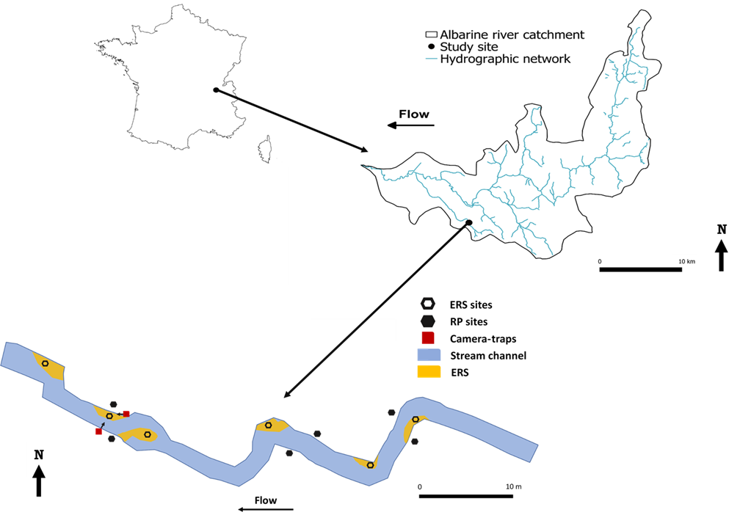
Figures
Fig. 1 Map of the Albarine river catchment, showing the location of the study site and the repartition of the different gravel bars and riparian zones used in this experiment

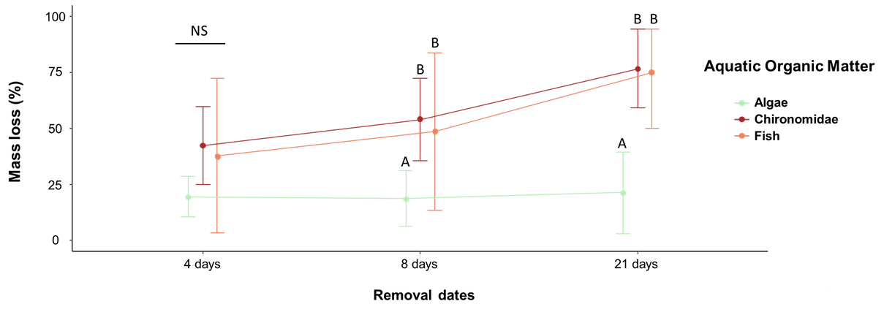
Fig. 2 Kinetic of the decomposition (mean ± SD) of the different types of aquatic organic matter. Samples from the ERS and the riparian zone were combined as no significant differences were found between the two habitats (mean ± SD). Different letters indicate significant differences between the type of AOM within each removal date; comparisons between the removal dates can be found in Table 2. Post hoc comparison within each removal date were obtained using a model containing only the AOM variable as predictor.

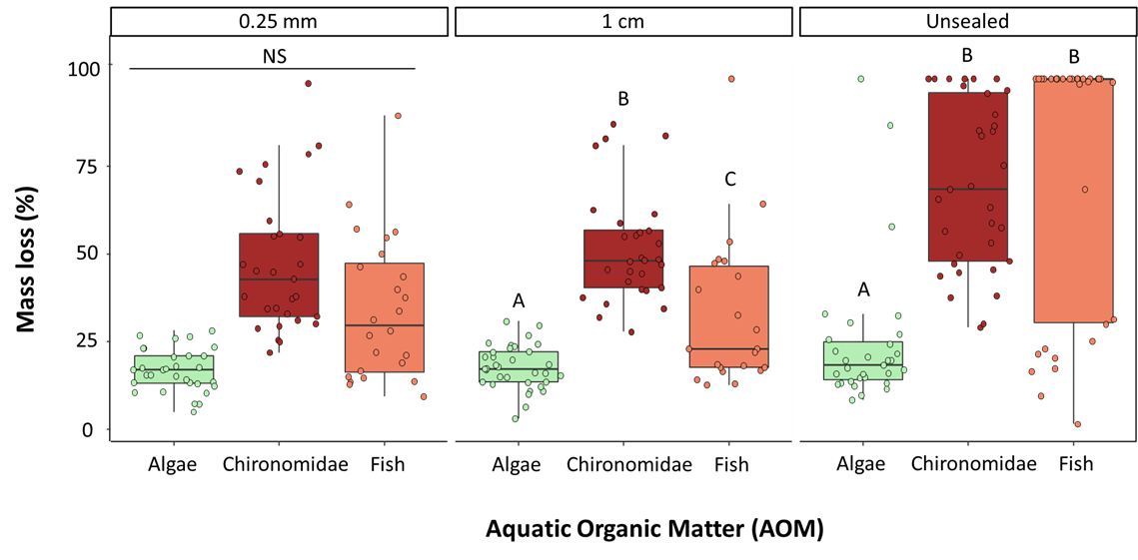
Fig. 3 Mass loss of the different types of AOM depending on the meshes applied to the cups, n = 84 for the 0.25 mm mesh, n = 85 for the 1cm mesh, n = 98 for cups without mesh. Different letters indicate significant differences between the type of AOM (all P<0.001). Differences between the mesh sizes can be found in Table 2.

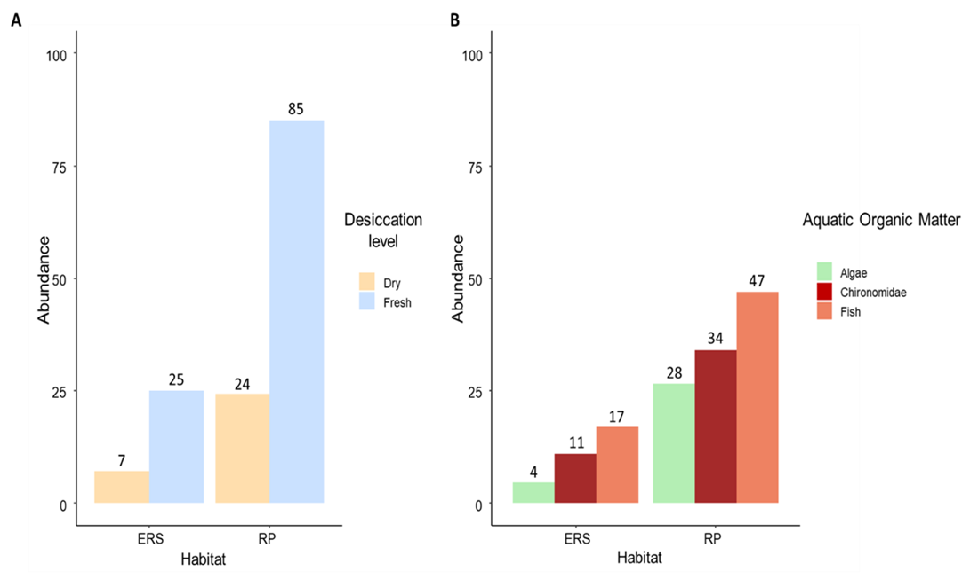
Fig. 4 A) Abundance of invertebrates found inside the cups in the exposed riverine sediments (ERS) and the riparian zone (RP) as a function of the type of treatment (Dry and Fresh). B) Abundance of invertebrates found inside the cups in the dry riverbed ERS and RP as a function of the type of organic matter present inside the cups

Supplementary Information

Order | Genus | Abundance
Diptera | Pediciidae Gen. sp. | 1
Diptera | Limoniidae Gen. sp. | 1
Diptera | Psychodidae Gen. sp. | 1
Diptera | Simuliidae Gen. sp. | 9
Diptera | Chironomidae Gen. sp. | 14
Trichoptera | Micropterna sp. | 12
Trichoptera | Stenophylax sp. | 23
Trichoptera | Drusus sp. | 1
Trichoptera | Rhyacophila sp. | 5
Trichoptera | Plectrocnemia sp. | 5
Trichoptera | Agapetus sp. | 1
Ephemeroptera | Rhithrogena sp. | 8
Ephemeroptera | Habrophlebia sp. | 5
Ephemeroptera | Baetis sp. | 3
Ephemeroptera | Alainites sp. | 2
Crustacea | Gammarus sp. | 8
Plecoptera | Brachyptera sp. | 208
Plecoptera | Nemoura sp. | 3
Plecoptera | Capnia sp. | 76
Plecoptera | Isoperla sp. | 19
Plecoptera | Perlodidae Gen. sp. | 6
Coleoptera | Agabus sp. Lv. | 1
Table S1: Macroinvertebrate abundance of the Buizin stream in March 2021. Invertebrate were sampled at 10 location, proportionally representing all benthic habitats, using a 500 µm mesh size surber sampler (0.5m²).

Table S2: Comparison of the estimates and p-values of the global generalized linear mixed effect model with a Binomial distribution and a Beta distribution. Contrast change results corresponds to the same model but with different contrast level. Unmentioned levels were the ones used as reference.
 | Binomial distribution |  | Beta  distribution
Variables | Estimate | P-value | Estimate | P-value
Intercept | -8.367 | <0.001 *** | -2.065 | <0.001  ***
Mesh size (1cm) | 0.539 | 0.623 | 0.394 | 0.124
Mesh size (unsealed) | 4.386 | <0.001 *** | 1.988 | <0.001  ***
AOM (Chironomidae) | 5.055 | <0.001 *** | 1.351 | <0.001  ***
AOM (Fish) | 4.212 | <0.001 *** | 1.607 | <0.001  ***
Removal dates (8 days) | 1.235 | 0.017 * | 0.373 | 0.017 *
Removal dates (21 days) | 3.764 | <0.001 *** | 1.041 | <0.001  ***
Desiccation level (fresh) | 1.262 | 0.191 | 0.282 | 0.252
Mesh size (1cm) : Desiccation level (fresh) | -0.632 | 0.621 | -0.523 | 0.128
Mesh size (unsealed) : Desiccation level (fresh) | -2.856 | 0.013 * | -1.088 | <0.001  ***
Contrast change
Intercept | -1.968 | 0.013 * | 0.053 | 0.811
Mesh size (0.25mm) | 0.103 | 0.925 | -0.394 | 0.124
Mesh size (unsealed) | 4.340 | <0.001 *** | 1.595 | <0.001  ***
AOM (Algae) | -4.428 | <0.001 *** | -1.351 | <0.001  ***
AOM (Fish) | -0.685 | 0.128 | 0.256 | 0.1
Removal dates (4 days) | -1.345 | 0.01 * | -0.373 | 0.017 *
Removal dates (21 days) | 2.552 | <0.001 *** | 0.668 | <0.001  ***
Desiccation level (fresh) | 0.999 | 0.265 | -0.241 | 0.316
Mesh size (0.25mm) : Desiccation level (fresh) | 0.059 | 0.963 | 0.523 | 0.128
Mesh size (unsealed) : Desiccation level (fresh) | -2.889 | 0.008 ** | -0.565 | 0.069

Table S3: Variable selected in the secondary models to test the different hypothesis
Subset of data used for the secondary models | Removal date | Dessiccation  level | Mesh size | AOM | Site | Hypothesis tested
AOM = Algae | X |  |  |  | X | H2
AOM = Chironomidae | X |  |  |  | X | H2
AOM = Fish | X |  |  |  | X | H2
Mesh size = 0.25mm |  |  |  | X | X | H3
Mesh size = 1cm |  |  |  | X | X | H3
Mesh size = unsealed |  |  |  | X | X | H3
Removal dates = 4 days |  | X |  | X | X | H4
Removal dates = 8 days |  | X |  | X | X | H4
Removal dates = 21 days |  | X |  | X | X | H4

The data were subdivided to test the different hypothesis. The different variables and subset of data were selected accordingly to their relevance to the targeted hypothesis.

Table S4: Results obtained in the secondary models focusing on H2
 | AOM Algae |  | AOM Chironomidae |  | AOM Fish
 | AIC: 34.6 |  | AIC: 86.8 |  | AIC: 99.9
Variables | Estimate | P-value | Estimate | P-value | Estimate | P-value
Intercept | -3.526 | <0.001 *** | -1.871 | <0.001 *** | -1.099 | 0.007 **
Removal dates (8 days) | -0.029 | 0.984 | 1.635 | 0.010 * | 0.234 | 0.69
Removal dates (21 days) | 0.348 | 0.809 | 5.13 | <0.001 *** | 2.261 | <0.001 ***
Contrast change
Intercept | -3.555 | <0.001 *** | -0.236 | 0.494 | -0.865 | 0.040 *
Removal dates (4 days) | 0.029 | 0.984 | -1.635 | 0.01 * | -0.234 | 0.691
Removal dates (21 days) | 0.377 | 0.793 | 3.495 | 0.001 ** | 2.028 | 0.002 **

Table S5: Results obtained in the secondary models focusing on H3
 | Mesh size: 0.25mm |  | Mesh size: 1cm |  | Mesh size: unsealed
 | AIC: 69.9 |  | AIC: NA |  | AIC: 109.4
Variables | Estimate | P-value | Estimate | P-value | Estimate | P-value
Intercept | -34.17 | 0.939 | -1.528 | <0.001 *** | -2.234 | <0.001 ***
AOM (Chironomidae) | 33.53 | 0.940 | 1.559 | <0.001 *** | 3.0667 | <0.001 ***
AOM (Fish) | 32.83 | 0.941 | 0.782 | <0.001 *** | 3.109 | <0.001 ***
Contrast change
Intercept | -6.419e-01 | 0.1 | 0.031 | 0.808 | 0.833 | 0.028
AOM (Algae) | -3.433e+01 | 1 | -1.559 | <0.001 *** | -3.066 | <0.001 ***
AOM (Fish) | -6.931e-01 | 0.276 | -0.776 | <0.001 *** | 0.043 | 0.936

AIC = NA is due to the use of a quasibinomial distribution for the respective model.

Table S6: Results obtained in the secondary models focusing on H4
 | Removal dates (4 days) |  | Removal date (8 days) |  | Removal date (21 days)
 | AIC: 77.1, 78.1, 79.0 |  | AIC: NA |  | AIC: NA
Variables | Estimate | P-value | Estimate | P-value | Estimate | P-value
Intercept | -8.494 | 0.928 | -1.647 | <0.001 *** | -1.332 | <0.001 ***
Desiccation level (fresh) | 4.980 | 0.958 | 2.351 | <0.001 *** | 30.916 | 0.99
Desiccation level (fresh): AOM (Chironomidae) | -5.189 | 0.956 | -0.607 | 0.235 | 0.198 | 0.735
Desiccation level (fresh): AOM (Fish) | -5.492 | 0.954 | -1.593 | 0.004 ** | -28.969 | 0.99
Contrast change
Intercept | -1.780 | 0.004 ** | 0.292 | 0.241 | 1.009 | 0.002
Desiccation level (fresh): AOM (Algae) | 3.2325 | 0.981 | 0.607 | 0.235 | -0.198 | 0735
Desiccation level (fresh): AOM (Fish) | -0.303 | 0.732 | -0.987 | 0.049* | -28.166 | 0.99

AIC = NA is due to the use of a quasibinomial distribution for the respective model, several AIC values correspond to the AIC values of the selected models that were used for the model averaging process.

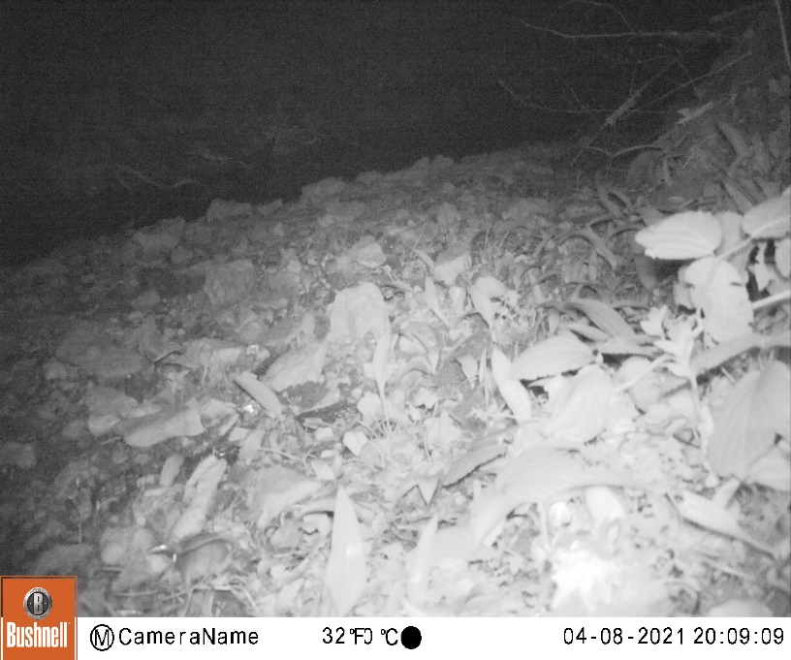
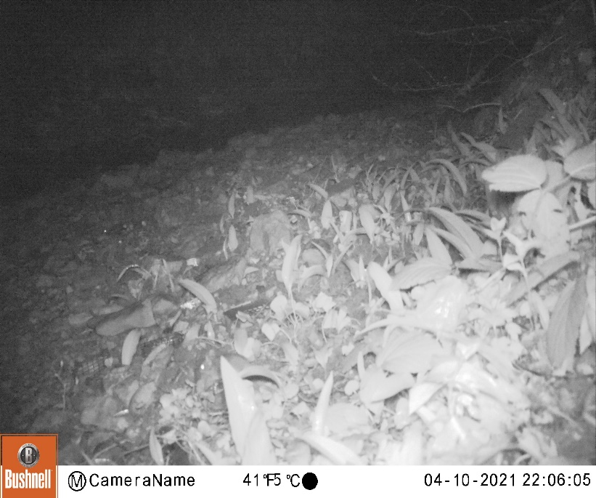
Fig. S1 Photos from the camera trap facing the aluminum cups placed in a gravel bars, red circles highlight rodents near aluminum cups

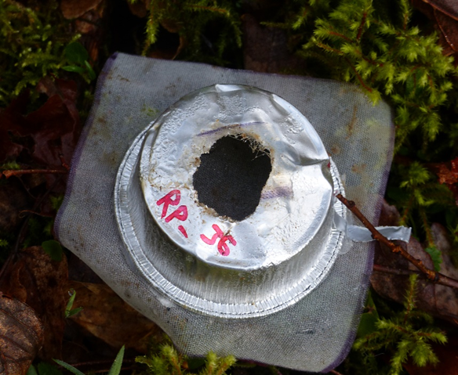

Fig. S2 Damaged and emptied sealed (0.25mm) aluminum cup that contained dried fish

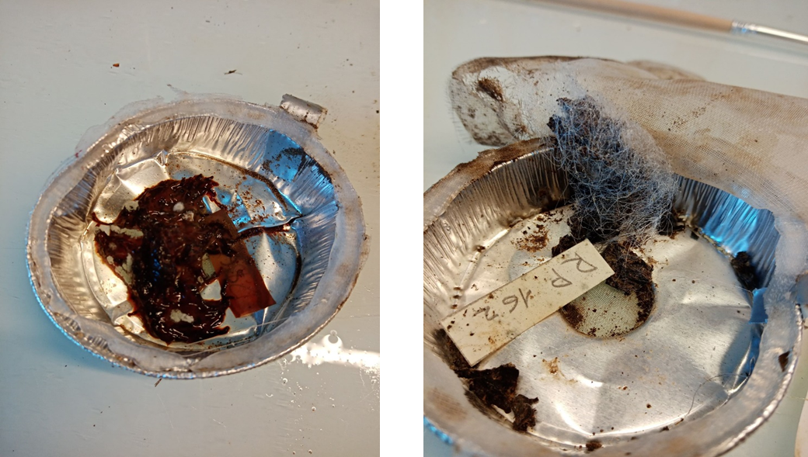
Fig. S3: Different types of molds found on the Chironomidae AOM after 21 days, fresh Chironomidae (left) and dry Chironomidae (right).

