Sustainability and operational performance assessment of supermarket air-conditioning architectures using secondary fluids and slurries

Yasmine SALEHY1,*, Hong-Minh HOANG1, Pascal CLAIN3, 1, Didier DALMAZZONE2, Laurence FOURNAISON1, Anthony DELAHAYE1

*1 Université Paris-Saclay, INRAE, FRISE, 92761, Antony, France*

*2 UCP/ENSTA Paris, Institut Polytechnique de Paris, 91120, Palaiseau, France*

*3 Léonard de Vinci Pôle Universitaire, Research Center, 92916, Paris la Défense, France*

*\*Corresponding author. E-mail addresse: yasmine.salehy@inrae.fr (Y. Salehy)*

ABSTRACT

Secondary loop architectures and phase change material (PCM) slurries could reduce the environmental impact of refrigeration and air-conditioning systems by lowering significantly the amount of primary refrigerants. However, there is a barrier to their industrial development due to the lack of studies on their behaviour in operational scenarios. The present work analyses the behaviour of different secondary loop systems in an industrial context, here the air conditioning of a supermarket in France. For this purpose, a generic approach, developed in previous work, is proposed to assess their potential of adoption. This modelling approach is able to describe the sustainability and operational performance (energy, environmental, economic, social) of refrigeration systems. After validation of the model on real architecture and components, five standard or new architectures were tested: centralized direct expansion system; secondary loop system with ethylene glycol water; secondary loop system with ice slurries, TBPB hydrate slurries or CO2 hydrate slurries. The main results of this study show that new secondary systems using hydrate slurries have better cooling energy performance than direct expansion or classical brine / ice slurry secondary systems. Moreover, even including pumping power, the life cycle climate performance of secondary loop systems is much better than that of direct expansion systems. However, the total cost of ownership of direct expansion systems is lower than that of secondary systems, but with little differences for smaller pipes. Finally, trade-offs between several performances can be proposed. For example, some architectures with suitable pipe diameters could meet TCO/LCCP-based and CAPEX/pumping-based trade-offs.

Keywords: air-conditioning, multi-performances, hydrate slurry, secondary loop, sustainability

# Introduction

With 20 % of electricity consumption worldwide (Dupont et al. 2019), the refrigeration and air conditioning (RAC) industry is one of the most energy intensive industries. Due to global warming and population growth, these figures are likely to increase significantly in the coming years. In addition, the vast majority (90 %) of RAC systems still use large amounts of primary refrigerants considered as harmful greenhouse gases (GHG) and are thus heavily regulated, with banning/strong reduction by 2030 (IEA 2020). Thus, in the context of climate change, it seems inevitable that the RAC industry must reduce significantly its carbon footprint. However, the industrial development of many sectors, such as food preservation, air conditioning, electronics, health, is dependent heavily on the cold production by refrigeration equipment (5 billion units in the world). Consequently, cold production must face both environmental challenges and industrial constraints: reducing its environmental impact while ensuring its fundamental role in the various applications.

In this context, technological innovations can be an option to achieve more sustainable solutions. For example, environmentally friendly secondary fluids can be used in indirect systems (secondary loops) to transport cold energy from production (refrigeration machine containing the primary refrigerant) to the places of use, thereby significantly reducing the primary refrigerant charge and its impact. However, as an indirect system, the secondary loop generates exergy losses due to additional components (heat exchanger, pumps). To compensate for these losses, secondary fluids with high energy density, such as PCM (Phase Change Material) suspensions (Selvnes et al. 2021), called slurries can be used. Indeed, PCM slurries, capable of storing large quantities of cold by latent heat (Song et al. 2018), theoretically improve the dimensioning, the flexibility and thus the efficiency of the installations (Dufour et al. 2017).

However, as pointed out in previous work (Salehy et al. 2023), even if the intrinsic value of an innovative technology is demonstrated to address climate change, its adoption requires consideration of the complexity of realistic industrial conditions. Moreover, it is necessary to take into account the evolution over time of the complexity of technologies and the ability of stakeholders (operators, designers, users…) to adapt to them. For example, PCM slurries are intended to improve the energy performances of secondary loops, but can also be more complex to implement with appropriate generators and control systems, which may hinder their adoption.

To better understand the potential of innovative technologies in a realistic decision-making context, it seems essential to aggregate industrial performance into a single global analysis providing interpretable data for benchmarking purposes. To address this issue, the present work aims to test the adoption potential of low-TRL (Technology Readiness Level, to assess the level of industrial maturity of a technology) slurries as secondary fluid for supermarket air conditioning using for the first time a multidisciplinary process/industrial engineering knowledge framework developed in previous work (Salehy et al. 2023). This knowledge framework combines process engineering to assess the performance of refrigeration systems and industrial engineering to structure the assessment. A case study of supermarket air-conditioning (AC) in France was chosen for the present work, as this application represents a significant energy use in buildings, accounting for about 10 % of global electricity consumption. Moreover, this application allows to test the potential of various slurries stable at temperatures above and below 273 K. The three pillars of sustainable development (Purvis et al. 2019) are assessed, i.e. environmental, economic, and social. Five potential configurations are tested (direct expansion system – DX ; secondary loop system using ethylene glycol, ice slurry, salt hydrate slurry or CO2 hydrate slurry as secondary fluids– SL) using realistic data and air conditioning system design’s data from manufacturers and literature.

# Method

The methodology used in the present work was previously dedicated to architectures of supermarket refrigeration systems (Salehy et al. 2023). The objective here is to describe the multi-performance assessment of slurry systems, i.e. technological clusters, for air conditioning. For this purpose, a knowledge framework, which follows the three standard steps of a design process (Pahl and Beitz 2013), was developed:

* Design problem definition (or task clarification): this first step aims at defining the system environment and the related requirements (here air-conditioning needs).
* Architecture definition (or conceptual design): this second step aims to define the feasible solutions, namely the system structure, including architecture, combination of components, technological innovative clusters.
* Performance assessment (or embodiment design): for this third step, various feasible solutions, even solutions at low TRL, are evaluating based on mathematical models to link together different criteria/performances.

Finally, the knowledge framework aims to highlight the need for trade-offs in scenarios based on real supermarket data. The knowledge framework is summarized in Figure 1 and detailed in the next sections.

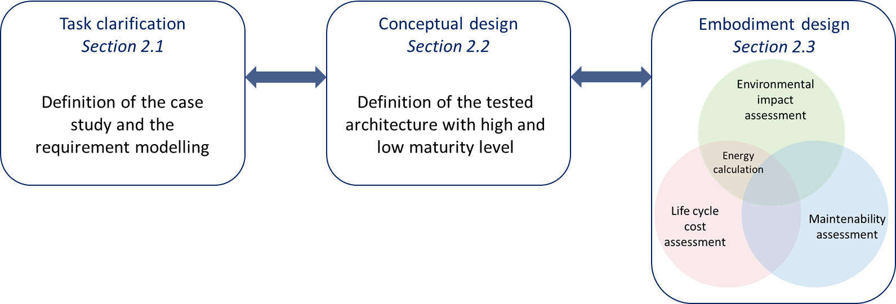

Figure 1. Summary of the knowledge framework detailed in the next sections

## Design problem definition

The objective of the design problem definition is to represent the problem scope in order to find a design solution (Gero 1990), based on two descriptions: of the system environment and of the modelling requirements/assumptions.

In this case, the description of system environment includes all the information/variables/operational conditions (Table 1) needed to calculate the internal and external cooling load and therefore the air-conditioning requirements of the supermarket: location, supermarket description (store area, opening hours, number of employees, customers, description of the walls, display cabinets).

Table 1. Variables description for the calculation of cooling load from a typical supermarket in Europe (Cecchinato et al. 2012)

|  |  |  |
| --- | --- | --- |
| Variable name | Description | Fixed data in this paper |
| Locstore | Location of the store | Paris |
| Text | External temperature | From MeteoFrance |
| Tset-point | Temperature set point for air-conditioning | 21°C, chosen in the usual range [20;25]°C |
| Astore | Store area | 3000 m² |
|  | AC working months | April to September |
| ∆t | Functioning hours | 8 hours/day |
| Nbemployees | Number of employees |  |
| Nbcustumers | Number of customers |  |
| Awall; Uwall | Walls composition, area and thermal transmittance | Concrete and glass for the windows |
| NbDC | Number of display cabinets | 15 |

Moreover, the modelling of the air conditioning (AC) requirements (or cooling power) considers the following assumptions:

* The heat losses in pipes are neglected
* In secondary loop system, temperature difference between inlet and outlet at the evaporator/heat exchanger is considered 6 K for the glycol water and less (cf. Table 3) for slurries due to the latent heat of melting of the solid-liquid phase change materials.

The cooling power for AC was calculated from the system environment variables. It can be calculated as the sum of the external and internal cooling loads:

|  |  |
| --- | --- |
| $${{\dot{Q}}_{AC} = \dot{Q}}_{external}+ {\dot{Q}}_{internal}$$ | (1) |

Where ${\dot{Q}}_{external}$, the external loads include heat flows from the external environment and ${\dot{Q}}_{internal}$, the internal loads include heat flows generated inside the building.

External loads include sensible/latent loads through the building envelope (roof, walls, floors, windows), infiltration and ventilation. Internal cooling loads include sensible/latent loads due to people, appliances, lighting and machinery, as pointed out in ASHRAE (2021) and Bhatia (2014).

In our study, the cooling requirement is based on the supermarket data from Cecchinato et al. (2012). However, multiple adaptations have been made: the location of the store is in France and the set point temperature is set to 21°C instead of 26°C. Moreover, the required cooling capacity is increased by approximately 30 % as applied by industrial designers who take into account errors or abnormal peak demands. Thus, the calculated AC cooling load is 250 kW.

## Architecture description

Two types of architecture are tested in this study: centralized direct expansion system and secondary loop refrigeration system using single phase or two-phase slurries, summarized in the Table 2.

Table 2. Summary of the tested architectures

|  |  |
| --- | --- |
| *Acronyms* | *Description* |
| DX | Direct expansion system using R404A as primary refrigerant |
| SL EG | Secondary loop system using R404A as primary refrigerant and ethylene glycol as secondary fluid |
| SL ICE | Secondary loop system using R404A as primary refrigerant and ice slurry as secondary fluid |
| SL HYD TBPB | Secondary loop system using R404A as primary refrigerant and Tetra-Butyl-Phosphonium Bromide (TBPB) hydrate slurry as secondary fluid |
| SL HYD CO2 | Secondary loop system using R404A as primary refrigerant and CO2 hydrate slurry as secondary fluid |

### Centralized direct expansion system

Supermarkets typically use centralized direct expansion (called DX in the following) system, which is a cold production system connected to the entire store by a piping network supplying primary refrigerant to all air conditioning evaporators. The cold production is usually located in a machine room, separated from the sales area. A centralized system uses multiple compressors to meet the required cooling capacity. If some compressors are not always used, the system is oversized (which is generally the case in industrial practice, as mentioned above). Here, the primary refrigerant tested is R404a. Figure 2.a illustrates the modelled centralized system (without fans and control components).

For comparison purposes, the DX system is defined as reference architecture in the following.

### Secondary loop system

Secondary loop (SL) refrigeration systems, also known as “Liquid-Chilling Systems” (ASHRAE 2008), are frequently used in industrial refrigeration and commercial comfort cooling. This architecture was first introduced to limit the use of refrigerants (toxicity/flammability, high GWP). It is composed of two loops (Figure 2.b). The primary loop, a direct expansion system using a primary refrigerant (here R404a), cools a secondary fluid in a secondary loop via the primary loop’s evaporator (Wang et al. 2010). This secondary fluid provides the cooling capacity to the places of use through heat exchangers, instead of traditional evaporators.

SL allows the containment of the primary loop and the use of climate-friendly secondary refrigerants (also known as heat transfer fluids). It reduces then the amount of primary refrigerant charge and the refrigerant leakage due to shorter circuits. Service and maintenance of SL are easier than a primary centralized system (Horton 2004). The additional cost of the pumps and heat exchanger could be offset by reducing refrigerant charge and copper pipe length (by using plastic pipe for the secondary loop) (DelVentura et al. 2007; Kazachki and Hinde 2006). They identified one disadvantage: additional energy consumption due to the intermediate circulation pumps and heat exchanger.

In this study, one single-phase fluid (ethylene glycol water) and three two-phase fluids (ice slurries, TBPB hydrate slurries, CO2 hydrate slurries) are tested.

#### Single phase secondary fluids

In traditional indirect systems, single-phase secondary fluids based on aqueous solutions have been used. Today there are also other promising technologies with secondary fluids, like two-phase carbon dioxide and ice slurry. Aqueous solutions (water + additives) have excellent thermo-physical properties. The choice of additive depends on the application. The most common freezing point depressant additives for water are glycols, alcohols and salts. For freezing (low temperature) application, salts are frequently used. Non-aqueous solutions are also used for low temperature refrigeration. To reduce energy consumption, particularly pumping power, it is preferable to use a secondary fluid with good energy transport/transfer capacity and low viscosity. To keep the maintenance cost low, it is also important to pay attention to corrosion, material compatibility, toxicity and handling security (Hägg and Melinder, 2002). So, when choosing a fluid, it is important to consider the key parameter for the application.

Ethylene glycol is slightly flammable and harmful (minimum lethal dose: 1-1.5 ml/kg). Short-term exposure can result in eye irritation, skin and respiratory tract. Repeated or long-term exposure can have effects on the central nervous system and eyes. Propylene glycol is slightly water-polluting but practically non-toxic to humans (minimum lethal dose of pure propylene glycol more than 15 times greater than with ethylene glycol). Propylene glycol has lower fire hazard when exposed to heat or flame. Propylene glycol can have quite a low pH that might affect the corrosion potential. In the following, the SL system with ethylene glycol water was studied. This configuration is called SL EG.

#### Two-phase secondary fluids

Other promising developments are two-phase secondary refrigerants such as ice or hydrate slurries. Thermophysical properties of these slurries are provided in Table 3.

Ice slurry systems offer an advantageous feature of increased thermal storage capacity in the system, thanks to the latent heat of the ice, which is approximately 333 kJ.kg-1. It involves a mixture of fluid and ice particles, formed by cooling an aqueous solution (ethanol, propylene/ethylene glycol) below its depressed freezing point (Egolf and Kauffeld 2005). The utilization of ice slurry brings enhanced heat transfer capacity. Notably, extensive testing has been conducted in display cases, yielding promising results (Bellas and Tassou 2005; Ben-Abdallah et al. 2019). Furthermore, supermarkets have also undergone testing for the implementation of ice slurry systems (Lakhdar 1998). Findings from a supermarket in France utilizing ice slurry demonstrate a higher working temperature range (268 K to 269 K) compared to the conventional range of 263 K to 265 K for the same display cabinet. Additionally, this technology exhibits improved defrosting capabilities and effective distribution of the ice slurry. However, ice slurry systems do have a drawback, namely the high cost of ice generation and accumulation, which outweighs the savings in distribution and accumulation expenses (Rivet, 2001). In the following, the SL system studied with ice slurry is called SL ICE.

TBPB (Tetra-Butyl-Phosphonium Bromide) hydrate are phase-change material, as ice, but stable at temperature higher than 273 K, up to 281 K, which improves the thermodynamic efficiency at the evaporator. Like ice, TBPB hydrates increase the storage capacity of the system thanks to their latent heat. However, the latent heat of fusion of TBPB hydrates is lower than that of ice (between 210 and 230 kJ.kg-1), implying the use of a larger solid fraction (TBPB hydrates) for the same thermal storage capacity. In addition, TBPB is quaternary phosphonium salt, highly soluble in water and classified as harmful. In the following, the SL system studied with TBPB hydrate slurry is called SL HYD TBPB.

CO2 hydrates have several advantages: they are stable over a wide range of temperature and have the highest latent heat of fusion (500 kJ.kg-1water) among all PCMs in refrigeration and air-conditioning, so the slurry flow rate or the temperature variation can be reduced to reach the desired power (Marinhas et al. 2006). The energy consumption of the secondary loop auxiliaries could thus be reduced. In addition, the high latent heat of hydrates gives thermal stability to the secondary fluid, which reduces thermodynamic irreversibility. Finally, they are green materials because they are made up of only water and CO2. In addition, a CO2 pressure higher than 1°MPa is necessary to form CO2 hydrates. In the following, the SL system studied with ice slurry is called SL HYD CO2.

|  |  |
| --- | --- |
| (a) | (b) |

Figure 2. Simplified schemes of the architectures: (a) centralized direct expansion system; (b) secondary loop refrigeration system

## Performances assessment

To assess and compare design solutions, four performances are modelled: energy consumption; environmental impact (Life Cycle Climate Performance – LCCP); financial cost (Total Cost of Ownership – TCO); and maintenance score. Energy consumption is used as an input for both environmental impact and financial cost. As in industrial design approach, the performance analysis is based on the manufacturer’s data when available, and on the choice and the sizing of components according to the cooling requirement. In particular, the maintenance score involves the knowledge of operational/industrial conditions according to the system configuration. Performance modelling steps are detailed in the following sections. In the present study, only the supermarket air conditioning is modelled.

### Energy performance assessment

#### Energy consumption

As pointed out in Ge and Tassou (2011a), the total energy consumption due to cold production in a supermarket can be defined as the sum of the contributions of the subsystems, display cabinets, cold rooms and air-conditioning. The total energy consumption can be evaluated for different time scales: yearly, monthly or daily.

In the present work, only the sub-system air-conditioning is considered. For a daily energy consumption of the air-conditioning, $E_{AC}$ (kWh/day) is calculated as follows for the reference architecture, i.e. centralized direct expansion system (DX):

|  |  |
| --- | --- |
| $${E_{AC REF}=\dot{W}}_{comp}* ∆t$$ | (2) |

Where $∆t$ is the air conditioning functioning hours, and where:

|  |  |
| --- | --- |
| $${\dot{W}}_{comp}= \frac{{\dot{Q}}_{AC}}{COP}$$ | (3) |

With ${\dot{W}}_{comp}$ the energy consumption by the compressor in kW; ${\dot{Q}}_{AC}$ the cooling power from Equation (1).

And the coefficient of performance (COP) of the refrigeration system is defined as:

|  |  |
| --- | --- |
| $$COP={COP}_{theorical}* η$$ | (4) |

With $η$ the efficiency of the compressor based on manufacturer data. In this paper, compressor irreversibility is included in this efficiency, as well as pinch in evaporator/condenser (in the following), and subcooling/superheating (included in cooling power). Other irreversibilities such as pressure drop or non-isentropic expansion are not considered.

The theoretical $COP$ is related to the cooling power ${\dot{Q}}_{AC}$, the compressor power ${\dot{W}}_{comp_day}$, and thus the power at the condenser, and is defined as follows:

|  |  |
| --- | --- |
| $${COP}_{theorical}=\frac{T_{c}}{T_{h}-T_{c}}$$ | (5) |

With $T_{c}=T_{set point}-{Pinch}_{c}$ and $T_{h}=T_{outside}+{Pinch}_{h}$. ${Pinch}_{c}$ and ${Pinch}_{h}$ are defined as the difference between the air temperature and the evaporating or condensing temperature, respectively. This data is provided by manufacturer and depends on the type of architecture and the type of primary fluid used.

The other four architectures considered in this work (SL EG; SL ICE, SL HYD TBPB; SL HYD CO2) are based on potential technological clusters (secondary loop; secondary fluid – single-phase fluid or PCM slurries; type of PCM– CO2 hydrate, TPBP hydrate, ice). For each architecture, the calculation of $E_{AC}$ is based on $E_{AC REF}$ defined in Equation (2) and an additional term, $E_{cluster}$, corresponding to the energy consumption added (lost) or removed (gained) by the technological cluster:

|  |  |
| --- | --- |
| $$E_{AC}=E_{AC REF}+E_{cluster}$$ | (6) |

The term $E_{cluster}$ is due to two changes induced by the four architectures: an additional pumping energy, $E_{cl pump}$, to circulate the fluid (single-phase or slurry) in the secondary loop; a change in the COP of the primary machine due to the indirect system (secondary loop) resulting in a modified compression work, $E_{cl COP}$:

|  |  |
| --- | --- |
| $$E_{cluster}=E_{cl pump}+E_{cl COP}$$ | (7) |

The pumping energy $E_{cl pump}$ is conventionally calculated from the flow rate and the pressure drop in the secondary loop. In this work, the pressure drop is assimilated in first approach to the linear pressure drop.

|  |  |
| --- | --- |
| $$E_{cl pump}=(∆P×\dot{V})×∆t$$ | (8) |

With $∆P$ is the pressure drop determined from Equation (9), $∆t$ the time (could be opening and closing hours), $\dot{V}$ the volumetric flow rate determined for the single-phase secondary fluid from the power and temperature difference data at the heat exchangers (Table 3). The same flow rate is used in the case of slurries where the linear pressure drop $∆P$ is calculated using the Darcy-Weisbach formula:

|  |  |
| --- | --- |
| $$∆P=f\frac{ρu^{2}L}{2D}$$ | (9) |

With *D* the diameter and *L* the length of the pipes, *u* and $ρ$ the velocity and the density of the fluid, and *f* the Darcy friction coefficient, related to the Reynolds number (in laminar or turbulent regime), itself depending on the viscosity of the fluid. The viscosity of the fluid is given by rheological models developed in previous work for ice (Lakhdar 1998) , TBPB hydrate (Clain et al. 2012; Salehy et al. 2017) and CO2 hydrate slurries (Jerbi et al. 2013). These models show that viscosity depends on hydrate fraction and that hydrate slurries are non-Newtonian fluids and so, also depends on shear rate. The behavior models used in our work have been compared to other existing models in the literature (Majid et al. 2018). The results show that the behaviors obtained of different experimentations are similar, albeit with slightly different models.

The modified compression work due to the cluster, $E_{cl COP}$, results from the difference between the compression work using the COP of the reference system (centralized direct expansion system), ${COP}_{REF}$, and the compression work using the COP with the cluster, ${COP}_{cluster}$:

|  |  |
| --- | --- |
| $$E_{cl COP}=\left(\frac{{\dot{Q}}_{AC}}{{COP}_{cluster}}-\frac{{\dot{Q}}_{AC}}{{COP}_{REF}}\right)∆t$$ | (10) |

Finally, the determination of the COP with the cluster is related to several factors: the type of primary refrigerant used (which can be different between a centralized direct expansion system and a secondary loop) and consequently the temperature change of the primary fluid at the evaporator and the condenser; the efficiency of the compressor (Wang et al. 2010).

#### Determination of secondary fluid properties

The knowledge of the secondary fluid properties is necessary to calculate the energy consumption due to secondary loop systems. In particular, the thermal behavior of the secondary fluid submitted to cooling/heating flux has an impact on COP.

In the case of single-phase secondary fluids, the cooling capacity, ${\dot{Q}}_{AC}$, leads to a temperature variation ($∆T$) between the inlet and the outlet of the secondary-loop heat exchangers used to absorb heat from the environment, according to the following equation:

|  |  |
| --- | --- |
| $${\dot{Q}}_{AC}=\dot{V}ρ_{liq}{Cp}_{liq}∆T$$ | (11) |

Where $\dot{V}$ is the volume flow rate of the secondary fluid, $ρ_{liq}$ the density of the liquid, ${Cp}_{liq}$ the heat capacity of the liquid, and $∆T$ the temperature difference between the inlet and the outlet of the secondary-loop heat exchangers. The same $∆T$ is found between the inlet and the outlet of the evaporator on the secondary fluid side. Indeed, in a first approach, the piping system is considered perfectly insulated (consistent hypothesis insofar as thermal leakage could also contribute to the cooling of the ambient) and the heating due to the friction of the secondary fluid negligible compared to the cooling demand. As a result, this additional $∆T$ due to the secondary loop modifies the evaporation temperature of the primary fluid ($T_{c}$), and therefore the COP (cf. Equations (4) and (5)).

However, in the case of PCM slurries, the cooling capacity leads to both a temperature variation ($∆T$) and a melting of a part of the PCM resulting in a variation of the PCM volume fraction ($∆φ$) between the inlet and outlet of the secondary-loop heat exchanger. To determine the couple ($∆T$, $∆φ$), two thermal and thermodynamic approaches are used. The first is a heat balance between the inlet and the outlet of the secondary-loop heat exchanger:

|  |  |
| --- | --- |
| $${\dot{Q}}_{AC}=\dot{V}\int_{inlet}^{outlet}{[φ_{PCM}ρ_{PCM}C_{p, PCM}dT+\left(1-φ_{PCM}\right)ρ_{liq}C_{p,liq}dT+ρ_{PCM}{∆H}_{PCM}}dφ_{PCM}]$$ | (12) |

Where $φ_{PCM}$ is the volume fraction of PCM, $ρ_{PCM}$ the density of the PCM, and $C_{p, PCM}$ the heat capacity of the PCM, and ${∆H}_{PCM}$ the latent heat of melting of the PCM.

The thermodynamic momentum law based on the solid-liquid equilibrium curve (liquidus) in the case of ice slurry and TBPB hydrate slurry (Figure 3) gives the second relationship. In fact, during the formation of PCM slurries, the solute fraction (ethanol in the case of ice slurries or TBPB in the case of TBPB slurries) of the residual liquid varies. For ice slurries, the PCM (ice) is only composed of water, so the solute fraction of the residual liquid increases during the PCM formation. For TBPB hydrate slurries, the PCM (TBPB hydrate) is composed of water and TBPB at the stoichiometric concentration, 37 wt% of TBPB according to Dyadin and Udachin (1984) and Mayoufi et al. (2011), corresponding to the following hydrate composition: TBPB.32H2O. This concentration corresponds to a compound exhibiting congruent melting, as pointed out in our previous paper (Mayoufi et al. 2011). Dyadin and Udachin (1984) also mentioned the existence of a second, noncongruent melting hydrate TBPB.36H2O, and Muromachi et al. (2014) a composition of 2TBPB･76H2O, i.e TBPB.38H2O: these two compositions are closed, and corresponds to TBPB concentration ranging from 33 to 35 wt%. In the following, two TBPB stoichiometric concentrations will be tested: 33 and 37 wt%.

Thus, for initial solute fraction lower than the stoichiometric composition, the PCM formation causes a decrease of the solute fraction of the residual liquid. For both slurries, however, the same momentum law can be defined, from Guilpart et al. (2006) or Clain et al. (2012). This relationship expresses the mass fraction of PCM in the slurry, $X_{PCM}$, from the initial mass fraction of solute, $x_{ini}$, the final mass fraction of solute in the residual liquid phase (depending on the final temperature), and the solute composition of the PCM, $x_{PCM}$ (0 wt% for ice and 37,1 wt% for TBPB hydrate):

|  |  |
| --- | --- |
| $$X_{PCM}(T)=\frac{x_{fin}(T)-x_{ini}}{x_{fin}(T)-x_{PCM}}$$ | (13) |

In the case of CO2 hydrate, a fraction model inspired by the momentum law adapted to the three-phase equilibrium CO2 Hydrate-Liquid-Vapor (HLV) was developed in previous work (Marinhas et al. 2006) and used to determine the mass fraction of CO2 hydrate in the secondary loop.

Finally, mass fraction of PCM was converted into volume fraction by the following equation:

|  |  |
| --- | --- |
| $$φ_{PCM}(T)=\frac{\frac{X_{PCM}(T)}{ρ_{PCM}}}{\frac{X_{PCM}(T)}{ρ_{PCM}}+\frac{1-X_{PCM}(T)}{ρ_{liq}}}$$ | (14) |

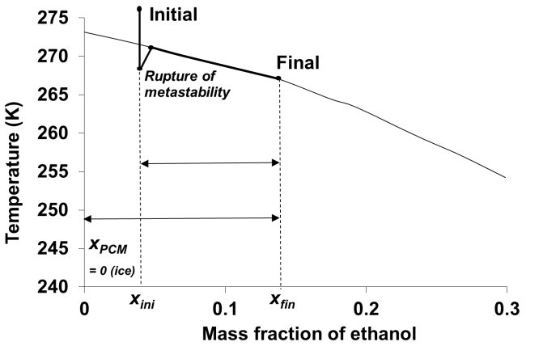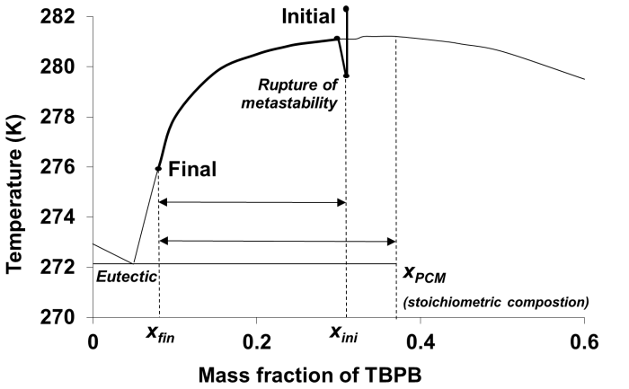

Figure 3. Phase diagram of water-ethanol (a) and water-TBPB (b) to illustrate the calculation of the mass fraction of PCM (momentum law).

### Environmental impact assessment

To assess the environmental impacts of the refrigeration system, the chosen method is Life Cycle Climate Performance (LCCP), characterising the global emissions of a refrigeration system during its whole lifecycle (Huang et al. 2015):

|  |  |
| --- | --- |
| $$LCCP= \sum{DEm}+\sum{IEm}+\sum{EEm}$$ | (15) |

With $DEm$ the direct emissions; $IEm$ the indirect emissions; $EEm$ the embodied emissions.

In this study, LCCP is expressed in kgCO2eq, without considering other categories of environmental impacts such as ozone depletion or eco-toxicity. The detailed equations can be found in Salehy et al. (2023).

The direct emissions are the sum of the emissions related to the refrigerant leakage occurring during the exploitation phase, also called Middle Of Life (MOL), and the End-Of-Life (EOL) treatment phases:

|  |  |
| --- | --- |
| $$\sum{DEm}= DEm_{refleak,MOL}+ {DEm}_{refleak,EOL}+/- {DEm}_{cluster}$$ | (16) |

The indirect emissions are the emissions related to the energy (electric) consumption of the system during the MOL:

|  |  |
| --- | --- |
| $$\sum{IEm}= {IEm}_{sys,MOL}+/- I{Em}_{cluster}$$ | (17) |

The embodied emissions are the emissions related to the manufacture called Beginning Of Life (BOL) and EOL treatment:

|  |  |
| --- | --- |
| $$\sum{EEm}= EEm_{sys,BOL}+ EEm_{ref,BOL}+ EEm_{sys, EOL}+/- {EEm}_{cluster}$$ | (18) |

The lifetime of the refrigeration system is considered to be ten years. The necessary properties (GWP of each material manufacture, electricity) were found in EcoInvent v3.8 database (Wernet et al. 2016).

### Total costs

To evaluate the cost of the refrigeration system through its lifecycle, the chosen metric is the Total Cost of Ownership (TCO) (Ellram 1995). It is calculated as the addition of all direct and indirect costs during the system lifecycle. It consists in the sum of the capital costs (CAPEX) and the operational costs (OPEX).

The TCO is calculated based on the following equations:

|  |  |
| --- | --- |
| $$TCO= CAPEX+OPEX$$ | (19) |

Where the installation costs depend on the cooling requirement in kW and the type of architecture installed. The maintenance costs depend on the system architecture, presented in previous work (Salehy et al. 2023).

### Maintenance evaluation

In this paper, the maintenance is evaluated both quantitatively by the TCO and qualitatively as a score that depends on the architecture and the refrigerant. It is based on four sub-classes from Geng et al. (2013): accessibility, error proofing, ergonomic and physical injury. Some evaluation elements, such as ergonomics is adapted for refrigeration systems, as well as rank illustrations according to an illustration table detailed in Salehy et al. (2023). The higher the score, the more difficult the system is to be maintained and installed. The maintenance score is evaluated as follows:

|  |  |
| --- | --- |
| $$MS=AS+RS+CS$$ | (20) |

Where $MS$ is the total maintenance score, $AS$ the architecture score and $RS$ the refrigerant score are defined in equation 21 and 22 as:

|  |  |
| --- | --- |
| $$AS=accessibility score+ error proofing score+ ergonomic score+ physical injury score$$ | (21) |
| $$RS= error proofing score+ physical injury score$$ | (22) |

As presented by Geng et al. (2013), the concept of accessibility encompasses various elements, including visibility, reachability, and operation space. The visibility score ensures that personnel have a clear view of the system during maintenance, playing a crucial role in man-machine interaction and manipulation. Reachability score assesses the feasibility of accessing the system along predetermined maintenance paths. Operation space score considers the available space for human movement and operation.

The error-proofing score is concerned with enhancing maintenance safety by scrutinizing designs and marking criteria. This includes evaluating the percentage of marked design characteristics.

The ergonomic score focuses on the man-machine interface, taking into account physiological and psychological factors to identify design flaws. It aims to provide suggestions for ensuring safe operation during the maintenance process.

The physical injury score is utilized to validate criteria for preventing physical harm, aligning with the criteria for error-proofing design.

And $CS$ the cluster score is the additional score of the other technological clusters included in this study, i.e., secondary loop components.

# Results

## Model verification

To check whether the modelling method is well implemented, the energy consumption of a refrigeration system for air conditioning only was simulated and compared to experimental data from a case study of a simulated supermarket (Cecchinato et al. 2012).

The surface area of the supermarket is approximately 3 000 m². The air conditioning is considered active during the summer period from April to September inclusive, 14 hours per day, 6 days per week. The set point temperature is 26°C and the relative humidity is 60 %. The total energy consumption obtained in their study for air conditioning only from April to September was 53 500 kWh. In the proposed model, the total energy consumption obtained was 50 681 kWh. Thus, there is a relative difference of 5 %, which is considered acceptable.

## General results

In the following sections, the results include the monthly and yearly energy consumption for air conditioning, the lifecycle climate performance (LCCP), the total cost of ownership (TCO) and the maintenance scores.

### Preliminary results of secondary fluid behavior

Before modelling the energy consumption in various systems, the thermal behavior of the secondary fluids was determined. In the case of a single-phase secondary fluid (ethylene glycol), the cooling capacity is directly related to the sensible heat of the fluid, and therefore to its temperature variation. According to the section 2.2 (Design problem definition), the temperature difference between the inlet and the outlet at the evaporator/heat exchanger is set at 6 K, while the cooling capacity is 250 kW. Using Equation (11), it is possible to deduce the flow rate of the secondary fluid.

In the case of PCM slurries (ice, TPBP hydrate, CO2 hydrate), the cooling capacity is mainly due to the melting of a part of the PCM ($∆φ$), but also to a temperature variation ($∆T$). The coupling between the thermal approach (by heat balance, Equation (12)) and the thermodynamic approach (by the momentum law, Equation (13)) allows a unique couple ($∆T$, $∆φ$) to be defined. This couple ($∆T$, $∆φ$) is obtained with the same volume flow rate and is suitable for the power and temperature level required by the application. To facilitate the reformation of slurry in the loop, it is recommended to keep a minimum PCM fraction in flow. Thus, the PCM fraction of the low concentrated slurry (part of the loop from the heat exchanger outlet to the evaporator inlet) was set to 2 %. The PCM fraction of the more concentrated slurry (from the evaporator outlet to the heat exchanger inlet) was then deduced by adding the fraction difference ($∆φ$). Table 3 gathers various properties including $∆T$ and $∆φ$ for all the secondary fluids, corresponding to a cooling capacity of 250 kW and the same flow rate as for the single-phase fluid (11.2 10-3 m3.s-1). The heat capacity of all solid PCMs is considered equivalent to that of ice (2 kJ.kg-1.K-1). This assumption is based on the fact that a 10% error on this value results in a negligible error on $∆T$ and $∆φ$.

Table 3. *Properties of the secondary fluids for a cooling capacity of 250 kW and a flow rate of 11.2 10-3 m3.s-1*

|  |  |  |  |  |  |  |  |  |
| --- | --- | --- | --- | --- | --- | --- | --- | --- |
| Secondary fluid | (kg.m-3) | (kJ.kg-1.K-1) | (kg.m-3) | (kJ.kg-1) | (K) | (K) | (vol%) | (vol%) |
| Single-phase (EG-water) | 1053 | 3.56 | - | - | 278 | 6 | - | - |
| Ice slurry (EA-water) | 984 | 4.39 | 917 | 333 | 267 | 0.3 | 19.2 | 6.9 |
| TBPB hydrate slurry (TBPB.32H2O) | 1000 | 4.18 | 1140 | 204 | 278 | 0.9 | 16.6 | 8.2 |
| CO2 hydrate slurry | 1012 | 4.18 | 1065 | 374 | 278 | 2.1 | 5.5 | 3.5 |

According to Table 3, the use of slurries decrease logically the temperature difference between inlet and outlet of the heat exchanger (∆T), and thus of the evaporator in the opposite direction, from 6 k to 0.3 K, 0.9 K, and 2.1 K, for ice slurries, TBPB hydrate slurries, and CO2 hydrate slurries, respectively. This temperature difference decrease is accompanied with a PCM melting of 6.9 vol%, 8.2 vol%, and 3.5 vol%, for the same slurries. In the case of TBPB hydrate, if the stoichiometric concentration is changed from 37 to 31 wt%, the differential hydrate fraction in the heat exchanger $∆φ$ would change from 8.2 to 8.4 vol% which corresponds to a differential temperature $∆T$ of 0.78 K (instead of 0.9 K), and the hydrate fraction at the inlet of the heat exchanger $φ_{PCM inlet}$ would change from 16.6 to 19.6 vol%. The impact on the heat exchanger is thus not significant, but the pumping power could increase by approximately 7 %. In the following, the performances will be calculated with a stoichiometric concentration of 37 wt%.

Thus, the melting of a few percent of PCM in the case of ice or TBPB hydrate slurries is accompanied by a small temperature variation. This behavior is due to the solid-liquid phase diagram (liquidus curve) of ethylene glycol-water (forming ice slurries) and TBPB-water (forming TBPB hydrate slurries) which has a slope close to the horizontal under our operating conditions. Such characteristic has two consequences on the system control. On the one hand, the adjustment of the solid fraction of the slurry is delicate, which is emphasized by Guilpart et al. (2006) who recommend working at a temperature lower than 268 K (in the case of water-ethanol mixture, which is very close to ethylene glycol-water mixture in our operating range) to ensure sufficient accuracy. On the other hand, once the slurry is formed, its control inside the heat exchanger is less difficult because the melting of the PCM does not involve a large temperature variation.

The lower value of melted fraction for CO2 hydrate slurry ($∆φ=3.5 \%$) is due to a higher latent heat of melting (dissociation enthalpy), compared to ice and TBPB hydrate. This lower value of PCM melted also corresponds to a higher value of temperature difference, which is governed by a CO2-Liquid-Vapor Hydrate phase diagram with a greater dependence on temperature. This slurry is therefore easier to control than the other two systems (ice and TBPB hydrate), but is accompanied during the melting of the CO2 hydrate by a small but significant temperature variation.

### Energy consumption

#### Cooling energy consumption

Figure 4 represents the yearly cooling energy consumption and the COP for the air conditioning of a supermarket (described in Section 2.3.1.) from April to September for the five studied architectures: centralized direct expansion using R404a (DX); secondary loop using ethylene glycol water (SL EG); secondary loop using ice slurry (SL ICE); secondary loop using TBPB hydrate slurry (SL HYD TBPB); secondary loop using CO2 hydrate slurry (SL HYD CO2). The energy consumption for air cooling and the COP depends mainly on the architecture and the associated components (including secondary fluids), while the cooling requirement and the weather are the same for all architectures.

According to Figure 4, the secondary loop system using single-phase fluid (SL EG) or ice slurry (SL ICE) are more energy consuming than the centralized direct expansion system (DX). This result seems logical since SL EG and SL ICE are indirect systems which use additional components (pump, heat exchanger). However, in the case of secondary loop, the compressor efficiency can be higher than in the case of direct expansion system due to lower condensing pressure floating, as pointed out in Wang et al. (2010). But this improvement is compensated by a lower theoretical COP due to a lower operating temperature of the evaporator. Indeed, for SL EG, the temperature difference between the inlet and outlet of the evaporator on the secondary fluid side is 6 K, while for SL ICE, it is necessary to reach a temperature lower than 273 K. Indeed, for ice slurries, the range of application is limited due to the thermodynamic stability of ice slurries. According to Kauffeld et al. (2005), slurries are stable only between -5 and -6°C. In addition, extra energy for defrosting could be added in the case of ice slurry. As a consequence, SL EG and SL ICE have the lowest COP, 5.3 and 4.5, respectively. In contrast, SL systems using TBPB hydrate or CO2 hydrate slurry are more efficient than SL EG, SL ICE and even DX system according to our model. Indeed, this can be explained mainly by the fact that these hydrate slurry systems work at higher temperature than 273 K, contrary to SL ICE, and also because the evaporator/heat exchanger temperature difference for TBPB hydrate and CO2 hydrate slurries are only 0.9 K and 2.1 K, respectively, which is about 6 to 3 times lower than for SL EG. Consequently, considering the COP of the various architectures, the energy consumption of the primary circuit compressor with SL HYD TBPB and SL HYD CO2 system is much lower than SL ICE and SL EG system, and even lower than DX system due to the weak temperature differences combined to the better compressor efficiency of SL system.

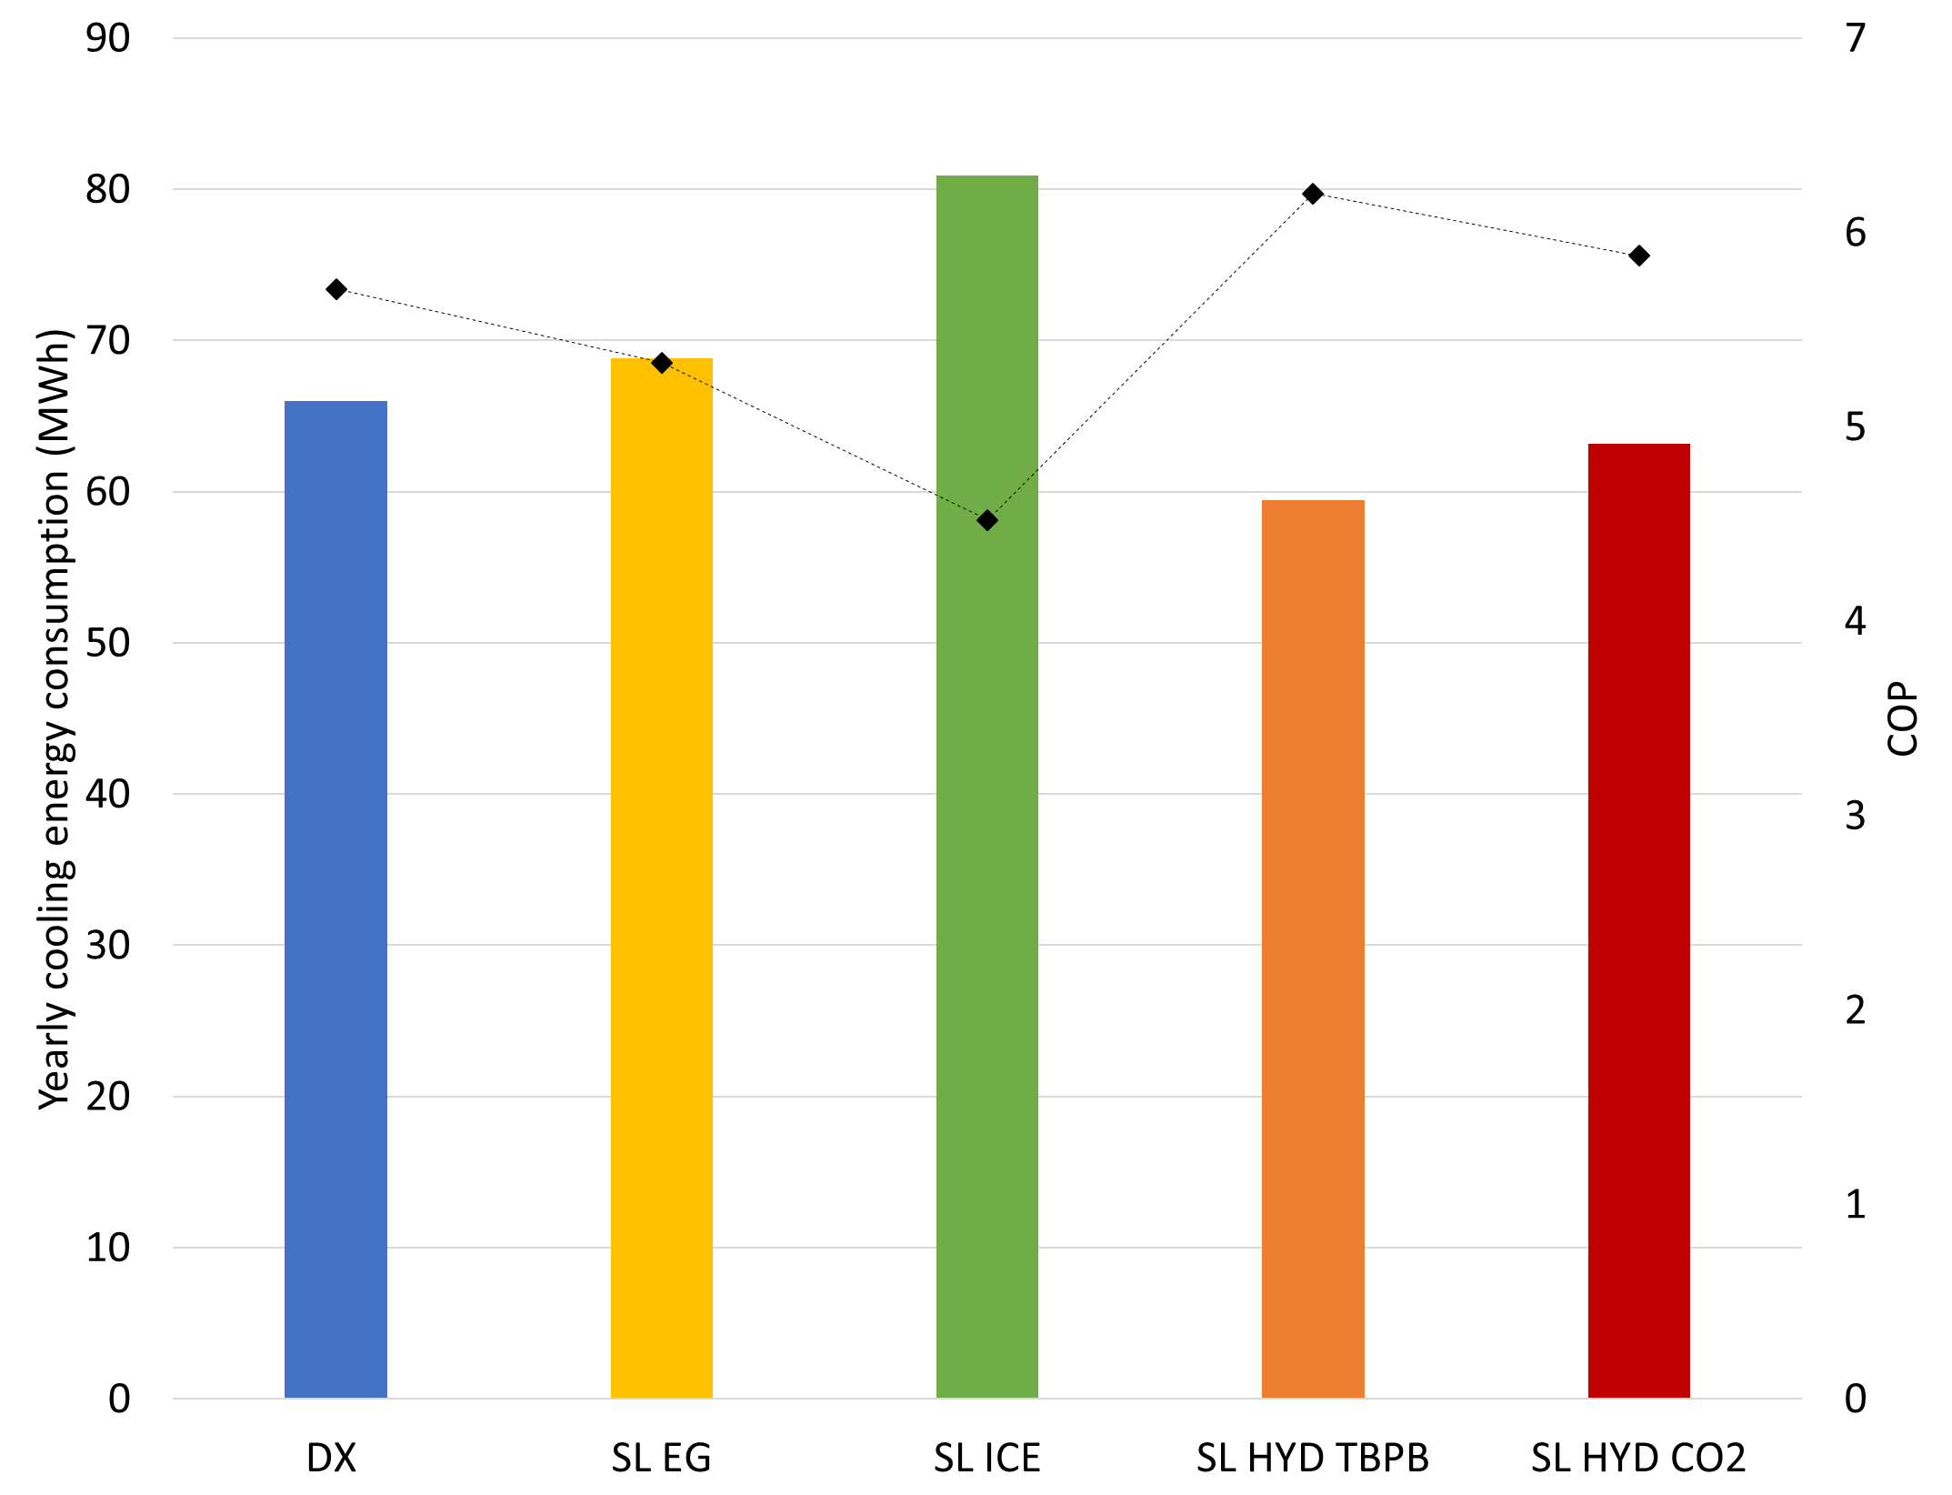

Figure 4. Yearly cooling energy consumption (histograms) and mean COP (points) for the five architectures: DX; SL EG; SL ICE; SL HYD TBPB; SL HYD CO2

#### Cooling and pumping energy consumption

In order to compare the total energy consumption of the various systems, it is necessary to consider not only the cooling energy consumption, but also the contribution of the pumping energy to circulate the secondary fluid in the SL system. Figure 5 represents the total energy consumption (cooling and SL pumping) for the same five architectures: DX; SL EG; SL ICE; SL HYD TBPB; SL HYD CO2.

As explained in Section 2.3.1., the pumping power is calculated from the fluid velocity and the friction factor, and thus from the Reynolds number, itself related to the viscosity of the secondary fluid. In the case of slurry, the viscosity, and thus the pumping energy, is higher with higher solid (ice, hydrate) fraction. This also explains why the viscosity of slurries is higher than the viscosity of a single-phase fluid, and so the pumping energy, even if SL EG and SL HYD CO2 results are close, as shown in Figure 5.

It is important to note that, according to the rheological models used in this work, the viscosity of ice slurry (Lakhdar 1998) is higher than that of TBPB hydrate slurry (Clain et al. 2012), itself higher than that of CO2 hydrate slurries (Jerbi et al. 2013), for the same solid fraction. In addition, SL ICE needs to operate at a maximum temperature of 268 K to be sufficiently accurate (Guilpart et al. 2006). Consequently, a minimum solid fraction about 19 vol% is required for SL ICE. For the same reason related to the phase diagram (Figure 3), a solid fraction about 16 vol% is obtained for SL HYD TBPB On the other hand, CO2 hydrate slurries need only a low solid fraction about 5 vol% thanks to their thermodynamical behaviour, and also to their high latent heat of melting. Consequently, due to the solid fraction dependency of the viscosity and the solid fraction range for each slurry, the viscosity, and thus the pumping energy, is the highest for SL ICE and the lowest for SL HYD CO2 when comparing the three slurry systems.

Moreover, since the pumping energy depends strongly on the pipe diameter, the results of Figure 5 are presented for various pipe diameters, from 0.05 to 0.1 meters. In the case of 0.08 and 0.1 pipe diameter, the pumping energy is much lower than the cooling energy. The total energy consumption, including pumping and cooling energy, is even very close to the total energy consumption of DX system. However, as the pipe diameter is reduced, the pumping energy may equal or exceed the cooling energy for some configurations. Only based on this figure, the 0.05 pipe diameter should not be retained since in this case the pumping energy is even higher than the cooling energy. At this stage, to confirm the interest of using 0.06, 0.08 or 0.1 pipe diameter, an analysis considering both energy consumption and cost can be useful.

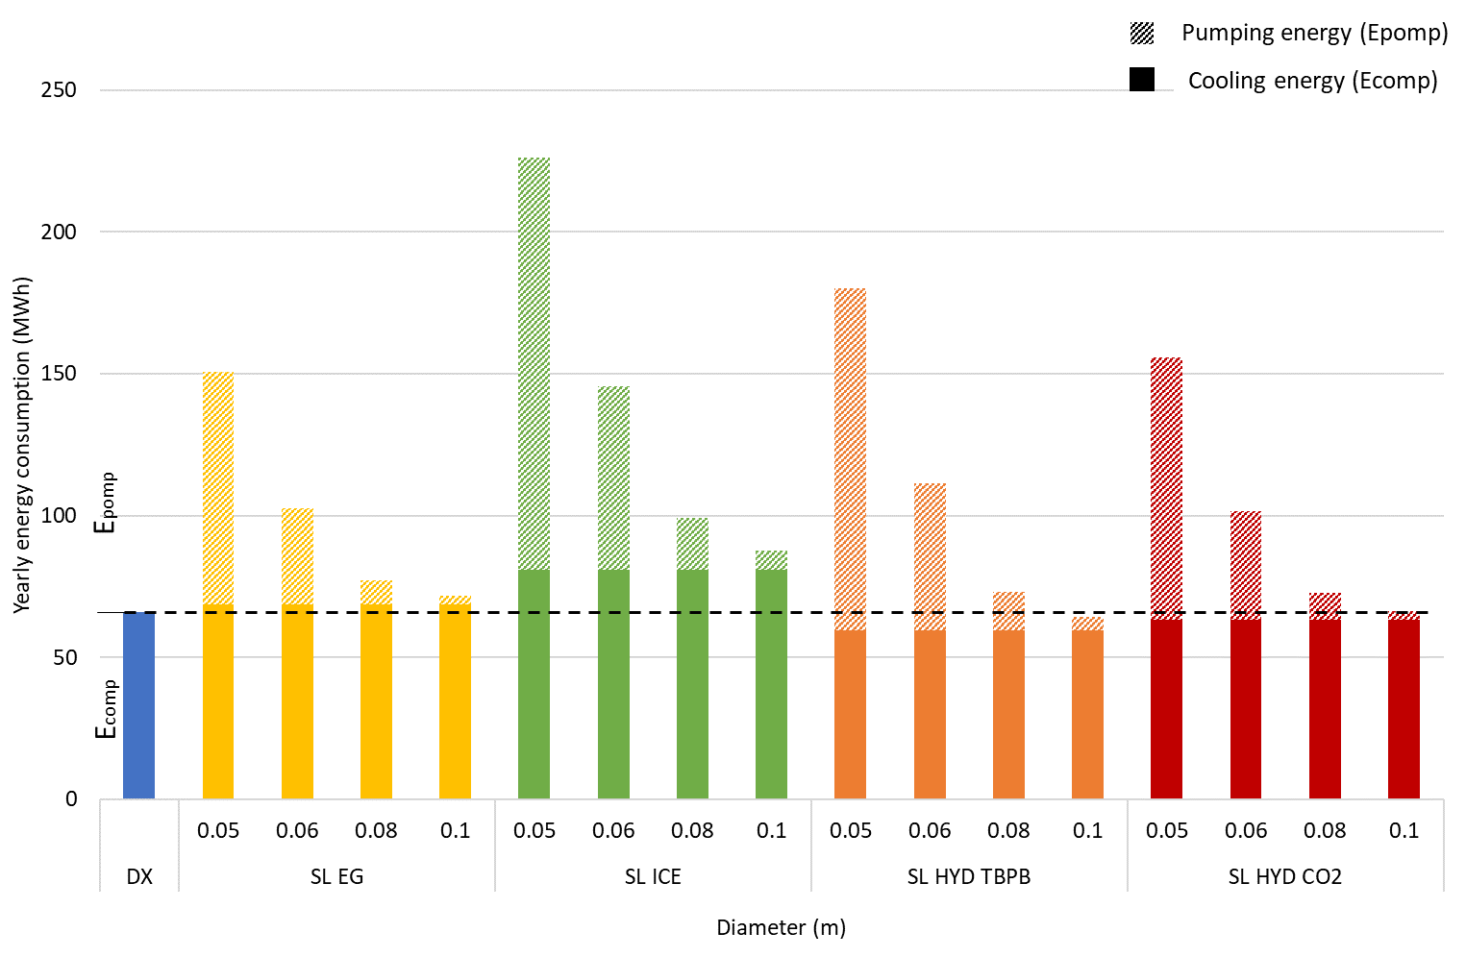

Figure 5. Yearly energy consumption, composed of the cooling energy (Ecomp) and the pumping energy (Epump) for the five architectures: DX; SL EG; SL ICE; SL HYD TBPB; SL HYD CO2

Figure 6 represents the pumping power of the various SL systems as a function of the pipe diameter. Moreover, the cooling powers for all systems (DX and the four SL) are illustrated by horizontal lines for comparison with the pumping powers. Finally, the capital cost (CAPEX) of the pipes is also represented as a function of the pipe diameter. As expected, the pumping power decreases while the CAPEX increases when increasing the pipe diameter. The length of the pipes is almost the same for all of the diameters, since only the length of the pipe in the heat exchangers varies due to the diameter change. Moreover, the pumping power is lower than the cooling power only for 0.06, 0.08 and 0.1 diameters, which is consistent with Figure 5. However, the difference between pumping and cooling power is not the same for all the secondary fluids. The pumping powers for SL EG and SL HYD CO2 are close to each other (13% difference). The pumping power for these configurations is clearly lower than the cooling power at 0.06 diameter by about 50%, and even lower at 0.08 (88% less) and 0.1 (95% less). In the case of SL ICE and SL HYD TBPB, the difference between cooling and pumping powers is less significant at 0.06 with only 15% difference, but clearly higher at 0.08 (77% less) and 0.1 (92% less). However, the CAPEX for 0.08 and 0.1 m diameter pipes is higher than 0.05 and 0.06. So, a trade-off could be found with a diameter higher than 0.06 m to have a significant effect on pumper power decrease and lower than 0.08 m to have a significant effect on the CAPEX. It is important to note that the TCO (total cost of ownership) is not represented in Figure 6, but the CAPEX is also considered as a crucial data to be taken into account by the stakeholders when deciding on the choice of architecture, even if the operational costs can offset the investment expenses.

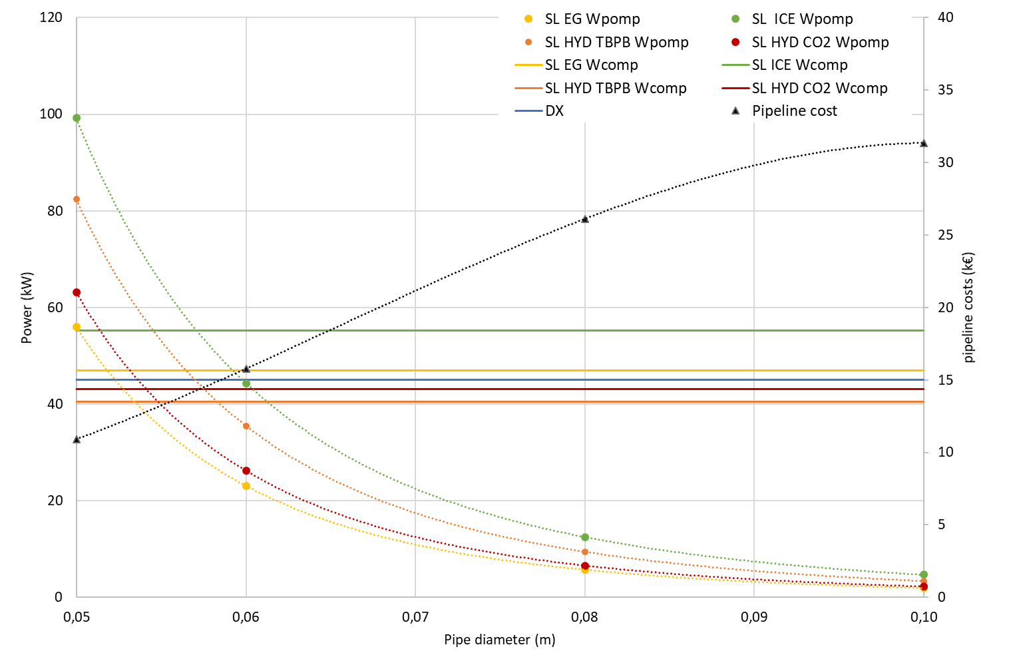

Trade-off zone

Figure 6. Pumping power and pipeline costs as a function of the pipeline diameters for the five architectures: DX; SL EG; SL ICE; SL HYD TBPB; SL HYD CO2.

### LCCP

Figure 7 represents the LCCP calculated over ten years for all of the architectures: DX; SL EG; SL ICE; SL HYD TBPB; SL HYD CO2, obtained with different pipeline diameters. The histograms detail the embodiment emissions of the manufacturing and end-of-life phases (full histogram, EEm, Equation (18)), the indirect emissions from energy consumption (hatched histogram, IEm, Equation (17)) and the direct emissions from refrigerant use and leakage during the different phases of the machine's life cycle (histogram with points, DEm, Equation(16)).

Although the impact due to energy consumption of SL systems with brine and ice slurry is higher than that of DX, the LCCP of DX is much higher than that of SL. The main difference between the DX and SL systems is the type of primary fluid used, which has a high GWP (R404a). Moreover, DX systems use larger amounts of primary refrigerant than SL systems. Indeed, for the DX system, the quantity of refrigerant is approximately 262 kg, with a flow rate of 5.1 10-2 m3.s-1. As for SL system, the quantity is reduced by a ratio of 10, to around 28 kg. This is mostly due to the confinement of the primary circuit in the machine rooms. In the environmental impact assessment, the type of fluid and leakage during the different phases of the life cycle are two factors that significantly influence the LCCP. First, the amount of primary fluid is almost 10 times higher in DX systems than in SL systems, with a leakage rate in DX about 10% during the operation phase (ADEME 2017) and up to 70% during EOL treatment (ARMINES/ADEME 2011). For SL systems, the leakage rate of the primary refrigerant is about 10% and the use of a low environmental impact secondary refrigerant significantly reduces the share of LCCP due to the use of primary refrigerant. Secondly, the GWP in the use phase of R404a is 3922 kg CO2 eq / kg of fluid. The environmental impact due to its production is about 130 kg CO2 eq / kg of fluid, according to Ecovent v3.8 data. The GWP of glycol water in SL EG in the use phase is 3 kg CO2 eq / kg of fluid and the environmental impact due to its production is about 0.51 kg CO2 eq / kg of fluid. For CO2 hydrates, the GWP due to production is slightly higher that the GWP in the use phase 1 kg CO2 eq / kg of fluid.

A limitation of this study is the consideration of the hydrate slurry manufacturing. Indeed, it is considered that the hydrate slurry is already formed and circulates in the secondary loop. However, it is known that the LCCP over a ten-year period is primarily due to the operation stage and, to a lesser extent, the manufacturing stage. Still, in this manufacturing stage, the use of larger pipes logically leads to increased emissions (full part in the histograms).

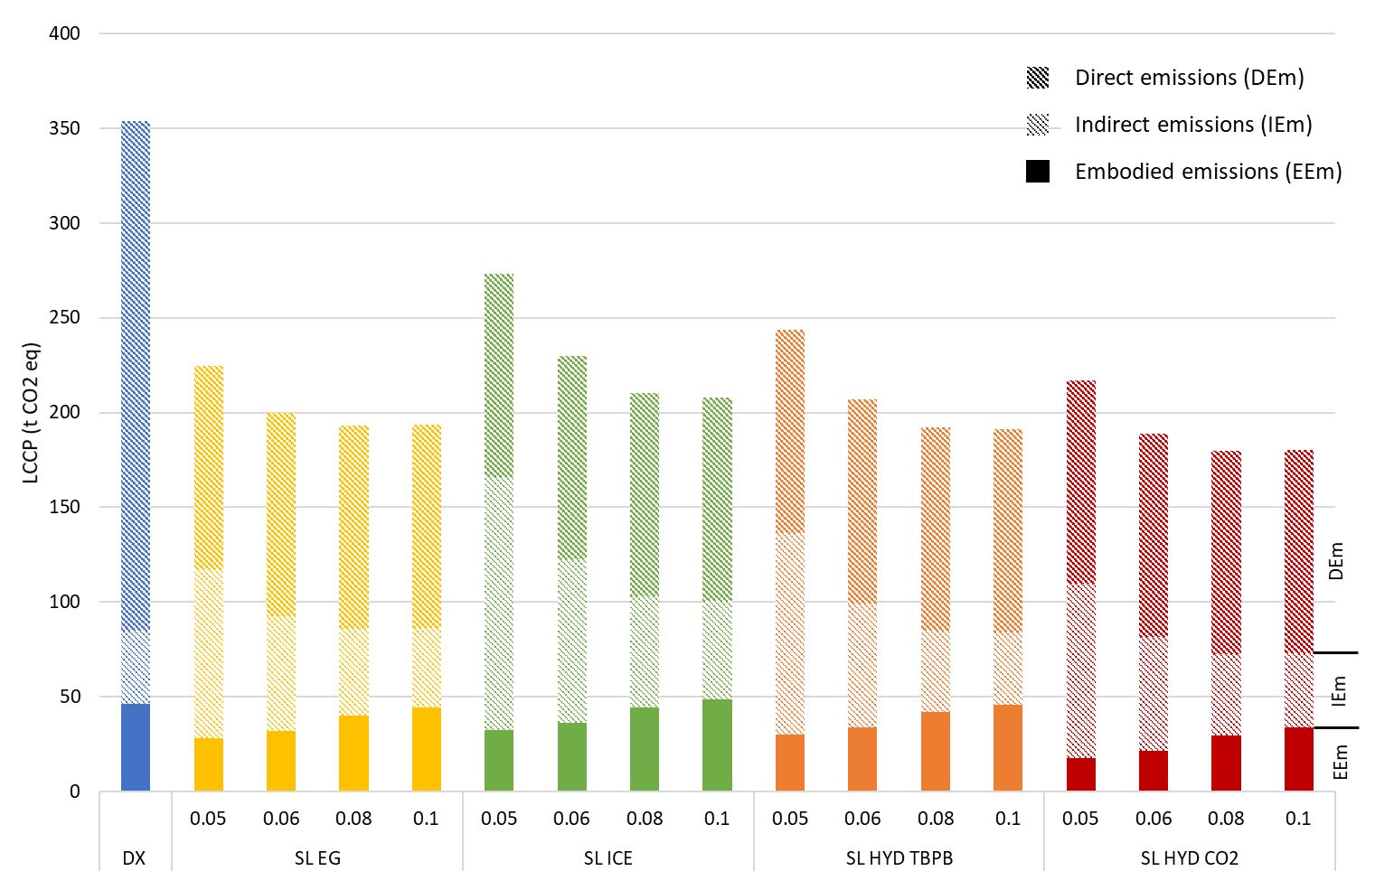

Figure 7. LCCP calculated over ten years for the five architectures: DX; SL EG; SL ICE; SL HYD TBPB; SL HYD CO2, and the different pipe diameters from 0.05 to 0.1 m.

### Total Cost of Ownership (TCO)

Figure 8 represents the TCO calculated over ten years for all the architectures: DX; SL EG; SL ICE; SL HYD TBPB; SL HYD CO2, and the different pipeline diameters. The histograms detail the costs of the manufacturing and end-of-life phases (full histogram), the energy costs and the replacement of refrigerant (hatched histogram) and the maintenance costs (histogram with points) which only depend on the type of architecture and refrigerant use. As a reminder (section 2), TCO is an economic metric corresponding to the total costs of a system during its entire life cycle (from manufacturing to end-of-life treatment).

First, the TCO of all architectures is highly dependent on the energy consumption of the systems. This is why the TCO of SL ICE for the same pipeline diameter is higher than that the other systems. In the case of DX system, the low value of TCO is due to a combination of moderate energy consumption and low installation/EOL treatment and maintenance cost.

Moreover, it is interesting to note that the contribution of installation and end-of-life treatment costs, which is higher for larger diameter SL systems, does not change the order of the TCO. This puts into perspective the installation cost result in Figure 6 discussed earlier.

Finally, the maintenance contribution in the TCO for slurry systems (SL ICE, SL HYD TBPB, and SL HYD CO2) is higher than that of DX and SL EG system. In fact, to ensure that the PCMs (ice or hydrates) are properly formed and used in the system, more regular maintenance and training for operators in this type of system should be considered. In this study, SL HYD CO2 and SL HYD TBPB systems are considered to have the same maintenance parameters as SL ICE systems. In addition, the TCO calculations do not account for the auxiliary components required to form the CO2 and TBPB hydrate slurry, which can influence the trends.

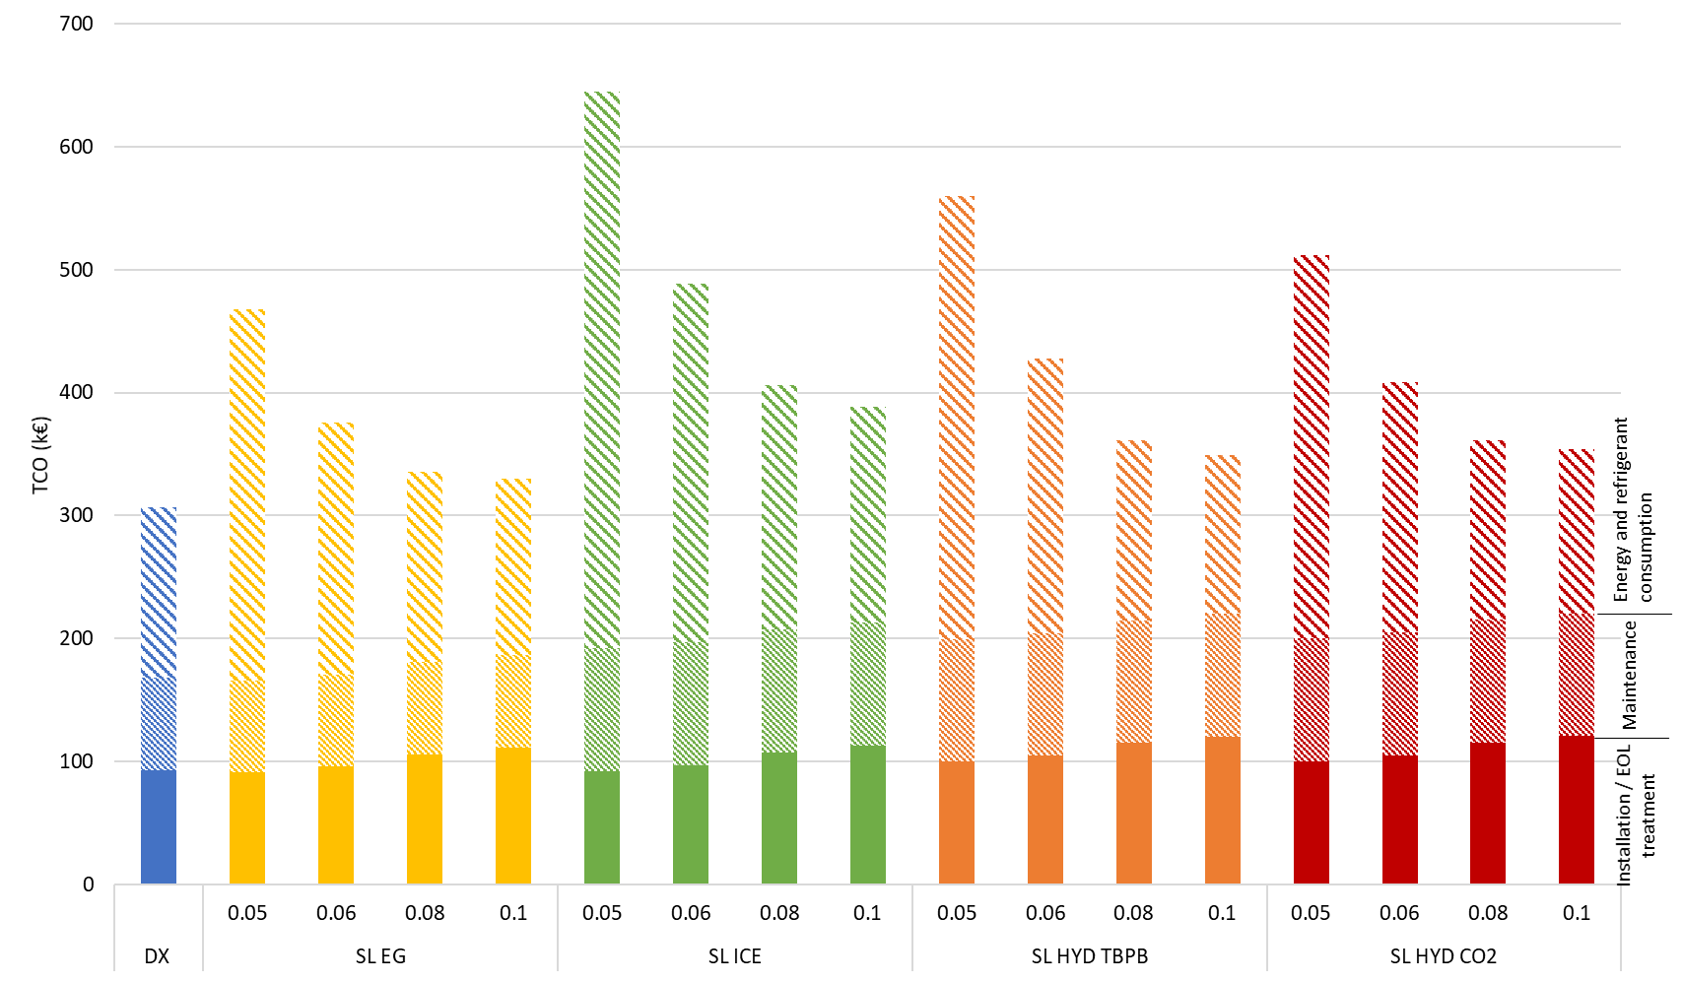

Figure 8. TCO calculated over ten years for the five architectures: DX; SL EG; SL ICE; SL HYD TBPB; SL HYD CO2, and the different pipe diameters from 0.05 to 0.1 m.

Since LCCP (Figure 7) and TCO (Figure 8) are not ranked in the same order across architectures, it is interesting to plot TCO versus LCCP to find trade-off zones according to the different systems. Figure 9 shows the average annual TCO versus the average annual LCCP calculated over ten years for all architectures: DX; SL EG; SL ICE; SL HYD TBPB; SL HYD CO2, and different pipeline diameters: 0.05, 0.06, 0.08 and 0.1 m. First, DX systems have the lowest TCO and the highest LCCP, as shown previously. All of the SL systems have lowest LCCP than DX systems, which is consistent with the regulation on primary refrigerant and is favourable for indirect systems. However, depending on the pipe diameter of the SL systems, their TCO is between double or close to the TCO of the DX system. All SL systems with a diameter of 0.05 or 0.06 meters are over 40 k€, which is at least 30 % higher than the TCO value of the DX systems. However, SL systems with a diameter of 0.08 (except SL ICE) or 0.1 meters, are between 32 k€ and 40 k€, which represents an interesting trade-off (circled in dotted line) compared to the value of the DX systems, and with a much better LCCP (equivalent to half of the DX systems). This TCO/LCCP-based trade-off zone is shifted to the higher diameters (0.08 and 0.1 m) compared to the one shown in Figure 6 that only considered CAPEX/pumping (between 0.06 and 0.08 m). The TCO gives an interesting trend, but as mentioned earlier, the CAPEX is also a crucial data for the stakeholders. Finally, the 0.08 diameter could meet both the TCO-based and CAPEX-based trade-offs.

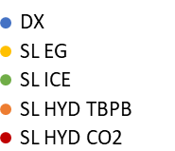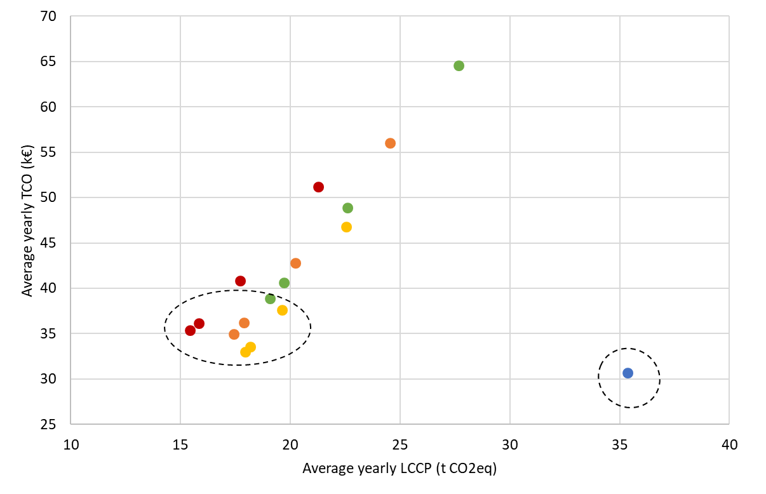

Figure 9. Average annual TCO versus LCCP calculated over ten years for the five architectures: DX; SL EG; SL ICE; SL HYD TBPB; SL HYD CO2, and the different pipeline diameters from 0.05 to 0.1 m.

### Maintenance score

The maintenance score for each architecture and refrigerant is presented in Figure 10 and Table 4. Maintenance was already taken into account quantitatively in TCO sections. In this section, the maintenance is assessed based on the qualitative analysis of the domain experts from French installation and maintenance companies. The architecture maintenance score is based on the installation, maintenance and EOL handling of the system. The aim of the score now is to compare different operational conditions of refrigeration systems. This score is used to highlight the potential operating difficulties of the machines in the different categories. It is to be updated according to technological and operational developments.

DX or SL EG systems are the most frequently used system for supermarket due to their ease of installation, and better operator experience. However, the maintenance of DX is more frequent because of high-GWP refrigerant usage. Moreover, condensers located on the rooftop require a secured accessibility for the operators.

SL HYD TBPB and SL HYD CO2 are more complicated to assess as they are not yet industrialized. SL HYD CO2 uses CO2 gas and should therefore be subject to pressure equipment regulations in the same way as CO2 systems (e.g. transcritical, subcritical), which increases the score. SL HYD TBPB uses TBPB salt that is very toxic and can cause human harm. In addition, the risks associated with the use of this new technology are reflected in the much higher score than for the other two proven systems. Moreover, the EOL treatment parties are not yet prepared for such system (Salehy et al. 2021). The score for SL HYD TBPB and SL HYD CO2 are thus expert-based.

Due to lack of knowledge for each component of the system, the score is assessed only depending on the architecture and refrigerant used. It should be completed with the scores of each component, for example type of installed compressor or condenser.

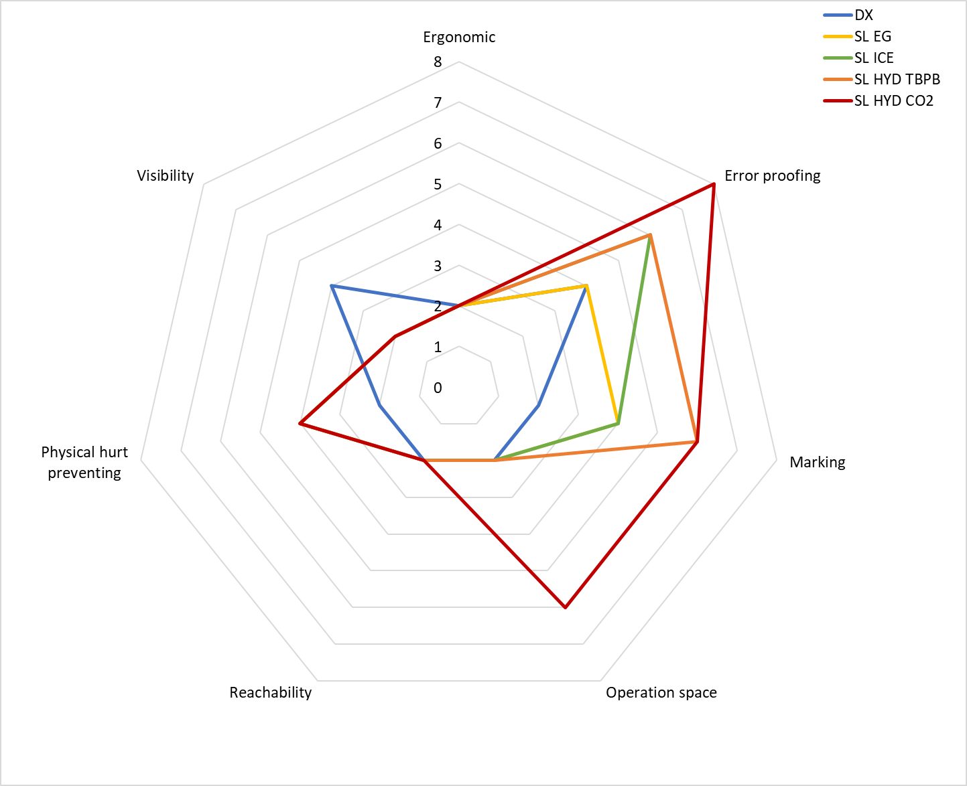

Figure 10. Maintenance score for the five architectures

Table 4. Maintenance score

|  |  |  |  |  |  |
| --- | --- | --- | --- | --- | --- |
| Category | DX | SL EG | SL ICE | SL HYD TBPB | SL HYD CO2 |
| Ergonomic | 2 | 2 | 2 | 2 | 2 |
| Error proofing | 4 | 4 | 6 | 6 | 8 |
| Marking | 2 | 4 | 4 | 6 | 6 |
| Operation space | 0 | 2 | 2 | 2 | 6 |
| Reachability | 2 | 0 | 0 | 0 | 0 |
| Physical hurt preventing | 0 | 4 | 4 | 4 | 4 |
| Visibility | 2 | 0 | 0 | 0 | 0 |
| **Total maintenance score** | **12** | **16** | **18** | **20** | **26** |

# Conclusion and perspectives

This paper proposes a multi-disciplinary (process engineering, industrial engineering) knowledge framework, including task clarification, conceptual design, and embodiment design, used for the first time to assess different air conditioning scenarios based on secondary loop architectures with various fluids/slurries. Four sustainability performances were defined: energy consumption, environmental impact (Life Cycle Climate Performance – LCCP), economic impact (Total Cost of Ownership – TCO) and social impact (maintenance scores).

First, a real architecture and components already developed industrially were used to validate the proposed approach only for total energy consumption. Then five classical and new architectures were tested: centralized direct expansion system using R404a; secondary loop system using one-phase fluid (ethylene glycol water), or two-phase fluids, namely ice slurries, TBPB hydrate slurries or CO2 hydrate slurries.

The main results of this work are listed below:

* Despite the higher efficiency of the primary circuit compressor in the case of a secondary loop, cooling energy consumption when using a single-phase secondary fluid or ice slurry is higher than in the case of a direct expansion system, due to lower operating temperature of the evaporator. The use of TBPB hydrate or CO2 hydrate slurries in a secondary loop is, however, more efficient than direct expansion, due to the low temperature variations combined with better compressor efficiency
* However, when pumping power is added, all secondary loop systems consume more energy than direct expansion, but with a slight difference for larger pipe diameters
* A first CAPEX/pumping-based trade-off was proposed for intermediate diameters, higher than 0.06 m to have a significant effect on pumping power decrease and lower than 0.08 to have a significant effect on the CAPEX
* Despite a lower energy consumption, the LCCP of direct expansion systems is much higher than that of secondary loop systems, due to the type and amount of primary fluid
* The TCO of all architectures is highly dependent on the cooling and pumping energy consumption
* The TCO/LCCP-based trade-off zone is shifted to the higher diameters (0.08 and 0.1) compared to the one only considering CAPEX/pumping (between 0.06 and 0.08 m)
* Consequently, the 0.08 diameter could meet both the TCO/LCCP-based and CAPEX/pumping-based trade-offs
* Due to their low level of maturity and the operational conditions related to TBPB and CO2 hydrate slurries, these systems have the highest maintenance score (most difficult to install and maintain).

This research has showcased various refrigeration system architectures, encompassing both primary and secondary loop systems. Additional architectural types, previously examined in a study for a different application, such as the transcritical CO2 system, demonstrated interesting performance. In future studies different architectural types will be investigated, novel fluids like HFO primary refrigerants or alternative slurries, and various components. This present study focused on air-conditioning applications to assess slurries compatible with a specific temperature range. For instance, CO2 hydrate slurries are not suitable for sub-zero temperatures in food preservation applications. However, future studies may explore the prospect of correlating secondary fluids with their optimal refrigeration applications.

The ultimate objective of this approach is to assist in the decision-making process for the implementation of more sustainable technologies to be developed in Research and Development (R&D). To apply our methodology in this objective, it would be advisable to test the technology in a real industrial setting, via a technology transfer center that would enable hydrate slurry technologies to be scaled up (from laboratory to industrial scale) through further characterization tests.

# Acknowledgements

This work was supported by the French National Research Agency under the program MUSCOFI (ANR-18-CE0-0028) and undertaken in the frame of the US Partnership for International Research and Education program (National Science Foundation Award Number 1743794) and of the French Research Consortium “GDR-2026 Hydrates de gaz”.

# Nomenclature

|  |  |  |  |
| --- | --- | --- | --- |
| GWP | Global Warming Potential | $${EE}_{m}$$ | Embodied emissions |
| $${\dot{Q}}_{X}$$ | Heat flows | $${IE}_{m}$$ | Indirect emissions |
| $${\dot{W}}_{x}$$ | Compressor power | $$TCO$$ | Total cost of Ownership |
| $${∆t}_{x}$$ | Functioning hours | $$CAPEX$$ | Capital costs |
| $${E_{si}}_{}$$ | Electric consumption | $$OPEX$$ | Operational costs |
| $$COP$$ | Coefficient of performance | $$MS$$ | Maintenance score |
| $$T_{x}$$ | Temperature | $$AS$$ | Architecture score |
| $$η$$ | Efficiency | $$RS$$ | Refrigerant score |
| $$LCCP$$ | Life cycle climate performance | $$CS$$ | Cluster score |
| $${DE}_{m}$$ | Direct emissions |  |  |

# References

ADEME. 2017. *Détection de fuite Etude sur les moyens de détection de fuites de fluides frigorigènes des installations de réfrigération et de climatisation*.

ARMINES/ADEME. 2011. 'Inventaire des émissions des fluides frigorigènes et leurs prévisions d'évolutions jusqu'en 2025'.

ASHRAE. 2008. *ASHRAE Handbook—HVAC Systems and Equipment* (ASHRAE Atlanta, GA).

———. 2021. "2021 ASHRAE handbook. Fundamentals." In. Peachtree Corners, GA: ASHRAE.

Bellas, I., and S. A. Tassou. 2005. 'Present and future applications of ice slurries', *International Journal of Refrigeration*, 28: 115-21.

Ben-Abdallah, R., D. Leducq, H.M. Hoang, L. Fournaison, O. Pateau, B. Ballot-Miguet, and A. Delahaye. 2019. 'Experimental investigation of the use of PCM in an open display cabinet for energy management purposes', *Energy Conversion and Management*, 198: 111909.

Bhatia, A. 2014. *HVAC Cooling Load - Calculations and Principles: Quick Book* (CreateSpace Independent Publishing Platform).

Cecchinato, Luca, Marco Corradi, and Silvia Minetto. 2012. 'Energy performance of supermarket refrigeration and air conditioning integrated systems working with natural refrigerants', *Applied Thermal Engineering*, 48: 378-91.

Clain, Pascal, Anthony Delahaye, Laurence Fournaison, Nadia Mayoufi, Didier Dalmazzone, and Walter Fürst. 2012. 'Rheological properties of tetra-n-butylphosphonium bromide hydrate slurry flow', *Chemical Engineering Journal*, 193-194: 112-22.

DelVentura, Robert, Celena L. Evans, and Ira Richter. 2007. 'Secondary loop systems for the supermarket industry', *Bohn White paper setembro de*.

Dufour, Thomas, Hong Minh Hoang, Jérémy Oignet, Véronique Osswald, Pascal Clain, Laurence Fournaison, and Anthony Delahaye. 2017. 'Impact of pressure on the dynamic behavior of CO2 hydrate slurry in a stirred tank reactor applied to cold thermal energy storage', *Applied Energy*, 204: 641-52.

Dupont, Jean-Luc, Piotr Domanski, Philippe Lebrun, and Felix Ziegler. 2019. "The role of refrigeration in the global economy - 38 Informatory Note on Refrigeration Technologies." In, 31. France.

Dyadin, Y.A., Udachin, K.A. (1984). Clathrate Formation in Wateer-Peralkylonium Salts Systems. In: Atwood, J.L., Davies, J.E.D., Osa, T. (eds) Clathrate Compounds, Molecular Inclusion Phenomena, and Cyclodextrins. Advances in Inclusion Science, vol 3. Springer, Dordrecht. https://doi.org/10.1007/978-94-009-5376-5_4

Egolf, Peter W., and Michael Kauffeld. 2005. 'From physical properties of ice slurries to industrial ice slurry applications', *International Journal of Refrigeration*, 28: 4-12.

Ellram, Lisa M. 1995. 'Total cost of ownership: an analysis approach for purchasing', *International Journal of Physical Distribution & Logistics Management*, 25: 4-23.

Geng, Jie, Dong Zhou, Chuan Lv, and Zili Wang. 2013. 'A modeling approach for maintenance safety evaluation in a virtual maintenance environment', *Computer-Aided Design*, 45: 937-49.

Gero, John S. 1990. 'Design prototypes: a knowledge representation schema for design', *AI magazine*, 11: 26-26.

Guilpart, Jacques, Evangelos Stamatiou, Anthony Delahaye, and Laurence Fournaison. 2006. 'Comparison of the performance of different ice slurry types depending on the application temperature', *International Journal of Refrigeration*, 29: 781-88.

Horton, William Travis. 2004. 'Modeling of secondary loop refrigeration systems in supermarket applications.'.

Huang, X., K. Yang, V. B. Lawrence, and P. Perner. 2015. *Advances in data mining: Applications and theoretical aspects. LNCS*.

IEA. 2020. "Cooling Emissions and Policy Synthesis Report." In. Paris.

Jerbi, Salem, Anthony Delahaye, Jérémy Oignet, Laurence Fournaison, and Philippe Haberschill. 2013. 'Rheological properties of CO2 hydrate slurry produced in a stirred tank reactor and a secondary refrigeration loop', *International Journal of Refrigeration*, 36: 1294-301.

Kauffeld, Michael, M. Kawaji, et P.W. Egolf. 2005. Handbook on Ice Slurries: Fundamentals and Engineering.

Kazachki, Georgi S., and David K. Hinde. 2006. 'Secondary coolant systems for supermarkets', *ASHRAE journal*, 48: 34-47.

Lakhdar, Ben. 1998. 'Thermal-hydraulic behavior of a two phase mixture: ice slurry. Theoretical and experimental studies'.

Majid, Ahmad A. A., David T. Wu, et Carolyn A. Koh. 2018. A Perspective on Rheological Studies of Gas Hydrate Slurry Properties. Engineering 4 (3): 321‑29. https://doi.org/10.1016/j.eng.2018.05.017

Marinhas, Sandrine, Anthony Delahaye, Laurence Fournaison, Didier Dalmazzone, Walter Fürst, and Jean-Pierre Petitet. 2006. 'Modelling of the available latent heat of a CO2 hydrate slurry in an experimental loop applied to secondary refrigeration', *Chemical Engineering and Processing*, 45: 184-92.

Mayoufi, Nadia, Didier Dalmazzone, Anthony Delahaye, Pascal Clain, Laurence Fournaison, and Walter Fürst. 2011. 'Experimental Data on Phase Behavior of Simple Tetrabutylphosphonium Bromide (TBPB) and Mixed CO2 + TBPB Semiclathrate Hydrates', *Journal of Chemical & Engineering Data*, 56: 2987-93.

Muromachi, Sanehiro, Toru Abe, Yoshitaka Yamamoto, et Satoshi Takeya. 2014. « Hydration structures of lactic acid: characterization of the ionic clathrate hydrate formed with a biological organic acid anion ». Physical Chemistry Chemical Physics 16 (39): 21467‑72. https://doi.org/10.1039/C4CP03444A.

Pahl, Gerhard, and Wolfgang Beitz. 2013. *Engineering design: a systematic approach* (Springer Science & Business Media).

Purvis, Ben, Yong Mao, and Darren Robinson. 2019. 'Three pillars of sustainability: in search of conceptual origins', *Sustainability Science*, 14: 681-95.

Salehy, Yasmine, Anthony Delahaye, Hong Minh Hoang, Laurence Fournaison, François Cluzel, Yann Leroy, and Bernard Yannou. 2023. 'Choosing an optimized refrigeration system based on sustainability and operational scenarios applied to four supermarket architectures in three European countries', *Journal of Cleaner Production*, 392: 136307.

Salehy, Yasmine, Clain Pascal, Amokrane Boufares, Véronique Osswald, Anthony Delahaye, and Laurence Fournaison. 2017. 'Rheological study on CO2 hydrate slurries for secondary refrigeration', *Energetika*, 63.

Salehy, Yasmine, Bernard Yannou, Yann Leroy, François Cluzel, Laurence Fournaison, Hong-Minh Hoang, Robin Lecomte, and Anthony Delahaye. 2021. 'Diagnosis of development opportunities for refrigeration socio-technical system using the radical innovation design methodology', *Proceedings of the Design Society*, 1: 1263-72.

Selvnes, Håkon, Yosr Allouche, Raluca Iolanda Manescu, and Armin Hafner. 2021. 'Review on cold thermal energy storage applied to refrigeration systems using phase change materials', *Thermal Science and Engineering Progress*, 22: 100807.

Song, Mengjie, Fuxin Niu, Ning Mao, Yanxin Hu, and Shiming Deng. 2018. 'Review on building energy performance improvement using phase change materials', *Energy and Buildings*, 158: 776-93.

Wang, Kai, Magnus Eisele, Yunho Hwang, and Reinhard Radermacher. 2010. 'Review of secondary loop refrigeration systems', *International Journal of Refrigeration*, 33: 212-34.

Wernet, Gregor, Christian Bauer, Bernhard Steubing, Jürgen Reinhard, Emilia Moreno-Ruiz, and Bo Weidema. 2016. 'The ecoinvent database version 3 (part I): overview and methodology', *The International Journal of Life Cycle Assessment*, 21: 1218-30.